Analyzing Traffic Accident Contributing Factors for Enhanced Road Safety
By Athapattu Dissanayakage Savith Rangana
Programme title | Master of Information Technology
Course code and title | PGDAV8.100 Data Analytics and Visualisation T2 2025
Lecturer name | Dr. Farhad Mehdipour
Assessment title | TOPIC TWO – DATA ACQUISITION, WRANGLING and EDA
Due date | 20/05/2025

Name |  | ID |  | Signature | Date
A D Savith Rangana |  | 2024003716 |  | ADSavith | 19/05/2025

Table of Contents

1. Business Scenario 1
2. Data Source 1
3. Data Wrangling 2
3.1 Fix data type 2
3.2 Remove duplicate records 3
3.3 Change “Unknown, Other and Not Applicable” cells to real NA 3
3.4 Trim spaces and clean text 4
3.5 Add new columns 4
4. Exploratory Data Analysis (EDA) 6
4.1 Questions 6
4.2 Descriptive Analysis 6
4.2.1 Central Tendency 6
4.2.2 Graphical EDA 7
5. References 12

Business Scenario

City authorities are under pressure to reduce the deaths and injuries on the road. For example, Wellington’s safety strategy sets a 40% reduction target for deaths and serious injuries by 2030 (Wellington, 2021). To show how data analytics can handle this evidence based problem, this study analyse road accident dataset to answer simple business question of “Which conditions most elevate the chances of crash becomes fatal or incapacitating and when should road safety resources be deployed?”. The insights will help policing hours, lighting upgrades and weather responsive speed limits (Yakupova et al., 2020).

Data Source

The dataset using for this analysis is traffic accident dataset which is retrieved from Kaggle. The dataset has 209306 records and 24 variables (Ördekçi, 2025). Figure 1 and Figure 2 illustrates the variables. The mix of numerical and categorical variables is useful for plots, tests and machine learning models.
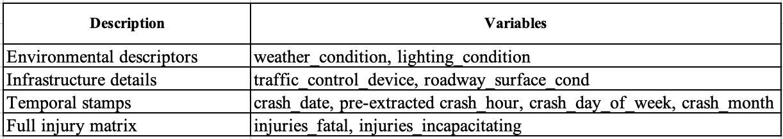
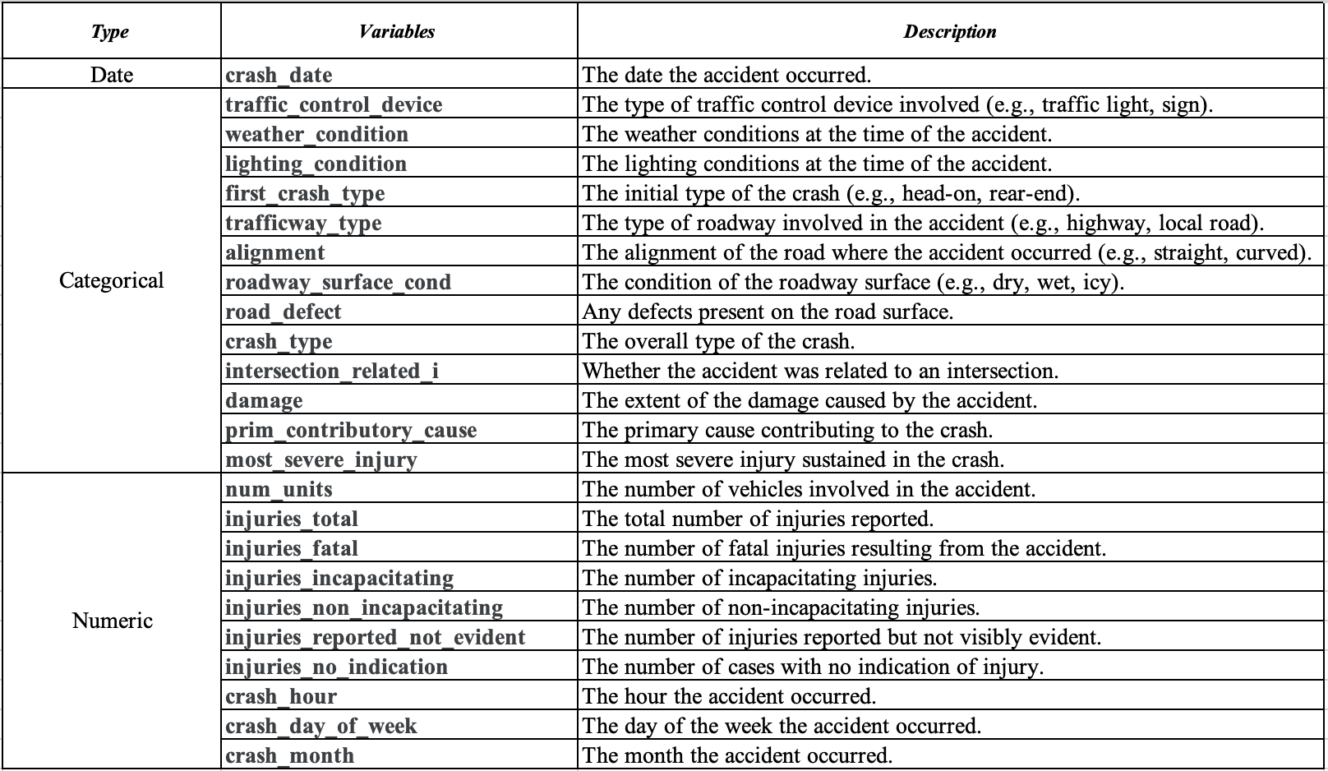

Data Wrangling

The dataset is processed and cleaned using R Studio to make it ready for EDA. Flowing wrangling techniques were used for data wrangling.
First read the dataset into R studio using below code.
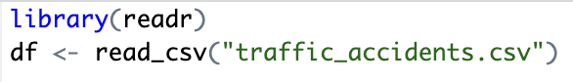
Then load required libraries for wrangling.
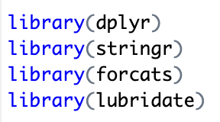

Fix data type

Created a new column crash_dt by turned the crash_date variable into real date format, created a new Boolean column intersection using intersection_related_i variable and order the damage scale. Below is the code used.
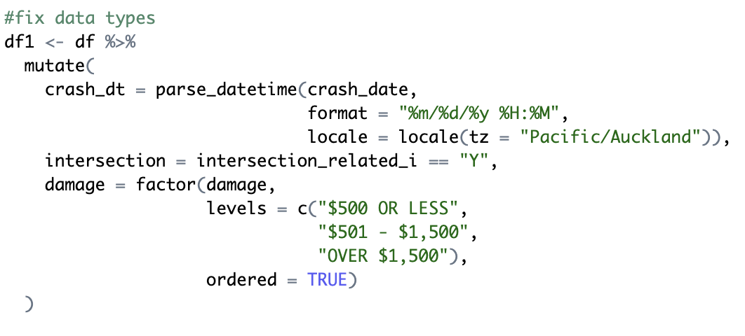

Created two new columns.
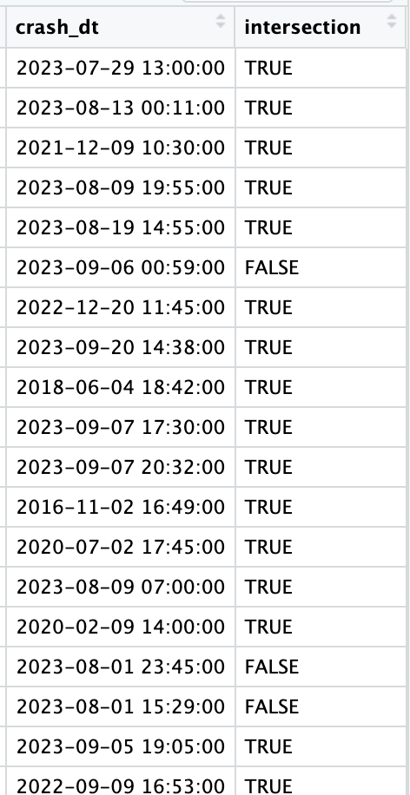

Remove duplicate records

Dataset initially had 209306 records. After removing 31 duplicated records, the dataset now have 209275 records. Remove duplicates is important for the consistency and accuracy of the analysis. Below code is used to remove duplicates.
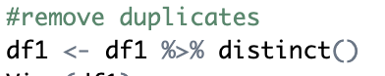

Change “Unknown, Other and Not Applicable” cells to real NA

To protect data quality and make analysis accurate, change all the Unknown, Other and Not applicable values into true NA.
First checked the NA values using below code.
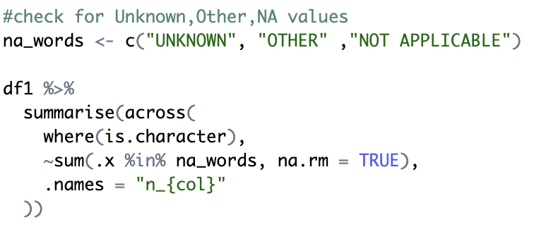

It gave the below output, mentioning the variables with NA values.
Then changed all the NA values using below code
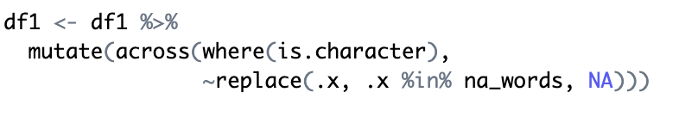

Trim spaces and clean text

Using below code removed all the unneeded spaces which makes charts clear.
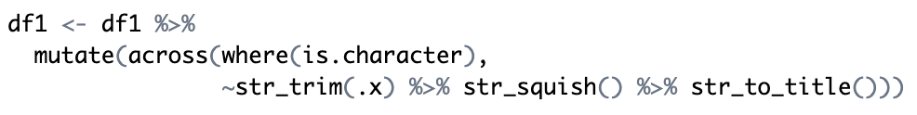

Add new columns

Added 8 extra columns using date and weather columns to get clear insights. Below is code for that and crated columns.
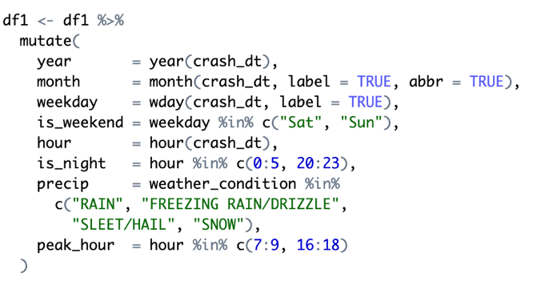
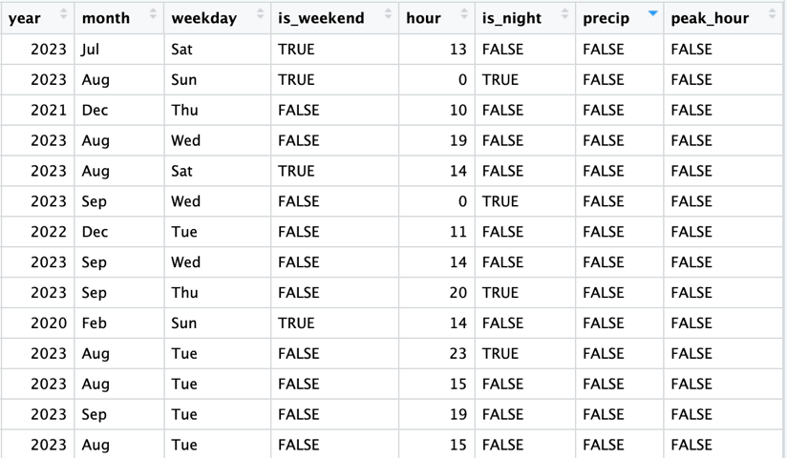
Added another column severity to get idea of crash severity level from six injury count columns.
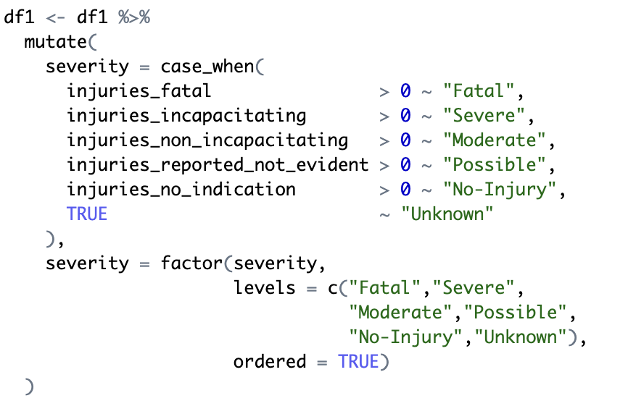
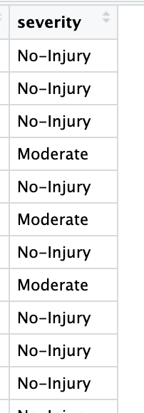

Exploratory Data Analysis (EDA)

Questions

- Which road, time and weather conditions most increase the probability that a crash turns fatal or severe?
  - The high risk combinations will help the authorities to target the upgrades and warning signs.
- How does the number of crashes changes from month to month, is there any seasonal pattern?
  - This will reveal regular highs and lows in volume. Understanding the cycle helps authorities to allocate staff in high volume months.
- Does night time driving lift fatal or severe count versus day time?
  - Test the impact of low visibility and higher speeds after dark which guide decisions on street lights and night enforcements.
- Does the weekend keep a higher fatal percentage after we control for night and weather?
  - Checking the social factors increasing the risk.
- Do peak hour crashes show more events but lower per crash harm?
  - The high traffic adds incidents but slower speeds may reduce the injury severity.
- Do multi vehicle crashes carry higher median severity than single vehicle ones?
  - Main focus should be speed and spacing campaings.

4.2 Descriptive Analysis

4.2.1 Central Tendency

- Mean monthly crash count is 1758.613.
- Median is 2101 which is above the mean that shows many lower count months pull the average down.
- Standard deviation is 738.0842, so a typical month is about 740 crashes away from the mean.
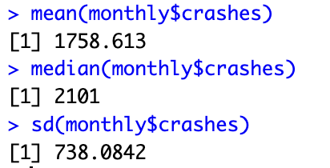
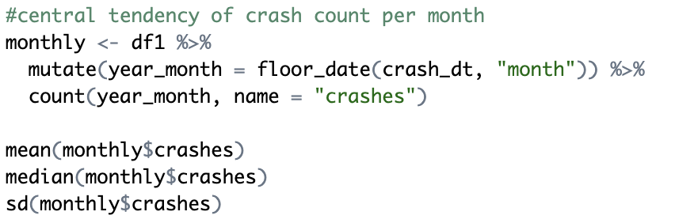

4.2.2 Graphical EDA

- Crash count with harm rate by hour
Figure 1 shows crash volume and crash harm do not move together. When roads are busy and congested, cars move slowly. That creates minor crashes with gentle impacts. When roads are quite late at night, drivers have open space and drive faster which makes severe or fatal crashes but fewer crash count.
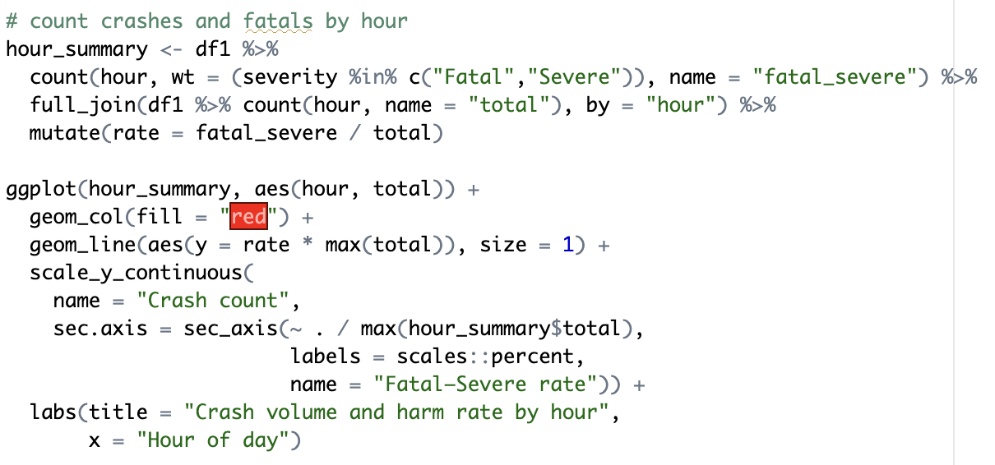
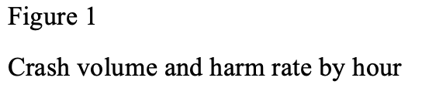

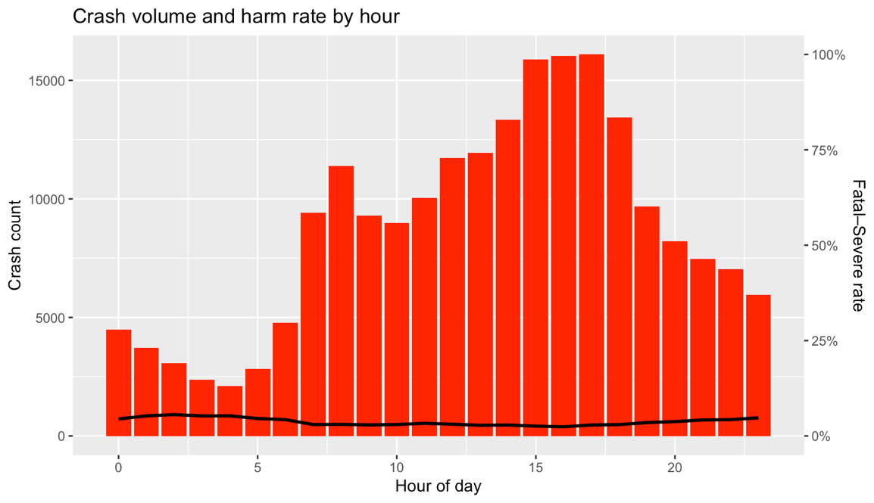

- Monthly crash trend
Monthly counts swing between 1100 and 2600 crashes. Peak months are May and September but the median is still above the mean which few exceptional low months (March 2020, December 2024) drag the average down. Those dips with Covid lockdowns and holiday slow downs drove the short term drops.
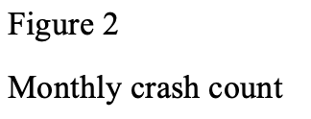
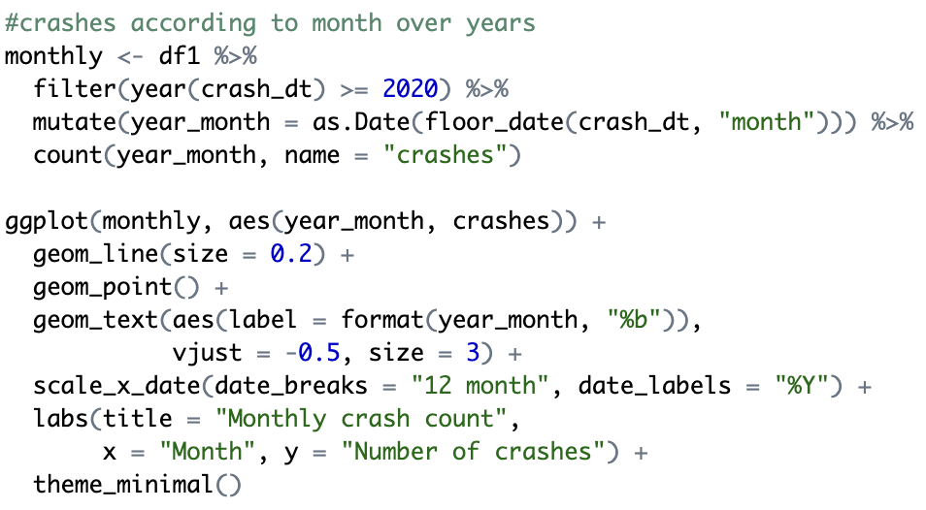
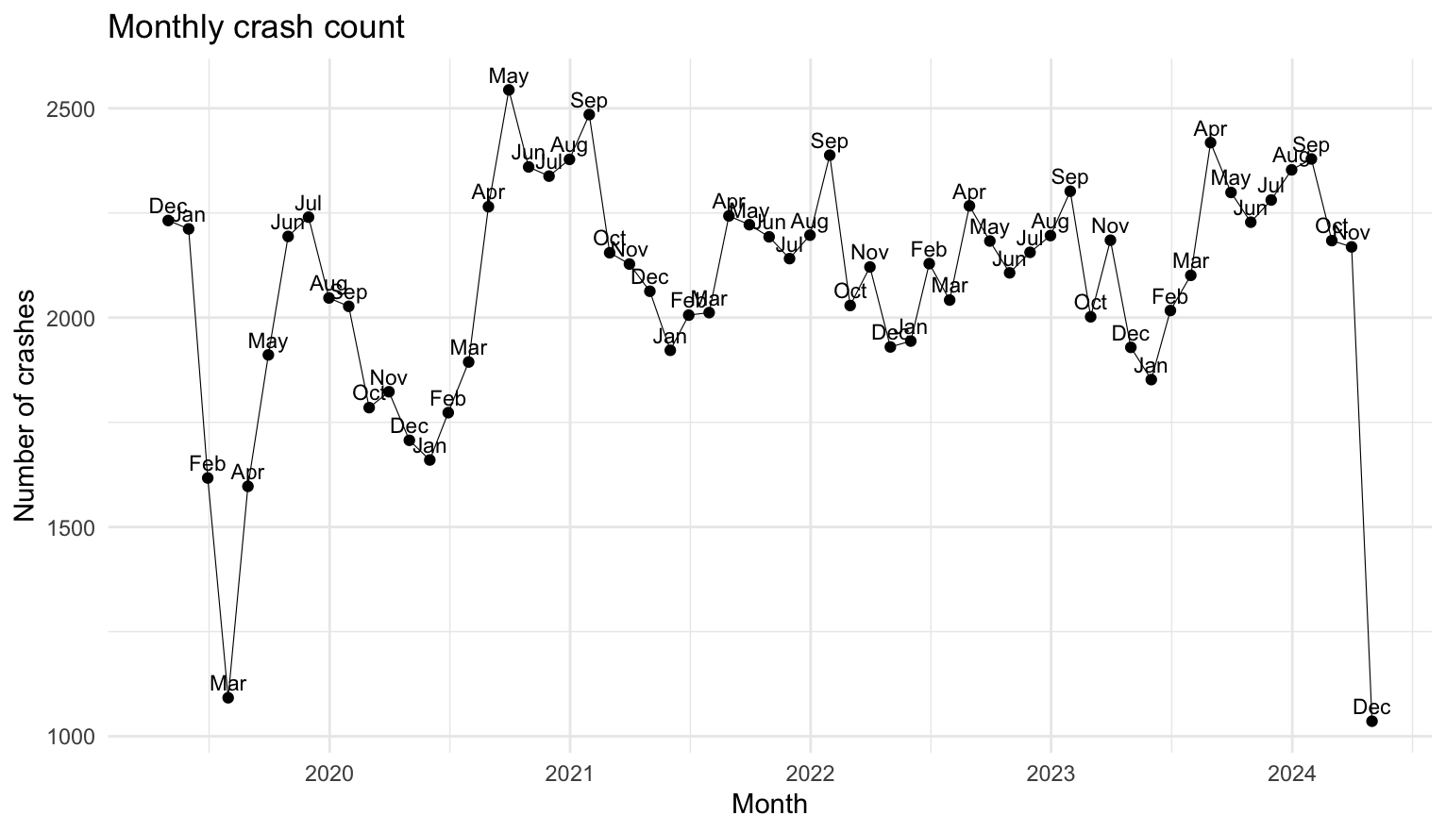

- Severity by weather condition
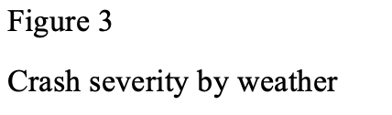
This demonstrate that rain, sleet and wind gate almost double the fatal or severe percentage even though clear weather accounts for three quarters of crashes.

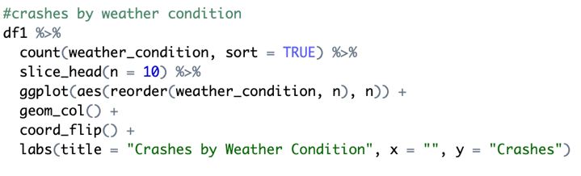
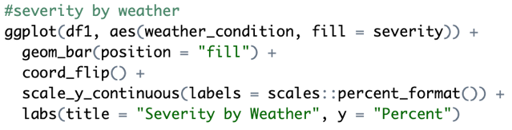

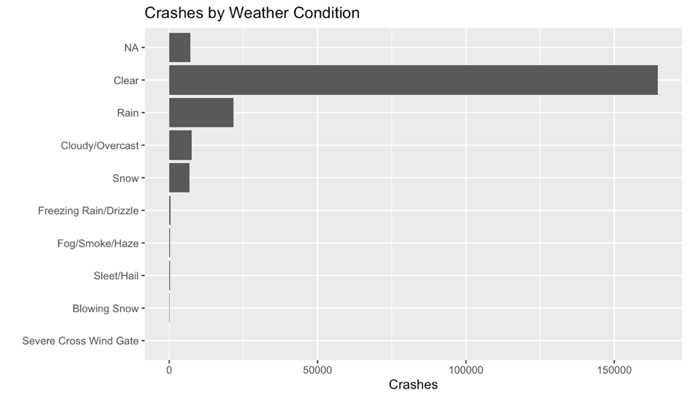

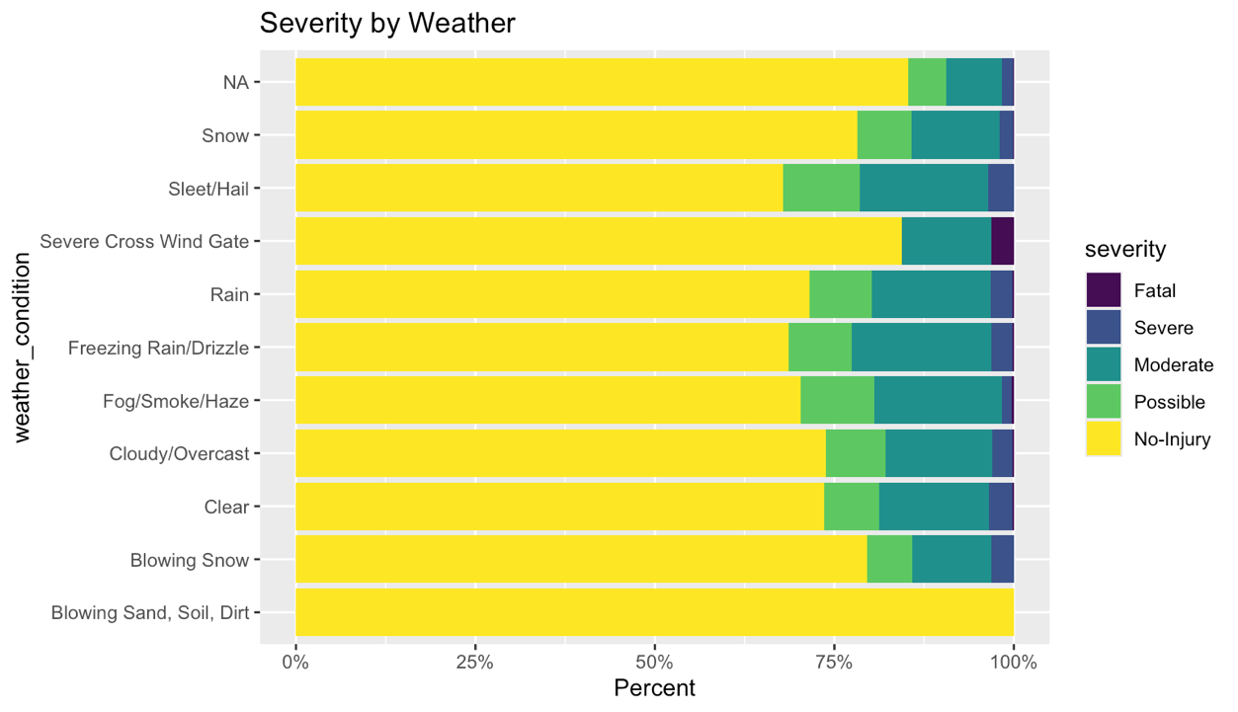

- Day of the week and night flag

This shows daylight dominates overall numbers Monday to Friday but the night bars for Friday to Saturday surge which reflecting alcohol and fatigue related behavior. When link this to weather small subset of wet night events produces a disproportionate percent of deaths.
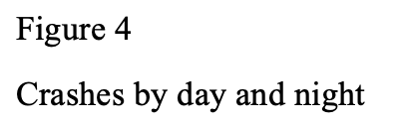
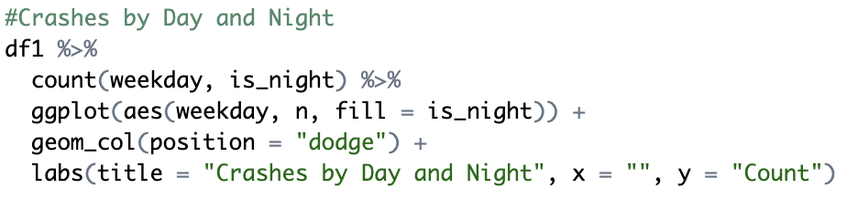

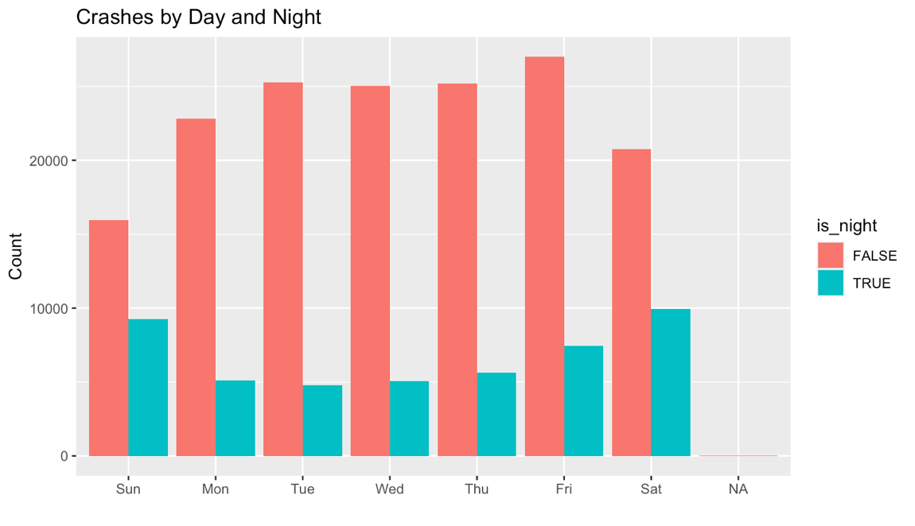

- Number of vehicles and severity

The vehicle counts against severity shows the median stays at two for every group. Single vehicle loss of control crashes are the deadliest. This finding shift attention from multi vehicle pile ups to speed management and roadside protection.
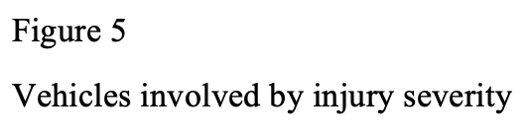
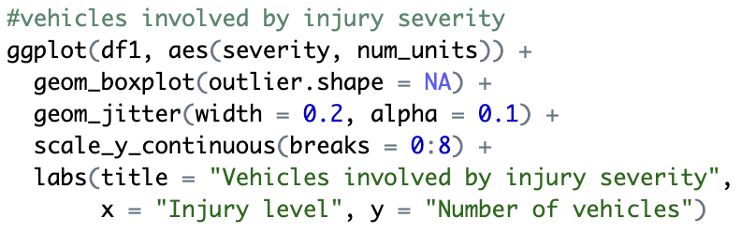
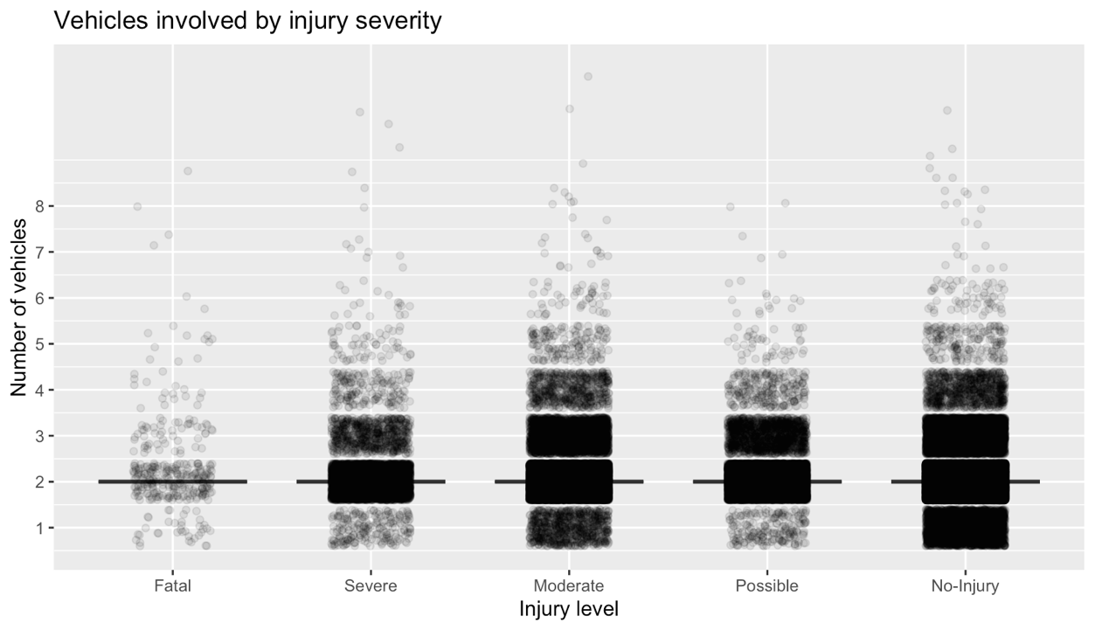

Across all the figures, The evidence points to one high risk window which late evening, wet or icy conditions, especially on weekends, when speeds are high and driver vigilance is low. Lighting upgrades, weather responsive speed limits and targeted night time enforcement align directly with these findings and are likely to yield better safety returns than broad daytime measures (Chand et al., 2021).

References

Chand, A., Jayesh, S., & Bhasi, A. (2021). Road traffic accidents: An overview of data sources, analysis techniques and contributing factors. Materials Today: Proceedings, 47, 5135-5141.
Ördekçi, O. (2025). Traffic Accidents. https://www.kaggle.com/datasets/oktayrdeki/traffic-accidents
Wellington, G. (2021). Wellington regional land transprt plan. Retrieved from https://www.gw.govt.nz/assets/Documents/2021/10/Wellington-Regional-Land-Transport-Plan-2021web.pdf?utm_source=chatgpt.com
Yakupova, G., Buyvol, P., & Shepelev, V. (2020). Identification of factors affecting the road traffic injury rate. Transportation Research Procedia, 50, 735-742. https://doi.org/https://doi.org/10.1016/j.trpro.2020.10.086

