Analyzing Traffic Accident Contributing Factors for Enhanced Road Safety
By Athapattu Dissanayakage Savith Rangana
Programme title | Master of Information Technology
Course code and title | PGDAV8.100 Data Analytics and Visualisation T2 2025
Lecturer name | Dr. Farhad Mehdipour
Assessment title | TOPIC THREE & 4A
Due date | 03/06/2025
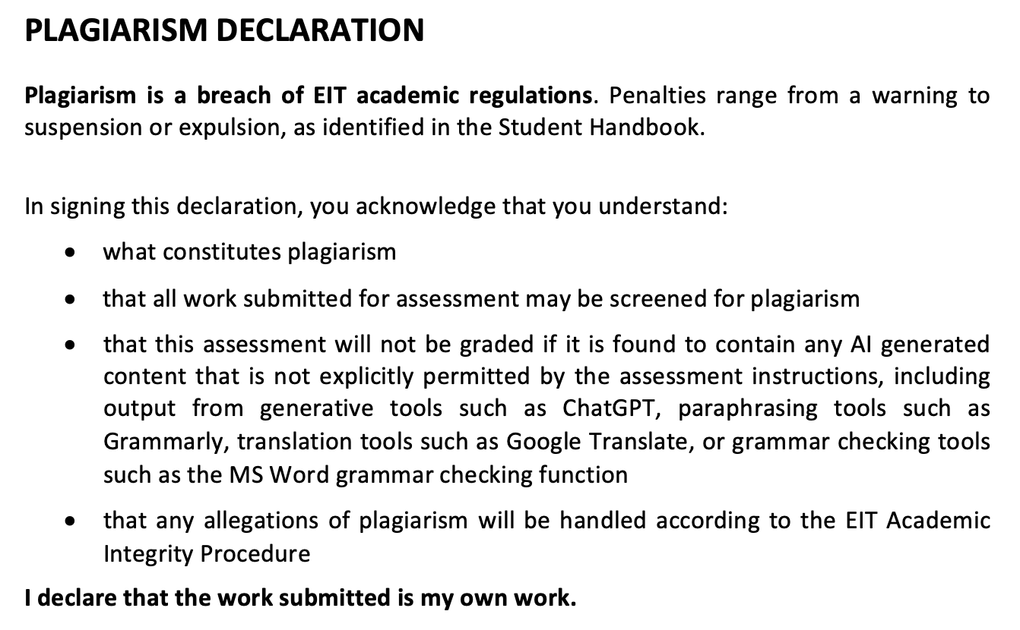
Name |  | ID |  | Signature | Date
A D Savith Rangana |  | 2024003716 |  | ADSavith | 02/06/2025

Table of Contents

1. Business Scenario & Key EDA Out Comes 2
2. Statistical Inference 2
2.1 Correlation Analysis 2
2.2 Hypothesis Testing 3
2.2.1 Q1: Does night time driving increase the chance a crash is fatal or severe? 3
2.2.2 Q2: Does a wet or icy surface add risk after we account for light? 4
2.2.3 Q3: Do rush hour periods show lower harm per crash than late night? 5
2.2.4 Q4: Are multi vehicle pile-ups are harmful than single vehicle crashes? 6
3. Predictive Modelling 7
4. References 9

Business Scenario & Key EDA Out Comes

City authorities are under pressure to reduce the deaths and injuries on the road. For example, Wellington’s “Road to Zero” strategy aims to cut deaths and serious injuries by 40% before 2030 (Wellington, 2021). Beacause Wellington crash data are sparse, we have analysed a traffic accidents around various regions which has 209275 records as a substitute assuming collision mechanics are the same. Topic two showed that,
- Crash volume high in 3pm – 6pm window and the fatal or severe percentage doubles on wet weekend nights after 8pm.
- Single vehicle loss of control events dominate fatalities and muti car pile ups mainly cause minor wounds.
Those insights produces five low level risk questions (night, wet surface, weekend, rush hour, vehicle count). In this report we tests the statistical significance of each factor.

Statistical Inference

Correlation Analysis

In Figure 1, Pearson correlation heat map shows high correlation only between injuries_total and injuries_non_incapacitating (p = 0.77), with lesser overlap for injuries_incapacitating (p = 0.55). All other numeric pairs sits below 0.35, so linear inter dependence among the remaining numeric fields is negligible. To eliminate this single source of highly correlated variables we drop the derived variable injuries_total.
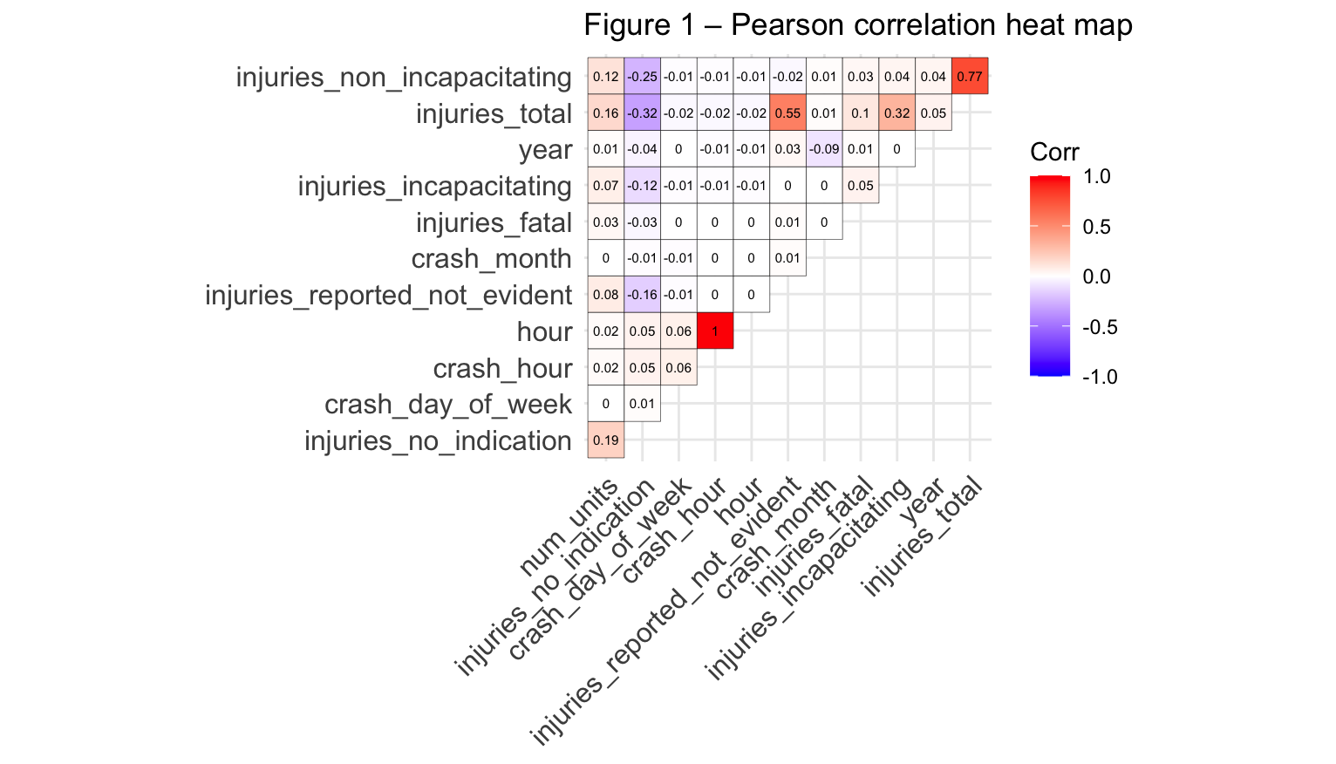

Hypothesis Testing

Hypothesis testing is used to evaluate the significance of correlations among variables. It is helpful to identify whether the observed differences between groups are due to chance or any underlying pattern (Frost, 2020).

Q1: Does night time driving increase the chance a crash is fatal or severe?

We use the chi squared test to analyse below hypothesis because both is_night and highharm are binary categorical variables and chi squared test is designed to assess independence between such categories.
- H₀ – Night and day crashes have the same high harm rate.
- H₁ – Night crashes have a different (higher) high harm rate.
Figure 2
Chi Squared test for question 1
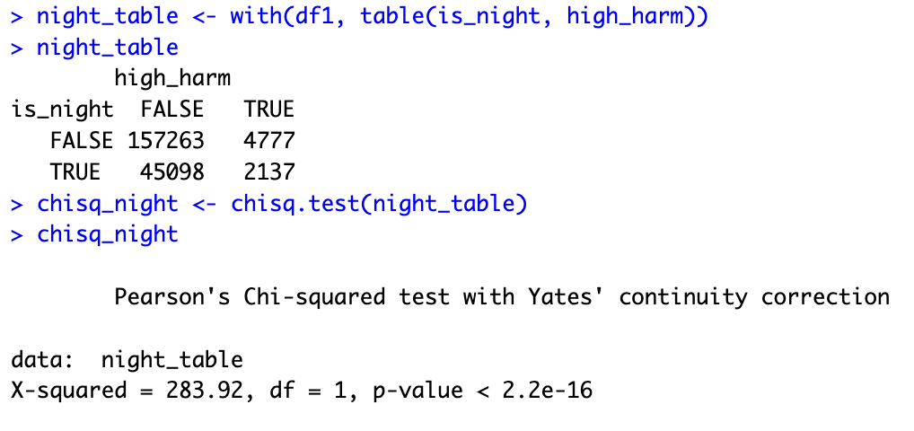
Based on P – Value ( 2.2e-16 < 0.05 ), we can reject the H₀ and accept the alternative hypothesis with 95% confident. The night time crashes are higher and likely to be fatal or severe.

Q2: Does a wet or icy surface add risk after we account for light?

We apply Mantel Haenszel Chi Squared test because both predictors, road surface and outcome (high_harm – fata/severe vs other) are binary, and the effect must be adjusted for another binary field which is light condition (is_night). This procedure pools 2x2 tables across levels and yields an overall odds ratio while controlling for that factor which makes it standard method recommended for categorical data (De Silva Perera & Sooriyarachchi, 2012).
- H₀ – Within each light condition, wet roads have the same high-harm odds as dry roads.
- H₁ – Wet roads have a different (higher) odds.

Figure 3
Mantel-Haenszel Chi Squared test for question 2
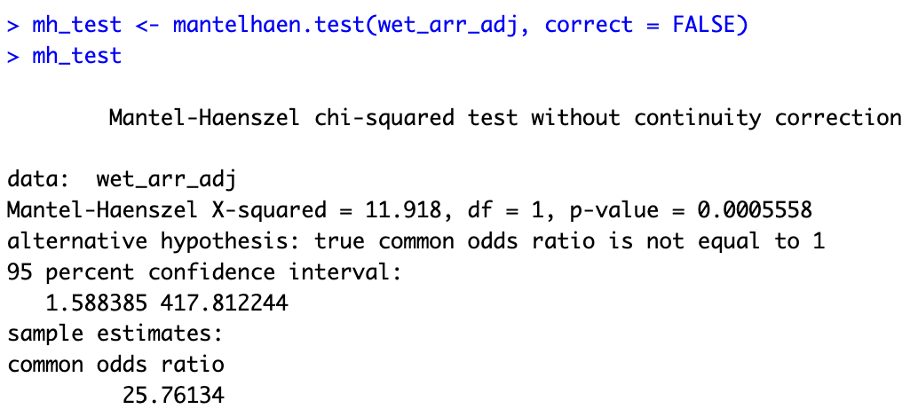

Based on P – Value ( 0.0005558 < 0.05), we can reject the H₀ and accept the alternative hypothesis with 95% confident. Wet or icy roads make crashes more likely to be fatal or severe.

Q3: Do rush hour periods show lower harm per crash than late night?

We use the Pearson’s chi squared test because both variables involved time of day period (Rush and Late) and crash outcome (high_harm) are binary categorical.
- H₀ – Hourly fatal/severe rate is equal across the 24 hours.
- H₁ – Some hours (late at night) differ.
Figure 4
Pearson’s Chi Squared test for question 4
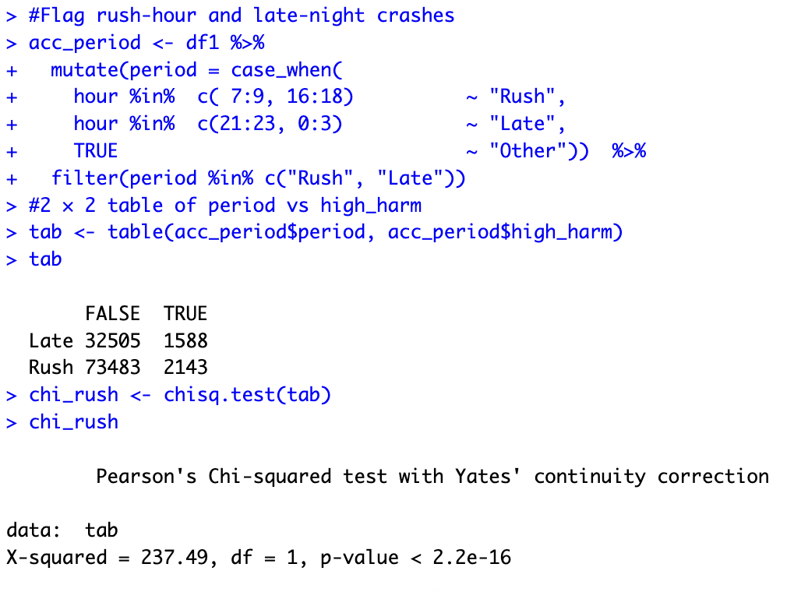
Based on P – Value ( 2.2e-16 < 0.05), we can reject the H₀ and accept the alternative hypothesis with 95% confident. Rush hour crashes show a significantly lower fatal or severe percentage than late night crashes.

Q4: Are multi vehicle pile-ups are harmful than single vehicle crashes?

We use Kruskal Wallis test because injury severity is recorded on an ordinal scale. The Kruskal Wallis procedure compares median ranks across independent samples without assuming normality or equal variances (Yan et al., 2024).
- H₀ – Median severity is equal across 1, 2, 3 + vehicle crashes.
- H₁ – At least one group is differ.
Figure 5
Kruskal Wallis test for question 4.
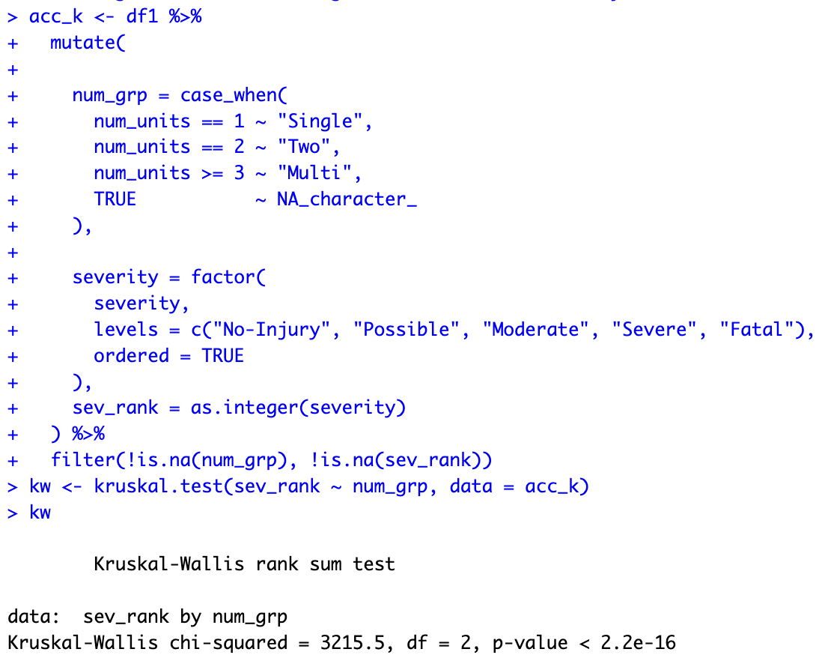

Based on P – Value ( 2.2e-16 < 0.05), we can reject the H₀ and accept the alternative hypothesis with 95% confident. The median injury severity is not the same across the vehicle count groups.

Predictive Modelling

We will build a logistic regression model to answer the question, “given night – light, weather, day type and basic scene facts, what is the probability this crash will be high harm?”
The data were split into 80% training and 20% test set.
Figure 6
Data splitting
We ran a binomial logistic regression. Predictor variables were night flag, weekend flag, wet flag, rush hour flag, vehicle count and intersection flag. Night time and vehicle count were the strong contributors. Night driving raised about 60% to the odds of fatal or severe harm. Each extra vehicle raises the odds about 70%. Weekend and rush hour were not significant once the other factors were included in the model.
Figure 7
Logistic regression model
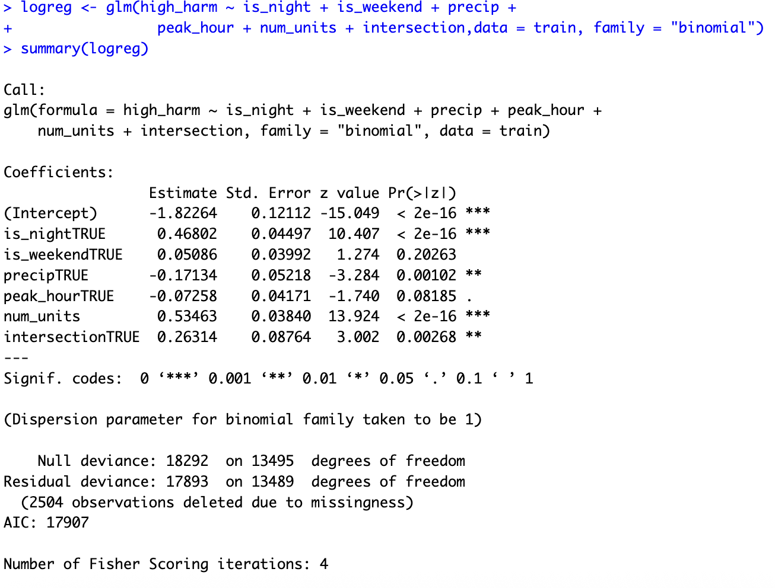
The confusion matrix shows the model accuracy about 62% which slightly better thatn the 60% no information rate. The model successfully identified 88% of low-harm crashes but it detects only 21% of fatal or severe crashes.
Figure 8
Confusion matrix
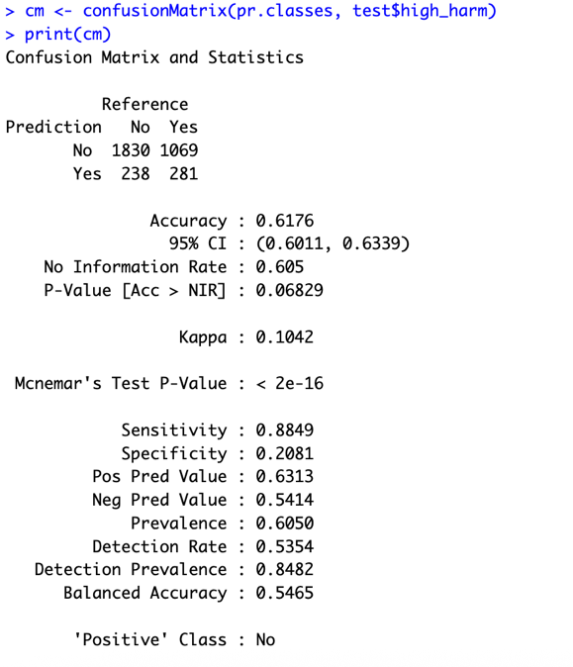
Figure 9
Plotting confusion matrix
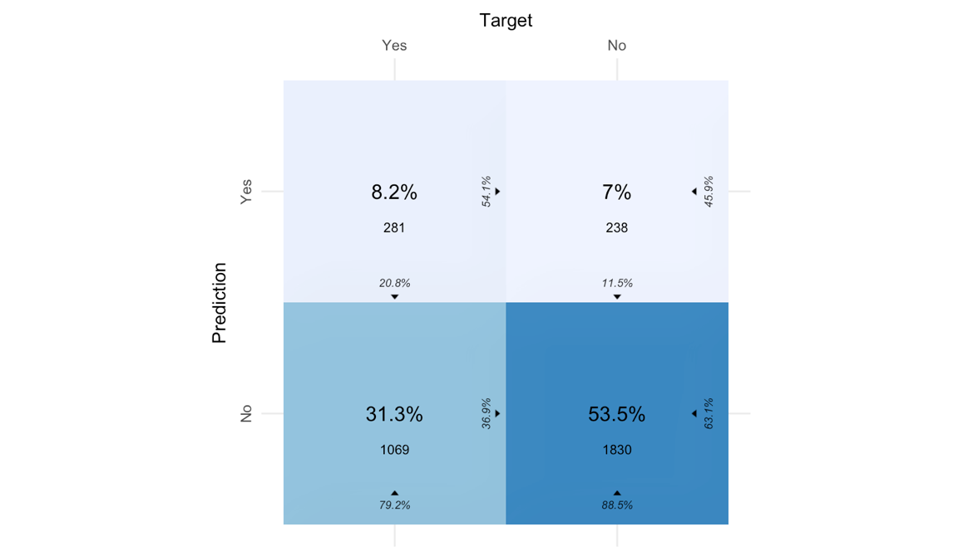

The baseline logistic model confirms that night time conditions and multi vehicle involvement are the most reliable early indicators of high harm.

References

De Silva Perera, U., & Sooriyarachchi, R. (2012). Generalized Cochran Mantel Haenszel Test for Multilevel Correlated Categorical Data: An Algorithm and R Function. Journal of the National Science Foundation of Sri Lanka, 40. https://doi.org/10.4038/jnsfsr.v40i2.4441
Frost, J. (2020). Statistical Hypothesis Testing Overview. https://statisticsbyjim.com/hypothesis-testing/statistical-hypothesis-testing-overview/
Wellington, G. (2021). Wellington regional land transprt plan. Retrieved from https://www.gw.govt.nz/assets/Documents/2021/10/Wellington-Regional-Land-Transport-Plan-2021web.pdf?utm_source=chatgpt.com
Yan, R., Hu, L., Li, J., & Lin, N. (2024). Accident Severity Analysis of Traffic Accident Hot Spot Areas in Changsha City Considering Built Environment. Sustainability, 16(7), 3054. https://www.mdpi.com/2071-1050/16/7/3054

