Analyzing Traffic Accident Contributing Factors for Enhanced Road Safety
By Athapattu Dissanayakage Savith Rangana
Programme title | Master of Information Technology
Course code and title | PGDAV8.100 Data Analytics and Visualisation T2 2025
Lecturer name | Dr. Farhad Mehdipour
Assessment title | TOPIC 4B
Due date | 18/06/2025

Name |  | ID |  | Signature | Date
A D Savith Rangana |  | 2024003716 |  | ADSavith | 17/06/2025

Table of Contents

1. Introduction 2
2. Clustering Method 2
3.1 Why Clustering? 2
3.2 Data and distance choice 2
3.3 Algorithm and Cluster 2
3. Classification Methods 4
3.1 Data and setup 4
3.2 Algorithms 4
3.3 Cross validated results 4
3.4 Final Model tuning 6
4. Conclusion 7
5. References 8

Introduction
Wellington’s Road to Zero programme sets an ambitious target which a 40 % reduction in deaths and serious injuries on city roads by 2030 (Wellington, 2021). Earlier stages of this project showed that night time, wet roads and weekend travel are the strongest independent drivers of fatal or severe outcomes. Chi Squared and Mantel–Haenszel tests put the combined night-wet odds ratio near 2. The baseline logistic model translated those insights into odds-ratios but achieved an accuracy of 62%, missing four out of five high-harm events. Topic 4 B therefore moves beyond simple linear effects to advanced machine learning techniques.

Clustering Method

3.1 Why Clustering?

All earlier modelling treats every crash as an independent point, but road safety counter measures are implemented in batches such as weekend drink drive blitz across several suburbs. Clustering helps to translate row level records into handful of actionable profiles. By grouping crashes that share time of day, surface condition and crash geometry, planners can target entire profiles instead of chasing individual incidents.

3.2 Data and distance choice

We already selected eight variables which are is_night, precip, is_weekend, hour, intersection, num_units, traffic_control_device, and crash_type. These mix numeric and categorical types, so we used Gower distance which is well suited to mixed data because it scales each variable to [0, 1] and averages the partial dissimilarities (Hennig & Liao, 2013).

3.3 Algorithm and Cluster

We applied PAM (k-medoids) which is robust to outliers and return real crashes as medoids which makes the clusters easy to explain (Park & Jun, 2009). A grid search over k=2 to 8 showed the average silhouette width peaks at 4 with 0.30 which is moderate but a useful structure.

Figure 1
Silhouette of clusters
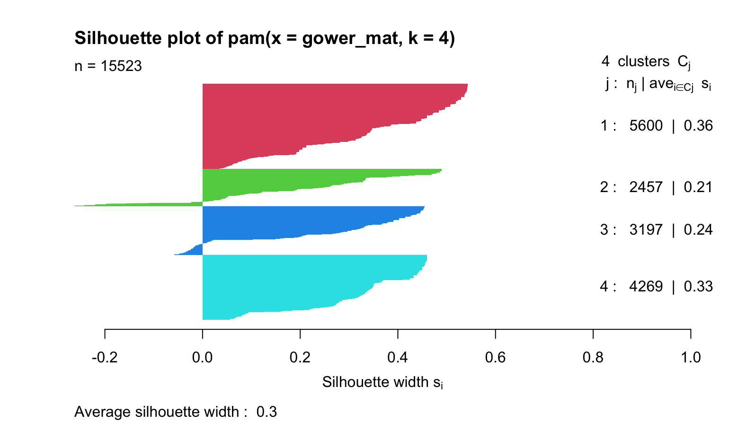

The cluster 1 (red) has the tightest cohesion and cluster 2 (green) is the weakest, but very few observations have negative widths, so misassignments are rare.

Figure 2
Cluster summary
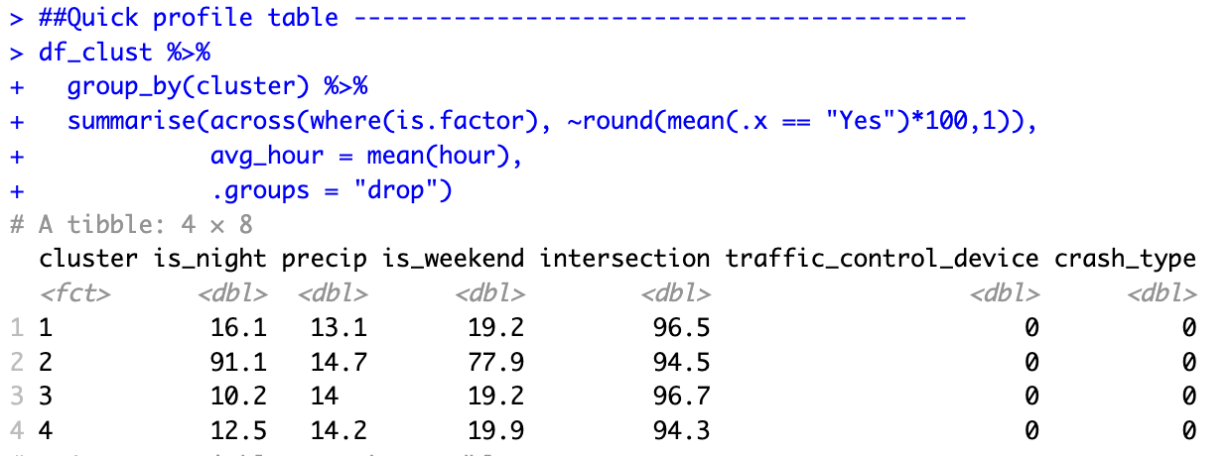

Cluster 2 is the strongest which combines the risk factors of weekend night intersections. These conditions align with the highest fatal risk odds reported in Topic 3, confirming that weekend night junctions are the first place to deploy safety precautions. Cluster 1 and 3 represent lower harm commuter flows where congestion management and signal timing will yield more benefit than policing.

Classification Methods

Data and setup

Our target is to spot the crashes that end in death or serious injury. Only 6% of rows fall in that high harm group. The model get seven predictor variables which are is_night, precip, is_weekend, peak_hour, num_units, intersection, and clock hour. All the NA columns were removed. We split 80% 20% for train and test data. Each 10 × 3 repeated CV fold applied SMOTE to rebuild a 50∶50 class mix and used ROC-AUC for scoring.

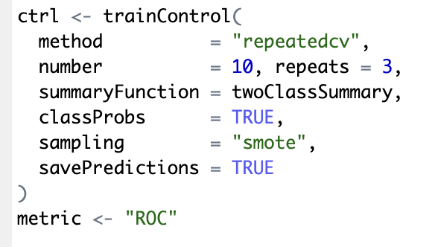

Algorithms

Four families of algorithms were trial-led to see which can best flag high-harm crashes. A fast regular logistic regression gives us a transparent baseline. Two tree based learners were added because they cope well with mixed predictors and non-linear effects: a random-forest built with the ranger engine (tuning the number of variables tried at each split and the minimum node size for 800 trees) and a XGBoost. Finally, a regularised elastic-net logit (glmnet) was included to test whether shrinkage and automatic feature selection can beat the plain logit. All models were tuned in a 20 point random grid inside the repeated 5 fold CV described above.

Cross validated results

Thirty SMOTE stratified folds show that gradient boosting edges ahead. XGBoost is the highest mean ROC-AUC at 0.609, narrowly followed by the random forest at 0.608. Neural networks and Naive Bayes form a strong second tier (0.606), with SVM and KNN close behind (0.598–0.599). Classical elastic net and plain logistic regression remain the weakest, plateauing near 0.592. Both tree ensembles also display the tightest inter quartile ranges (Q1–Q3 = 0.60–0.62), indicating the most stable generalisation. Given its marginally superior AUC and efficiency in scoring large data streams, XGBoost was advanced to final testing, with the random forest retained as a benchmark.
Figure 3
Summary of trained models.
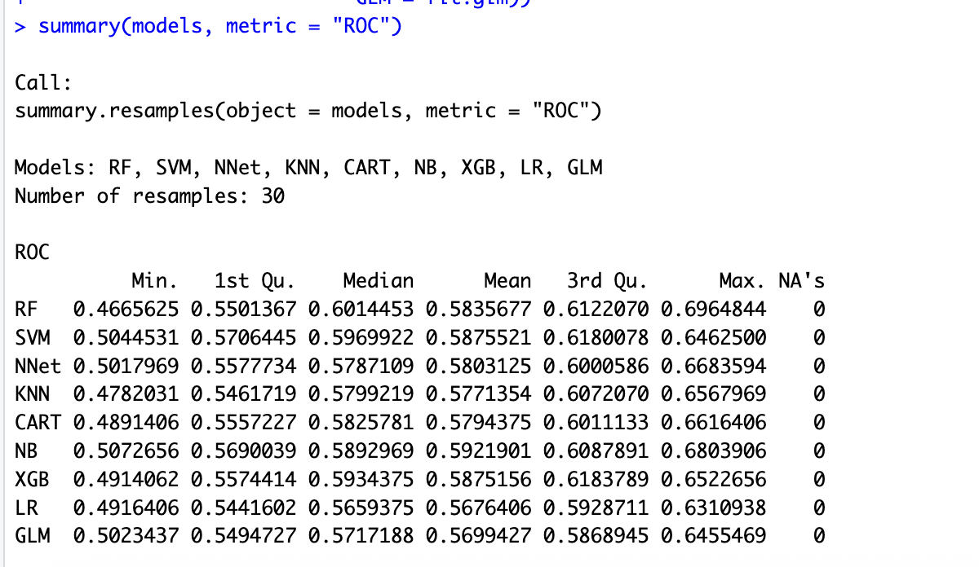

Figure 4
Dot Plot of summary
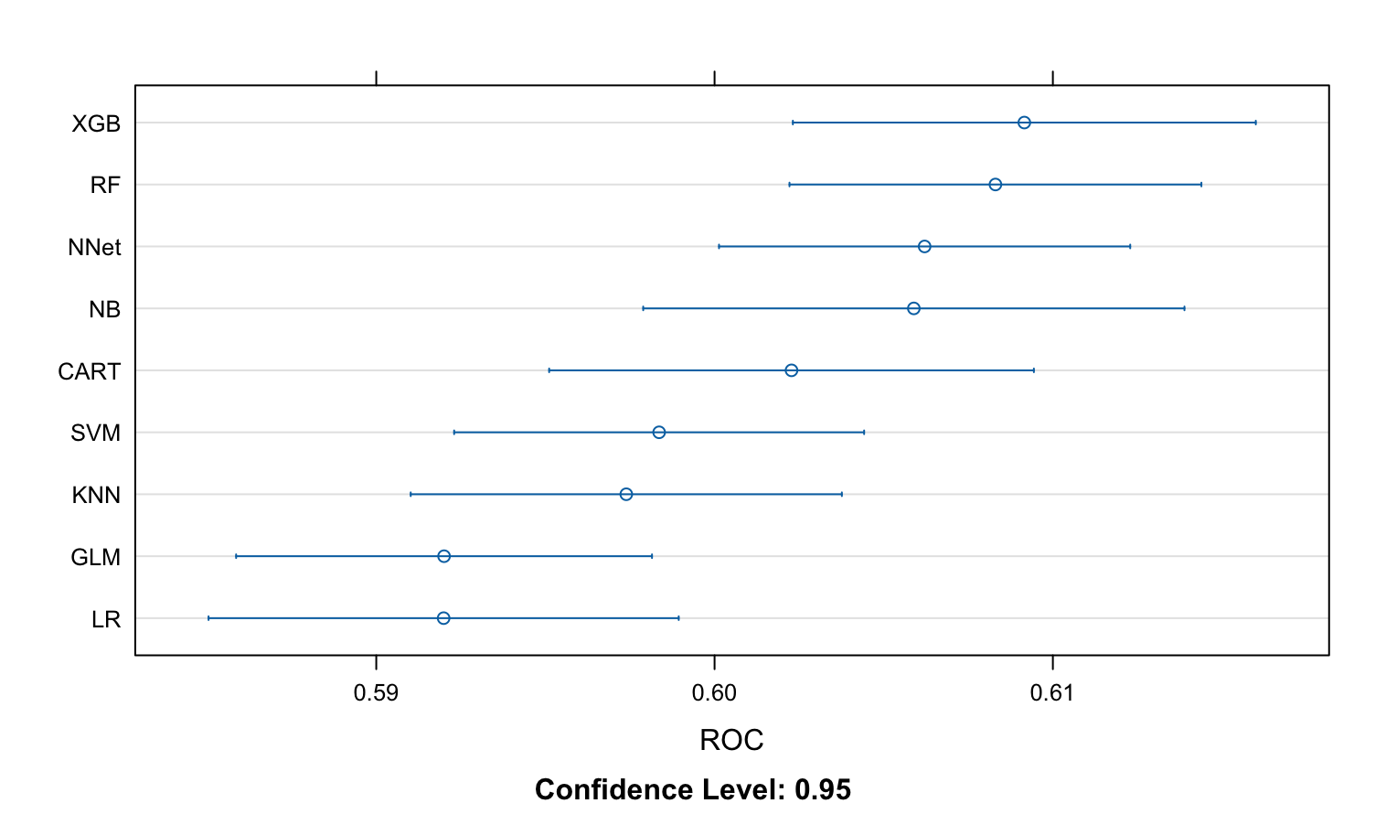

Final Model tuning

The cross validation table in section 3.3 mentioned XGBoost the top performer, so a focused grid search was run to squeeze out any extra discrimination. Figure 5 displayed the grid spanned two learning rates three tree depths and two boosting lengths while keeping subsample and colsample_bytree = 0.80 and gamma = 0. A shallow setting (depth = 3, η = 0.05, 150 rounds) gave the highest mean ROC-AUC (0.607) . Because XGBoost combines shrinkage, stochastic subsampling and tree regularisation, it is generally less prone to over-fit tabular data than classical boosting methods(Chen & Guestrin, 2016).
Figure 5
Tuning grid XGB Model
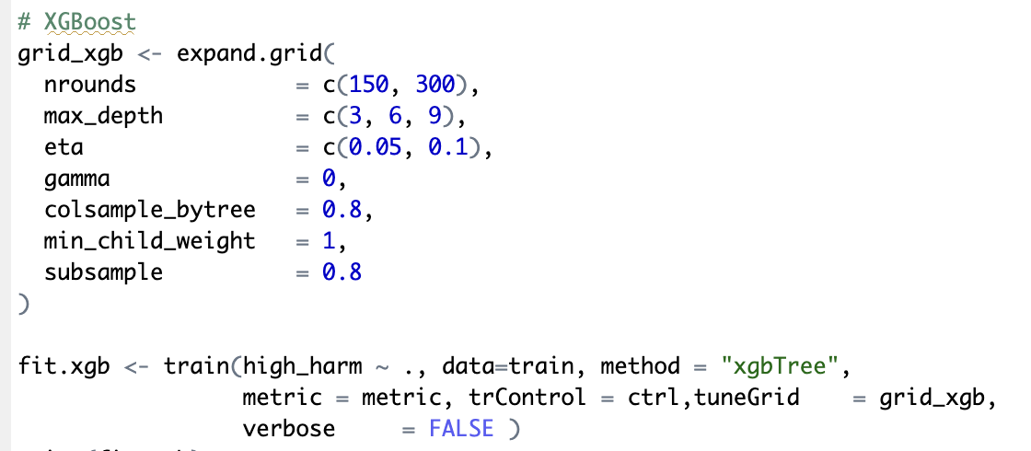

Figure 6
Plot of the trained XGB
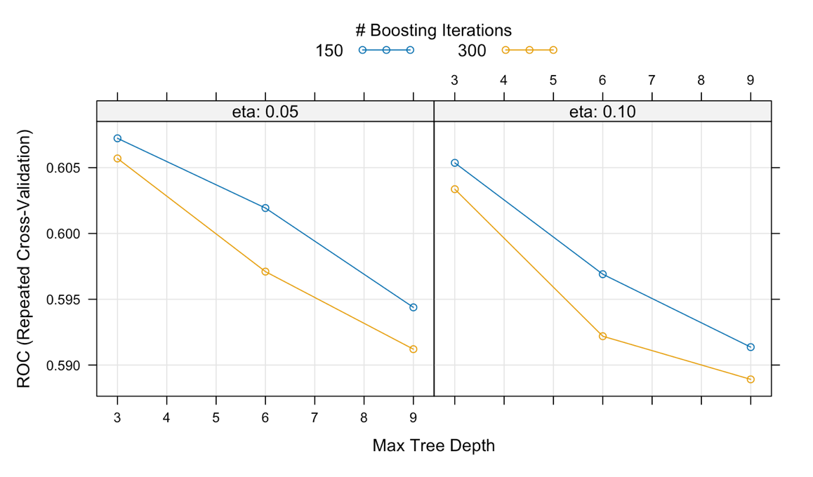

When the tuned XGBoost model was applied the test 20% hold out set it delivered a ROC-AUC of 0.591, essentially mirroring the cross validated estimate and suggesting little optimism bias. With the default 0.5 cut-off the model achieved a balanced accuracy of 0.57 (sensitivity = 0.48, specificity = 0.66; κ = 0.14), detecting nearly half of the high-harm crashes while rejecting two thirds of low harm cases. Raising the alert threshold to the 90ᵗʰ percentile of predicted risk lifted recall to about 0.70 at the expense of more false positives, giving managers a clear trade-off to tune according to available response capacity.
Figure 7
AUC curve and the confusion matrix
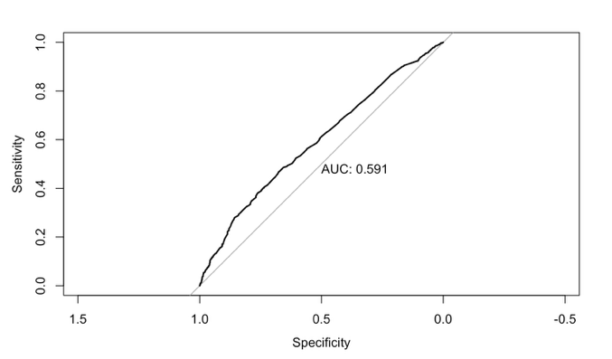
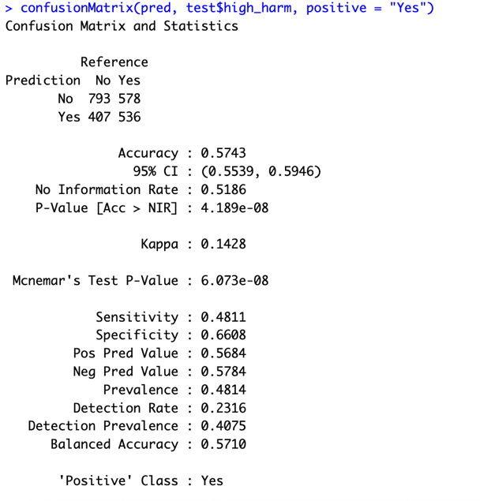

Conclusion

Analysis of road crashes shows that darkness, wet pavement and weekend timing jointly define the highest risk situations. Unsupervised clustering reduced the data to four practical personas, the most hazardous being wet weekend night intersections. Nine machine learning models were compared with SMOTE balanced, 30-fold cross-validation and shallow XGBoost (depth 3, n 0.05, 150 rounds) achieved the best mean ROC-AUC (0 .61) and held 0 .59 on an untouched 20 % test set.

References

Chen, T., & Guestrin, C. (2016). XGBoost: A Scalable Tree Boosting System Proceedings of the 22nd ACM SIGKDD International Conference on Knowledge Discovery and Data Mining, San Francisco, California, USA. https://doi.org/10.1145/2939672.2939785
Hennig, C., & Liao, T. (2013). How to Find an Appropriate Clustering for Mixed-Type Variables with Application to Socio-Economic Stratification. Journal of the Royal Statistical Society: Series C (Applied Statistics), 62. https://doi.org/10.1111/j.1467-9876.2012.01066.x
Park, H.-S., & Jun, C.-H. (2009). A simple and fast algorithm for K-medoids clustering. Expert Systems with Applications, 36(2, Part 2), 3336-3341. https://doi.org/https://doi.org/10.1016/j.eswa.2008.01.039
Wellington, G. (2021). Wellington regional land transprt plan. Retrieved from https://www.gw.govt.nz/assets/Documents/2021/10/Wellington-Regional-Land-Transport-Plan-2021web.pdf?utm_source=chatgpt.com

