User Manual – Road Crash Insights Dashboard
By Athapattu Dissanayakage Savith Rangana
Programme title | Master of Information Technology
Course code and title | PGDAV8.100 Data Analytics and Visualisation T2 2025
Lecturer name | Dr. Farhad Mehdipour
Assessment title | TOPIC 5 – User Manual
Due date | 18/06/2025
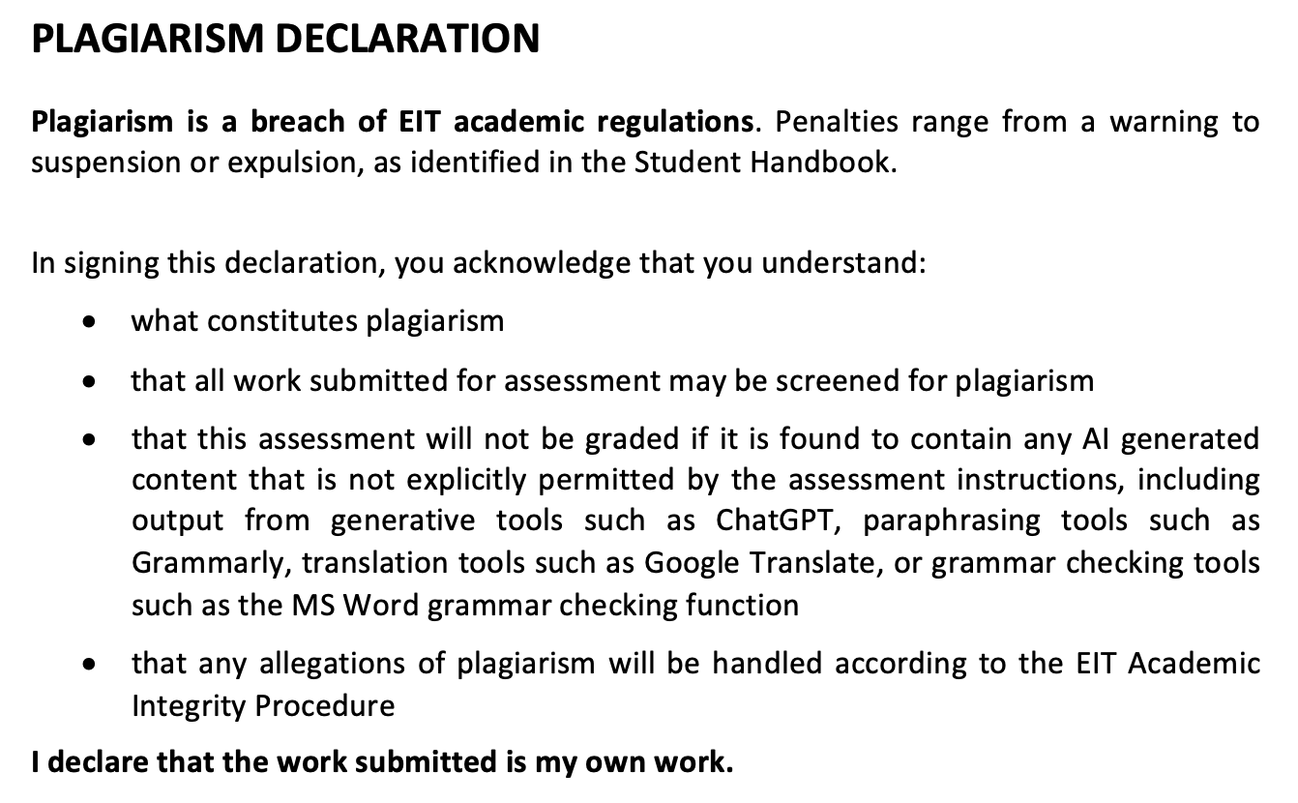
Name |  | ID |  | Signature | Date
A D Savith Rangana |  | 2024003716 |  | ADSavith | 17/06/2025

Table of Contents

1. Purpose 2
2. Target Users 2
3. How to Open 2
4. Specifications of Dashboard 3
4.1 Slicers/Filters (Left Panel) 3
4.2 KPI Cards 4
4.3 Crash Trend by Hour 4
4.4 Crash Severity by Weather 4
4.5 Crash Count by Day of Week 5
4.6 Severity by Vehicle Count 5
4.7 Crash Density Heatmap 6
4.8 Crash Forecast 6
5. Future Directions 7

Purpose
This Power BI dashboard enables users to explore and interpret traffic crash patterns using interactive visualizations. It supports data driven decisions to improve road safety by identifying high risk conditions, times, and behaviors.

Target Users
This dashboard is designed for a variety of public and operational decision makers:
- City Planners: To prioritize infrastructure upgrades in high risk areas and times.
- Police and Traffic Authorities: To plan patrols and enforcement during peak risk periods.
- Public Safety Analysts: To explore crash patterns and recommend targeted safety strategies or campaigns.
- Policy Makers: To understand the effectiveness of current traffic policies and where to focus funding or new regulations.

How to Open
- Open Power BI Desktop.
Figure 1
Power BI Icon in desktop

- Go to File > Open and select road_crash_insights_dashboard.pbix
Figure 2
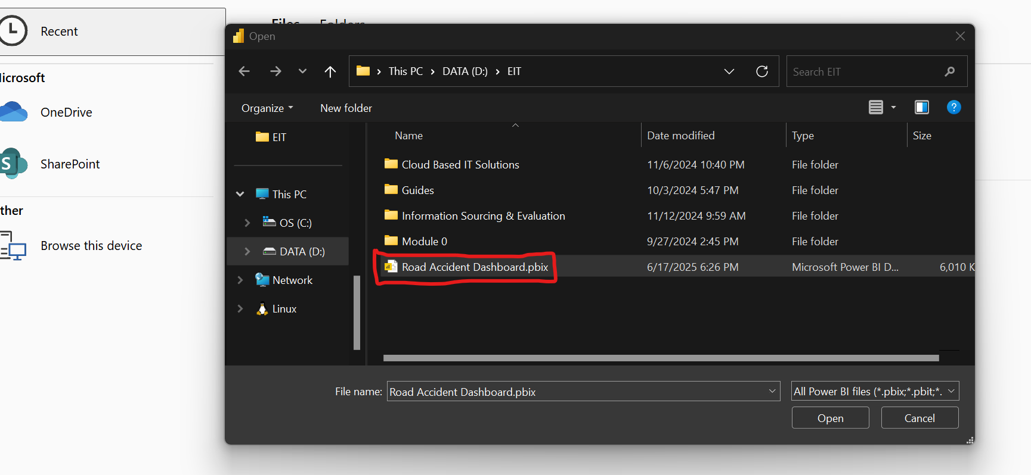
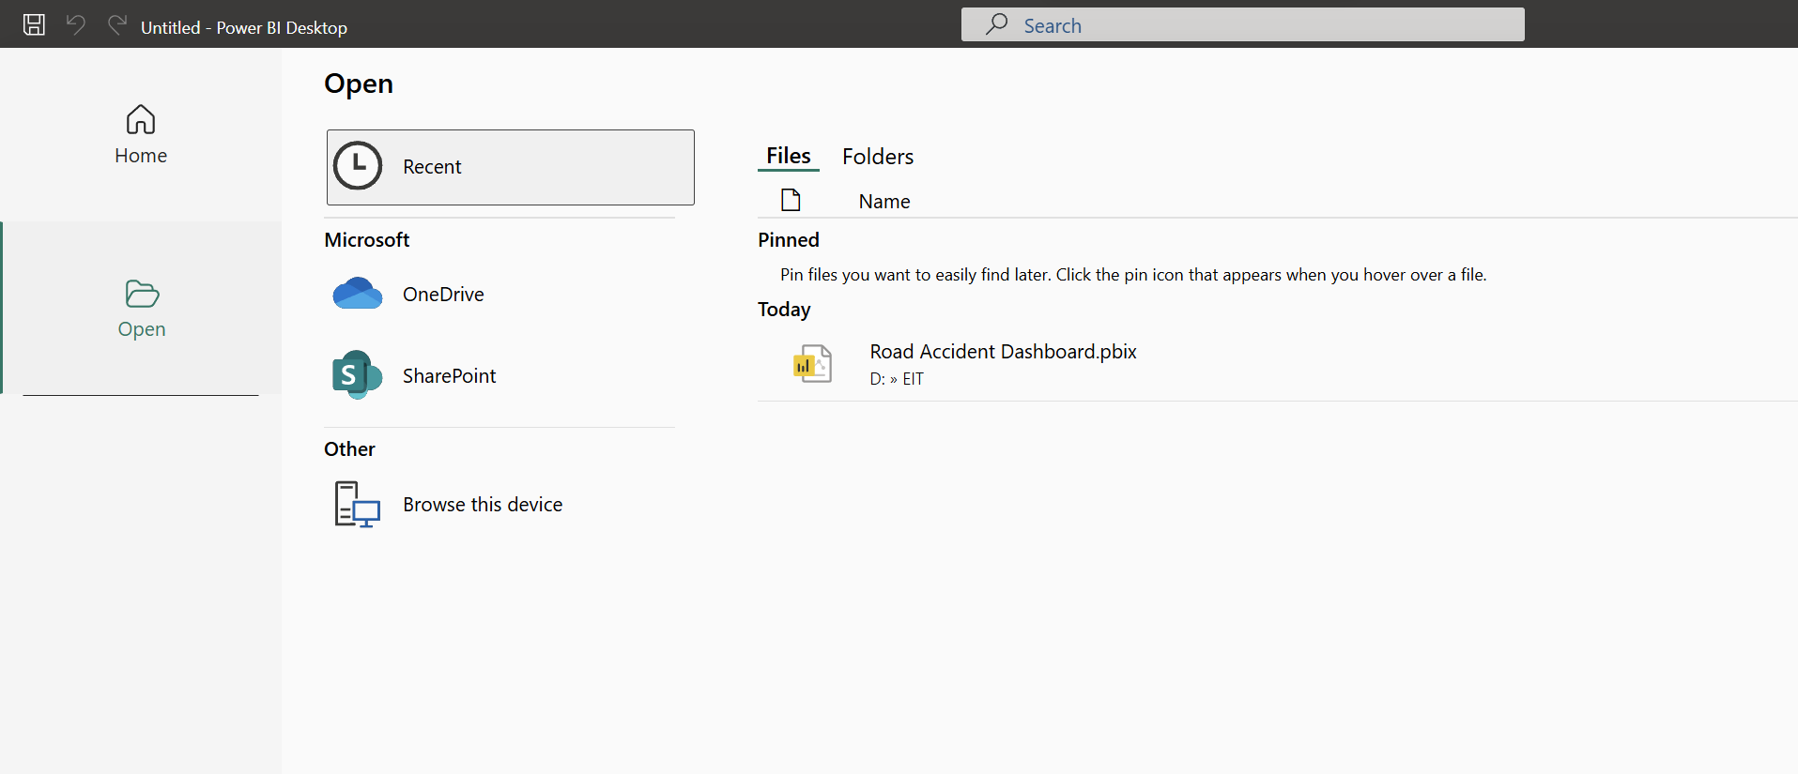
Browsing from file and selecting file.

4. Specifications of Dashboard

Figure 3
Dashboard UI
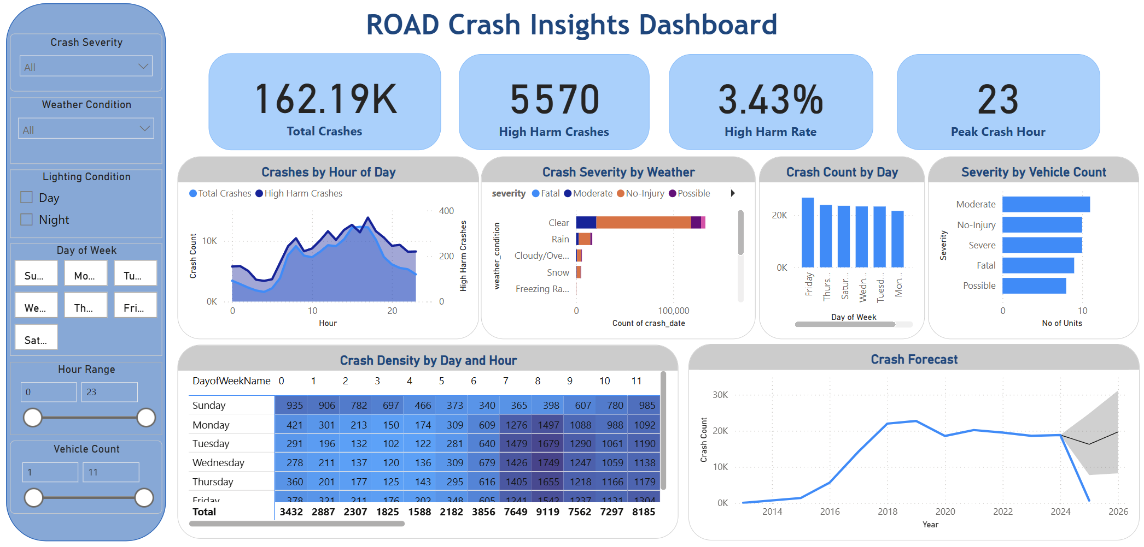

The dashboard is an interactive setting presenting key road crash metrics and trends to support decision making by target users. The product is designed with interactivity and clarity in mind, utilizing Power BI’s advanced visual features to provide a comprehensive view of crash patterns and risk factors.

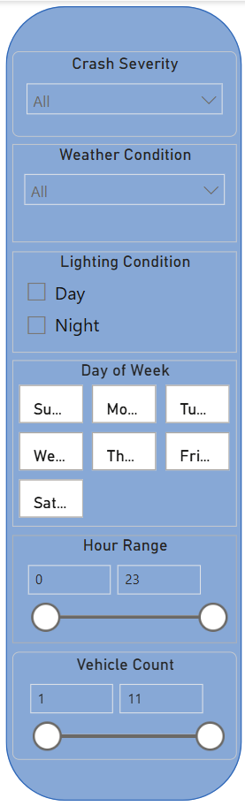
4.1 Slicers/Filters (Left Panel)

These filters dynamically control all visuals:
- Crash Severity (Fatal, Severe, etc…)
- Weather Condition (Rain, Clear, etc…)
- Lighting Condition (Day or Night)
- Day of the Week
- Hour of Day
- Vehicle Count (Single vs. Multi vehicle)

Figure 4
Left panel (filters and slicers)

4.2 KPI Cards

- Total Crashes: Total number of crashes in the dataset.
- High Harm Crashes: Count of crashes marked as Fatal or Severe.
- Harm Rate: Percentage of high harm crashes vs total.
- Peak Crash Hour: Hour of the day with the highest number of crashes.

Figure 5
KPI Cards UI
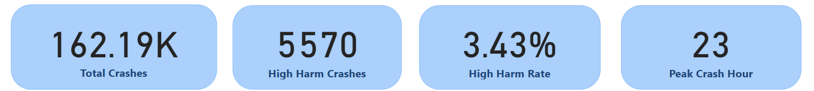

4.3 Crash Trend by Hour

This line chart identifies hourly patterns and compare crash count with high harm rate.
Figure 6
Crash trend by hour line chart
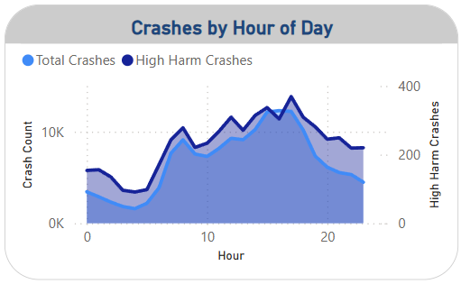

4.4 Crash Severity by Weather

This stacked bar chart reveals how different weather conditions relate to crash severity levels.

Figure 7
Crash severity by weather stack bar chart

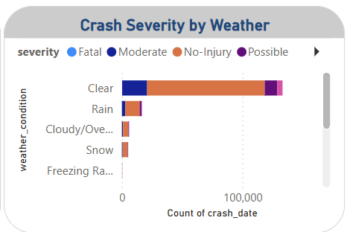

4.5 Crash Count by Day of Week
This column chart shows which weekdays or weekends experience more crashes.
Figure 8
Crash count by day of week column chart
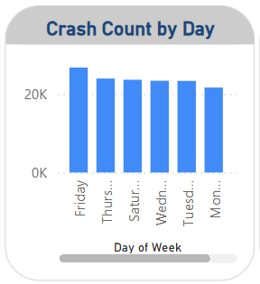

4.6 Severity by Vehicle Count
This bar chart compares severity in single vehicle vs multi vehicle crashes.
Figure 9
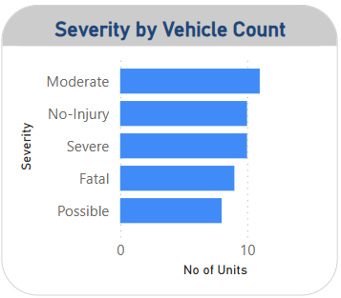
Severity by vehicle count bar chart

4.7 Crash Density Heatmap

This matrix combines day of week and hour to reveal peak crash periods.
Figure 10
Crash density heatmap matrix
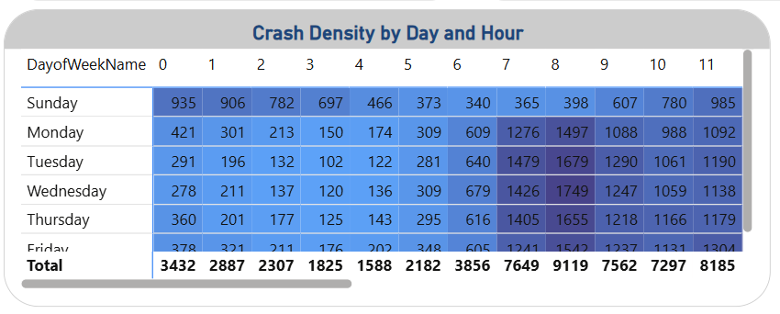

4.8 Crash Forecast

This line chart predicts upcoming crash volume based on historical data
Figure 11
Crash forecast line chart
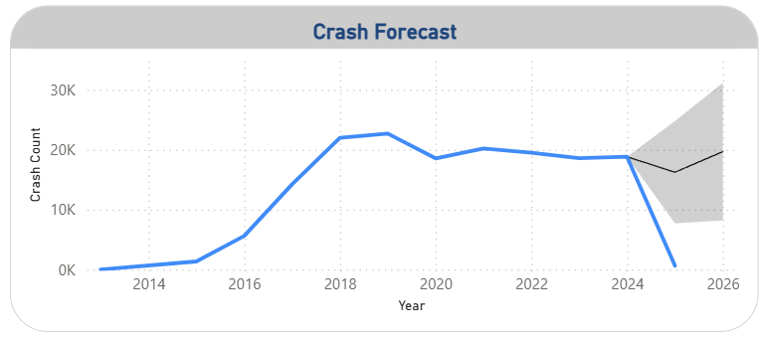

Future Directions

- Add map visual for spatial crash analysis.
- Embed real time crash scoring models using R or Python.
- Link live data sources for dynamic monitoring.

