PROJECT REPORT
ON

‘RAILWAY ENQUIRY AND RESERVATION SYSTEM’

SUBMITTED BY
D’SOUZA SAVIO S. (ROLL NO: 10)
DESAI MAYUR I. (ROLL NO: 12)
DEVARDEKAR SUDARSHAN M. (ROLL NO: 09)

UNDER THE GUIDANCE OF
MR. A.M. PATRAVALE


DEPARTMENT OF COMPUTER SCIENCE & ENGINEERING

BHARATI VIDYAPEETH’S
COLLEGE OF ENGINEERING, KOLHAPUR.

Contents
SYNOPSIS - 3 -
CANDIDATE'S DECLARATION - 6 -
CERTIFICATE - 7 -
INTRODUCTION - 8 -
INTRODUCTION TO THE ORGANIZATION - 9 -
INTRODUCTION TO THE RESERVATION SYSTEM - 9 -
RAILWAY RESERVATION METHODS - 11 -
EXISTING RESARVATION SYSTEM –SHORT COMMING - 12 -
PROPOSED RESERVATION SYSTEM- ADVANTAGE - 12 -
MAIN OBJECTIVES OF THE PROJECT - 13 -
SCOPE OF OUR PROJECT WORK - 13 -
REASONS FOR SELECTING THIS SYSTEM IN OUR PROJECT - 14 -
FEATURES OF C++ - 14 -
BENEFITS OF OBJECT ORIENTED PROGRAMMING - 14 -
APPLICATIONS OF OBJECT ORIENTED PROGRAMMING - 14 -
SRS-SOFTWARE REQUIREMENT SPECIFICATION - 14 -
DESIGN OF THE CURRENT SYSTEM - 14 -
DESIGN OF TABLES - 14 -
SNAPSHOTS OF FORMS - 20 -
CONCLUSION - 20 -
FUTURE - 21 -

SYNOPSIS

Imagine traveling from Pune to Chennai on a train while you are staying in Kolhapur. The only way you would book the ticket will be standing in the long queues at the railway station’s booking counter. You would always wish that you would just do it in and out of the queue just by the click of the button. Also you would wish you could check the status of your reservation, had it been on waiting and also check the availability of the ticket for the planned trip. This could all be done by software that could be installed and be used through online product.
During the initialization of the project the team reviewed all the potential projects prior to the extensive planning for any one project. Amongst all the project topic suggested the group decided to work on stimulation of railway enquiry and reservation system. The key element in optimization and finalization of this project was that the group wanted to work at the application level and also use the knowledge it has obtained uptil now in the engineering course.
The project is a stand alone application. In our project we are computerizing the manual process that is currently in use in any railway reservation center. This project not only manages the current manual process but also provides the user with many additional facilities. A few to mention are that the software has a very in-depth database of the railway trains and time schedule. This database can be accessed by the user to check out the train information. The other worth mentioning feature is that reservations can be made at any stations according to the train number of the required train. Reservations can be made upto the maximum of thirty days and upto a minimum of one day before the date of departure of the train. This system can generate an unique reference code i.e. PRN number for accessing the reservation record of the particular person. Reservations made can also be cancelled by this software. The only thing required is an unique reference code i.e. PRN number.

During the research phase the group pin pointed many flaws/points for improvement in the existing system that can be improvised or updated. A few to mention will be that our current railway reservation system does not have the facility to check the status of the train i.e. whether it is boarded or departed or checked. At present this system only tells us the time schedule and tickets left which is still an insufficient detail for a person who has least idea about railways. However our project will emphasize on these issues and make the railway reservation system very easy for the common man. This software can also be made multi user software by using some online product as mentioned above.
Object oriented programming [OOP] has become the preferred programming approach by the software industry. This language offers a powerful way to cope with the complexity of real world problems. Among the object oriented programming [OOP] languages available today ‘C++’ is by far the most widely used language. So we have made use of this language as a tool to build our project.
India has the world’s second biggest railway transport services which itself is very creditable in the motive of choosing the project. If the software developed by our team can be advancedly developed using some advanced programming languages and some web applications. By this up-gradation the software will not only serve as useful tool for ticket reservation in railway stations but will also help the amateur train travelers to book their ticket without waiting inline. The best part of this type of reservation will be that the person unknown to train names and number can access the help or the database option in the software and check all the required information about the train which will help in reducing confusion while booking the ticket.

CANDIDATE'S DECLARATION

We the students of Bhartividyapeeth’s College Of Engineering, hereby declare that this project report titled “RAILWAY RESERVATION SYSTEM “submitted towards the completion of Second Year Engg. Mini-Project in 4rd semester of is an authentic record of our work carried out under the guidance of Mr. Amol Patravale

Date: March, 09, 2009
Place: Kolhapur.

Mayur Desai(12)
Savio D’souza(10)
Sudarshan Devardekar(09)

CERTIFICATE

This is to certify that the above declaration made by Mr. Savio D’souza, Mr. Mayur Desai and Mr. Sudarshan Devardkar is true to the best of my knowledge and belief.

Date: April 6, 2009
Place: Kolhapur

Mr.A.M.PATRAVALE Prof.U.B.CHAVAN Dr.J.A.TAMBOLI (Staff Incharge) (H.O.D) (Principal)

ACKNOWLEDGEMENT

It gives us immense pleasure in presenting the report of RAILWAY RESERVATION SYSTEM the mini project is completed by support of professors and college mates.

We would like to give a moment of thanks to these persons. We would like to express our grateful thanks for help and advice by our guide Mr.Amol Patravale.

We are sincerely thankful to our head of department Prof.U.B. CHAVAN and our principal Dr.J.A. Tamboli.

Lastly we are thankful to our lab assistants for providing computers in the actual development period.

Hardware & software are used as core2 duo @2.66Ghz, ASUS P5N E SLI motherboard , 2GB RAM @800Mhz, 250+80+160GB HDD, SONY DVD RW ,Windows XP OS, Microsoft Word 2007,Turbo C editor.

INTRODUCTION

HISTORY
A plan for a rail system in India was first put forward in 1832, but no further steps were taken for more than a decade. In 1844, the Governor-General of India Lord Hardinge allowed private entrepreneurs to set up a rail system in India. Two new railway companies were created and the East India Company was asked to assist them. Interest from a lot of investors in the UK led to the rapid creation of a rail system over the next few years.
Railways were first introduced to India in 1853. By 1947, the year of India's independence, there were forty-two rail systems. In 1951 the systems were nationalised as one unit, becoming one of the largest networks in the world. IR operates both long distance and suburban rail systems on a multi-gauge network of broad, metre and narrow gauges. It also owns locomotive and coach production facilities.
The first train in India became operational on 1851-12-22, and was used for the hauling of construction material in Roorkee. A few years later, on 1853-04-16, the first passenger train between Bori Bunder, Bombay and Thana covering a distance of 34 km (21 miles) was inaugurated, formally heralding the birth of railways in India.

INTRODUCTION TO THE ORGANIZATION

Indian Railways have been divided into 9 Zones - Western, Central, Eastern, Northern, North Eastern, Northeast Frontier, Southern, South Central & South Eastern covering the largest route length of over 63000 Kms of total Indian boundary. The last stations of the four directional boundaries are West-Mumbai, South-Kanyakumari, East-Guwahati, North-Jammu. It is the most convenient way of travelling if you are travelling on a budget. The railways have one of the most efficient communication systems between 2 stations. The types of class available are 1st class, AC 2tier, AC 3tier, 2nd class sleeper & chair car. The 1st class being phased out being converted in to AC 2 tier/AC 3 tier (recently being introduced in some of the trains).

INTRODUCTION TO THE RESERVATION SYSTEM
The Indian Railways (IR) carries about 5.5 lakh passengers in reserved accommodation every day. The computerised Passenger Reservation System (PRS) facilitates booking and cancelling of tickets from any of the 4000 terminals (i.e PRS booking windows) all over the country. These tickets can be booked or cancelled for journeys commencing in any part of India and ending in any other part, with travel times as long as 72 hours and distances up to several thousand kilometers.
The pilot project of PRS was launched on 15 November 1985, over Northern Railway with the installation of the Integrated Multiple Train Passenger Reservation System (IMPRESS), an online transaction processing system developed by the Indian Railways in association with Computer Maintenance Corporation (CMC) Ltd., at New Delhi. The objective was to provide reserved accommodation on any train from any counter, preparation of train charts and accounting of the money collected. This application was subsequently implemented in 1987, at Mumbai, Chennai, Kolkata and Secunderabad. With the addition of new locations and many redefinitions, the IMPRESS system fell short of growing expectations of the travelling public. Hence a new application software, i.e., Country Wide Network for Computerised Enhanced Reservation and Ticketing (CONCERT) was developed by the Centre for Railway Information Systems (CRIS), New Delhi primarily using ‘C’ and also using ‘FORTRAN’. The application was first implemented at the Secunderabad PRS site in September 1994 and subsequently at the other four PRS sites. Currently, the PRS servers are maintained at the five sites in Delhi, Mumbai, Kolkata, Chennai and Secunderabad and operate in a distributed database process environment. Communication of all the terminals with their server was established using Railway/Department of Telecommunication (DOT) channel lines, fibreoptic cable/microwave channels, switches, modem, multiplexers etc. The inter-networking of five PRS nodes was completed in April 1999. Interconnectivity is established between the five PRS centres over 2 mbps leased Bharat Sanchar Nigam Limited (BSNL) lines. The system has the capability of issuing reserved tickets from anywhere to anywhere, in any train, date or class between any pair of stations from any booking terminal of the PRS.
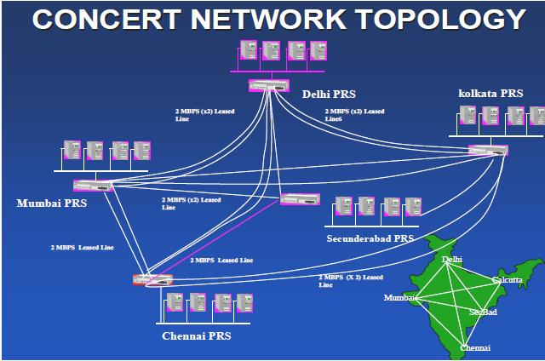
The main modules of the PRS are the Reservation module, the Cancellation and Modification Module, the Charting Module, the Accounting Module, and the Database Module. The passengers’ request for reservation, cancellation and modification of journey are handled by the system through requisition slips. Major outputs generated by the system are Reservation cum- journey tickets, Cancellation/Modification tickets, Reservation Charts
and Daily Terminal Cash Summary. The system is also capable of generating different types of Management Information System (MIS) Reports. Indian railway is having ten zonal railways namely Eastern Railway (ER), Northern Railway (NR), Southern Railway (SR), Central Railway (CR), Western Railway (WR), South Central Railway (SCR), North Eastern Railway (NER), South Eastern Railway (SER), North East Frontier Railway (NFR) and East Central Railway (ECR).

RAILWAY RESERVATION METHODS :

- Online Booking
- Counter Booking

ONLINE BOOKING:
This facility is given to general public by railway department. With the help of this facility people can book their tickets through internet, sitting in their home by a single click of the mouse. Using their credit card people can easily get their tickets done within minutes. There are certain charges for online booking as well.
COUNTER BOOKING:
This is oldest method of booking the ticket. The reservation counters are there at railway departments from where people can get the tickets to their respective destinations. Nowadays there are various ticket counters, apart from railway station counters where tickets are available.

EXISTING RESERVATION SYSTEM –SHORT COMMING

- Railway passengers frequently need to know about their ticket reservation status, ticket availability on a particular train or for a place, train arrival and departure details, special trains etc. Customer information centers at the railways station are unable to serve such queries at peak periods.
- As of now there are no call centers facilities available to solve the queries of the Indian passengers and customers.
- The number of reservation counters available to the Indian passengers and customers are very less.
- On most of the reservation centers in India there are always long queues, so it takes a long time for any individual to book the tickets.
- In case of booking e-ticket or I- ticket by IRCRC the only disadvantage is any individual cannot plan for onward journey.
- In case of e-ticket and I- ticket if there is any case of cancellation the amount to be refunded to the customer is not been credited to the customer’s account instantly, it takes a long time.

PROPOSED RESERVATION SYSTEM- ADVANTAGE

- The proposed system is comparatively faster than the existing system.
- As the proposed system is comparatively faster than the existing system, there will be very less rush and shorter queues at the reservation counters or centers.
- In the proposed system, we are also making database for all the trains running across the country.
- As required, we can edit the database of the trains and also add the new trains which will be proposed in future budgets

MAIN OBJECTIVES OF THE PROJECT

- The acquisition and maintenance of a relational database with the help of hardware, communication network and software including system design.

- To assess the if system chosen in the project operates in an adequately controlled environment.

- Whether the application’s control are adequate and if the system is in compliance with rules.

- Adequate security from possibilities of fraud.

- To show an effective mechanism to ensure most economic usage of available resources.

- The control mechanism for credit card transactions were adequate.

SCOPE OF OUR PROJECT WORK

- The scope of project included evaluation of the application and was primarily concerned with the transactions related to booking of tickets from the terminals operated by the railway personnel.

- Application controls and simulation were used to evaluate data validation and program logic. The selected data, as made available, for substantive checking of the completeness, integrity and consistency of data using C++.

- The records maintained in the database of the railways reservation centre were also reviewed. Discussions were held with the database users to gain understanding regarding the various functional aspects of the system.

REASONS FOR SELECTING THIS SYSTEM IN OUR PROJECT

- Indian Railways is huge. There are umpteen number of database in its system. The use of C++ enables the person at the booking counter a customized and easy retrieval of information.

- An online ticketing database allows the users of the Indian Railways Reservation System to track the whereabouts of their travel. The passengers who need to know whether they are in waiting list or confirmed need not travel to the ticket counter or call railway service system. With the help of an online system they can show the information in a click.

- In case of cancellation, the online system instantly credits the amount from the passengers’ account.

- It updates the changes instantly, thus, the user working on the database will not have to go to each database and make the changes.

FEATURES OF C++

Highlights
Object Oriented Programming(OOP) has become the preferred programming approach by the software industries , as it offers a powerful way to cope with complexity of real world problem .Among the OOP languages available today , C++ is by far the most widely used language .
It was created by Bjarne Stroustrup in the early 1980’s . C++ has undergone many changes and improvements since then . The key concepts used by us in our project of this language are ,

- Object Oriented Programming(OOP)
- Objects
- Classes
- Data abstraction
- encapsulation
- Inheritance
- Polymorphism
- File handling
- Mouse handling
- Graphics in C++
And a few more concepts of C++ is used by us.
Objects are the basic runtime entities in the object oriented system , they may represent a person , a place, a bank account, a table of data or any item that the program has to handle .Program object should be chosen such that , they match with real world objects .
Objects contain data and quotes to manipulate the data. The entire set of data and code of an object, can be made user defined data type with the help of a Class .In fact, objects are variable of type class .Once a class has been defined we can create any number of objects belonging to that class .Each object is associated with the data type class with which they are created. A class is thus a collection of objects or similar types.
The wrapping up of data and functions into a single unit (called class) is known as Encapsulation. Data encapsulation is the most striking feature of the class. Insulation of data from direct access by the program is called data hiding or Information hiding.

Abstraction refers to the act of representing essential features without including the background details or explanation. Classes use the concept of abstraction and are defined as a list of abstract attributes and functions to operate on this attributes. The attributes are sometimes called data members, because they hold information .The functions that operate on this data are sometimes called methods or member functions.
Inheritance is the process by which objects of one class acquire the properties of objects of another class .It supports the concept of Hierarchical classification.
In OOP the concept of Inheritance provide the idea of reusability. This means that we can add additional features to an existing class, without modifying it.
Polymorphism is another important OOP concept which means the ability to take more than one form .An operation may exhibit different behaviours in different instances .The process of making an operator exhibit different behaviours in different instances is known as Operator overloading .Using a single function name to perform two different kinds of tasks is known as Function overloading .Polymorphism plays important role in allowing objects having different internal structures to share the same external interface .Polymorphism is extensively used in implementing inheritance .

Data is stored in Hard Disk using the concept of Files .A file is a collection of related data stored in particular area on the disk . The I/O system of C++ handles file operations which are very much similar to the console input and output operations. It uses file stream’s as an interface between the programs and the files.
Binding refers to the linking of a procedure call to the code to be executed in response to the call. Dynamic Binding (also known as, late binding) means that, the code associated with a given procedure form is not known until the time of the call at runtime.
Benefits of Object Oriented Programming(OOP)
OOP offers several benefits to both the program designer and the user. Object orientation contributes to the solution of many problems associated with the development and quality of softw3are products. The new technology promises better programmer productivity, better quality of software and lesser maintenance cost. The principle advantages are:
- Through inheritance we can eliminate redundant code and extend the use of existing classes.
- The principle of data heading helps the programmer to build secure programs that cannot be invaded by code in other parts of program.
- It is possible to map objects in the program domain to those in the program.
- It is easy to partition the work in a project work in a project based on objects.
- OOP systems can be easily upgraded from small to large systems.
- Software complexity can be easily managed.

APPLICATIONS OF OOP
The most popular application of OOP has been in the area of user interface design such as windows. A real business systems are often much more complex and contains many of more objects with complicated attributes and methods. OOP is useful in this type of applications because it can simplify a complex problem. The promising areas for application of OOP includes:

- Real time systems
- Simulation and modeling
- Object oriented database
- Hypertext, hypermedia and expertext
- AI and expert systems
- Neural networks and parallel programming
- Decision support and office automation systems
- CIM/CAM/CAD systems

SRS-Software Requirement Specifications

- The initial specification of user requirements may be based on interviews with the database users and on the designers own analysis of the enterprise.
- The basic issues that the SRS writer(s) shall address are the following:
  - Functionality. What is the software supposed to do?
b) External interfaces. How does the software interact with people, the system’s hardware, other hardware, and other software?
c) Performance. What is the speed, availability, response time, recovery time of various software functions, etc.?
d) Attributes. What are the portability, correctness, maintainability, security, etc. considerations?
e) Design constraints imposed on an implementation. Are there any required standards in effect, implementation language, policies for database integrity, resource limits, operating environment(s) etc.?

A DESIGN OF THE CURRENT SYSTEM
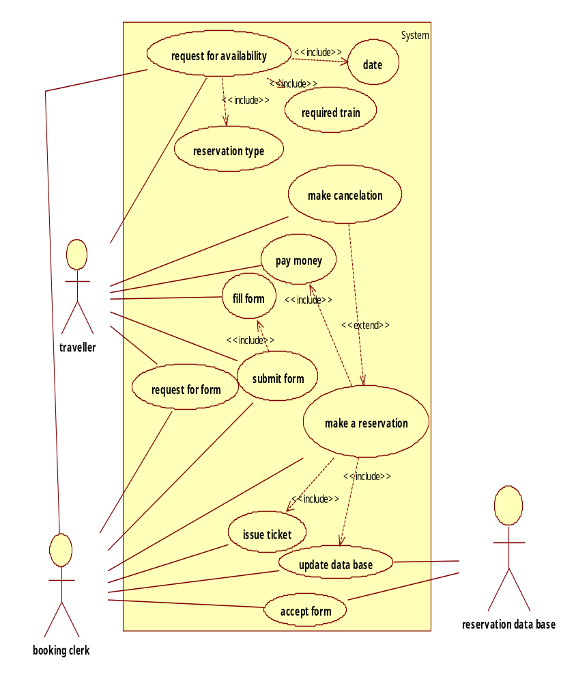

DESIGN OF TABLES

We have designed two tables one for passenger database and second for train database.
The passenger database will contain following fields
- NAME
- AGE
- GENDER
- TOTAL PASSENGER
- DATE OF TRAVEL
- TRAIN NO.
The train database will contain following field
- Train name
- Train no. (Primary key)
- Route from-to
- Departure time

SNAPSHOTS OF FORMS

PASSENGER RESERVATION FORM

FORM FOR TRAINS

CONCLUSION

This project is about the designing the railway reservation database system using C++. This project presents an investigative view of present railway reservation system including the history of railways and detail of network topology of PRS. Present system of Indian railway reservation system is having some shortcoming on which we have tried to work on that to eliminate the disadvantages.
We have made a database for passengers and trains and connected these two tables from the custom made data entry form built in C++. There are options for new entry which will be stored in database and retrieved from database in future.
This project was a small attempt to make the railway reservation database system using C++. We have talked with some of railway officers about the features and shortcoming of present railway reservation system after the research with the associated people and other sources we were able to found out some of the major facts regarding the reservation system and tried to eliminate the shortcoming of system.
In the last we conclude that Indian Railway is having a strong IT Infrastructure and a well-equipped railway reservation system but there is some shortcoming in the system on which we have tried to work on it and successfully completed our project.

FUTURE

If anyone wants to extend this project then he or she can make an additional database of TRAINFARE. And database for updated availability of seats which is available after the cancellation of ticket on that specific train. Etc.
He or she can also add some more command buttons in the existing software and extend working of the existing software.

