Noida Institute Of Engineering and Technology
Greater Noida


A
Project Report
Of
Summer Internship 2008 at
Department of Embedded System,
The council of research and training, Ducat Noida,
(A Training Partner of GnixINFOSOFT)
Noida.
Embedded System
&
Prototype of MetroTrain

Project Submitted to: Project Submitted By:
Mrs. Jayeeta Biswas Santosh Singh Chauhan
0513331090
NIET, Greater Noida.
List of Contents

Preface 1
Acknowledgement 2
1. Profile of Company 3
1.1 Gnix Philosophy and Mission 3
1.2 Company Partner - Ducat India 3
1.3 Services 4
1.4 Support 7
2. Microcontroller 8
2.1 Introduction 8
2.2 Definition of a Microcontroller 8
2.3 Pin Configuration 10
2.4 Reset Circuit 12
2.5 Ram Architecture 13
2.6 Microcontrollers vs Microprocessors 16
2.7 Central Processing Unit 17
2.8 Bus 17
2.9 Input Output Unit 18
2.10 Serial Communication 19
2.11 Timer Unit 20
3. LCD Interfacing 21
3.1 Pin description 21
3.2 DDRAM - Display Data RAM 22
3.3 BF - Busy Flag 23
3.4 Instruction Register (IR) and Data Register (DR) 23
3.5 Commands and Instruction set 23
3.6 Sending Commands to LCD 23
4. DC Motor Interfacing 24
4.1 Push-pull four channel driver 24
4.2 Block Diagram 24
4.3 Features 25
5. Power Supply System 26
5.1 Power Supply Circuit 26
5.2 Transformer 27
5.3 Rectifier 28
5.4 Regulator 28
5.5 Filter 29
5.6 LED (Light Emitting Diodes) 29
5.7 Circuit Operation 29
6. Project Description 30
6.1 Introduction of Project 30
6.2 Circuit Diagram of Metro Train Prototype 31
6.3 Project Methodology 32
6.4 Procedure 33
6.5 General Working 33
7. Future Scope 35
8. References and Bibliography 36
Appendix: List of diagrams 37

Preface

This training report is all about the embedded systems and its application in various fields of real world. We are living in the Embedded World. We are surrounded with many embedded products and our daily life largely depends on the proper functioning of these gadgets. Television, Radio, CD player, Washing Machine or Microwave Oven in our kitchen, Card readers, Access Controllers, Palm devices of our work space enable us to do many of our tasks very effectively. Apart from all these, many controllers embedded in our car take care of car operations between the bumpers. All kinds of magazines and journals regularly dish out details about latest technologies, new devices; fast applications which make us believe that our basic survival is controlled by these embedded products. Now we can agree to the fact that these embedded products have successfully invaded into our world. What is this Embedded System?

Theoretically, an embedded controller is a combination of piece of microprocessor based hardware and the suitable software to undertake a specific task.

I have made a Project based on Microcontroller that is a Prototype of Metro Train. This training report covers all about the microcontroller and project description. In this project I have implemented the Prototype of Metro Train that is describing a small application of microcontroller.

Acknowledgement

I would like to express my sincere gratitude to GnixINFOSOFT for giving me an opportunity to undergo my Industrial Training for six week as well as DUCAT, Noida for providing me the knowledge of Embedded System. I would also like to thank to all the technical experts, engineers and executives for explaining practical aspects of the theoretical knowledge.

My greatest debt in creating this project goes to the technical experts Mr. Chandra Prakash, Mr. Amrit Pal and Mr. Devajyoti Barman. I would also like to acknowledge my teacher Mr. Ashutosh Kumar who has given me the basic concepts of C under Linux. Thank you to Sir for encouraging me every step of the way.
I am deeply indebted to my HOD Mr. V K Pandey and to coordinator Mr. Satyendra Sharma whose help, stimulating suggestions and encouragements was always with me.

1. Profile of the Company- GnixINFOSOFT

Started as a software outsourcing center, Gnix has later diversified its activities by developing and distributing its own software solutions. Its expertise spans a wide and constantly expanding array of technologies and programming languages.
Gnix is the number one choice for global enterprises seeking offshore software development.
In the outsourcing arena it can offer anything from product design and development to maintenance of legacy systems, testing and technical support. In addition, it can handle Internet and intranet technologies, system programming, business applications and web-based solutions. While it focuses on Java and Microsoft technologies, it can cover other areas as well, by enlisting the help of their partner companies.

1.1 Gnix Philosophy and Mission in its own words
Driven by an insatiable desire to learn and adjust, we are aiming to build an enduring bridge for you, one that can take you to a world free of the IT&C worries.
Apply the principle "Think Unlimited" by letting us bring the future closer to you, so that when major and unexpected changes occur you are ready for them, even welcoming them with a peaceful smile on your face.

1.2 Company Partner- Ducat India
Ducat is a technology training partner, whose projects are focused on providing an extensible development platform and application frameworks for building software. Ducat provides extensible tools and frameworks that span the software development lifecycle, including support for modeling, language development environments for Java, .NET, ABAP/4, IBM Mainframe, AS/400, RTO-Linux, C/C++ and others, testing and performance, business intelligence, rich client applications and Embedded development.
Resulting from the profound combination of DUCAT's training and development experience, and its customer relationship processes, Ducat INDIA offers a complete tailored and personalized framework for supporting its existing and future customers, be it locally or globally.
1.3 Services
Their Core Values
- Quality
- Reliability
- Responsibility
- Honesty
- Flexibility
- Elegance
Gnix is a highly experienced team of software developers specializing in emerging internet and web technologies. It builds professional, innovative and creative solutions for the web, based on open source components, open standards and frameworks. It works closely with their clients to provide a clear vision and understanding of how emerging technologies can be used to gain a distinct advantage over their competitors.

OVERVIEW
It tries to push the technologies further by embracing and even triggering changes, to impress us with their professional approach and innovative solutions as providers of both software outsourcing and proprietary software applications.
Develop World-Class Application Management Skills
To stay competitive, organizations need to adopt a proactive approach to Web application performance management. Enterprise IT teams must continually measure performance and identify potential bottlenecks throughout each stage of the application lifecycle - development, QA and production. By doing so, these teams can better ensure that performance issues are identified quickly and accurately before application failures affect customers and threaten revenue streams. But adopting a proactive management approach for next-generation composite applications often requires developing new roles, processes and skills for detecting, triaging and resolving performance issues.
Consultancy
Gnix offers a range of professional IT consulting services to global companies. Designed to update and enhance internal and external business systems, these services include IT project management, strategy development, upgrades, systems advice and more.
No high quality product can be used efficiently today without embedding it in a rich framework of services. Although their products render a high degree of user-friendliness, other problems remain to be solved that their located down- or upstream of the software use.

Their consultants are experts in IT services. Their experience in IT and in depth knowledge of business essentials can save our considerable time and money. Let them improve the performance of our IT department and our business. Apart from their services in Web Marketing, their IT Department offers expert technical support, making available the solutions to both complex queries and some of the more commonly asked questions.
Spectrum of services
The close combination of development and consulting is the foundation of a continuing improvement process of their products. By these means products are created that are directly targeting the needs of their customers.
To accomplish the best service for their customers, the following areas are their prior objectives:
* Elaboration of the strategic goals
* Individual and guided survey of the analysis problem
* Selection of the best suited analysis methods (model selection)
* Porting of existing data
* Development of an individually tailored integration concept into existing data- processing infrastructures
* Extensive training and the encouragement of the internal and external acceptance
* Individual support and maintenance

Skills
It emphasizes in the following fields
Programming languages / platforms | OS (Operating System)
* C, C++  * .NET, VB.NET, ASP.NET, C#.NET  * JAVA, J2EE, JSP, Servlets, RMI, CORBA  * PHP, Perl, Python | * MS Windows NT / 2000 / XP  * Linux
Databases | Technologies
* Oracle  * DB / 2  * MS SQL  * My SQL, etc. | * Interprocess communication  * Client-server application development  * Interoperability (CORBA)  * Distributed networks und multiplatform programming

Consulting Areas
* Data mining and data analysis for the banking and insurance industry
* Value at Risk and combined risk analysis methods
* Selection of the appropriate data mining techniques and infrastructures
* Use of artificial intelligence (neural networks, genetic algorithms) and autoregressive methods

Management
Mission : Global Management
To provide customers with the techniques and tools required for the economical implementation of high quality software systems. Gnix Infosoft provides strategic technology management advice to organizations with internal software development capabilities. It specializes in preparing organizations for software development in-the-large, and in managing the risks of product development in a geographically distributed team environment.
As software development process and tool experts, Gnix is able to integrate the components of software development environment and to achieve new levels of productivity.
Their consultants have an extensive track record of guiding software organizations through difficult technology transitions and paradigm shifts. It can supply the methods, architecture skills, and tools to set up an efficient software factory based on software product-line architectures.
Their consultants can help in implementing best practices for iterative software development that go beyond the scope of the IBM Rational Unified Process or agile approaches such as Extreme Programming. How much or how little process we need depends not only on the size of our organization and the scale of our projects, it also depends on the skills and experience levels of the individuals in our team. The best results are obtained if the approach is fine-tuned to the specific characteristics of the type of software developed, and if tools are used to eliminate highly repetitive and manual steps.
This is what we call industrialized software asset development. Many of the tools Gnix recommends are available as Open Source software, and can be configured to work on different technology platforms.

1.4 Support
Support options
* Telephone support
* Email support
* Onsite support
COMING SOON
* Forum support
* CHAT support
Gnix Infosoft, is committed to providing high quality innovative Information Technology (IT) solutions at cost-effective prices. It provides custom IT solutions for businesses, nonprofit organizations, government agencies, and the military. Gnix Infosoft specializes in integrating commercial off-the-shelf (COTS) IT products into custom solutions for their clients.
Gnix is a solution provider of Information Technology (IT) products and services that include:
* Custom / proprietary applications
* Expert System maintenance aids
* Information and Knowledge Management solutions
* Web sites, Intranet/Extranet, Portals, Custom Web applications
* Mobile handheld solutions
* Wireless network and surveillance solutions
* Computer Help Desk solutions for corporations, government agencies, and software publishers
* IT Consulting
* ON-DEMAND wide-area video, audio, and data recording, storage solution
* Creating, editing, and publishing (print and online) custom and proprietary documents

2. MICROCONTROLLERS

2.1 Introduction
Circumstances that we find ourselves in today in the field of microcontrollers had their beginnings in the development of technology of integrated circuits. This development has made it possible to store hundreds of thousands of transistors into one chip. That was a prerequisite for production of microprocessors, and the first computers were made by adding external peripherals such as memory, input-output lines, timers and other. Further increasing of the volume of the package resulted in creation of integrated circuits. These integrated circuits contained both processor and peripherals. That is how the first chip containing a microcomputer, or what would later be known as a microcontroller came about.
2.2 Definition of a Microcontroller

Microcontroller, as the name suggests, are small controllers. They are like single chip computers that are often embedded into other systems to function as processing/controlling unit. For example, the remote control you are using probably has microcontrollers inside that do decoding and other controlling functions. They are also used in automobiles, washing machines, microwave ovens, toys ... etc, where automation is needed.
The key features of microcontrollers include:
- High Integration of Functionality
- Microcontrollers sometimes are called single-chip computers because they have on-chip memory and I/O circuitry and other circuitries that enable them to function as small standalone computers without other supporting circuitry.
- Field Programmability, Flexibility
- Microcontrollers often use EEPROM or EPROM as their storage device to allow field programmability so they are flexible to use. Once the program is tested to be correct then large quantities of microcontrollers can be programmed to be used in embedded systems.
- Easy to Use
Assembly language is often used in microcontrollers and since they usually follow RISC architecture, the instruction set is small. The development package of microcontrollers often includes an assembler, a simulator, a programmer to "burn" the chip and a demonstration board. Some packages include a high level language compiler such as a C compiler and more sophisticated libraries.

Most microcontrollers will also combine other devices such as:
- A Timer module to allow the microcontroller to perform tasks for certain time periods.
- A serial I/O port to allow data to flow between the microcontroller and other devices such as a PC or another microcontroller.
- An ADC to allow the microcontroller to accept analogue input data for processing.

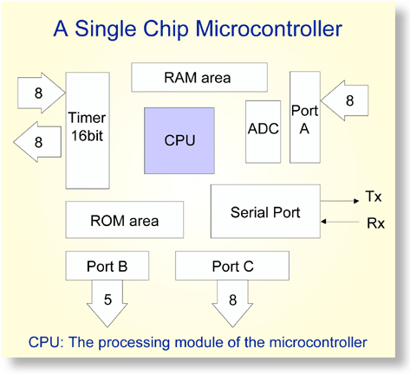
Figure 2.1: Showing a typical microcontroller device and its different subunits

2.3 PIN CONFIGURATION
figure 2.2 Pin configuration of Microcontroller

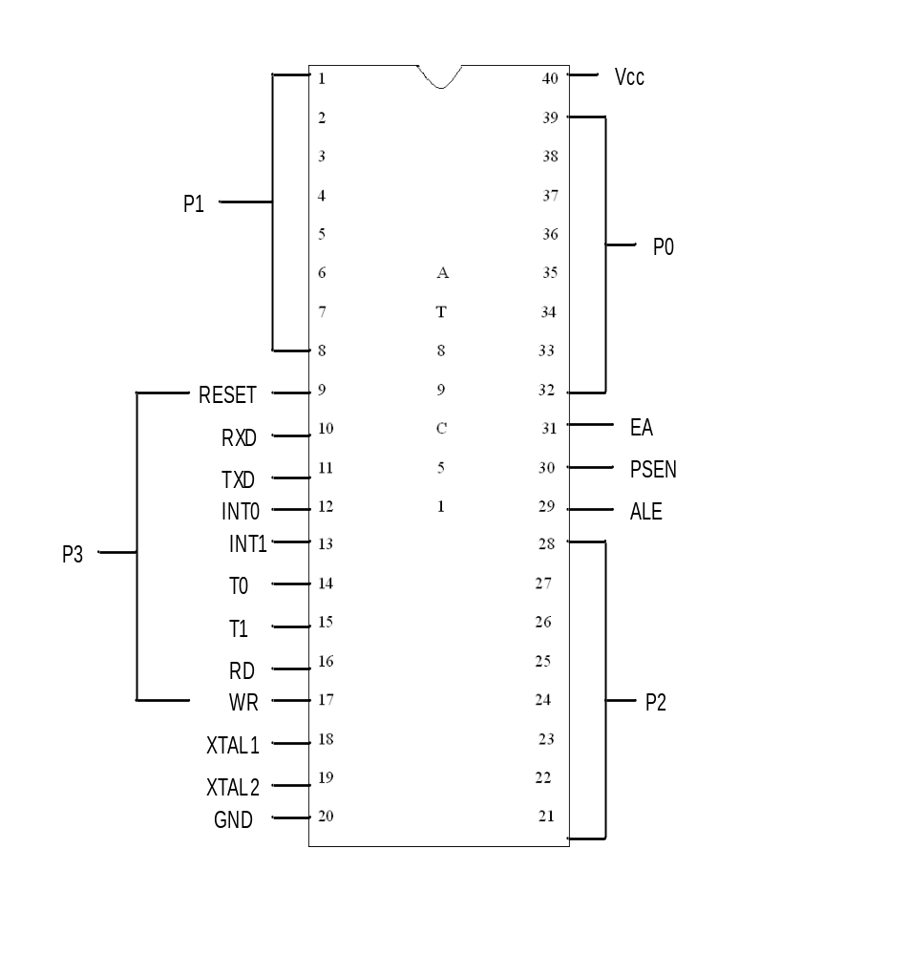

We have 4 ports in 8051 micro controller. They are port0, port1, port2, port3 which can
be accessed as i/o ports. The pins of the micro controller are explained below.

Reset: It resets total 8051 micro controller.

RXD: It receives data in serial communication.

TXD: It transmits data in serial communication.

INT0: External interrupt for timer 0.

INT1: External interrupt for timer1

T0: Timer0.

T1: Timer1.

RD: To read into external memory.

WR: To write into external memory.

XTAL1 & XTAL2: To connect the crystal oscillator.

ALE: Address latch enable which is used to access the address locations
from external memory.

PSEN: Program store enable which is used for storing programming
code into the external memory.

EA: External Access: 64 KB of ROM is the limit for external memory.

2.4 RESET CIRCUIT
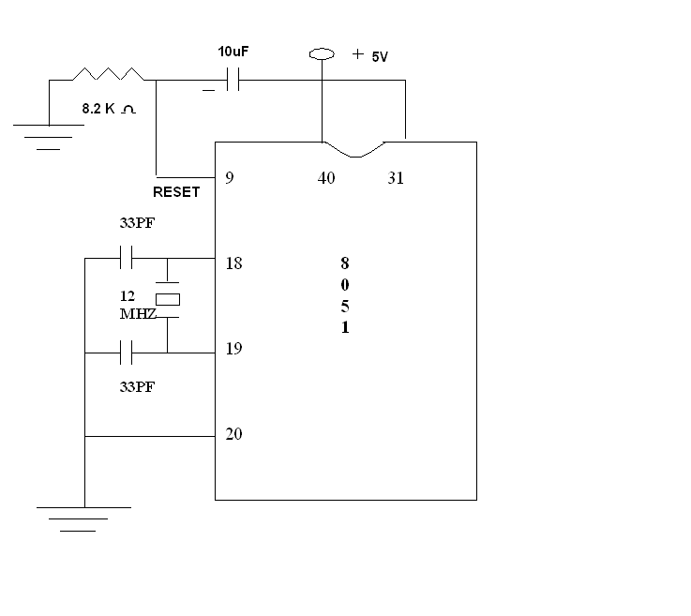
figure2.3 : Reset circuit of microcontroller
Capacitor is storing charge permanently until we use it. Crystal Oscillator is used to generate a carrier signal with stable frequency. With the help of this oscillator we will deduce the execution speed in terms of bytes/ sec.It generates 12 clock pulses /machine cycle. Capacitors provide charge for crystal oscillator. If we are not connecting any external memory to micro controller, EA is connected to Vcc in case of 8051.

2.5 RAM ARCHITECTURE
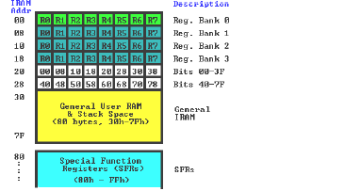
figure 2.4: Ram Architecture
The 8051 has a bank of 128 bytes of Internal RAM. This Internal RAM is found on-chip on the 8051 so it is the fastest RAM available, and it is also the most flexible in terms of reading, writing, and modifying its contents. Internal RAM is volatile, so when the 8051 is reset this memory is cleared. The 128 bytes of internal ram is subdivided as shown on the memory map. The first 8 bytes (00h - 07h) are "register bank 0". These alternative register banks are located in internal RAM in addresses 08h through 1Fh.Bit memory actually resides in internal RAM, from addresses 20h through 2Fh. The 80 bytes remaining of Internal RAM, from addresses 30h through 7Fh, may be used by user variables that need to be accessed frequently or at high-speed. This area is also utilized by the microcontroller as a storage area for the operating stack.

Register Banks
The 8051 uses 8 "R" registers which are used in many of its instructions. These "R" registers are numbered from 0 through 7 (R0, R1, R2, R3, R4, R5, R6, and R7).These registers are generally used to assist in manipulating values and moving data from one memory location to another. The concept of register banks adds a great level of flexibility to the 8051.
Bit Memory
The 8051, being a communication oriented microcontroller, gives the user the ability to access a number of bit variables. These variables may be either 1 or 0. There are 128 bit variables available to the user, numbered 00h through 7Fh. The user may make use of these variables with commands such as SETB and CLR. It is important to note that Bit Memory is really a part of Internal RAM. In fact, the 128 bit variables occupy the 16 bytes of Internal RAM from 20h through 2Fh.

Special Function Register (SFR) Memory
Special Function Registers (SFRs) are areas of memory that control specific functionality of the 8051 processor. For example, four SFRs permit access to the 8051’s 32 input/output lines. Another SFR allows a program to read or write to the 8051’s serial port .SFR is a part of Internal Memory. This is not the case. When using this method of memory access (it’s called direct address), any instruction that has an address of 00h through 7Fh refers to an Internal RAM memory address; any instruction with an address of 80h through FFh refers to an SFR control register.

Registers
The Accumulator
The Accumulator, as its name suggests, is used as a general register to accumulate the results of a large number of instructions. It can hold an 8-bit (1-byte) value and is the most versatile register

The "R" registers
The "R" registers are a set of eight registers that are named R0, R1, etc. up to and including R7. These registers are used as auxiliary registers in many operations.

The "B" Register
The "B" register is very similar to the Accumulator in the sense that it may hold an 8-bit (1-byte) value. The "B" register is only used by two 8051 instructions: MUL AB and DIV AB.

The Data Pointer (DPTR)
The Data Pointer (DPTR) is the 8051’s only user-accessible 16-bit (2-byte) register. The Accumulator, "R" registers, and "B" register are all 1-byte values. DPTR, as the name suggests, is used to point to data. It is used by a number of commands which allow the 8051 to access external memory.

The Program Counter (PC)
The Program Counter (PC) is a 2-byte address which tells the 8051 where the next instruction to execute is found in memory. When the 8051 is initialized PC always starts at 0000h and is incremented each time an instruction is executed.
.
The Stack Pointer (SP)
The Stack Pointer, like all registers except DPTR and PC, may hold an 8-bit (1-byte) value. The Stack Pointer is used to indicate where the next value to be removed from the stack should be

Addressing Modes
An "addressing mode" refers to how you are addressing a given memory location. The addressing modes are as follows,
With an example of each:
Immediate Addressing MOV A, #20h
Direct Addressing MOV A, #30h
Indirect Addressing MOV A, @R0
External Direct MOVX A, @DPTR
Code Indirect MOVC A, @A+DPTR
Each of these addressing modes provides important flexibility.

Interrupts
An interrupt is a special feature which allows the 8051 to provide the illusion of "multitasking," although in reality the 8051 is only doing one thing at a time.
.
Timers
Timers are one of the categories of hardware time delays. Time delays are used to keep a system into halting System or sleepy mode. We have two timers-timer0, timer1.Hardware time delays are used to generate exact time delays.

2.6 Microcontrollers versus Microprocessors
Microcontroller differs from a microprocessor in many ways. First and the most important is its functionality. In order for a microprocessor to be used, other components such as memory, or components for receiving and sending data must be added to it. In short that means that microprocessor is the very heart of the computer. On the other hand, microcontroller is designed to be all of that in one. No other external components are needed for its application because all necessary peripherals are already built into it. Thus, we save the time and space needed to construct devices.

2.7 Central Processing Unit
Let add 3 more memory locations to a specific block that will have a built in capability to multiply, divide, subtract, and move its contents from one memory location onto another. The part we just added in is called "central processing unit" (CPU). Its memory locations are called registers.

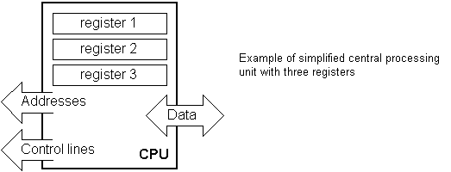
Figure2.5: Simplified central processing unit with three registers
Registers are therefore memory locations whose role is to help with performing various mathematical operations or any other operations with data wherever data can be found. Look at the current situation. We have two independent entities (memory and CPU) which are interconnected, and thus any exchange of data is hindered, as well as its functionality. If, for example, we wish to add the contents of two memory locations and return the result again back to memory, we would need a connection between memory and CPU. Simply stated, we must have some "way" through data goes from one block to another.

2.8 Bus
That "way" is called "bus". Physically, it represents a group of 8, 16, or more wires.
There are two types of buses: address and data bus. The first one consists of as many lines as the amount of memory we wish to address and the other one is as wide as data, in our case 8 bits or the connection line. First one serves to transmit address from CPU memory, and the second to connect all blocks inside the microcontroller.

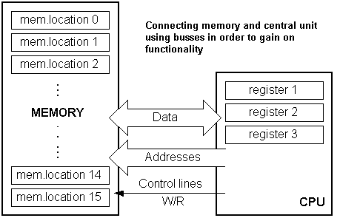
Figure2.6: Showing connection between memory and central unit using buses
As far as functionality, the situation has improved, but a new problem has also appeared: we have a unit that's capable of working by itself, but which does not have any contact with the outside world, or with us! In order to remove this deficiency, let's add a block which contains several memory locations whose one end is connected to the data bus, and the other has connection with the output lines on the microcontroller which can be seen as pins on the electronic component.
2.9 Input-output unit
Those locations we've just added are called "ports". There are several types of ports: input, output or bidirectional ports. When working with ports, first of all it is necessary to choose which port we need to work with, and then to send data to, or take it from the port.
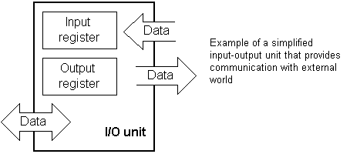
Figure2.7: Simplified input-output unit communicating with external world

When working with it the port acts like a memory location. Something is simply being written into or read from it, and it could be noticed on the pins of the microcontroller.

2.10 Serial communication
Beside stated above we've added to the already existing unit the possibility of communication with an outside world. However, this way of communicating has its drawbacks. One of the basic drawbacks is the number of lines which need to be used in order to transfer data. What if it is being transferred to a distance of several kilometers? The number of lines times’ number of kilometers doesn't promise the economy of the project. It leaves us having to reduce the number of lines in such a way that we don't lessen its functionality. Suppose we are working with three lines only, and that one line is used for sending data, other for receiving, and the third one is used as a reference line for both the input and the output side. In order for this to work, we need to set the rules of exchange of data. These rules are called protocol. Protocol is therefore defined in advance so there wouldn't be any misunderstanding between the sides that are communicating with each other. For example, if one man is speaking in French, and the other in English, it is highly unlikely that they will quickly and effectively understand each other. Let's suppose we have the following protocol. The logical unit "1" is set up on the transmitting line until transfer begins. Once the transfer starts, we lower the transmission line to logical "0" for a period of time (which we will designate as T), so the receiving side will know that it is receiving data, and so it will activate its mechanism for reception. Let's go back now to the transmission side and start putting logic zeros and ones onto the transmitter line in the order from a bit of the lowest value to a bit of the highest value. Let each bit stay on line for a time period which is equal to T, and in the end, or after the 8th bit, let us bring the logical unit "1" back on the line which will mark the end of the transmission of one data. The protocol we've just described is called in professional literature NRZ (Non-Return to Zero).
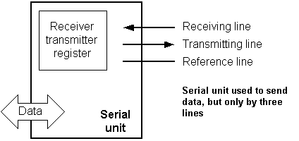
Figure2.8: Serial unit sending data through three lines only

As we have separate lines for receiving and sending, it is possible to receive and send data (info.) at the same time. So called full-duplex mode block which enables this way of communication is called a serial communication block. Unlike the parallel transmission, data moves here bit by bit, or in a series of bits what defines the term serial communication comes from. After the reception of data we need to read it from the receiving location and store it in memory as opposed to sending where the process is reversed. Data goes from memory through the bus to the sending location, and then to the receiving unit according to the protocol.
2.11 Timer unit
Since we have the serial communication explained, we can receive, send and process data.
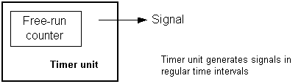
Figure2.9: Timer unit generating signals in regular time intervals
However, in order to utilize it in industry we need a few additionally blocks. One of those is the timer block which is significant to us because it can give us information about time, duration, protocol etc. The basic unit of the timer is a free-run counter which is in fact a register whose numeric value increments by one in even intervals, so that by taking its value during periods T1 and T2 and on the basis of their difference we can determine how much time has elapsed. This is a very important part of the microcontroller whose understanding requires most of our time.
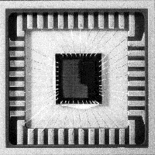
Figure2.10: Physical configuration of the interior of a microcontroller

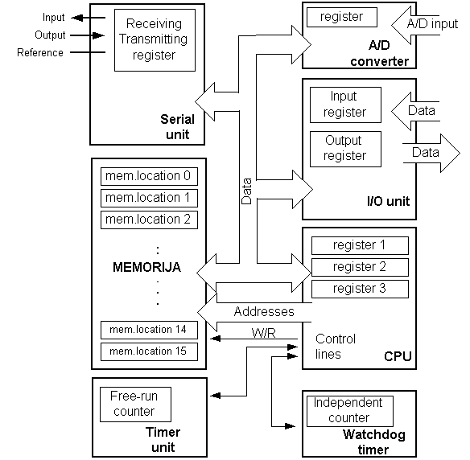
Figure2.11: Microcontroller outline with basic elements and internal connections
For a real application, a microcontroller alone is not enough. Beside a microcontroller, we need a program that would be executed, and a few more elements which make up interface logic towards the elements of regulation (which will be discussed next).

3- LCD INTERFACING

3.1 Pin Configuration

GND Vcc
1 16 2 15
80 | 81 | 82 | 83 |  | 84 | 85 | 86 | 87 | 88 | 89 | 8A | 8B | 8C | 8D | 8E | 8F
C0 | C1 | C2 | C 3 |  | C4 | C5 | C6 | C7 | C8 | C9 | CA | CB | CC | CD | CE | CF
H ->A
4
3
5

6

7 8 9 10 11 12 13 14

figure 3.1: 16x2 LCD Pin configuration

3- >VARISTOR
4-> RS
5-> RW
6-> EN
7-14-> DATA LINE INPUTS

LCD stands for Liquid Crystal Display. The most commonly used LCDs found in the market today are 1 Line, 2 Line or 4 Line LCDs which have only 1 controller and support at most of 80 characters.

3.2 DDRAM - Display Data RAM
Display data RAM (DDRAM) stores display data represented in 8-bit character codes. Its extended capacity is 80 X 8 bits, or 80 characters. The area in display data RAM (DDRAM) that is not used for display can be used as general data RAM. So whatever you send on the DDRAM is actually displayed on the LCD.

3.3 BF - Busy Flag
Busy Flag is a status indicator flag for LCD. When we send a command or data to the LCD for processing, this flag is set (i.e. BF =1) and as soon as the instruction is executed successfully this flag is cleared (BF = 0). This is helpful in producing and exact amount of delay. For the LCD processing. To read Busy Flag, the condition RS = 0 and R/W = 1 must be met and The MSB of the LCD data bus (D7) act as busy flag. When BF = 1 means LCD is busy and will not accept next command or data and BF = 0 means LCD is ready for the next command or data to process.
3.4 Instruction Register (IR) and Data Register (DR)
There are two 8-bit registers controller Instruction and Data register. Instruction register corresponds to the register where you send commands to LCD e.g. LCD shift command, LCD clear, LCD address etc. and Data register is used for storing data which is to be displayed on LCD. When send the enable signal of the LCD is asserted, the data on the pins is latched in to the data register and data is then moved automatically to the DDRAM and hence is displayed on the LCD.

3.5 Commands and Instruction set
Only the instruction register (IR) and the data register (DR) of the LCD can be controlled by the MCU. Before starting the internal operation of the LCD, control information is temporarily stored into these registers to allow interfacing with various MCUs, which operate at different speeds, or various peripheral control devices. The internal operation of the LCD is determined by signals sent from the MCU.

3.6 Sending Commands to LCD

To send commands we simply need to select the command register. Everything is same as we have done in the initialization routine. But we will summarize the common steps and put them in a single subroutine.

Following are the steps:
- Move data to LCD port
- Select command register
- Select write operation
- Send enable signal
- Wait for LCD to process the command

4 DC MOTOR INTERFACING
In this project the d.c motor interfacing consists of two motors .One motor is used to open & close the car door and the other is used to move the car forward. This interfacing is shown in fig. This uses L293D IC interfacing.

4.1 Push-Pull Four Channel Driver
Description
Output currents to 1A or 600mA per channel respectively. Each channel is controlled by a TTL-compatible logic input and each pair of drivers (a The L293 and L293D are quad push-pull drivers capable of delivering full bridge) is equipped with an inhibit input which turns off all four transistors. A separate supply input is provided for the logic so that it may be run off a lower voltage to reduce dissipation. Additionally the L293D includes the output clamping diodes within the IC for complete interfacing with inductive loads. Both devices is available in 16-pin Batwing DIP packages. They are also available in Power S0IC and Hermetic DIL packages.
4.2 Block Diagram
Figure 4.1: block diagram of load driver L293D
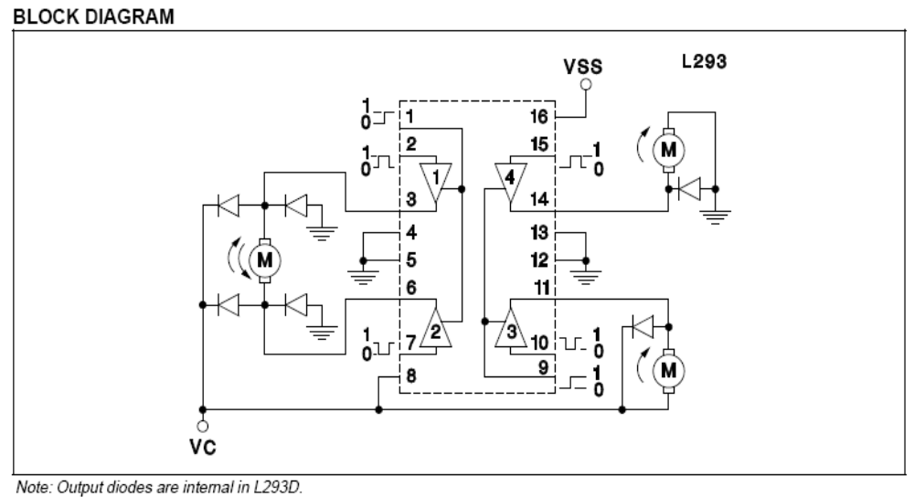

4.3 FEATURES:

- Output Current 1A Per Channel (600mA for L293D)
- Peak Output Current 2A Per Channel (1.2A for L293D)
- Inhibit Facility
- High Noise Immunity
- Separate Logic Supply
- Over-Temperature Protection

ABSOLUTE MAXIMUM RATINGS:

Collector Supply Voltage, VC. . . . . . . . . . . . . . . . . . . . . . . . . . . . . . . . . . . . . . . . . . . . 36V
Logic Supply Voltage, VSS . . . . . . . . . . . . . . . . . . . . . . . . . . . . . . . . . . . . . . . . . . . . . 36V
Input Voltage, VI. . . . . . . . . . . . . . . . . . . . . . . . . . . . . . . . . . . . . . . . . . . . . . . . . . . . . . . 7V
Inhibit Voltage, VINH . . . . . . . . . . . . . . . . . . . . . . . . . . . . . . . . . . . . . . . . . . . . . . . . . . .7V
Peak Output Current (Non-Repetitive), lOUT (L293) . . . . . . . . . . . . . . . . . . . . . . . . . . 2A
lOUT (L293D) . . . . . . . . . . . . . . . . . . . . . . . . . . . . . . . . . . . . . . . . . . . . . . . . . . . . . . . 1.2A

Total Power Dissipation

At T ground-pins = 80°C
N Batwing pkg, (Note) . . . . . . . . . . . . . . . . . . . . . . . . . . . . . . . . . . . . . . . . . . . . . . . . . 5W
Storage and Junction Temperature, Tstg, TJ . . . . . . . . . . . . . . . . . . . . . . . . -40 to +150°C

5 POWER SUPPLY SYSTEM

5.1 POWER SUPPLY CIRCUIT:

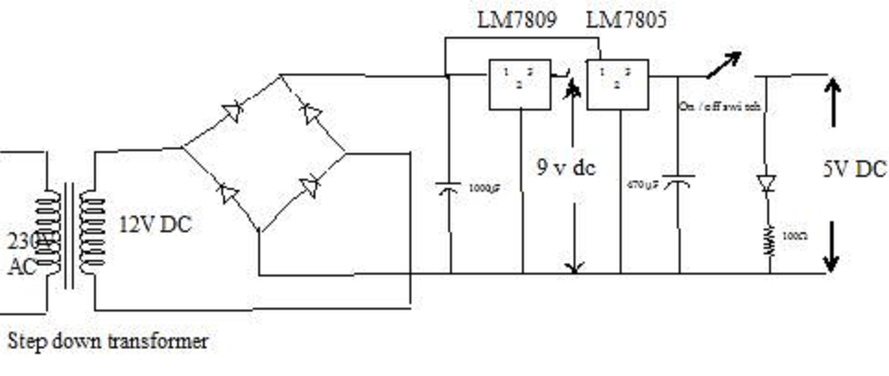
Figure 5.1: Circuit of power supply

The power supply consists of ac voltage transformer, diode rectifier, ripple filter, and voltage regulator. The description of the components is shown below.

5.2 TRANSFORMER:
Definition:
The transformer is a static electro-magnetic device that transforms one alternating Voltage (current) into another voltage (current).However; power remains the same during the transformation. Transformers play a major role in the transmission and distribution of ac power.
Principle:
Transformer works on the principle of mutual induction. A transformer consists of laminated magnetic core forming the magnetic frame. Primary and secondary coils are wound upon the two cores of the magnetic frame, linked by the common magnetic flux. When an alternating voltage is applied across the primary coil, a current flows in the primary coil producing magnetic flux in the transformer core. This flux induces voltage in secondary coil.
Transformers are classified as:
(a) Based on position of the windings with respect to core i.e.
- Core type transformer
- Shell type transformer
(b) Transformation ratio:
- Step up transformer
- Step down transformer
DC power supply exists in every electronic box whether it is a computer, TV, or equipment in the laboratory. The power supply consists of ac voltage transformer, diode rectifier, ripple filter, and voltage regulator. The transformer is an ac device. It has two coil windings, the primary and the secondary, around a common magnetic core. The current flowing in the primary winding generates a time varying electromagnetic field which in turn induces an output voltage across the secondary winding. The ratio of turns in the two windings determines the ratio of the input voltage and output voltage. The power supply that we are building in this experiment is a linear power supply. In other words, the circuit functions with analog signals. In our kit, we have a small transformer which can convert 230Vac from the wall plug to 6-12 V ac.

5.3 RECTIFIER:
The rectifier is based on p-n junction. One can use a single diode forming a half-wave rectifier or four diodes forming a full-wave rectifier or a bridge rectifier. In the experiment, we are going to use the power rectifying diode, 1N4001 or IN4007. You can read from the specification sheet the characteristics of the diode. The most important thing to know is the polarity of the diode. The arrow is the p-side and the bar is the n-side. A positive voltage is needed on the p-side to make the diode conduct. IN4001 can block off large negative bias in the hundred voltage range.

5.4 REGULATOR:
To make the output voltage as constant as possible, one needs a regulator. The regulator consists of a voltage reference, e.g., a Zener diode. It can also be an IC component with voltage reference and feedback control circuit inside.
Finally, you will characterize the performance of the power supply by measuring its output voltage and ripple as a function of the load current. The more the current, the higher is the ripple. Likewise, the more the current, the lower is the voltage. This is called loading.
Another semiconductor component to be used in this experiment is a voltage regulator, 7805. “78” indicates that it is a regulator for positive voltage. There is a corresponding “79” model for negative voltage. “05” indicates that it has an output of 5 V. 7805 is an integrated circuit. Just like the operational amplifier, the design engineer of the IC has optimized the circuit. The regulator IC requires an input voltage at least a couple of V higher than the output voltage in order to function properly. In a way, it is similar to the operational amplifier; the output is limited by the power supply voltage. Your output is always below the input. This voltage difference keeps all electronic circuits in the IC forwardly biased, hence, functioning properly in the linear regime.
The lower circuit is a bridge-wave rectifier. There are four diodes. They are arranged in such a way that the current always flows in the same direction through the load resistor no matter which node of the transformer is positive. You can trace the flow of the current. When the upper node of the transformer is positive, current flows through the first diode through the load, which is not shown, then it flows through the last diode to the lower node of the transformer completing the loop. When the lower node of the transformer is positive, current flows through the third diode to the load resistor then it flows through the second diode to the upper node of the transformer completing the loop. The current flows through the load resistor along the same direction all the time. The load resistor must have sufficient power handling capability. Otherwise, It may burn .The power dissipation is given by voltage square divided by resistance.
5.5 FILTER:
After the rectification process, the voltage signal contains both an average dc component and a time varying ac component called the ripple. To reduce or eliminate the ac component, one needs low pass filter(s). The low pass filter will pass through the dc but attenuate the ac at 60 Hz or its harmonics, i.e., 120 Hz. It has a resistor in front and a capacitor across the output and ground. (C-filter).

5.6 LED (Light Emitting Diodes):
As its name implies it is a diode, which emits light when forward biased. Charge carrier recombination takes place when electrons from the N-side cross the junction and recombine with the holes on the P side. Electrons are in the higher conduction band on the N side whereas holes are in the lower valence band on the P side. During recombination, some of the energy is given up in the form of heat and light. In the case of semiconductor materials like Gallium arsenide (GaAs), Gallium phosphate (Gap) and Gallium arsenide phosphate (GaAsP) a greater percentage of energy is released during recombination and is given out in the form of light. LED emits no light when junction is reversed biased.
5.7 CIRCUIT OPERATION:
In circuit operation, when the voltage generated by the transformer is higher than the capacitor voltage, the current flows through the diode charging the capacitors. At the same time, the load resistor drains current from the capacitors. When the amount of draining matches with the charging current, the voltage is stabilized. A sudden increase in load current will decrease the voltage across the capacitor. It will also increase the time period during which the diodes conduct, hence, the ripple.

6. Description of Project

6.1 Introduction

The Need

Delhi, the National Capital with a population of about 12 million is, perhaps, the only city of its size in the world, which depends almost entirely on buses on it sole mode of mass transport.bus services are inadequate and heavily over-crowded.. The result of extreme congestion on the road, ever slowing speeds, increasing accident rate, fuel wastage and environmental pollution. Delhi has now become the fourth most city in the world, with automobiles contributing more than two thirds of the total atmospheric pollution. Pollution related health problems are reaching disconcerting levels.
Immediate steps are, therefore, needed to improve both the quality and availability of mass transport service. This is possible only if a rail-based mass transit system, which is non-polluting, is introduced in the city without further delay.

Delhi MRTS Project
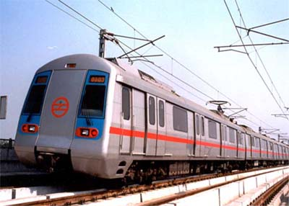
With a view to reducing the problems of Delhi’s commuter, the launching of an Integrated Multi Mode Mass Rapid Transport System for Delhi had long been under consideration. The first concrete step in this direction was, however, taken when a feasibility study for developing such a multi-modal MRTS system was commissioned by GNCTD (with support from GOI) in 1989 and completed by RITES in 1991.
My Prototype of metro train
I have made the prototype of Metro train using Microcontroller 89C51.The basic function of this project is given later. I have used a toy car to implementing it which has two DC motors. One is used for opening and closing the door and other is used for moving the car forward. The complete description of project is given below.

6.2 Circuit Diagram of Metro Train Prototype

Following figure shows the complete Metro Train Prototype.

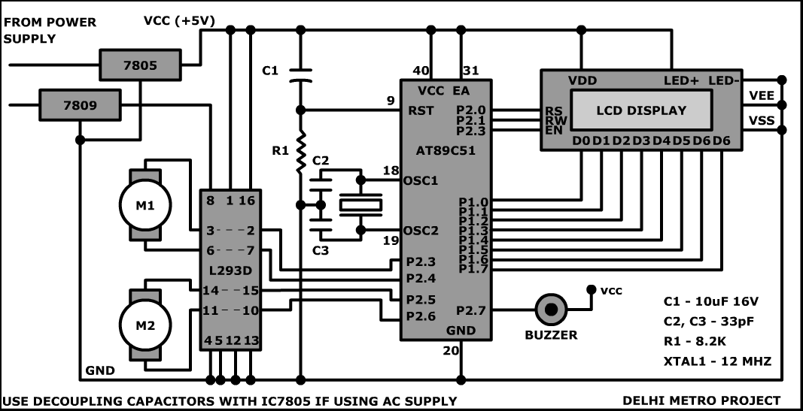

Figure 6.1: diagram of Metro Train Prototype

6.3 PROJECT METHODOLOGY

6.3(a) Components:

Component Name Quantity

- Power Supply Section
plug with wire 1
Step down transformer (230v/12v a.c) 1
1N4007 diodes 4
LM7809 1
LM7805 1
100 μF 1
ON/OFF switch 1
Red LED 1
1K Resistor 1

- Microcontroller Section
Microcontroller IC (AT89C51) with base 1
Crystal Oscillator (11.0592 MHz) 1
Capacitor (30pF) 2
Capacitor (10µF) 1
Resistor (8.2K) 1
LCD Connector 1
- Buzzer 1
- LCD(16x2) 1
- Load Driver (L293D) with base 1
- A Car (toy-driven by a DC motor) 1
- General Purpose Card 4
- Single Core Connecting Wires
- Reset Switch (Push-on) 1
- Old and Rough CD drive for making Door System 1
(We are to use only motor and Pulley system for door)

6.3(b) Softwares used:

- Keil µVision3.
- Top-View Simulator

6.3(c) Equipments used:

- Soldering iron, solder, flux.
- Hex Blade

6.4 Procedure of building the Prototype of Metro Train

Step 1: Circuit diagram of the proposed system is designed and finalized.(Refer to Figure 6.1 )
Step 2: All the components and software platform to be used are selected which are also mentioned above.
Step 3: All the hardware components are soldered on their respective printed circuit boards with the help of soldering ion, solder and flux according to the hardware schematic shown in the Figure
Step 5: Code/program of the proposed system is developed using assembly language with the help of software platform (Keil u vision3).The coding could be seen in section
Step 6: The hex code of the program being created by the software platform is burnt into the flash code memory of our microcontroller IC 89C51.
Step 7: Testing is done at various levels to finalize the appropriate program for the most proper working of the system

6.5 General Working

When the power is turned on a message (“welcome to metro”) is displayed on LCD.
Then a message “Current station is Kishan Ganj” is displayed and door is opened also.
A buzzer is also turned on when door opens. After some delay the door is closed and car is started to move forward. A message “current station is Kishan Ganj” is displayed also on LCD. After some delay a message “next station is Pratap nagar” is displayed. After
some time the train stops and a message “ current station is Pratap nagar” is displayed. This process is continued for five stations. In the end a message “End of line” is displayed on LCD. This whole process is repeated until we turned off the power supply.

7. FUTURE SCOPE


The new cars would feature the following:
- Stainless steel exteriors instead of an aluminium car body.
- Thinner, stronger stainless steel seats that offer more leg room. Each car would have 64 cloth-padded, taller seats with seat-back grab handles.
- A total end to carpeting. Floors would be rubberized.
- Interactive maps on LCD screens that would also likely display advertisements
- Automated station announcements. So no more "Judishuwary Square".
- Security cameras on all rail cars.
The 7000 series won't be ready for service for at least five years. The latest models are in the 6000 series, which were introduced last year.

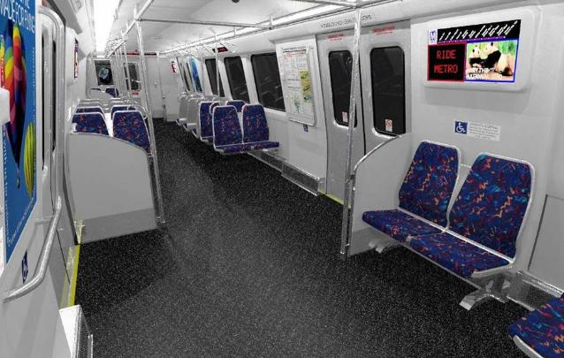

8. REFRENCES AND BIBLOGRAPHY

- “THE 8051 MICROCONTROLLER AND EMBEDDED SYSTEM” by Muhammad Ali Mazidi , Janice Gillispie Mazidi, Rolin D. Mckinlay.
- “The 8051 MICROCONTROLLER” by K. J. Ayala.
- "Advanced Microprocessors and Microcontrollers" by B.P. Singh & Renu Singh.
- "Let Us C" by Yashwant Kanitkar.
- "Data Structure through C" by Yashwant Kanitkar.

NET LINKS:
- www.8051projects.net
- www.atmel.com
- www.electronicsforyou.com
- www.encyclopedia.com
- www.wikipedia.com

Appendix

List of Essential Diagrams:
- Figure 2.1: showing a typical microcontroller device
and its different subunits 9
- Figure 2.2: Pin configuration of Microcontroller 10
- Figure 2.3: Reset circuit of Microcontroller 11
- Figure 2.4: Ram Architecture 13
- Figure 2.5: Simplified central processing unit
with three registers 17
- Figure 2.6: Showing connection between memory
and central unit using buses 18
- Figure 2.7: Simplified input-output unit communicating
with external world 18
- Figure 2.8: Serial unit sending data through three lines 19
- Figure 2.9: Timer unit generating signals in regular
time intervals 20
- Figure 2.10: Physical configuration of the interior of a
Microcontroller 20
- Figure 2.11: Microcontroller outline with basic elements
And internal connections 21
- Figure 3.1: 16x2 LCD pin configuration 22
- Figure 4.1: Block diagram of load driver L293D 24
- Figure 5.1: Circuit of power supply 26
- Figure 6.1: Circuit diagram of Metro train prototype 31

