RAILWAY RESERVAION
(Mini project)

BY
G.SHAKIR

Use Case Modeling

Use Case diagram for Reservation System:

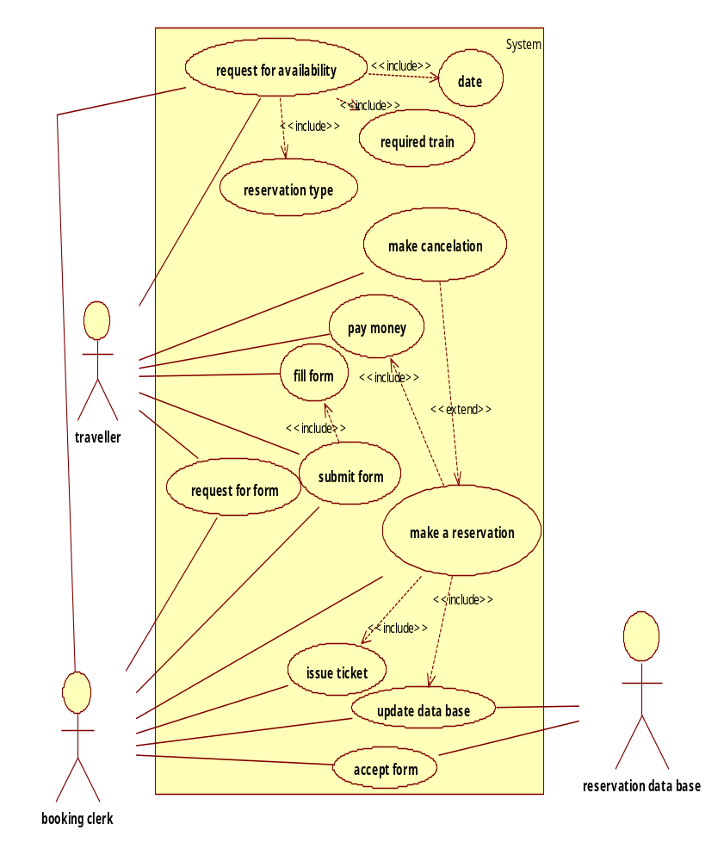

1.Request for availability - use case specifications

1.1 Brief Description

The main purpose of using this use case is to know details of particular trains available or not .Along with reservation type,date,particular train details are also known.

Flow of Events

1.2 Basic flow

1. User enquires booking clerk.
2. Booking clerk check the database.
3. On success traveller make reservation.

1.3 Alternate Flow

If in the basic flow, particular trains are not available then he choose any others trains go to destination place.

1.4 Pre Conditions

The traveller should have a train for destination place.

1.5 Post Conditions

The reservation database is modified after reservation.

2.Reservation type - use case specifications

1.1 Brief Description

The main purpose of using this use case is to know details of particular reservation type i.e. sleeper class, AC class, general etc.

Flow of Events

1.2 Basic flow

1. User enquires booking clerk.
2. Booking clerk checks the database.
3. On success traveller chooses required reservation type.

1.3 Alternate Flow

If in the basic flow, required reservation type is not present then he chooses any other reservation type.

1.4 Pre Conditions

The traveller should know reservation type.

1.5 Post Conditions

The reservation database is modified after choosing reservation type.

3.Date - use case specifications

1.1 Brief Description

The main purpose of using this use case is to know details of particular trains available or not on a particular date.

Flow of Events

1.2 Basic flow

1. User enquires booking clerk.
2. Booking clerk check the database.
3. On success traveller make reservation.

1.3 Alternate Flow

If in the basic flow,

1.4 Pre Conditions

The traveller should have a train for destination place.

1.5 Post Conditions

The reservation database is modified after reservation.

4.Request for availability - use case specifications

1.1 Brief Description

The main purpose of using this use case is to know details particular trains available or not .

Flow of Events

1.2 Basic flow

1. User enquires booking clerk.
2. Booking clerk check the database.
3. On success traveller make reservation.

1.3 Alternate Flow

If in the basic flow,

1.4 Pre Conditions

The traveller should have a train for destination place.

1.5 Post Conditions

The reservation database is modified after reservation.

5.Request for availability - use case specifications

1.1 Brief Description

The main purpose of using this use case is to know details particular trains available or not .

Flow of Events

1.2 Basic flow

1. User enquires booking clerk.
2. Booking clerk check the database.
3. On success traveller make reservation.

1.3 Alternate Flow

If in the basic flow,

1.4 Pre Conditions

The traveller should have a train for destination place.

1.5 Post Conditions

The reservation database is modified after reservation.

6.Request for availability - use case specifications

1.1 Brief Description

The main purpose of using this use case is to know details particular trains available or not .

Flow of Events

1.2 Basic flow

1. User enquires booking clerk.
2. Booking clerk check the database.
3. On success traveller make reservation.

1.3 Alternate Flow

If in the basic flow,

1.4 Pre Conditions

The traveller should have a train for destination place.

1.5 Post Conditions

The reservation database is modified after reservation.

7.Request for availability - use case specifications

1.1 Brief Description

The main purpose of using this use case is to know details particular trains available or not .

Flow of Events

1.2 Basic flow

1. User enquires booking clerk.
2. Booking clerk check the database.
3. On success traveller make reservation.

1.3 Alternate Flow

If in the basic flow,

1.4 Pre Conditions

The traveller should have a train for destination place.

1.5 Post Conditions

The reservation database is modified after reservation.

8.Request for availability - use case specifications

1.1 Brief Description

The main purpose of using this use case is to know details particular trains available or not .

Flow of Events

1.2 Basic flow

1. User enquires booking clerk.
2. Booking clerk check the database.
3. On success traveller make reservation.

1.3 Alternate Flow

If in the basic flow,

1.4 Pre Conditions

The traveller should have a train for destination place.

1.5 Post Conditions

The reservation database is modified after reservation.

9.Request for availability - use case specifications

1.1 Brief Description

The main purpose of using this use case is to know details particular trains available or not .

Flow of Events

1.2 Basic flow

1. User enquires booking clerk.
2. Booking clerk check the database.
3. On success traveller make reservation.

1.3 Alternate Flow

If in the basic flow,

1.4 Pre Conditions

The traveller should have a train for destination place.

1.5 Post Conditions

The reservation database is modified after reservation.

10.Request for availability - use case specifications

1.1 Brief Description

The main purpose of using this use case is to know details particular trains available or not .

Flow of Events

1.2 Basic flow

1. User enquires booking clerk.
2. Booking clerk check the database.
3. On success traveller make reservation.

1.3 Alternate Flow

If in the basic flow,

1.4 Pre Conditions

The traveller should have a train for destination place.

1.5 Post Conditions

The reservation database is modified after reservation.

1.Request for availability - use case specifications

1.1 Brief Description

The main purpose of using this use case is to know details particular trains available or not .

Flow of Events

1.2 Basic flow

1. User enquires booking clerk.
2. Booking clerk check the database.
3. On success traveller make reservation.

1.3 Alternate Flow

If in the basic flow,

1.4 Pre Conditions

The traveller should have a train for destination place.

1.5 Post Conditions

The reservation database is modified after reservation.

11.Request for availability - use case specifications

1.1 Brief Description

The main purpose of using this use case is to know details particular trains available or not .

Flow of Events

1.2 Basic flow

1. User enquires booking clerk.
2. Booking clerk check the database.
3. On success traveller make reservation.

1.3 Alternate Flow

If in the basic flow,

1.4 Pre Conditions

The traveller should have a train for destination place.

1.5 Post Conditions

The reservation database is modified after reservation.

12.Request for availability - use case specifications

1.1 Brief Description

The main purpose of using this use case is to know details particular trains available or not .

Flow of Events

1.2 Basic flow

1. User enquires booking clerk.
2. Booking clerk check the database.
3. On success traveller make reservation.

1.3 Alternate Flow

If in the basic flow,

1.4 Pre Conditions

The traveller should have a train for destination place.

1.5 Post Conditions

The reservation database is modified after reservation.

13.Request for availability - use case specifications

1.1 Brief Description

The main purpose of using this use case is to know details particular trains available or not .

Flow of Events

1.2 Basic flow

1. User enquires booking clerk.
2. Booking clerk check the database.
3. On success traveller make reservation.

1.3 Alternate Flow

If in the basic flow,

1.4 Pre Conditions

The traveller should have a train for destination place.

1.5 Post Conditions

The reservation database is modified after reservation.

