[IFIM]
Submitted to: Prof. Anupama Murli Krishna
Submitted By: - PGDM 08-10
Avinash Chandra Srivastava
Shalini Kumari
Tushara Pillai
Sudeep Agarwal
Nilesh Kumar
Date of submission:- March 09, 2009

[Pick the date]
RAILWAY RESERVATION DATABASE SYSTEM
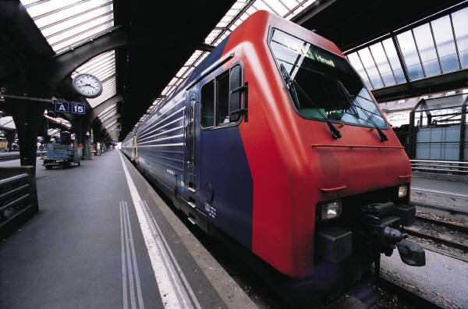

SYNOPSIS
RAILWAYS
OBJECTIVE- Designing a Database that gives us information about railway reservation of tickets. This database helps railways to retrieve data as and when required in future.
INTRODUCTION
Layout of railway reservation form and connection of this form with the database required to store information.
PASSENGERS DATABASE: database of passengers contains following fields
- Name…………………………
- Age…………………
- Gender……………..
- Total Number Of Passengers Travelling………
  - Number of Adults………..
  - Number Of children……..
  - Senior Citizen……………
- Date Of Travel…………………
- Class of Travel………………..

TRAIN DATABASE : database of train contains following fields
- Train Name……………………….
- Train Number……………………..
- Route…From…………..To………………..
- Train Time……………………………………
- Number of Compartments………………….
  - AC First Class………………………
  - AC 2 Tier……………………………
  - AC 3 Tier……………………………
  - Sleeper……………………………..
  - General…………………………….
- Number of Employees…………………….

Contents
SYNOPSIS 2
CANDIDATE'S DECLARATION 5
CERTIFICATE 6
INTRODUCTION 7
INTRODUCTION TO THE ORGANIZATION 8
INTRODUCTION TO THE RESERVATION SYSTEM 8
RAILWAY RESERVATION METHODS : 10
EXISTING RESARVATION SYSTEM –SHORT COMMING 11
PROPOSED RESERVATION SYSTEM- ADVANTAGE 11
MAIN OBJECTIVES OF THE PROJECT 12
SCOPE OF OUR PROJECT WORK 12
REASONS FOR SELECTING THIS SYSTEM IN OUR PROJECT 13
FEATURES OF VISUAL BASIC 13
FEATURES OF MS- ACCESS BASED USER INTERFACES 16
DESIGN OF TABLES 17
SNAPSHOTS OF TABLES 19
TABLE FORPASSENGERS 19
TABLE FOR TRAINS 20
SNAPSHOTS OF FORMS 21
PASSENGER RESERVATION FORM 21
FORM FOR TRAINS 22
CONCLUSION 23
FUTURE 24

CANDIDATE'S DECLARATION

We the students of IFIM B SCHOOL hereby declare that this project report titled “RAILWAY RESERVATION DATABASE SYSTEM “submitted towards the completion of I T for managers Project in 3rd trimester of PGDM in Institute of Finance and International Management, Bangalore is an authentic record of our work carried out under the guidance of Prof. Anupama Murli Krishna. Professor, IFIM B-School, Bangalore.

Date: March, 09, 2009
Place: Bangalore

Avinash Chandra Srivastava (12)
Shalini Kumari (46)
Tushara Pillai (56)
Sudeep Agarwal (54)
Nilesh Kumar (29)

CERTIFICATE

This is to certify that the above declaration made by Mr. Avinash Chandra Srivastava, Miss. Shalini Kumari, Miss. Tushara Pillai, Mr. Sudeep Agarwal and Mr. Nilesh Kumar is true to the best of my knowledge and belief.

Date: March 09, 2009
Place: Bangalore

Prof. Anupama Murli Krishna
Professor,
Institute of Finance and International Management, Bangalore

INTRODUCTION
HISTORY
A plan for a rail system in India was first put forward in 1832, but no further steps were taken for more than a decade. In 1844, the Governor-General of India Lord Hardinge allowed private entrepreneurs to set up a rail system in India. Two new railway companies were created and the East India Company was asked to assist them. Interest from a lot of investors in the UK led to the rapid creation of a rail system over the next few years.
Railways were first introduced to India in 1853. By 1947, the year of India's independence, there were forty-two rail systems. In 1951 the systems were nationalised as one unit, becoming one of the largest networks in the world. IR operates both long distance and suburban rail systems on a multi-gauge network of broad, metre and narrow gauges. It also owns locomotive and coach production facilities.
The first train in India became operational on 1851-12-22, and was used for the hauling of construction material in Roorkee. A few years later, on 1853-04-16, the first passenger train between Bori Bunder, Bombay and Thana covering a distance of 34 km (21 miles) was inaugurated, formally heralding the birth of railways in India.

INTRODUCTION TO THE ORGANIZATION

Indian Railways have been divided into 9 Zones - Western, Central, Eastern, Northern, North Eastern, Northeast Frontier, Southern, South Central & South Eastern covering the largest route length of over 63000 Kms of total Indian boundary. The last stations of the four directional boundaries are West-Mumbai, South-Kanyakumari, East-Guwahati, North-Jammu. It is the most convenient way of travelling if you are travelling on a budget. The railways have one of the most efficient communication systems between 2 stations. The types of class available are 1st class, AC 2tier, AC 3tier, 2nd class sleeper & chair car. The 1st class being phased out being converted in to AC 2 tier/AC 3 tier (recently being introduced in some of the trains).

INTRODUCTION TO THE RESERVATION SYSTEM
The Indian Railways (IR) carries about 5.5 lakh passengers in reserved accommodation every day. The computerised Passenger Reservation System (PRS) facilitates booking and cancelling of tickets from any of the 4000 terminals (i.e PRS booking windows) all over the country. These tickets can be booked or cancelled for journeys commencing in any part of India and ending in any other part, with travel times as long as 72 hours and distances up to several thousand kilometers.
The pilot project of PRS was launched on 15 November 1985, over Northern Railway with the installation of the Integrated Multiple Train Passenger Reservation System (IMPRESS), an online transaction processing system developed by the Indian Railways in association with Computer Maintenance Corporation (CMC) Ltd., at New Delhi. The objective was to provide reserved accommodation on any train from any counter, preparation of train charts and accounting of the money collected. This application was subsequently implemented in 1987, at Mumbai, Chennai, Kolkata and Secunderabad. With the addition of new locations and many redefinitions, the IMPRESS system fell short of growing expectations of the travelling public. Hence a new application software, i.e., Country Wide Network for Computerised Enhanced Reservation and Ticketing (CONCERT) was developed by the Centre for Railway Information Systems (CRIS), New Delhi primarily using ‘C’ and also using ‘FORTRAN’. The application was first implemented at the Secunderabad PRS site in September 1994 and subsequently at the other four PRS sites. Currently, the PRS servers are maintained at the five sites in Delhi, Mumbai, Kolkata, Chennai and Secunderabad and operate in a distributed database process environment. Communication of all the terminals with their server was established using Railway/Department of Telecommunication (DOT) channel lines, fibreoptic cable/microwave channels, switches, modem, multiplexers etc. The inter-networking of five PRS nodes was completed in April 1999. Interconnectivity is established between the five PRS centres over 2 mbps leased Bharat Sanchar Nigam Limited (BSNL) lines. The system has the capability of issuing reserved tickets from anywhere to anywhere, in any train, date or class between any pair of stations from any booking terminal of the PRS.
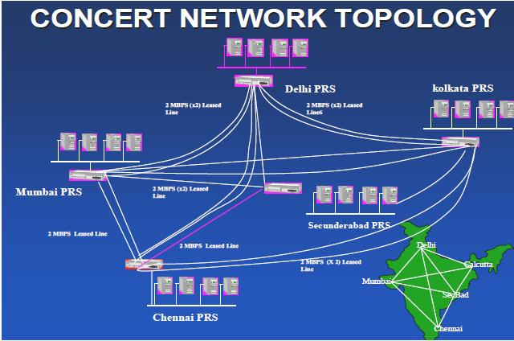
The main modules of the PRS are the Reservation module, the Cancellation and Modification Module, the Charting Module, the Accounting Module, and the Database Module. The passengers’ request for reservation, cancellation and modification of journey are handled by the system through requisition slips. Major outputs generated by the system are Reservation cum- journey tickets, Cancellation/Modification tickets, Reservation Charts
and Daily Terminal Cash Summary. The system is also capable of generating different types of Management Information System (MIS) Reports. Indian railway is having ten zonal railways namely Eastern Railway (ER), Northern Railway (NR), Southern Railway (SR), Central Railway (CR), Western Railway (WR), South Central Railway (SCR), North Eastern Railway (NER), South Eastern Railway (SER), North East Frontier Railway (NFR) and East Central Railway (ECR).

RAILWAY RESERVATION METHODS :

- Online Booking
- Counter Booking

ONLINE BOOKING:
This facility is given to general public by railway department. With the help of this facility people can book their tickets through internet, sitting in their home by a single click of the mouse. Using their credit card people can easily get their tickets done within minutes. There are certain charges for online booking as well.
COUNTER BOOKING:
This is oldest method of booking the ticket. The reservation counters are there at railway departments from where people can get the tickets to their respective destinations. Nowadays there are various ticket counters, apart from railway station counters where tickets are available.

EXISTING RESARVATION SYSTEM –SHORT COMMING

- Railway passengers frequently need to know about their ticket reservation status, ticket availability on a particular train or for a place, train arrival and departure details, special trains etc. Customer information centers at the railways station are unable to serve such queries at peak periods.
- As of now there are no call centers facilities available to solve the queries of the Indian passengers and customers.
- The number of reservation counters available to the Indian passengers and customers are very less.
- On most of the reservation centers in India there are always long queues, so it takes a long time for any individual to book the tickets.
- In case of booking e-ticket or I- ticket by IRCRC the only disadvantage is any individual cannot plan for onward journey.
- In case of e-ticket and I- ticket if there is any case of cancellation the amount to be refunded to the customer is not been credited to the customer’s account instantly, it takes a long time.

PROPOSED RESERVATION SYSTEM- ADVANTAGE

- The proposed system is comparatively faster than the existing system.
- As the proposed system is comparatively faster than the existing system, there will be very less rush and shorter queues at the reservation counters or centers.
- In the proposed system, we are also making database for all the trains running across the country.
- As required, we can edit the database of the trains and also add the new trains which will be proposed in future budgets

MAIN OBJECTIVES OF THE PROJECT

- The acquisition and maintenance of a relational database with the help of hardware, communication network and software including system design.

- To assess the if system chosen in the project operates in an adequately controlled environment.

- Whether the application’s control are adequate and if the system is in compliance with rules.

- Adequate security from possibilities of fraud.

- To show an effective mechanism to ensure most economic usage of available resources.

- The control mechanism for credit card transactions were adequate.

SCOPE OF OUR PROJECT WORK

- The scope of project included evaluation of the application and was primarily concerned with the transactions related to booking of tickets from the terminals operated by the railway personnel.

- Application controls, simulation and online enquiries were used to evaluate data validation and program logic. The selected data, as made available, for substantive checking of the completeness, integrity and consistency of data using computer assisted applications such as VB, MS Access and Structured Query Language (SQL).

- The records maintained in the database of the railways reservation centre were also reviewed. Discussions were held with the database users to gain understanding regarding the various functional aspects of the system.

REASONS FOR SELECTING THIS SYSTEM IN OUR PROJECT

- Indian Railways is huge. There are umpteen number of database in its system. The use of MS Access and Visual Basic enables the person at the booking counter a customized and easy retrieval of information.

- An online ticketing database allows the users of the Indian Railways Reservation System to track the whereabouts of their travel. The passengers who need to know whether they are in waiting list or confirmed need not travel to the ticket counter or call railway service system. With the help of an online system they can show the information in a click.

- In case of cancellation, the online system instantly credits the amount from the passengers’ account.

- It updates the changes instantly, thus, the user working on the database will not have to go to each database and make the changes.

FEATURES OF VISUAL BASIC

Highlights
- Addressing and changing Forms,
- Controls and records
- Responding to clicks, typing and other events.

The VBA-language itself is rather simple and has the same components as many other programming languages, for instance Java and C++. The difficult part is how the program cooperates with the built-in objects and how these objects really work. This is our focus in this chapter.

The objects in Access
Access concepts: tables, queries, forms, and controls. How do they relate to each other?
When we work with Access, we work with two different systems, the SQL engine and Access. TheAccess is primarily a tool for accessing data in databases through user windows (forms). Access can also work with other SQL engines than Jet, for instance Oracle. When doing this, we may lose some designer features but gain other qualities, for instance speed and reliability.
- Databases: Access can handle and connect to several open databases at the same time.
- Recordsets, tables and queries: A database contains a number of recordsets. Some recordsets are tables, others are queries (shown as subclasses). Each recordset has a description for each of its fields. The description includes the field name, the field type, format, etc. A query has also an SQL-property - the text that describes how to compute the records in the query. Tables and queries play much the same role. Both ofthem can for instance be the record source for a Form.
- Records and fields: Each recordset contains a number of records, and each record contains a number of fields. Each field has only one attribute, the value stored in the field. We can see the records in Datasheet view. We look either directly into a table or into records selected and computed by a query.
- Access instances: Access window has a title bar and a database window inside. The Access window corresponds to an object in the Access class.

Visual Basic tools
The Visual Basic window may contain many frames. In Access 2000 and 2003, they may be docked inside the window or undocked, i.e. floating as separate small windows. By accident it can be docked or undocked, and it may be very frustrating trying to get them back where its wanted. The frame will dock somewhere along a side of the window. Where it docks does not depend on where the frame is when the mouse button is released. It depends on where the mouse pointer is when we release the button.
- Project Explorer: To the left there is a list of all forms in the database. In object-oriented terminology, each form is a class. The class has a code module with event procedures for the controls on the form. When you double-click a form on the list, you will see the code module to the right in the Visual Basic window. The database may also contain code modules (classes) that are not forms. They are shown at the bottom of the Project Explorer list. All code modules may contain procedures and declare variables.
VBA offers three kinds of modules:
Form module: A form module has event procedures for all controls on the form, and it may have ordinary procedures too. It may declare variables. When you open a form, you get an object based on the form class. The object is a visible form and it has a set of variables corresponding to the declarations. We get more form objects, appearing as other open copies of the form. Each copy has its own variables, but the same code. When the code uses addresses such as Me.txtName, it refers to the controls and variables of this particular copy of the form.
Class module: A class module corresponds to a class in other object-oriented languages. It has procedures and declares variables, and you can create multiple objects based on the class, each with their own variables. The only difference between form modules and class modules is that the latter are not visible to the user and have no controls.
Module (simple): A simple module is similar to a class but there is only one object based on the module. The system creates this object automatically. The first versions of Visual Basic had no class modules, only simple modules.
- Code window: To the right in the Visual Basic window, there is a code window with the Visual Basic program. Scroll to other event procedures and controls, or they can be selected by means of the two combo boxes at the top.

Creating an event procedure: Initially, the event procedures are not in the code, but if we select one of them by means of the combo boxes, Visual Basic creates it. The same thing happens if an event procedure is selected through the control's property window. However, Access doesn't always coordinate these two things. An event procedure may be created in the code window, but it doesn't appear in the property box. As a result, Access never calls the event procedure.

FEATURES OF MS- ACCESS BASED USER INTERFACES
Highlights
• Construct user windows (Forms).
• Add fields, sub-windows, etc. (Controls).
• Construct menus and other details.

An Access-based user interface consists of user windows(called Forms in Access) , menus, and all the little things such as error messages (message boxes) and pop up help when the cursor rests on a field (control tips). These are the things the user sees on the screen. Access provides a lot of built-in functionality that makes the user interface respond to user actions. However, for a real system the built-in functionality is rarely sufficient, and you will have to add program pieces written in Visual Basic.
- Forms and simple controls: This window helps the ticket booker to find a passenger or a booking in the database. Any railways may have more than 100,000 passangers in the database. In the Access world, the window consists of a Form with various Controls on it. A control may be a simple field such as Last name, a button such as Find guest, an area for a list of records such as the list of stays, and several other things.
- Text box, label and command button: The screen should show a toolbox window where choosing between various controls. If it doesn't, use View -> Toolbox to see it. The Text Box tool looks like ab | . It should be two grid units high and about ten units wide. At this stage, the controls may not be properly aligned and sized. Access has automatically added a label part to the left of the field. If we double click the text box icon in the toolbox, the draw tool remains selected for many text boxes.

Creating a database:
- Transform the data model to a database in M S Access.
- Use lookup-fields to enter foreign keys and enumeration types.

Access 2000, but there are only small differences from Access 97 and Access 2003. We will use the railway reservation system as a base, and will construct several parts of the system.

DESIGN OF TABLES

We have designed two tables one for passenger database and second for train database.
The passenger database will contain following fields
- PNR NO (Primary key)
- NAME
- AGE
- GENDER
- TOTAL PASSENGER
- DATE OF TRAVEL
- CLASS
- TRAIN NO.
The train database will contain following field
- Train name
- Train no. (Primary key)
- Route from-to
- Departure time
- No of compartments
- 1 AC
- 2AC
- 3AC
- SLEEPER
- GENERAL
- SLR

SNAPSHOTS OF TABLES

TABLE FORPASSENGERS

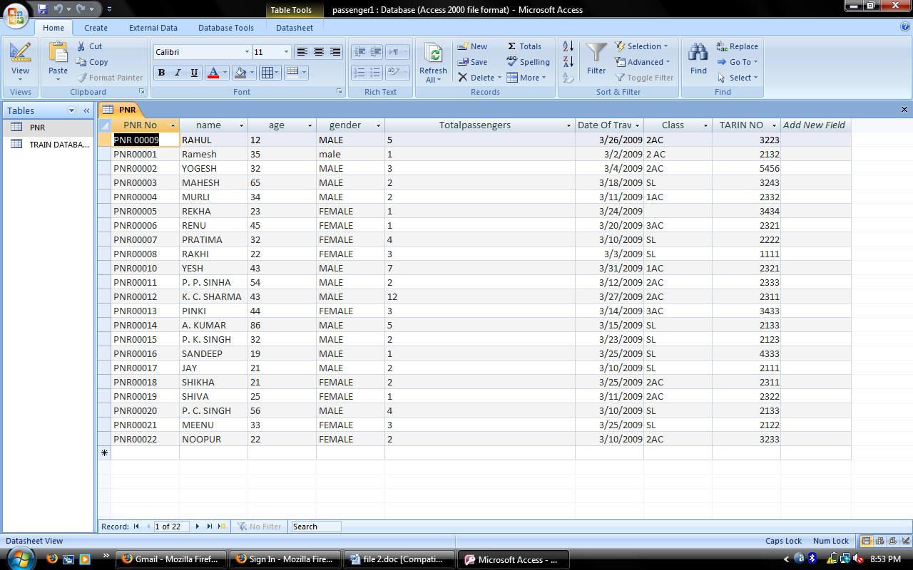

This is the original snapshot from M S Access. The primary key here is PNR NO. , this table also contains name of passenger, age, gender, total passenger travelling, date of travel, class and train no. in which they are travelling.

TABLE FOR TRAINS

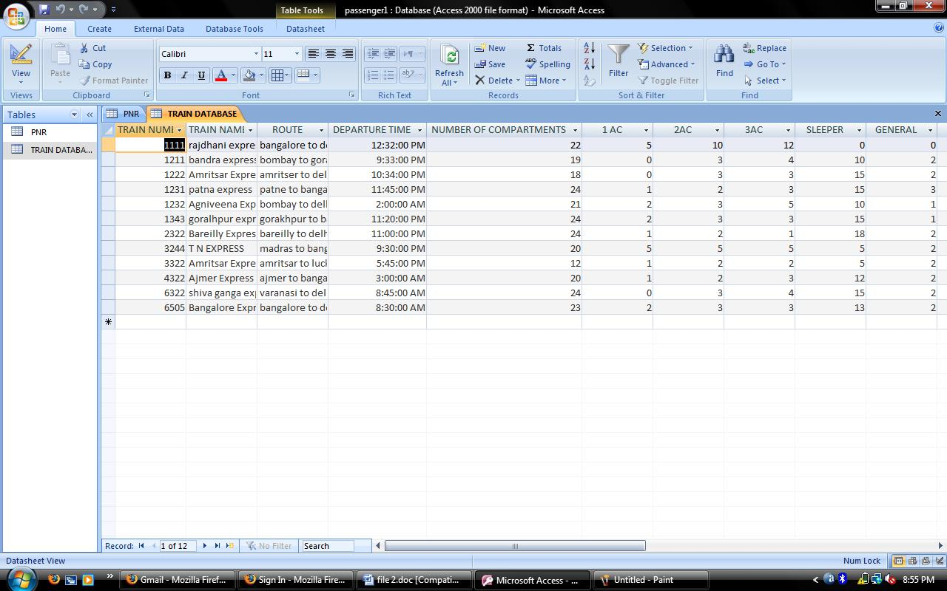

This is the original snapshot from M S Access. The primary key here is train no. , this table also contains train name, route, departure time from originating station, no. of compartments in whole train and class wise segmentation of compartments.

SNAPSHOTS OF FORMS

PASSENGER RESERVATION FORM

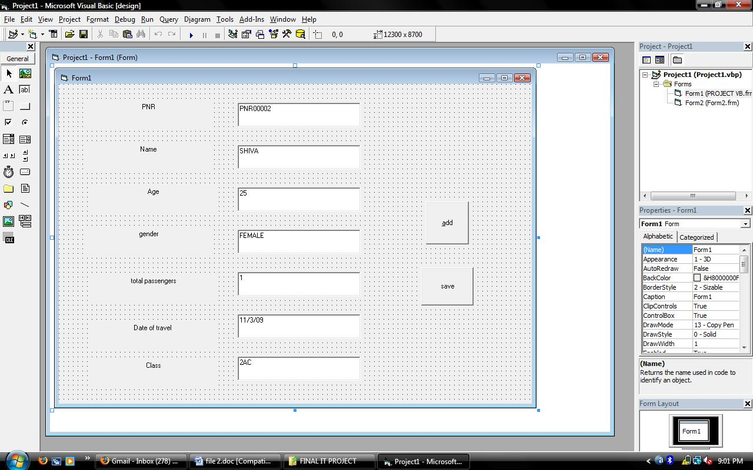

This form contain the same data labels whatever is there in M S ACCESS database i.e. name of passenger, age, gender, total passenger travelling, date of travel, class and train no. in which they are travelling

FORM FOR TRAINS

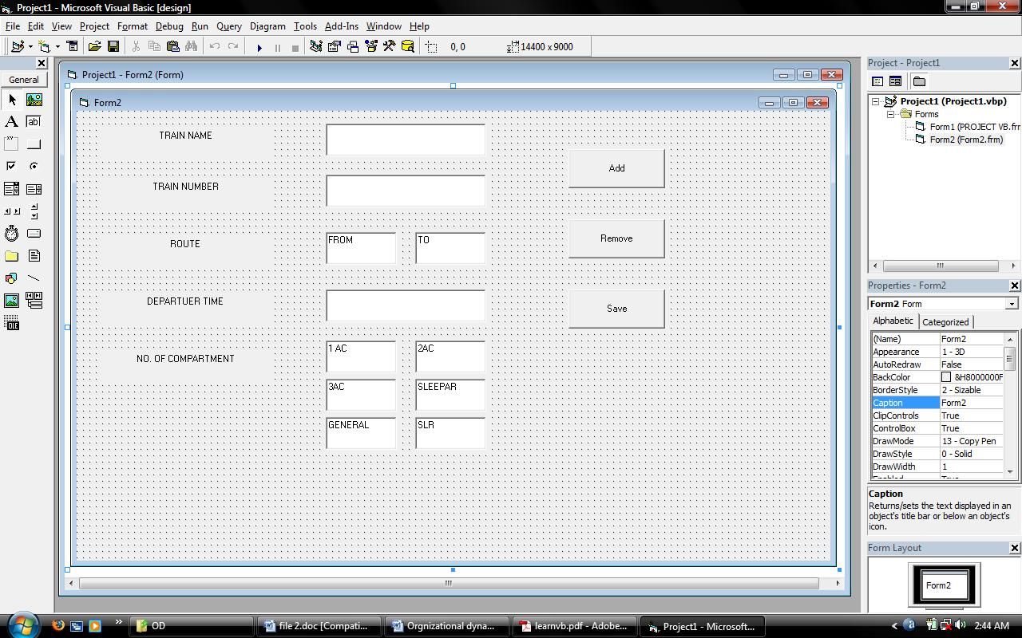

This form contains the same data labels whatever is there in M S ACCESS database. I.e. train name, route, and departure time from originating station, no. of compartments in whole train and class wise segmentation of compartments.

CONCLUSION

This project is about the designing the railway reservation database system using M S Access, and Visual Basic 6.0. This project presents an investigative view of present railway reservation system including the history of railways and detail of network topology of PRS. Present system of Indian railway reservation system is having some shortcoming on which we have tried to work on that to eliminate the disadvantages.
We have made a database for passengers and trains and connected these two tables from the custom made data entry form built in Visual Basic 6.0. There are options for new entry which will be stored in M S Access database and retrieved from database in future.
This project was a small attempt to make the railway reservation database system using M S Access, and Visual Basic 6.0. We have talked with some of railway officers about the features and shortcoming of present railway reservation system after the research with the associated people and other sources we were able to found out some of the major facts regarding the reservation system and tried to eliminate the shortcoming of system.
In the last we conclude that Indian Railway is having a strong IT Infrastructure and a well-equipped railway reservation system but there is some shortcoming in the system on which we have tried to work on it and successfully completed our project.

FUTURE

If anyone wants to extend this project then he or she can make an additional database of TRAINFARE. And database for updated availability of seats which is available after the cancellation of ticket on that specific train. Etc.
He or she can also add some more command buttons in the existing software and extend working of the existing software.

