Map and graph

6 june 2009

Map of cherry rows (red) and graph edges (purple)

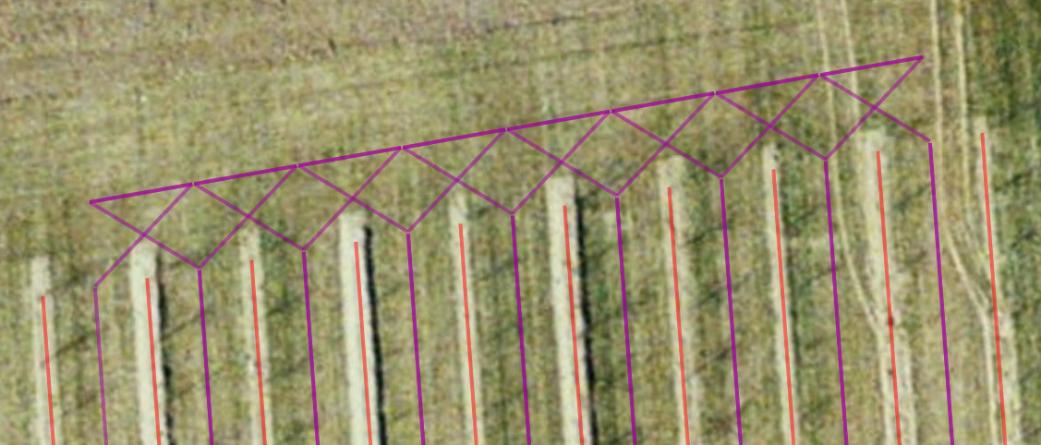Figure 1: Cherry - north end
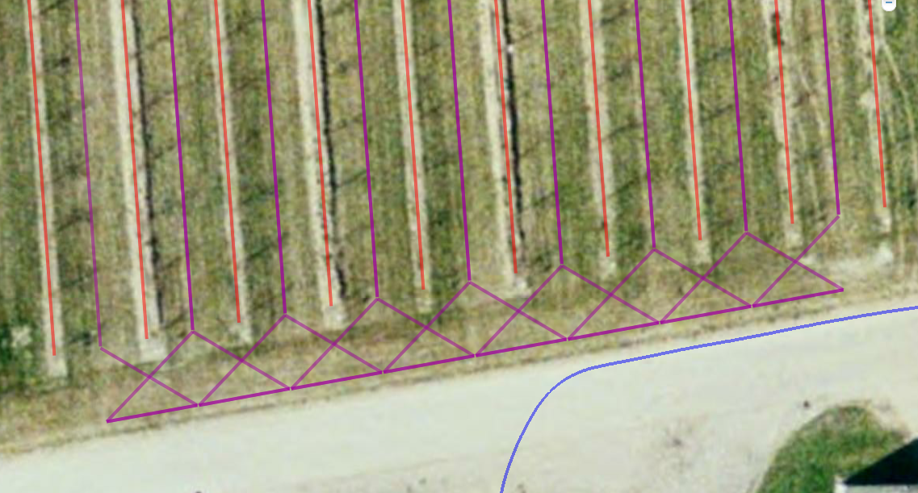Figure 2: Cherry - south end

