Guide: Creating Plugins for MARG

Contents

Creating a plugin to parse XML 1
Creating a plugin for a module 4
Starting from Templates 5

Creating a plugin to parse XML

1. Creating the Plugin
To create a plugin that can be used to parse received XML data, you must create a new class that implements XMLParsePlugin. It’s suggested to place the new class inside the package marg.model.plugin.

public class SomeDataPlugin implements XMLParsePlugin {
...
}

The interface XMLParsePlugin, which should be implemented, is defined as follows:

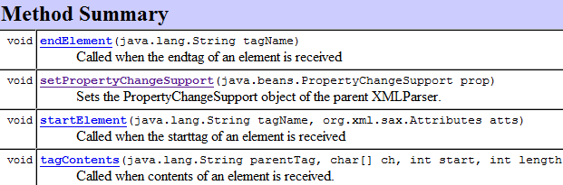

Further information about each method and how your plugin should implement it can be seen in the JavaDoc for XMLParsePlugin.

setPropertyChangeSupport is used to retrieve the central PropertyChangeSupport object. This object is used to subscribe to and perform callbacks to all subscribers when new data has been received. The received object should be stored in a local variable so that it can be used in other methods.
Further information about each method and what it does can be found in the JavaDoc of XMLParsePlugin.

2. Firing a callback event
To fire a callback from your plugin, use this example for guidance:
public class SomeDataPlugin implements XMLParsePlugin {

public final static String SUBSCRIBE_DATANAME = "uniqueString";
...
public void someMethod {
prop.firePropertyChange(SUBSCRIBE_DATANAME, oldValue, newValue);
}
}

The reason it’s a good idea to use a String that’s public, can be seen from the following example of a plugin subscribing to callbacks of this type of data:
handler.addPropertyChangeListener(this, SomeDataPlugin.SUBSCRIBE_DATANAME);

As you can see there is no need to use an exact String. It’s possible to just refer to the class’ public variable.
This makes it easier to change the String without having to correct it multiple places and there’s no need to worry about spelling it wrong. This is just a suggested way to do callbacks; it is not in any way mandatory.

3. Receiving callbacks
Any class that wishes to receive callbacks when firePropertyChange is called in an XMLParsePlugin needs to subscribe to the particular property and provide a PropertyChangeListener object to receive the callbacks.
Here are examples of how it is done for each module in the GUI:
public class ModuleTabs extends JPanel implements RobotModule, PropertyChangeListener {

...
handler.addPropertiesChangeListener(this, RawDataPlugin.SUBSCRIBE_RAWDATA, VarDataPlugin.SUBSCRIBE_VARDATA);
...

public void propertyChange(PropertyChangeEvent evt) {
if (evt.getPropertyName().equals(RawDataPlugin.SUBSCRIBE_RAWDATA)) {
newRawData(evt);
} else if (evt.getPropertyName().equals(VarDataPlugin.SUBSCRIBE_VARDATA)) {
newVarData(evt);
}
}

As seen in the code above the module has subscribed to events with itself as a listener. Therefore it has implemented the interface PropertyChangeListener, which defines the method propertyChange.
Since the module is receiving events from several plugins, it first separates the event according to which propertyName it has and then sends it on.

4. Adding your new XMLParsePlugin to the XMLParser
In order for your XMLParsePlugin to start receiving data, you must add it to the XMLParser of a client. This is done through its handler like this:
handler.getXMLParser().addParsePlugin(new SomeDataPlugin());

This will only register the plugin for this particular XMLParser. Each module in the system has its own XMLParser. To add a new parser for every single module that gets added, see the initXMLClient method in the ModuleTabs class.

Creating a plugin for a module

1. Creating the plugin
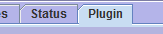
In order to create a plugin for a module you need to create a new class that implements the ModulePlugin interface. The new class must be created inside the package marg.gui.plugin in order to be automatically found when MARG is run.

public class ClassName implements ModulePlugin {
...
}

The interface ModulePlugin, which should be implemented, is defined as follows:
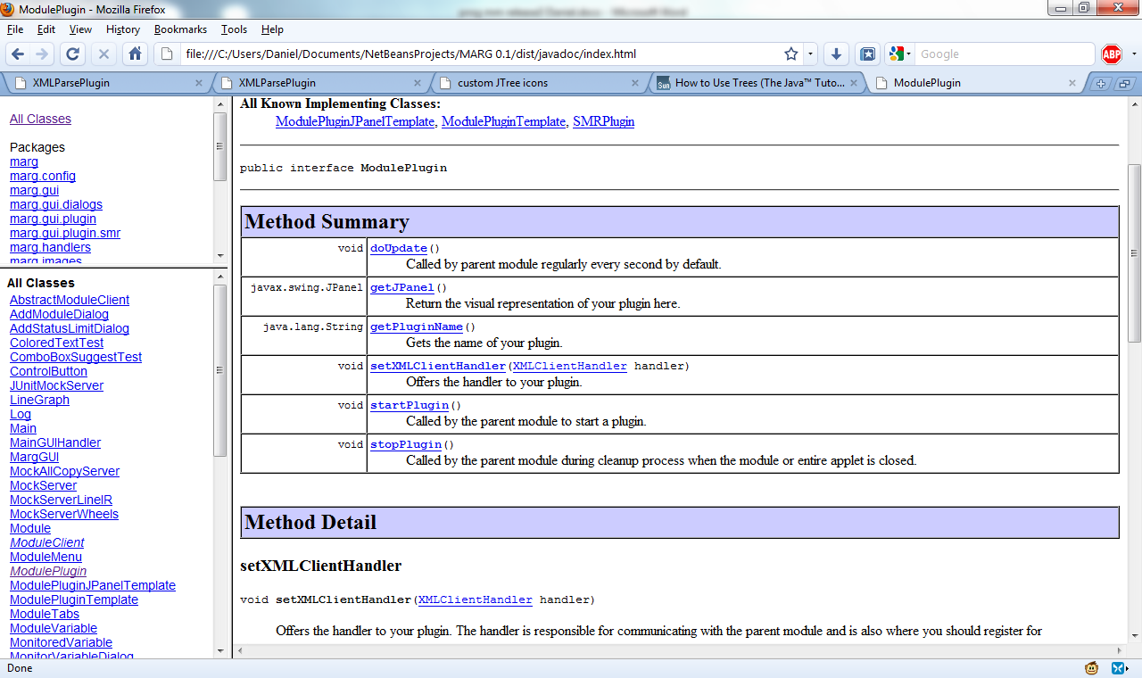

Further detailed information about each method and what it does can be found in the JavaDoc of ModulePlugin.

A module plugin can do pretty much anything you like once it has implemented the basic interface.
Most often you’ll want to subscribe to some data changes and make a visual representation of these on your JPanel. The JPanel can be a separate class or it can even be the ModulePlugin itself. Should it be needed by your plugin, it is possible to send commands through the sendCmd method of the handler.

2. Creating a JPanel that implements both plugin interfaces
With our design it is possible to gather all of the plugins and needed classes in a single Class like this:
public class MyPlugin extends JPanel implements ModulePlugin, XMLParsePlugin {

private XMLClientHandler handler;
private PropertyChangeSupport prop;

public void setXMLClientHandler(XMLClientHandler handler) {
this.handler = handler;
}
public void setPropertyChangeSupport(PropertyChangeSupport prop) {
this.prop = prop;
}

public JPanel getJPanel() {
return this;
}

public String getPluginName() {
return "MyPlugin";
}

public void startPlugin() {
//Registers itself as an XMLParsePlugin
handler.addParsePlugin(this);
}
(Left out rest of the implementation)
}

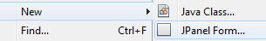
This way you can even create a plugin where you can design your JPanel with drag&drop, and implement the functionality behind it, in the very same class. In the popular Java IDE; Netbeans, you would do this by right-clicking in your project, choosing New and then “JPanel Form..”. Then you would just need to add the 2 interfaces as seen above.

Starting from Templates
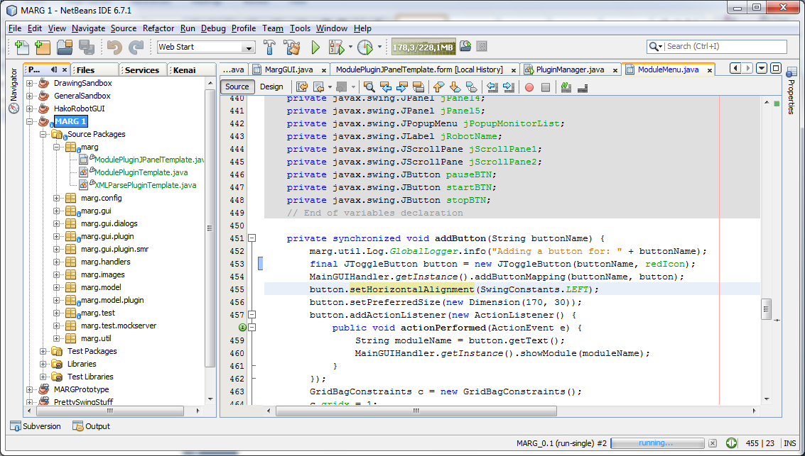
To make it easier to create new plugins we have created a few templates, which can be found inside the source of our project. When developing new plugins we highly recommend using Netbeans and opening our project folder.
All templates can be found in the base marg package.
When creating a plugin from a template, a copy of the template should be moved to its appropriate package and the template renamed to reflect the new plugin.

Templates to do with ModulePlugin should be copied to package:

Templates to do with XMLParsePlugin should be copied to package:

Templates are placed here so that the system doesn’t offer the templates as actual plugins in the GUI.

