SAVOIR PERSISTANCE DESIGN
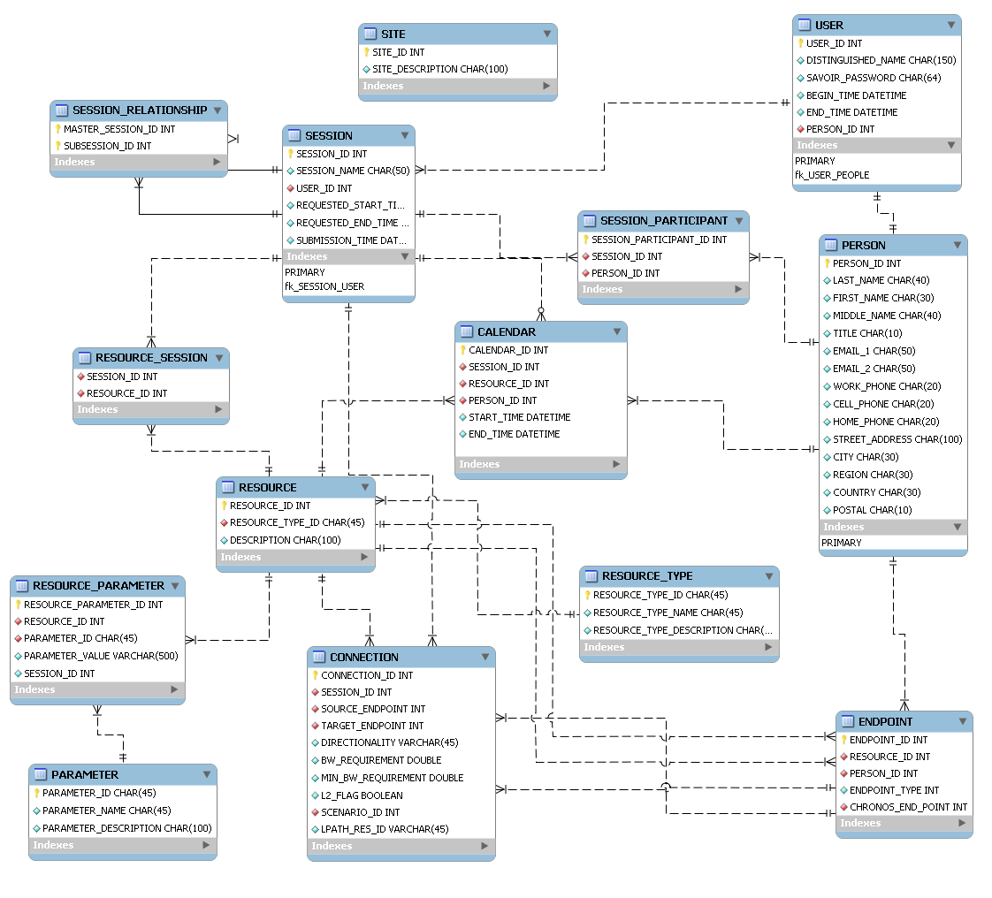
Figure 1 Database EER diagram
In the previous version of the middleware (Eucalyptus) the access to the database was directly made from the business code by executing SQL queries. Also the database had 26 tables and whenever a new resource is added, a new table has to be created. We decided in SAVOIR 2.0 to separate the data access layer from the business layer by creating a persistence layer that can be invoked through Data Access Objects (DAOs).
We also refactored the architecture of the database to make the schema simple but generic so we don’t lose the ability to model complex relationships. The new schema has 23 tables. The figure 1 doesn’t show the tables related to the credential and user managers.

USER:
An entry in this table represents a SAVOIR user. He is described by his credentials to SAVOIR (USER.DISTINGUISHED_NAME and USER.PASSWORD) and their validity period (USER.BEGIN_TIME and USER.END_TIME).
The user is part of the people involved in SAVOIR so the details about him will be stored in the PEOPLE table.

PEOPLE and SESSION_PARTICIPANT:
The people concept is new here and is introduced to differentiate between SAVOIR users and participants. A participant can be part of a collaboration session without being a SAVOIR user. We can think of skilled people that are invited occasionally to participate in a session created by a third party (a user). This involvement in sessions is stored in the table SESSION_PARTICIPANT.
SESSION and SESSION_RELATIONSHIP:
A SESSION in SAVOIR is defined recursively. A master session, requested by a user (SESSION.USER_ID), will have a set of children sessions. This relationship is encoded in the SESSION_RELATIONSHIP table.
RESOURCE, RESOURCE_SESSION, RESOURCE_TYPE, RESOURCE_PARAMETER and PARAMETER:
The modeling of the resource is very different from the one in Eucalyptus.
Mainly a resource has a resource type (RESOURCE.TYPE_ID) and a set of parameters stored in the RESOURCE_PARAMETER table. This is a generic definition that allows gathering the information about all the resources in the same tables.
A resource is part of a session if a record is added to the RESOURCE_SESSION table referencing the id of the resource and the session.
We distinguish between the different instances of a resource using the field RESOURCE_PARAMETER.SESSION_ID. If it is null then the value of the corresponding parameter is the default one.
The parameters are defined in a separate table PARAMETER so that we can have parameters with the same name but having different meanings depending on the resource they describe.

Table 1 Examples of parameters
RESOURCE_NAME | PARAMETER_NAME | PARAMETER_VALUE
PLEORA-FR | RECEIVER_IP | 198.164.42.251
 | TRANSMITTER_IP | 198.164.42.250
ULTRAGRID-OT | HOME_FOLDER | /home/crc/Ultragrid/uv-0.3.9.2/ultragrid/bin/
ISABEL-FR | BW_REQUIREMENT_MBPS | 300.0
PLEORA-OT | MAX_SIMULTANEOUS_CONN | 1
LP_APN | LP_APN_EPR | 04007040-fBB2-11dd-a618-ac1f33013682
LP_END_POINT | LP_END_POINT_SWITCH_ID | OTWA3OME1

As you can see in table 1 the network resources are also stored using these tables. The database stores the scenarios that can be set through the Scenarios-WS and the endpoints that can be connected through the Reservations-WS.
SITES:
One important parameter that a resource can have is the location. The location will be used to determine what endpoints to connect when a lightpath is needed.
To store these different possible sites the table SITES is defined. The value of the corresponding resource location parameter will hold the SITE_ID value.
CALENDAR:
The calendar table was introduced for scheduling purposes. This table can store temporal information on the SESSION, RESOURCE and PEOPLE entities by setting the value of exactly one of the three fields: CALENDAR.SESSION_ID, CALENDAR.RESOURCE_ID or CALENDAR.PEOPLE_ID.
It describes the start (CALENDAR.START_TIME) and end time (CALENDAR.END_TIME) of a session.
It also describes the unavailability of the resources and people. These entities can be unavailable because they are part of a scheduled session but also for reasons outside of the SAVOIR context. This possibly allows resources and people to export their agenda into SAVOIR making the scheduling of sessions more efficient.
CONNECTION and ENDPOINT: (proposal stage)
The connection table stores the connections that define a session: what resources will be used by what users and what network connectivity they require. The endpoint table contains the source and target of the connection. An endpoint can be a resource, a user or both at the same time. For example, when the connection is between a rendering cluster and database server then both endpoints are resources. endpoint.ENDPOINT_TYPE can be “HOST” or “CLIENT” and chronos_end_point corresponds to the resource_id of the layer 2 endpoint.
The directionality of a connection can be “ONE_WAY” or “TWO_WAY”. Scenario_id holds the resource_id of the assigned scenario when needed while lpath_res_id holds the ID of the chronos reservation (RESERVATION_ID:SERVICE_ID:CONNECTION_ID) when needed.
These two tables are used for the persistence of the details of the session defined in the session composer.

