# Tech Docs

Tech Docs 1

Main Framework 3

Beautify with QSS 3

Add QSqlite database 3

UI design and Table refreshments 3

Add Student Information 3

Main Functions: 3

ADD FUNCTION: 4

DELETE FUNCTION 5

-->Steps of building this app.

## Main Framework

## Beautify with QSS

## Add QSqlite database

## UI design and Table refreshments

## Add Student Information

### Main Functions:

* 1. Popup dialog for inputting student information
  2. Basic information form (text/date/drop-down)
  3. Photo upload and preview
  4. Data validation and database storage

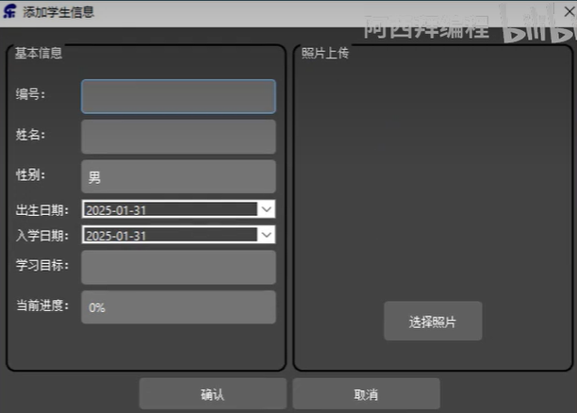

The Detail Steps:

#### ADD FUNCTION:

1. Click the “ADD STUDENT” Buton, and right click mouse to build slot function, when clicked it will trigger the function.
2. **Create a modal dialog using QDialog.** This will block its parent widget, it means you can’t use parent widget.

**Left part:** Group box is form group, we achieve it’s detail in “createFormGroup” function.

**Right part:** Group box is photo group, same as the left part, achieve it’s detail in “createPhotoGroup” function.

**So it need to declare and define the two function in header file, it need return QGroupBox pointer type.**



**Use connect function to handle “Confirm” and “Cancle” button.**

**Comfirmed:** achieve detail in “handleDialogAccepted” function. It uses the data in “FormGroup” and “PhotoGroup”.

**Canceled:** reject all.

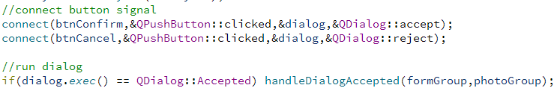

Declare in header file.

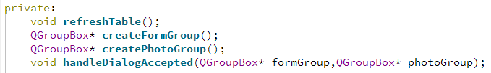

1. Write “createFormGroup” function. First, declare it in header file, it’s data type or return type is a pointer of Group Box. Define it in cpp file. Use Form Layout to add row with label and line edit.
2. Write “createPhotoGroup” function. First, declare it in header file, it’s data type or return type is a pointer of Group Box. Define it in cpp file. When save images, use label. And click button can open system file where user can select images. We use Pixmap class to smart zoom and then give to label to display. Use QBuffer to buffer the Byte data of picture, we will store it in data base.
3. Write “handleDialogAccepted” function. 1.get data from Form . 2.validates data, the id or name can’t be empty. 3.validate the uniqueness of id. 4.insert data. 5.blind parameters 6.check insert succeeded or not, it must satisfy database consistency. 7.refresh tables.

#### DELETE FUNCTION

##### Custom Delegation

1. Allow users to select values through a dropdown box and save the selected values to the model.
2. select a date through the calendar and save the selected value to the model.