1. Objective & Scope of the Project

Objective

The objective of this project is to create a Grocery Management System which can be used by customers to purchase items from the store and by the admin to view the data related to sales.

Scope

This project was constructed as a part of the 12th standard course.

It can be further modified to be used by a grocery store on a large scale as it provides functionality to purchase online and add home delivery and analyze sales later.

3. Life Cycle of the Project

System Development Life Cycle (SDLC)

The System Development Life Cycle (SDLC) is a set of activities that analysts, designers and users carry out to develop and implement an Information System.

The SDLC consists of the following activities.

Feasibility Study

↓

Requirement Definition (Analysis)

↓

Design (Database &amp; Program)

↓

Development of Software

↓

Unit Testing

↓

System Testing

↓

Implementation

↓

Evaluation

↓

Maintenance

CONTEXT DIAGRAM

4. Details of Hardware and Software used

Customer Mode

GROCERY MANAGEMENT SYSTEM

ADMIN MODE

MAKE PURCHASE

DATA VISUALISER

Hardware Specifications

Microprocessor (CPU) : Intel i5 7th Gen

Memory (RAM) : 8 GB DDR4 2400 MHz

Architecture : 64-bit

Hard Disk : 1 TB HDD + 256 GB SSD

VDU : HDMI

GPU : NVIDIA GTX 1650ti

Mouse : Mouse Esports

Printer : Brother

Software Specifications

Operating System : Windows 10

Front-End Design : Python 3.7.3

Back-End : CSV

Documentation : Microsoft Word 2013

5. PROJECT INTERFACE

CUSTOMER MODE:

Welcome Screen:

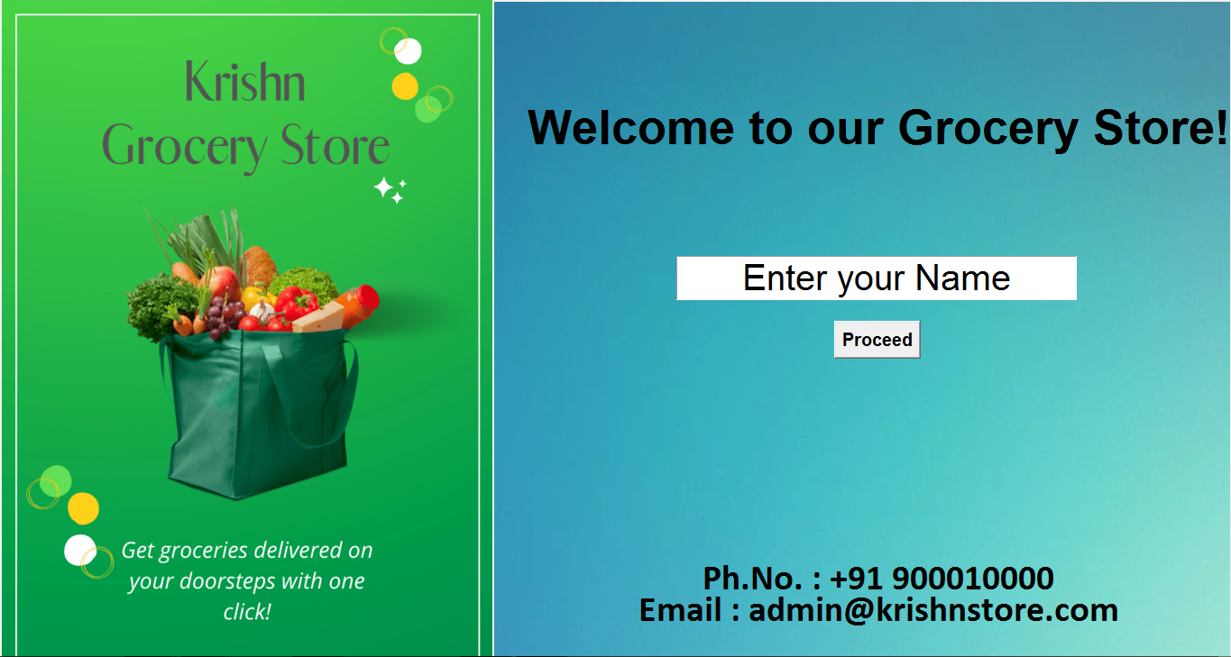

Here the customer has to enter his name

Order Screen

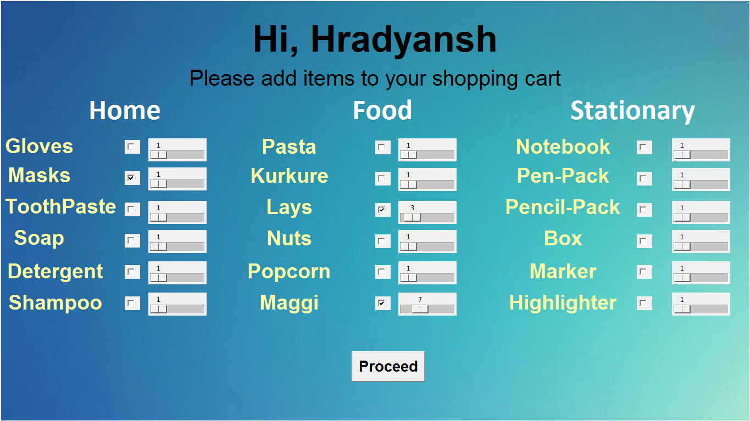

Here the customer will select the items and the amount which he wishes to purchase using a checkbox and dragbox

Billing Screen:

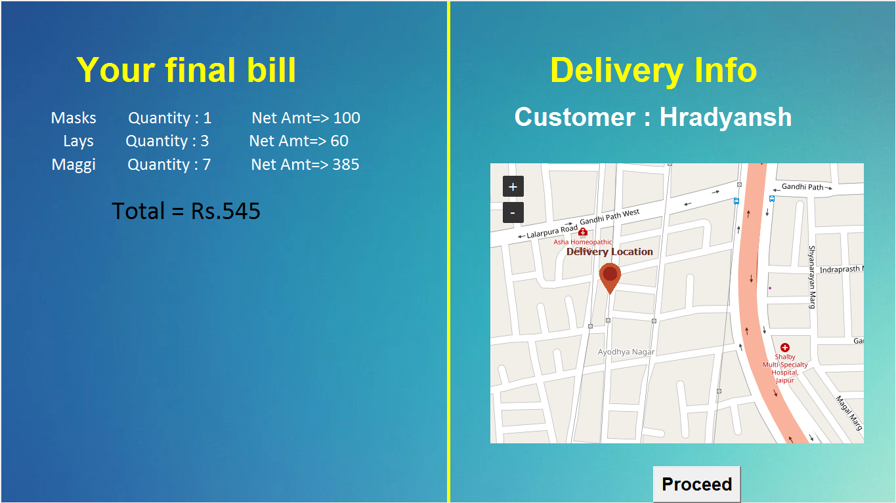

After the customer has selected his order, the screen will display the total bill and ask him to select his location on the map for Home Delivery.

End Screen:

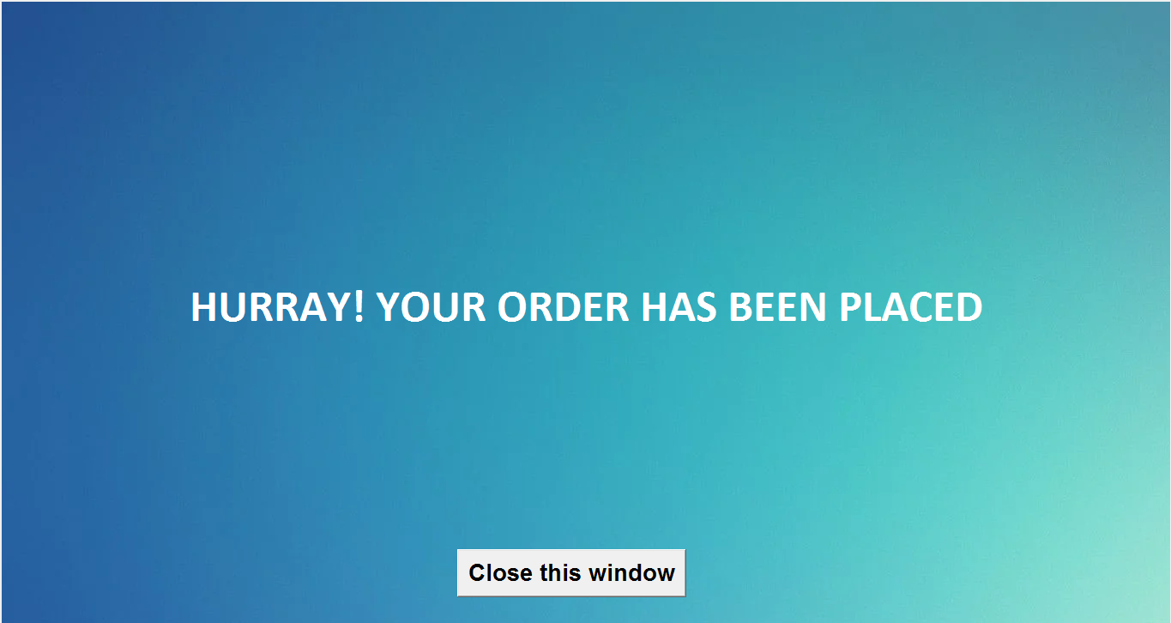

CSV

Data Added to CSV:

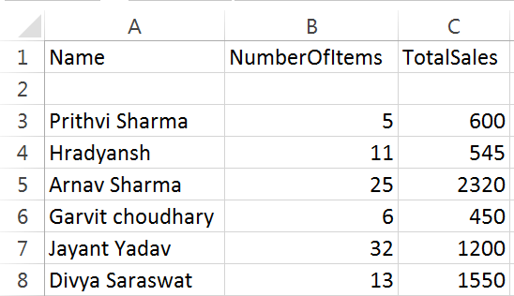

ADMIN MODE::

In admin mode you can visualize the past sales of the store through a line graph and a bar chart. The data for the sales is drawn from the sql file which stores the information regarding sales from the Customer Mode.

Start Screen :

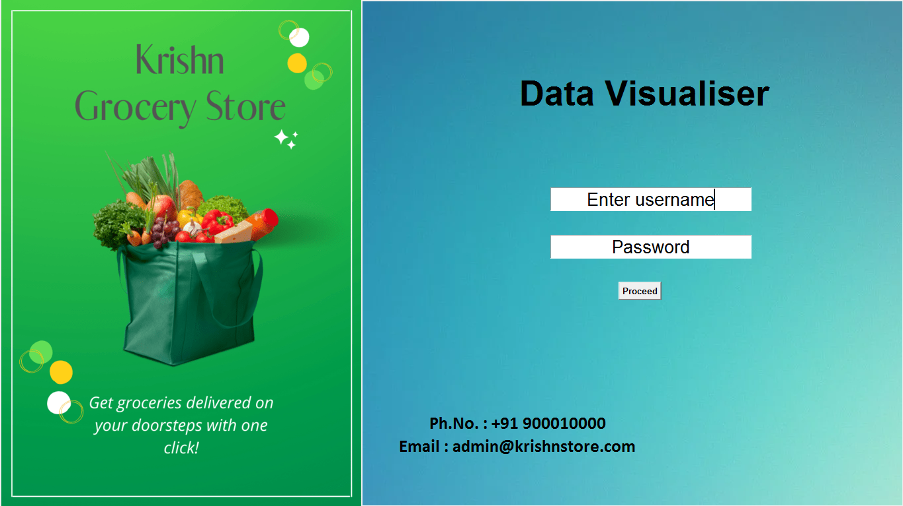

The initial screen asks you to enter your username and password to verify that you are the manager. On entering the correct values it proceeds to show the required graphs.

Error Message: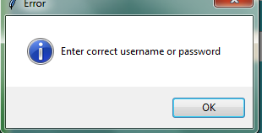

On entering wrong credentials the following popup is displayed.

Graph Screen :

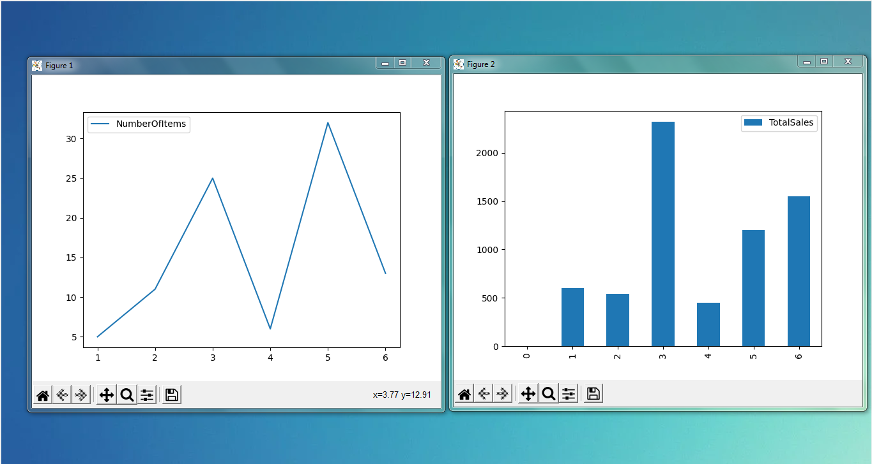

The program then displays a line chart and bar graph displaying the data of the various sales over time by drawing the information from the csv file.

The graphs were created and displayed using the Matplotlib python library

LIBRARIES USED :

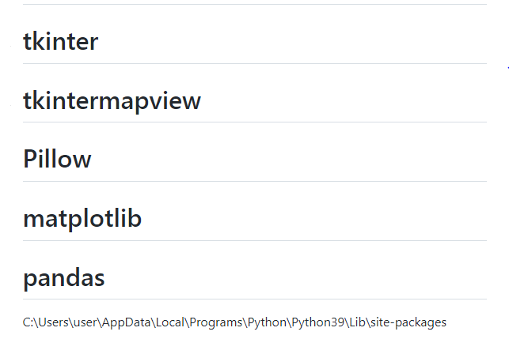

6. SOURCE CODE FOR THE PROJECT

Customer.py:

|  |
| --- |
| from tkinter import * |
| import tkinter as tk |
| from PIL import ImageTk,Image |
| import tkintermapview |
| import pandas as pd |
| from csv import writer |
| import os |
| root = Tk() |
| root.title= "Krishn E-Grocery" |
| root.geometry("1366x768") |
| img = ImageTk.PhotoImage(Image.open("./content/CXm5S7.png")) |
| imggc = ImageTk.PhotoImage(Image.open("./content/gc.png")) |
| my_Canvas = Canvas(root, width=1366, height = 768) |
| my_Canvas.pack(fill="both", expand=True) |
| my_Canvas.create_image(0, 0, image=img, anchor="nw") |
|  |
| item_list={ |
| "h1":["Gloves", 50, 0 , 0], |
| "h2":["Masks", 100, 0 , 0], |
| "h3":["toothpaste", 40, 0 , 0], |
| "h4":["Soap", 50, 0 , 0], |
| "h5":["Detergent", 200, 0 , 0], |
| "h6":["Shampoo", 120, 0 , 0], |
| "f1":["Pasta", 80, 0 , 0], |
| "f2":["Kurkure", 20, 0 , 0], |
| "f3":["Lays", 20, 0 , 0], |
| "f4":["Nuts", 50, 0 , 0], |
| "f5":["Popcorn", 30, 0 , 0], |
| "f6":["Maggi", 55, 0 , 0], |
| "s1":["Notebook", 90, 0 , 0], |
| "s2":["Pen-Packet", 100, 0 , 0], |
| "s3":["Pencil-Packet", 30, 0 , 0], |
| "s4":["box", 30, 0 , 0], |
| "s5":["Marker", 25, 0 , 0], |
| "s6":["Highlighter", 20, 0 , 0], |
|  |
| } |
|  |
|  |
| def switch1(): |
|  |
| global img |
| global e |
| global varch1 |
| global varch2 |
| global varch3 |
| global varch4 |
| global varch5 |
| global varch6 |
| global varcf1 |
| global varcf2 |
| global varcf3 |
| global varcf4 |
| global varcf5 |
| global varcf6 |
| global varcs1 |
| global varcs2 |
| global varcs3 |
| global varcs4 |
| global varcs5 |
| global varcs6 |
| global varsch1 |
| global varsch2 |
| global varsch3 |
| global varsch4 |
| global varsch5 |
| global varsch6 |
| global varscf1 |
| global varscf2 |
| global varscf3 |
| global varscf4 |
| global varscf5 |
| global varscf6 |
| global varscs1 |
| global varscs2 |
| global varscs3 |
| global varscs4 |
| global varscs5 |
| global varscs6 |
|  |
| global name |
| name = e.get() |
| my_Canvas.delete('all') |
| my_Canvas.create_image(0, 0, image=img, anchor="nw") |
| my_Canvas.create_text(682, 71, text="Hi, "+ name, font="Arial 50 bold" ) |
| my_Canvas.create_text(682, 142, text="Please add items to your shopping cart", font="Arial 30" ) |
| my_Canvas.create_text(227, 199, text="Home", font=" Calibri 40 bold", fill="white" ) |
| my_Canvas.create_text(696, 199, text="Food", font=" Calibri 40 bold", fill="white" ) |
| my_Canvas.create_text(1151, 199, text="Stationary", font=" Calibri 40 bold", fill="white" ) |
|  |
| my_Canvas.create_text(71, 266, text="Gloves", font="Arial 28 bold", fill="#fcffa4") |
| varch1 = IntVar() |
|  |
| c = Checkbutton(root, text="", variable=varch1) |
| c_window = my_Canvas.create_window(227, 255, anchor="nw", window=c) |
| varsch1 = IntVar() |
| sc = Scale( root, variable = varsch1, from_ = 1, to = 20, orient = HORIZONTAL) |
| sc_window = my_Canvas.create_window(270, 252, anchor="nw", window=sc) |
|  |
| my_Canvas.create_text(71, 319, text="Masks", font="Arial 28 bold", fill="#fcffa4") |
| varch2 = IntVar() |
| c = Checkbutton(root, text="", variable=varch2) |
| c_window = my_Canvas.create_window(227, 312, anchor="nw", window=c) |
| varsch2 = IntVar() |
| sc = Scale( root, variable = varsch2, from_ = 1, to = 20, orient = HORIZONTAL) |
| sc_window = my_Canvas.create_window(270, 305, anchor="nw", window=sc) |
|  |
| my_Canvas.create_text(110, 376, text="ToothPaste", font="Arial 28 bold", fill="#fcffa4") |
| varch3 = IntVar() |
| c = Checkbutton(root, text="", variable=varch3) |
| c_window = my_Canvas.create_window(227, 369, anchor="nw", window=c) |
| varsch3 = IntVar() |
| sc = Scale( root, variable = varsch3, from_ = 1, to = 20, orient = HORIZONTAL) |
| sc_window = my_Canvas.create_window(270, 366, anchor="nw", window=sc) |
|  |
| my_Canvas.create_text(71, 433, text="Soap", font="Arial 28 bold", fill="#fcffa4") |
| varch4 = IntVar() |
| c = Checkbutton(root, text="", variable=varch4) |
| c_window = my_Canvas.create_window(227, 426, anchor="nw", window=c) |
| varsch4 = IntVar() |
| sc = Scale( root, variable = varsch4, from_ = 1, to = 20, orient = HORIZONTAL) |
| sc_window = my_Canvas.create_window(270, 419, anchor="nw", window=sc) |
|  |
| my_Canvas.create_text(100, 494, text="Detergent", font="Arial 28 bold", fill="#fcffa4") |
| varch5 = IntVar() |
| c = Checkbutton(root, text="", variable=varch5) |
| c_window = my_Canvas.create_window( 227,483, anchor="nw", window=c) |
| varsch5 = IntVar() |
| sc = Scale( root, variable = varsch5, from_ = 1, to = 20, orient = HORIZONTAL) |
| sc_window = my_Canvas.create_window(270, 476, anchor="nw", window=sc) |
|  |
| my_Canvas.create_text(100, 551, text="Shampoo", font="Arial 28 bold", fill="#fcffa4") |
| varch6 = IntVar() |
| c = Checkbutton(root, text="", variable=varch6) |
| c_window = my_Canvas.create_window(227,540, anchor="nw", window=c) |
| varsch6 = IntVar() |
| sc = Scale( root, variable = varsch6, from_ = 1, to = 20, orient = HORIZONTAL) |
| sc_window = my_Canvas.create_window(270,533, anchor="nw", window=sc) |
|  |
|  |
|  |
|  |
| #Food |
|  |
|  |
|  |
|  |
|  |
| my_Canvas.create_text(526, 266.6, text="Pasta", font="Arial 28 bold", fill="#fcffa4") |
| varcf1=IntVar() |
| c = Checkbutton(root, text="", variable=varcf1) |
| c_window = my_Canvas.create_window(682.5, 256, anchor="nw", window=c) |
| varscf1 = IntVar() |
| sc = Scale( root, variable = varscf1, from_ = 1, to = 20, orient = HORIZONTAL) |
| sc_window = my_Canvas.create_window(725.25, 252.4, anchor="nw", window=sc) |
|  |
| my_Canvas.create_text(526, 320, text="Kurkure", font="Arial 28 bold", fill="#fcffa4") |
| varcf2 = IntVar() |
| c = Checkbutton(root, text="", variable=varcf2) |
| c_window = my_Canvas.create_window(682.5, 312.85, anchor="nw", window=c) |
| varscf2 = IntVar() |
| sc = Scale( root, variable = varscf2, from_ = 1, to = 20, orient = HORIZONTAL) |
| sc_window = my_Canvas.create_window(725.22, 305.75, anchor="nw", window=sc) |
|  |
| my_Canvas.create_text(526.14, 376.83, text="Lays", font="Arial 28 bold", fill="#fcffa4") |
| varcf3 = IntVar() |
| c = Checkbutton(root, text="", variable=varcf3) |
| c_window = my_Canvas.create_window(682.56, 369.72, anchor="nw", window=c) |
| varscf3 = IntVar() |
| sc = Scale( root, variable = varscf3, from_ = 1, to = 20, orient = HORIZONTAL) |
| sc_window = my_Canvas.create_window(725.22, 366.165, anchor="nw", window=sc) |
|  |
| my_Canvas.create_text(526.14, 433.71, text="Nuts", font="Arial 28 bold", fill="#fcffa4") |
| varcf4 = IntVar() |
| c = Checkbutton(root, text="", variable=varcf4) |
| c_window = my_Canvas.create_window(682.56, 426.6, anchor="nw", window=c) |
| varscf4 = IntVar() |
| sc = Scale( root, variable = varscf4, from_ = 1, to = 20, orient = HORIZONTAL) |
| sc_window = my_Canvas.create_window(725.22, 419.49, anchor="nw", window=sc) |
|  |
| my_Canvas.create_text(526.14, 494.145, text="Popcorn", font="Arial 28 bold", fill="#fcffa4") |
| varcf5 = IntVar() |
| c = Checkbutton(root, text="", variable=varcf5) |
| c_window = my_Canvas.create_window(682.56, 483.48, anchor="nw", window=c) |
| varscf5 = IntVar() |
| sc = Scale( root, variable = varscf5, from_ = 1, to = 20, orient = HORIZONTAL) |
| sc_window = my_Canvas.create_window(725.22, 476.37, anchor="nw", window=sc) |
|  |
| my_Canvas.create_text(526.14, 551, text="Maggi", font="Arial 28 bold", fill="#fcffa4") |
| varcf6 = IntVar() |
| c = Checkbutton(root, text="", variable=varcf6) |
| c_window = my_Canvas.create_window(682.56, 540.36, anchor="nw", window=c) |
| varscf6 = IntVar() |
| sc = Scale( root, variable = varscf6, from_ = 1, to = 20, orient = HORIZONTAL) |
| sc_window = my_Canvas.create_window(725.22, 533.25, anchor="nw", window=sc) |
|  |
|  |
|  |
|  |
|  |
|  |
|  |
|  |
| #Stationary |
|  |
| my_Canvas.create_text(1024, 267, text="Notebook", font="Arial 28 bold", fill="#fcffa4") |
| varcs1 = IntVar() |
| c = Checkbutton(root, text="", variable=varcs1) |
| c_window = my_Canvas.create_window(1159, 256, anchor="nw", window=c) |
| varscs1 = IntVar() |
| sc = Scale( root, variable = varscs1, from_ = 1, to = 20, orient = HORIZONTAL) |
| sc_window = my_Canvas.create_window(1223, 252, anchor="nw", window=sc) |
|  |
| my_Canvas.create_text(1024, 320, text="Pen-Pack", font="Arial 28 bold", fill="#fcffa4") |
| varcs2 = IntVar() |
| c = Checkbutton(root, text="", variable=varcs2) |
| c_window = my_Canvas.create_window(1159, 313, anchor="nw", window=c) |
| varscs2 = IntVar() |
| sc = Scale( root, variable = varscs2, from_ = 1, to = 20, orient = HORIZONTAL) |
| sc_window = my_Canvas.create_window(1223, 306, anchor="nw", window=sc) |
|  |
| my_Canvas.create_text(1024, 377, text="Pencil-Pack", font="Arial 28 bold", fill="#fcffa4") |
| varcs3 = IntVar() |
| c = Checkbutton(root, text="", variable=varcs3) |
| c_window = my_Canvas.create_window(1159, 370,anchor="nw", window=c) |
| varscs3 = IntVar() |
| sc = Scale( root, variable = varscs3, from_ = 1, to = 20, orient = HORIZONTAL) |
| sc_window = my_Canvas.create_window(1223, 366, anchor="nw", window=sc) |
|  |
| my_Canvas.create_text(1024, 434, text="Box", font="Arial 28 bold", fill="#fcffa4") |
| varcs4 = IntVar() |
| c = Checkbutton(root, text="", variable=varcs4) |
| c_window = my_Canvas.create_window(1159, 427, anchor="nw", window=c) |
| varscs4 = IntVar() |
| sc = Scale( root, variable = varscs4, from_ = 1, to = 20, orient = HORIZONTAL) |
| sc_window = my_Canvas.create_window(1223, 419, anchor="nw", window=sc) |
|  |
| my_Canvas.create_text(1024, 494, text="Marker", font="Arial 28 bold", fill="#fcffa4") |
| varcs5 = IntVar() |
| c = Checkbutton(root, text="", variable=varcs5) |
| c_window = my_Canvas.create_window(1159, 483, anchor="nw", window=c) |
| varscs5 = IntVar() |
| sc = Scale( root, variable = varscs5, from_ = 1, to = 20, orient = HORIZONTAL) |
| sc_window = my_Canvas.create_window(1223, 476, anchor="nw", window=sc) |
|  |
| my_Canvas.create_text(1024, 551, text="Highlighter", font="Arial 28 bold", fill="#fcffa4") |
| varcs6 = IntVar() |
| c = Checkbutton(root, text="", variable=varcs6) |
| c_window = my_Canvas.create_window(1159, 540, anchor="nw", window=c) |
| varscs6 = IntVar() |
| sc = Scale( root, variable = varscs6, from_ = 1, to = 20, orient = HORIZONTAL) |
| sc_window = my_Canvas.create_window(1223, 533, anchor="nw", window=sc) |
|  |
|  |
|  |
|  |
| pr2 = Button(root, text="Proceed", font="Arial 20 bold", command=p2) |
| pr2_window = my_Canvas.create_window(640,640, anchor="nw", window = pr2) |
|  |
|  |
| def switch3(): |
|  |
| ln1=[] |
| for i in range(0,3): |
| if(i == 0): |
| ln1.append(name) |
| if(i==1): |
| ln1.append(count) |
| if(i==2): |
| ln1.append(sum) |
|  |
| print(ln1) |
| with open('./storage/data.csv', 'a', newline='') as f_object: |
| writer_object = writer(f_object) |
| writer_object.writerow(ln1) |
| f_object.close() |
| my_Canvas.delete('all') |
| my_Canvas.create_image(0, 0, image=img, anchor="nw") |
| my_Canvas.create_text(683,355.5, text="HURRAY! YOUR ORDER HAS BEEN PLACED", font="Calibri 40 bold", fill="white") |
| pr33 = Button(root, text="Close this window", font="Arial 20 bold", command=root.destroy) |
| pr33_window = my_Canvas.create_window(533.25,640, anchor="nw", window = pr33) |
|  |
|  |
|  |
| def p2(): |
| item_list["h1"][2]=varch1.get() |
| item_list["h1"][3]=varsch1.get() |
| item_list["h2"][2]=varch2.get() |
| item_list["h2"][3]=varsch2.get() |
| item_list["h3"][2]=varch3.get() |
| item_list["h3"][3]=varsch3.get() |
| item_list["h4"][2]=varch4.get() |
| item_list["h4"][3]=varsch4.get() |
| item_list["h5"][2]=varch5.get() |
| item_list["h5"][3]=varsch5.get() |
| item_list["h6"][2]=varch6.get() |
| item_list["h6"][3]=varsch6.get() |
|  |
|  |
| item_list["f1"][2]=varcf1.get() |
| item_list["f1"][3]=varscf1.get() |
| item_list["f2"][2]=varcf2.get() |
| item_list["f2"][3]=varscf2.get() |
| item_list["f3"][2]=varcf3.get() |
| item_list["f3"][3]=varscf3.get() |
| item_list["f4"][2]=varcf4.get() |
| item_list["f4"][3]=varscf4.get() |
| item_list["f5"][2]=varcf5.get() |
| item_list["f5"][3]=varscf5.get() |
| item_list["f6"][2]=varcf6.get() |
| item_list["f6"][3]=varscf6.get() |
|  |
|  |
| item_list["s1"][2]=varcs1.get() |
| item_list["s1"][3]=varscs1.get() |
| item_list["s2"][2]=varcs2.get() |
| item_list["s2"][3]=varscs2.get() |
| item_list["s3"][2]=varcs3.get() |
| item_list["s3"][3]=varscs3.get() |
| item_list["s4"][2]=varcs4.get() |
| item_list["s4"][3]=varscs4.get() |
| item_list["s5"][2]=varcs5.get() |
| item_list["s5"][3]=varscs5.get() |
| item_list["s6"][2]=varcs6.get() |
| item_list["s6"][3]=varscs6.get() |
| my_Canvas.delete('all') |
| my_Canvas.create_image(0, 0, image=img, anchor="nw") |
| my_Canvas.create_line(683,0,683,768, fill="yellow", width=5) |
| bnm = Button(root, text="Proceed", font="Arial 20 bold", command=switch3) |
| bnm_window = my_Canvas.create_window(995, 711, anchor="nw" , window = bnm ) |
|  |
| bill() |
| script_directory = os.path.dirname(os.path.abspath(__file__)) |
| database_path = os.path.join(script_directory, "offline_tiles_nyc.db") |
| my_Canvas.create_text(995, 107, text="Delivery Info", font="Arial 40 bold", fill="yellow") |
| my_Canvas.create_text(995, 178, text ="Customer : "+ name, font="Arial 30 bold", fill="white") |
| global map_widget |
| map_widget = tkintermapview.TkinterMapView(root, width=569, height=427, corner_radius=0) |
| map_widget.set_position(26.899377700349195, 75.73601841291928) |
| map_widget.set_zoom(18) |
| mw_window = my_Canvas.create_window(1031,462, anchor=tk.CENTER, window = map_widget) |
| map_widget.add_right_click_menu_command(label="Add Marker", |
| command=add_marker_event, |
| pass_coords=True) |
|  |
|  |
|  |
|  |
| def add_marker_event(coords): |
| global new_marker |
| print("Add marker:", coords) |
| global cdds |
| cdds=coords |
| new_marker = map_widget.set_marker(coords[0], coords[1], text="Delivery Location") |
|  |
| def bill(): |
| global sum |
| global count |
| count = 0 |
| sum = 0 |
| my_Canvas.create_text(284, 107, text="Your final bill", font="Arial 40 bold", fill="yellow") |
| j = 0 |
| for i in item_list.values(): |
| if(i[2]==1): |
| count = count + i[3] |
| j= j + 35.55 |
| sum = sum + i[1]*i[3] |
| my_Canvas.create_text(312.84, 142.2+j, text=str(i[0])+" Quantity : "+str(i[3]) + " Net Amt=> " + str(i[1]*i[3]), font="Calibri 20", fill="white") |
| my_Canvas.create_text(284.4, 142.2 + j+71, text="Total = Rs." + str(sum), font="Calibri 30") |
|  |
| my_Canvas.create_text(974, 142, text="Welcome to our Grocery Store!", font="Arial 40 bold" ) |
| e = Entry(root, justify=CENTER, font="Arial 30") |
| e.insert(0, "Enter your Name") |
| e_window = my_Canvas.create_window(750, 284, anchor="nw", window=e) |
| b1 = Button(root, text="Proceed" ,font="Arial 15 bold", command = switch1) |
| l1 = Label(root, image=imggc) |
| l1_window = my_Canvas.create_window(0, 384, anchor="w", window=l1) |
| b1_window = my_Canvas.create_window(925, 355.5, anchor="nw", window=b1) |
| my_Canvas.create_text(974, 640, text="Ph.No. : +91 900010000", font="Calibri 30 bold") |
| my_Canvas.create_text(974, 675, text="Email : admin@krishnstore.com", font="Calibri 30 bold") |
| root.attributes('-fullscreen', True) |
|  |
|  |
|  |
|  |
| mainloop()  Data_visualiser.py:  from tkinter import *  import tkinter as tk  from PIL import ImageTk,Image  from matplotlib.pyplot import bar  from pyparsing import line  import tkintermapview  import pandas as pd  import matplotlib.pyplot as plt  from csv import writer    root1 = Tk()  root1.title= "Krishn E-Grocery"  root1.geometry("1366x768")  img = ImageTk.PhotoImage(Image.open("./content/CXm5S7.png"))  imggc = ImageTk.PhotoImage(Image.open("./content/gc.png"))  my_Canvas = Canvas(root1, width=1366, height = 768)  my_Canvas.pack(fill="both", expand=True)  my_Canvas.create_image(0, 0, image=img, anchor="nw")  df1 = pd.read_csv("./storage/data.csv", sep=",")[["Name","NumberOfItems"]]  df2 = pd.read_csv("./storage/data.csv", sep=",")[["Name","TotalSales"]]  def plot():  global e  global e1  un = "jphs123"  ps = "54321"  if(un == e.get() and ps == e1.get()):  my_Canvas.delete('all')  my_Canvas.create_image(0, 0, image=img, anchor="nw")  df1.plot(kind="line")  df2.plot(kind="bar")  plt.show()  else:  tk.messagebox.showinfo("Error", "Enter correct username or password")  mainn()    def mainn():  global e  global e1  my_Canvas.create_text(974, 142.2, text="Data Visualiser", font="Arial 40 bold" )  e = Entry(root1, justify=CENTER, font="Arial 20")  e.insert(0, "Enter username")  e_window = my_Canvas.create_window(831.87, 284.4, anchor="nw", window=e)  e1 = Entry(root1, justify=CENTER, font="Arial 20")  e1.insert(0, "password")  e1_window = my_Canvas.create_window(831.87, 355.5, anchor="nw", window=e1)  b1 = Button(root1, text="Proceed" ,font="Arial 10 bold", command = plot)  l1 = Label(root1, image=imggc)  l1_window = my_Canvas.create_window(0, 384, anchor="w", window=l1)  b1_window = my_Canvas.create_window(935,426.6, anchor="nw", window=b1)  my_Canvas.create_text(782.1, 639.9, text="Ph.No. : +91 900010000", font="Calibri 20 bold")  my_Canvas.create_text(782.1, 675.45, text="Email : admin@krishnstore.com", font="Calibri 20 bold")  root1.attributes('-fullscreen', True)  mainn()  mainloop() |