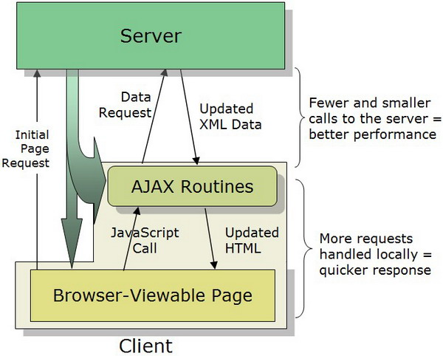

Wahts is Ajax?

- Asynchronus Javascript & XML
- Set of web technologies
- Send & recive data asynchronusly
- Does not interfere whit current web page
- JSON has repliced XML for the mosht part

Libraries & Other Methods
- jQuery
- Axios
- Superagent
- Fetch API
- Prototype
- Node HTTP

1. XMLHttpRequest (XHR) Object
- API in the form of an Object
- Providers by the browser’s JS envenronment
- Method transfer data between client/server
- Can be used whit other protoclus than HTTP
- Can work whit data other than XML (JSON, plain text)

HTTP Statuses
200: “OK”
403: “Forbidden”
404: “Not Found”

req.onload() = di jalankan apabila proses load telah berhasil
stateValue = 4

const req = XMLHttpRequest()

req.open(‘GET’, ‘url’, true);

--- 1 ---
req.onload = function() {
if(req.status == 200) {
console.log(this.responseText);
}
}

req.send();

readyState Values
0: request not initialized
1: server connection established
2: request received
3: processing request
4: request finished and response is ready

req.onreadystatecange() = agar dapat memantau proses readySate
stateValue = 1,2,3,4

--- 2 ---
req.onreadystatechange = function() {
if(this.readyState == 4 && this.status == 200) {

}
}

req.send();

Membuat visual proses Loading – Optional

res.onprogress = di jalankan saat masih proses stateValue = 3

2. mengunakan fatch()
fatch() merupakan function bawaan javascript yg mengunakan konsep promise. Ada 3 tahap dari fatching = pending, fulfilled, rejected.

** btw function fatch() juga mengunakan XMLHttpRequest

