INTI HR User Manual

INTI HR User Manual

2021

Table of Contents

1.0 Login & Reset Password 1

1.1 Login Page 1

1.2 Forget Password 2

2.0 Navigation SideBar & Notification 3

2.1 Normal Staff User 3

2.2 Supervisor User 4

2.3 Admin User 5

2.4 Notification 6

3.0 Dashboard 7

3.1 Dashboard > Personal 7

3.2 Dashboard > Department 8

3.3 Dashboard > Admin 9

4.0 Calendar 10

4.1 Calendar 10

5.0 Leave Module 11

5.1 Leaves Dashboard 11

5.2 Apply Leave Page 12

5.3 Leave History 13

5.4 Leave Requests 14

6.0 Training Module 15

6.1 Training Dashboard 15

6.2 Create Internal Training 16

6.3 Internal Training List 17

6.4 Training History 18

6.5 External Training Request 19

6.6 Pending External Request 20

6.7 Pending Training Completion 21

6.8 Track Training Progress 22

7.0 Setting Module 23

7.1 Setting > Holiday 23

7.2 Settings > Department 24

8.0 Employee Module 25

8.1 Employee 25

9.0 Setup Process 26

9.1 Create Department 26

9.2 Create Leave Type 27

9.3 Create Policy 28

9.4 Create New User Account 29

## 1.0 Login & Reset Password

### 1.1 Login Page

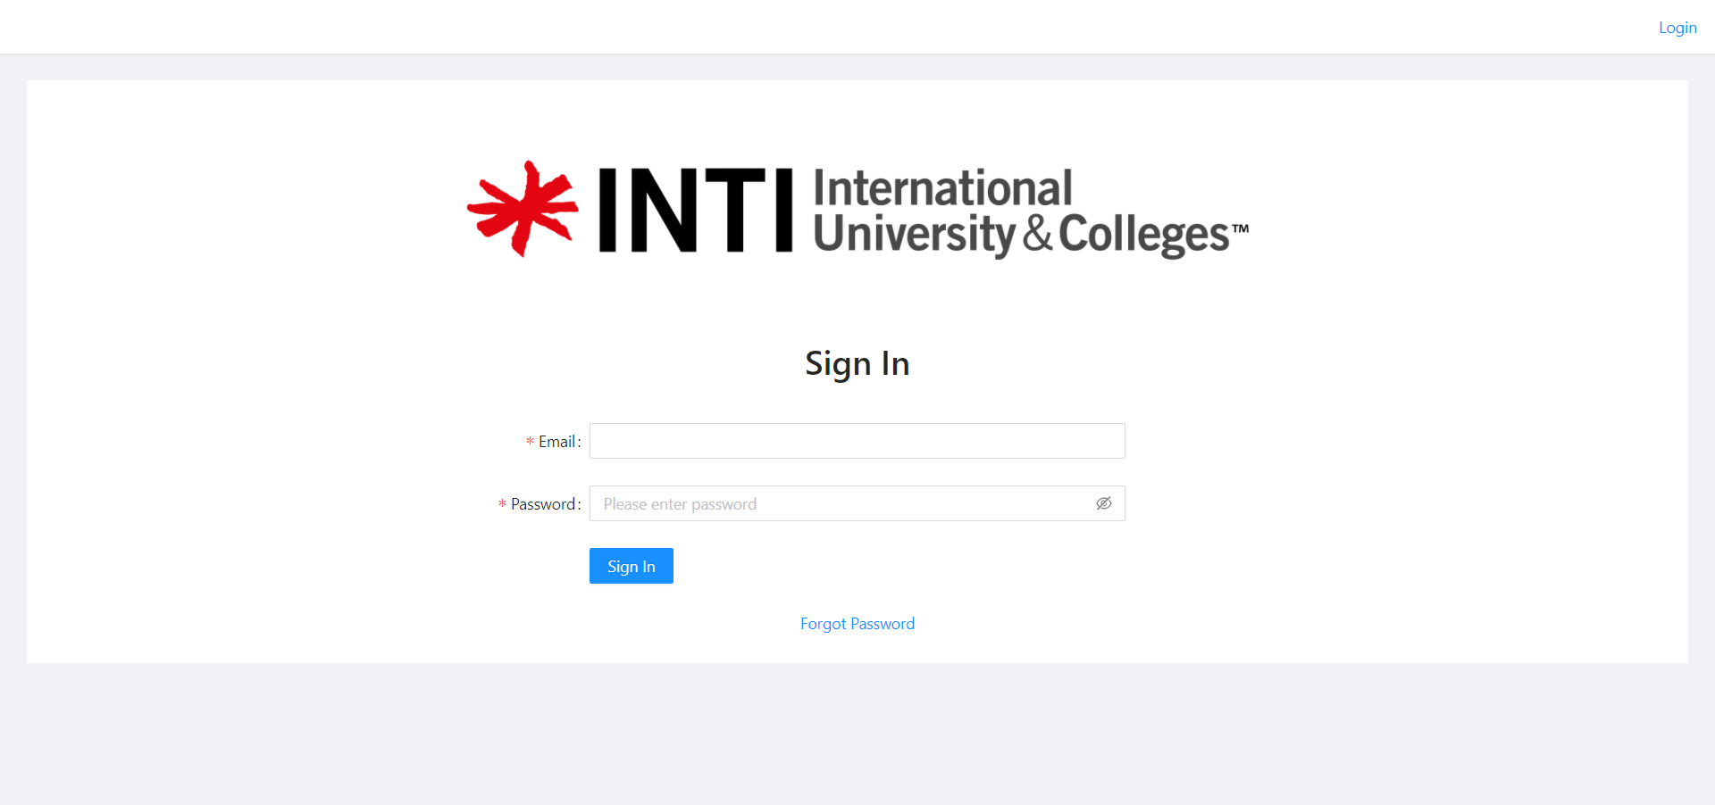

*Figure 1: Login Page*

INTI internal staff can access the login page as shown in Figure 1. Here they can use the login credentials that were registered previously to log into the system. If the credentials entered are incorrect, they will be shown an error message and denied access to the system. Once successful, they will be now logged in to the system using their registered username and can now use our functions under that username.

### 1.2 Forget Password

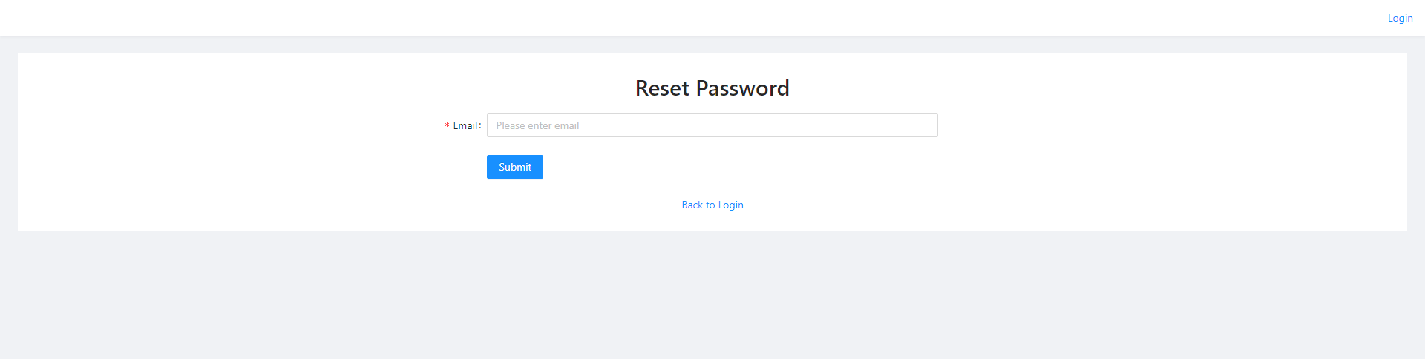

*Figure 2: Reset Password Page*

Here in figure 2 above is a reset password page which if a user has forgotten he or she password can click on forget password link at the login page and fill in their email. after once submitting. An email will be sent you the user to reset it’s password.

## 2.0 Navigation SideBar & Notification

### 2.1 Normal Staff User

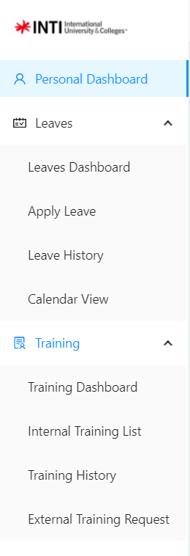

*Figure 3: Normal Staff Side Navigation*

### 2.2 Supervisor User

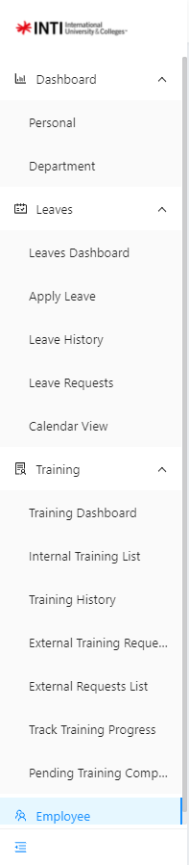

*Figure 4: Supervisor Staff Side Navigation*

### 2.3 Admin User

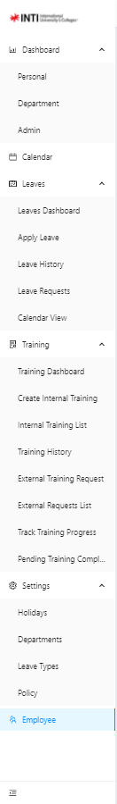

*Figure 5: Admin Staff Side Navigation*

### 2.4 Notification

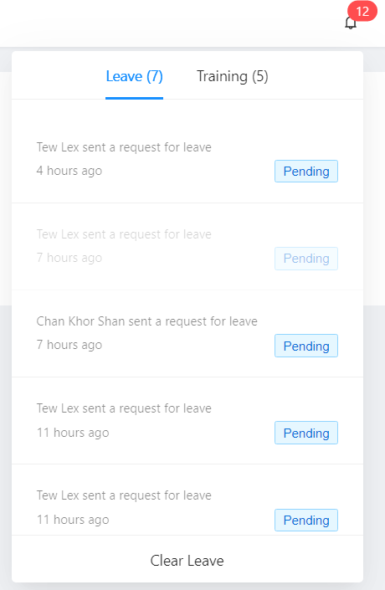

*Figure 6: Notification*

## 3.0 Dashboard

### 3.1 Dashboard > Personal

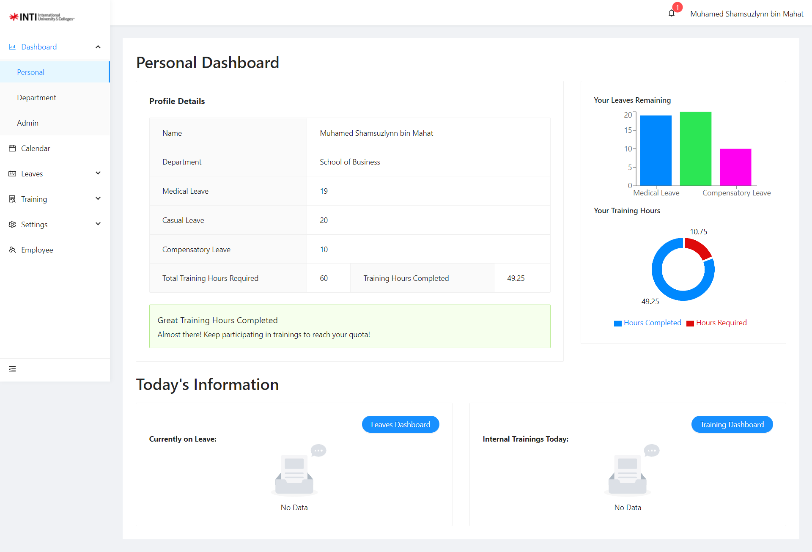

*Figure 7: Personal Dashboard*

After user have login, they will be directed to the dashboard page as shown above in figure 7. Here similarly to staff, they can view their details and balance of their remaining training hours or leaves days. On the left top corner on the table show the staff details and their remaining balance of training hours or leaves. On the right top corner show the colorful graphical which shows the remaining leaves as well as the amount of training hours that they have achieved. Lastly, the bottom both tables show the staff that are currently on leave and the internal training that will be held on that day. By clicking on the red button on the bottom both table will direct the users to the leaves dashboard and training dashboard.

### 3.2 Dashboard > Department

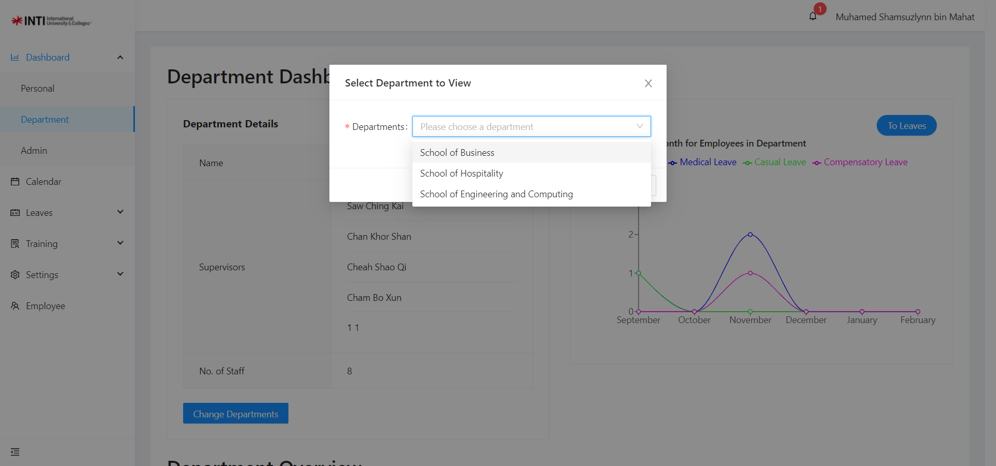

*Figure 8: Department Dashboard*

Here figure 29 above show Department Dashboard Page, where the user is able to view employee performance and also details of the department where they can select the department. On the top corner left table show the department details like department name, code and list of employee and also total employee in the department. On the top corner right show a statistic to show the number of employee taking leaves. On the bottom left corner show any staff that are currently on leave from the department. Lastly, bottom right corner table show a few of employees that have completed the most training hours in the department.

### 3.3 Dashboard > Admin

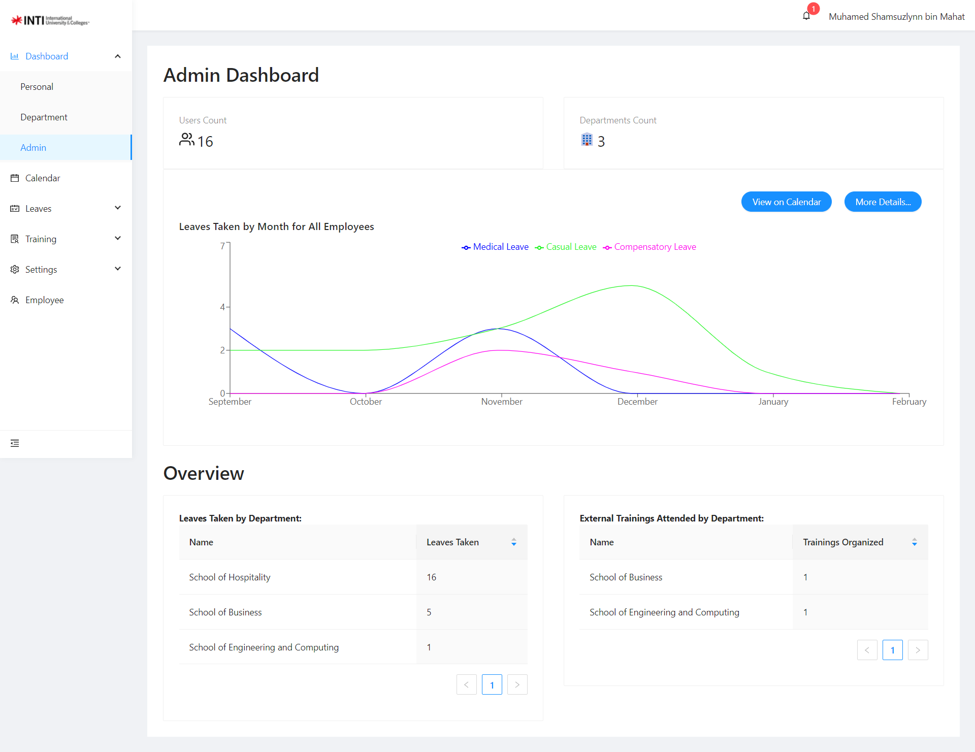

*Figure 9: Dashboard*

Here in figure 9 above shows the admin dashboard where the admin gets to view and monitor all employee performance. On the top left corner table shows the total employee and the top right corner shows the total department. The middle graph shows a statical graph which show which months that the employee is taking leave. Lastly, both tables on the left and right show total leave taken by the employee by department and on the right show number of employee that apply to external trainings by department.

## 4.0 Calendar

### 4.1 Calendar

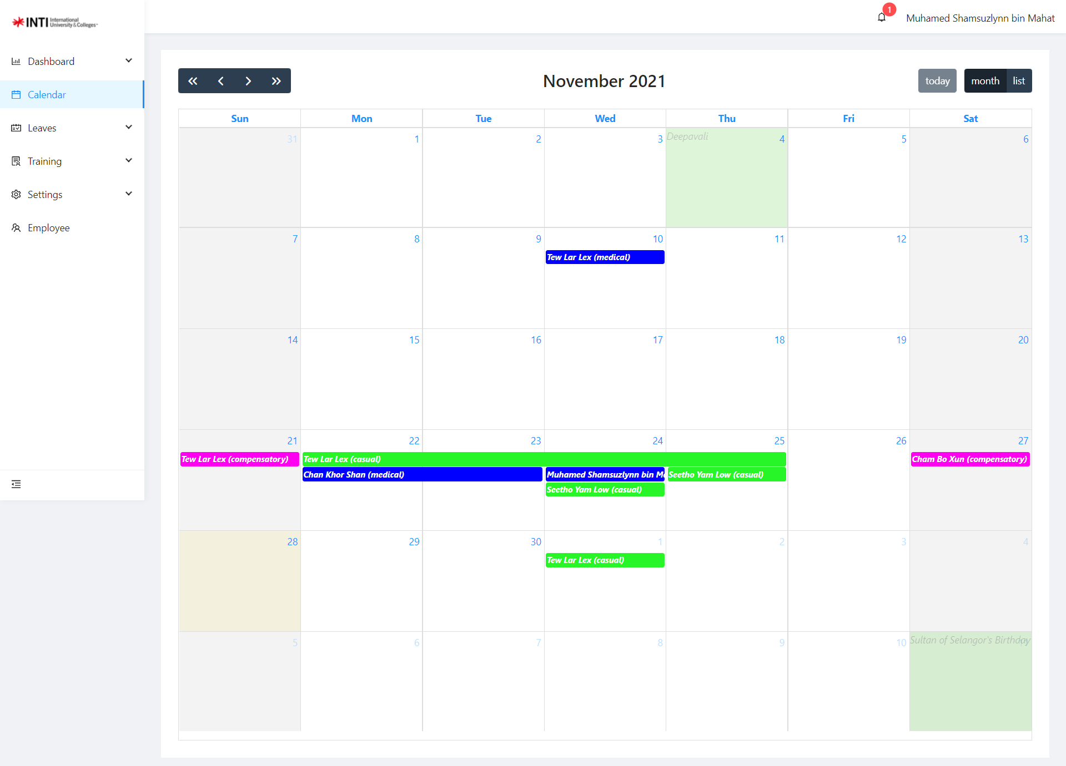

*Figure 10: Calendar*

Here at figure 10 above show the calendar page where admin can view all the dates that the employees have applied and to show the public holiday on Selangor to know when to plan any workshop in the future.

## 5.0 Leave Module

### 5.1 Leaves Dashboard

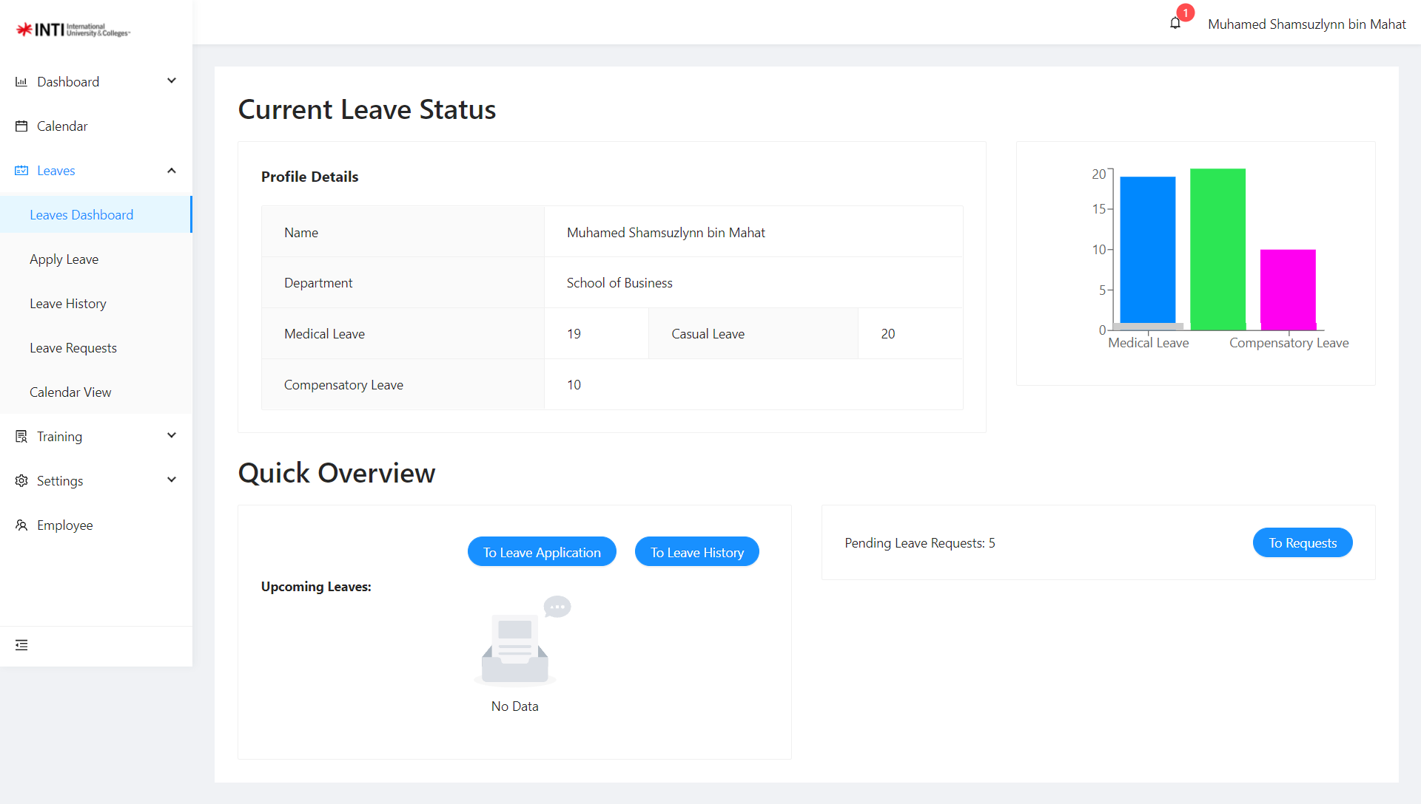

*Figure 11: Leaves Dashboard*

Here is the Leaves dashboard as show at figure 11 above, users can view their remaining balance and their details of the user. On the left top corner on the table show the staff details and their remaining balance of leaves. On the right top corner show the colorful graphical which shows the remaining leaves. On the bottom left table shows any leaves that are upcoming within the next week that have been approved. The bottom right shows the amount of pending leave requests that the supervisor has received from the staff in their department and provides a button which leads to the leave requests page.

### 5.2 Apply Leave Page

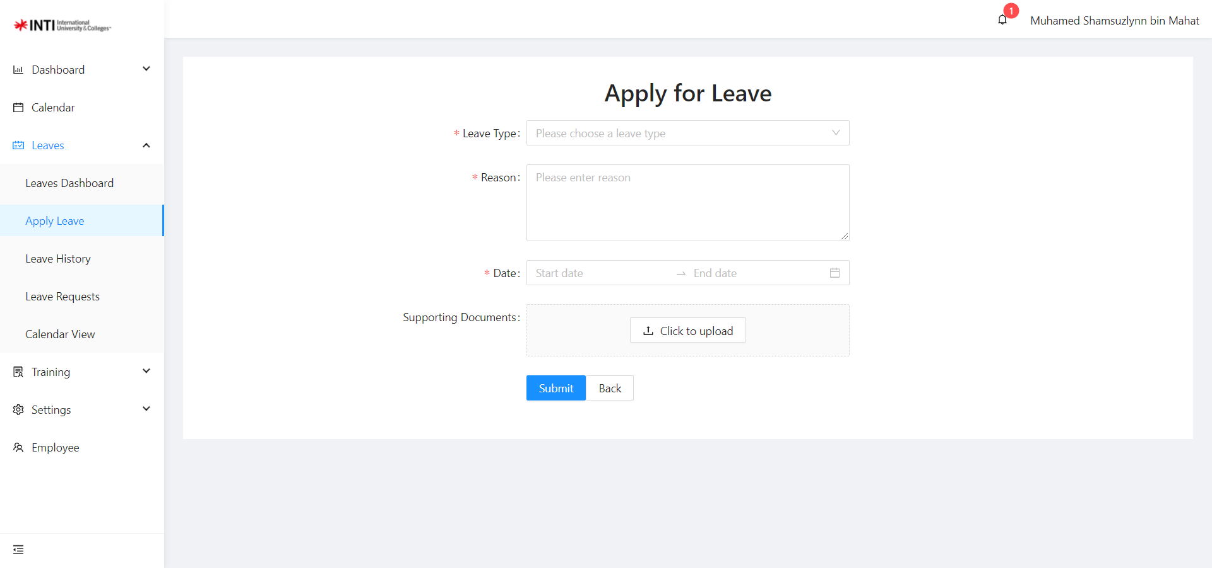

*Figure 12: Apply Leave Page*

Here users can apply their leave by filling up the form like the leave type, what is the reason for applying it, select the date to and from that the staff wanted to take and also upload any supporting document or receipt to show proof.

### 5.3 Leave History

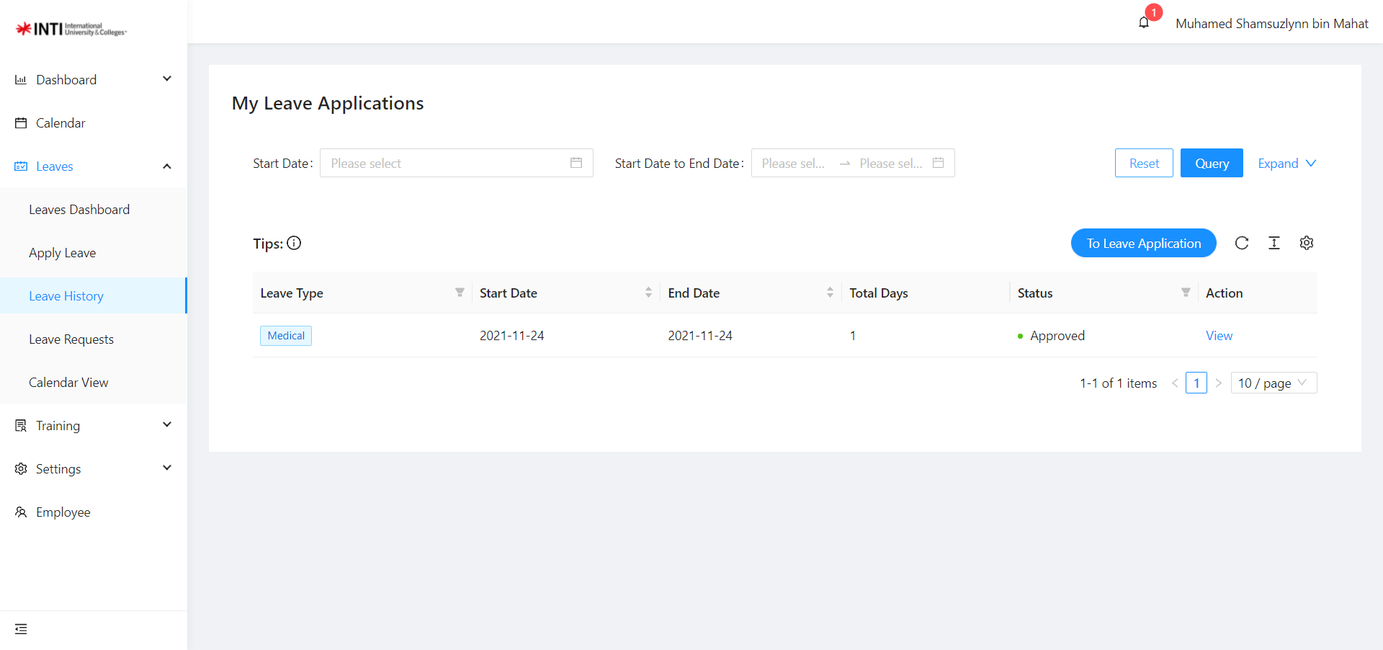

*Figure 13: Leave History Page*

Here users can view their leave history that they have applied from the past. They can filter their leave type or their specific date that they wanted to view. On the table here you can view their leave type, start, and end date that they have applied, status of the leaves. The leave history also can view by all users and for admin and supervisor able to edit the details of the leave that they have applied but are still pending. However, when the status is approved or rejected the edit feature will be disabled.

### 5.4 Leave Requests

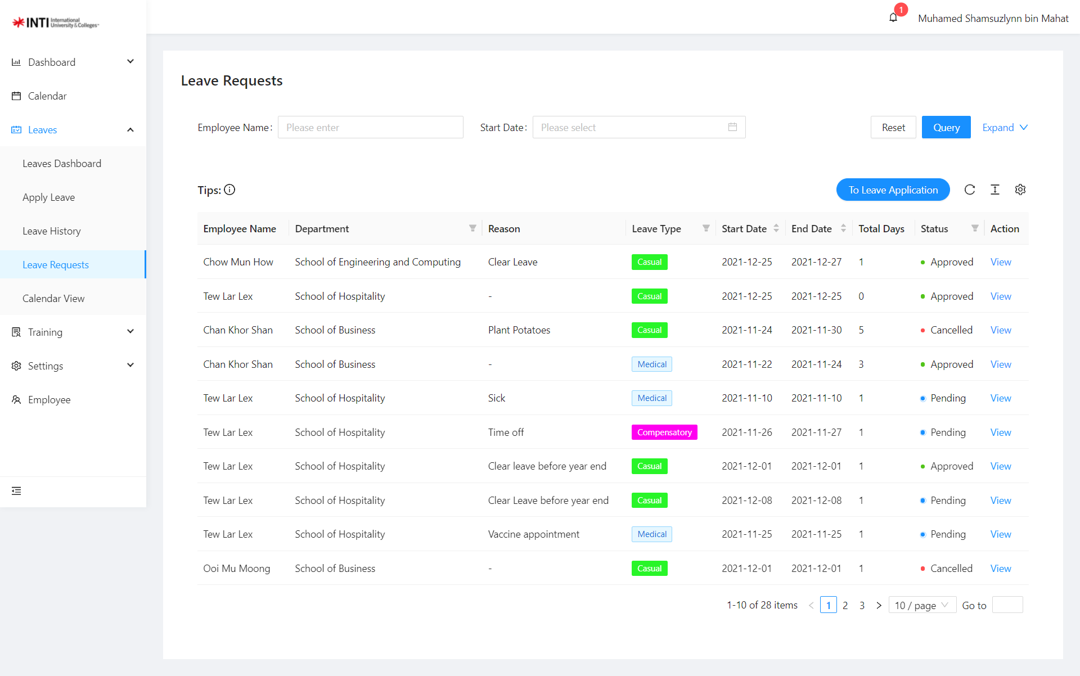

*Figure 14: Leave Request Page*

Here in figure 14 above show the leave request page show the list of leave requests that they received. Users can click on the view button to view all the leave details that the employee has applied. Admin and supervisor can decide to approve or reject the employee request on this page.

## 6.0 Training Module

### 6.1 Training Dashboard

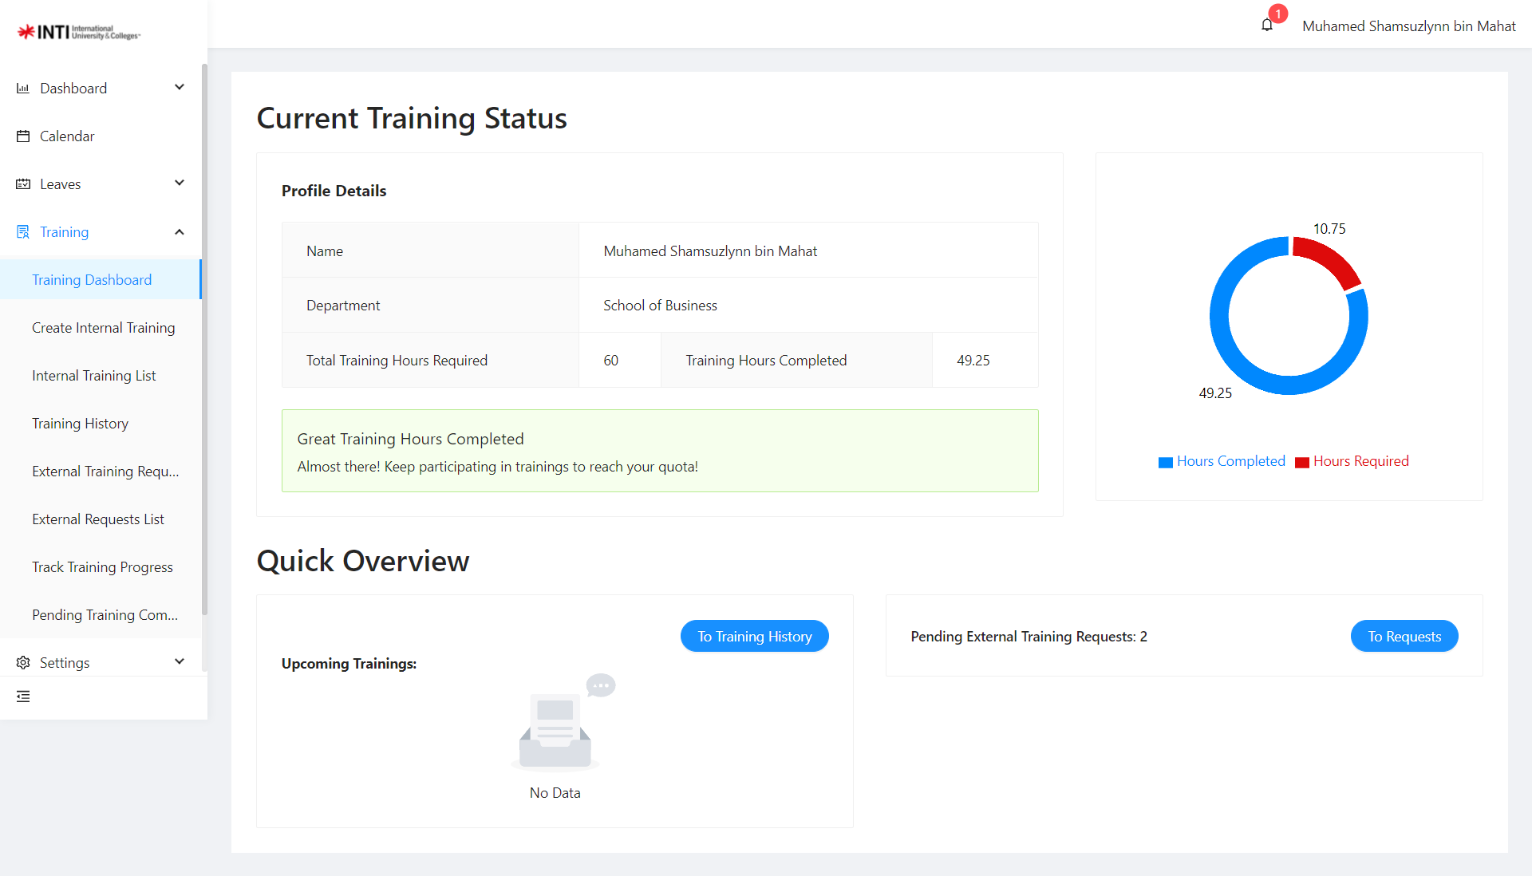

*Figure 15: Training Dashboard*

Here is the Training dashboard as show at figure 15 above, the user can view their remaining balance and their details of the user. On the left top corner on the table show their details and their completed training hours. On the right top corner show the colorful graphical which shows the completed hours as well as remaining hours required. Below, the number of pending requests for external training that they have received will be shown and it includes a button that leads to the Pending External Requests page. On the bottom table show the internal training that you have joined or external training that have been approved that are upcoming within the next week and you can view workshop details.

### 6.2 Create Internal Training

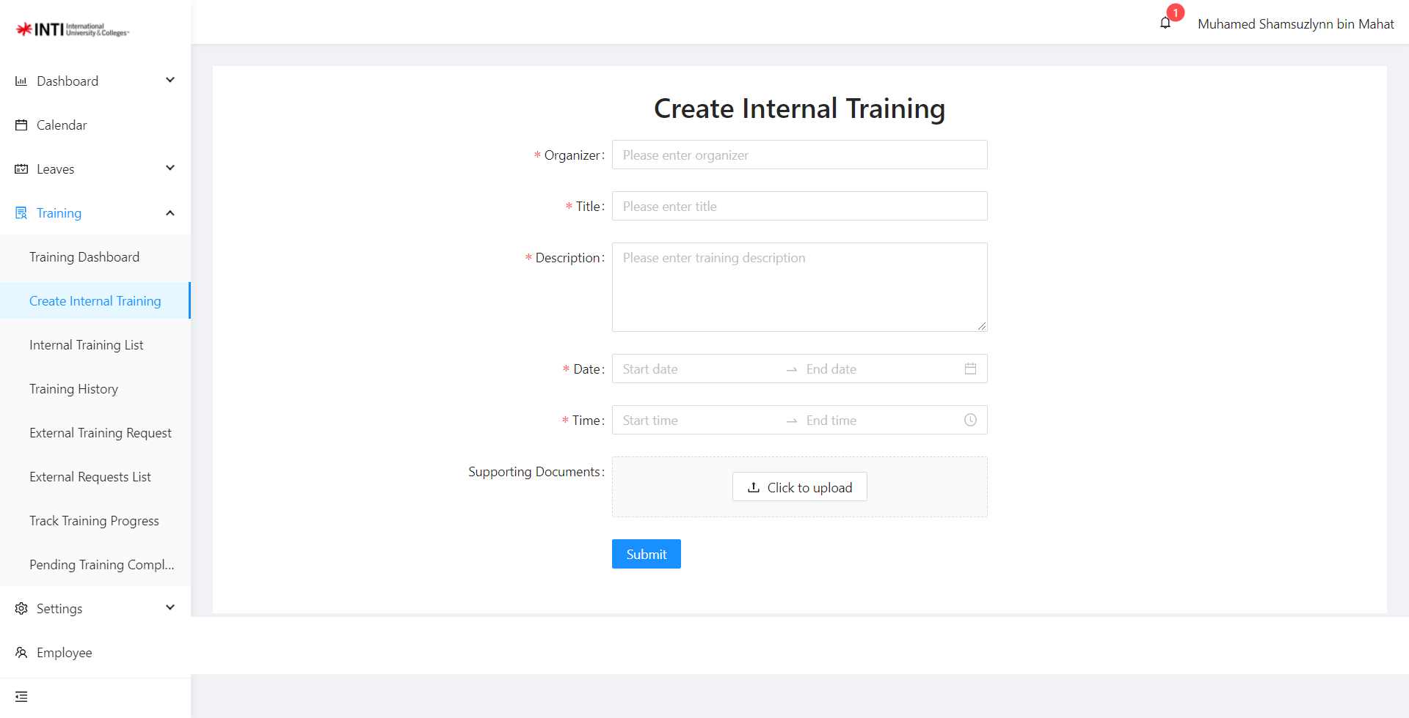

*Figure 16: Internal Training*

Here at figure 16 above show create internal training where admin can create an internal workshop and publish it for the internal staff to join.

### 6.3 Internal Training List

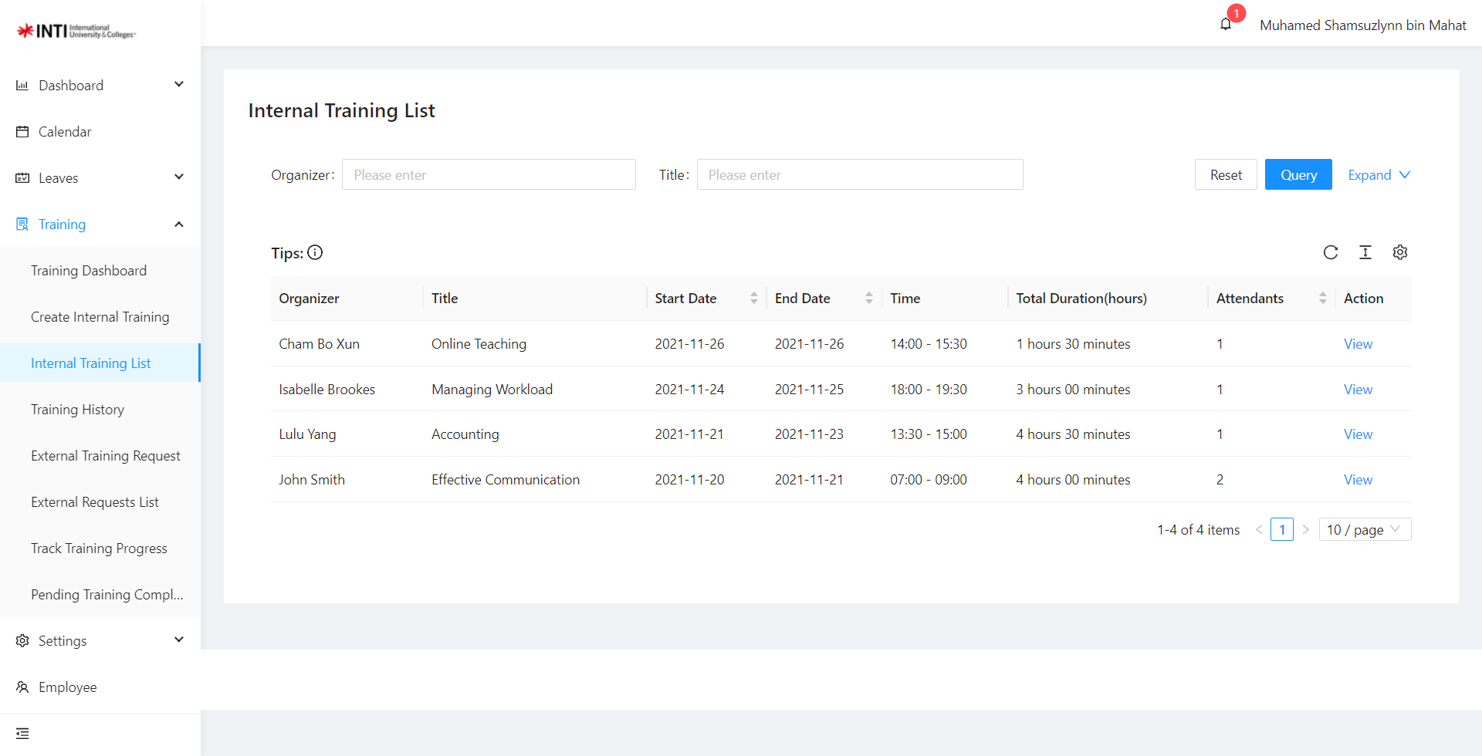

*Figure 17: Internal Training List*

Here is the Internal training list page as shown above in figure 17 where it will list down any upcoming internal workshop for staff to join. All users have permission to view this list.

### 6.4 Training History

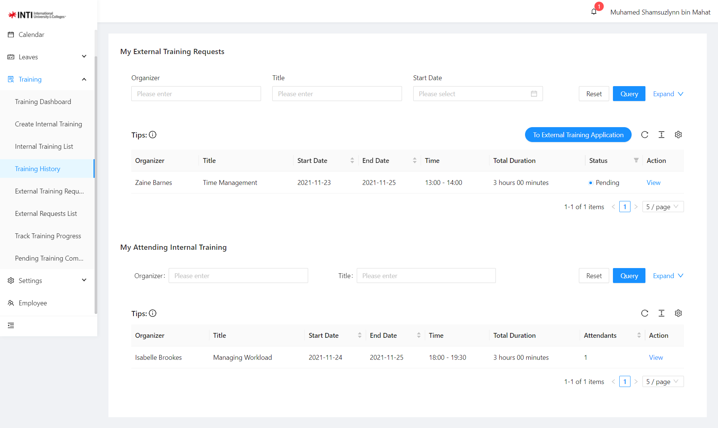

*Figure 18: Training History*

Here training history page as shown above at figure 18, show all the internal and external training that the staff have attended. Users can filter the organizer name, the workshop title and its specific date to view the workshop that they have attended. Furthermore, you can click the view button on the table to view the workshop details.

### 6.5 External Training Request

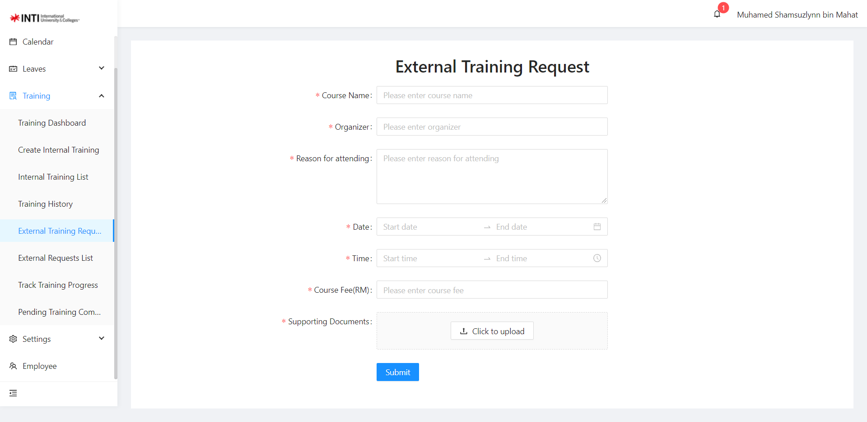

*Figure 19: External Training Request*

Here users can apply their external training request by filling in the workshop name, the organizer name, the reason for attending the workshop, the time and date of the workshop start and end, and the course fee if there is any. Lastly, upload any supporting document to support the request if needed. After submitting the request, the admin and supervisor will have to review the request and decide to approve or reject the request.

### 6.6 Pending External Request

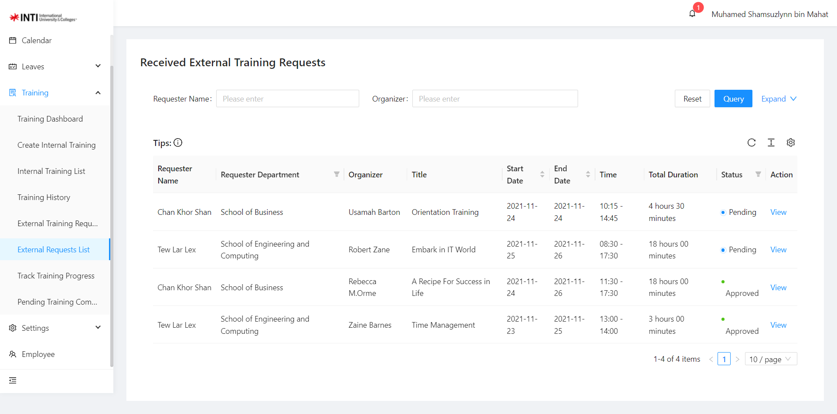

*Figure 20: Pending External Request*

Here in figure 19 above show the pending external request page where the external requests from all staff will be shown. Admin and Supervisor can click on the view button to view the workshop details and made the decision to approve or reject.

### 6.7 Pending Training Completion

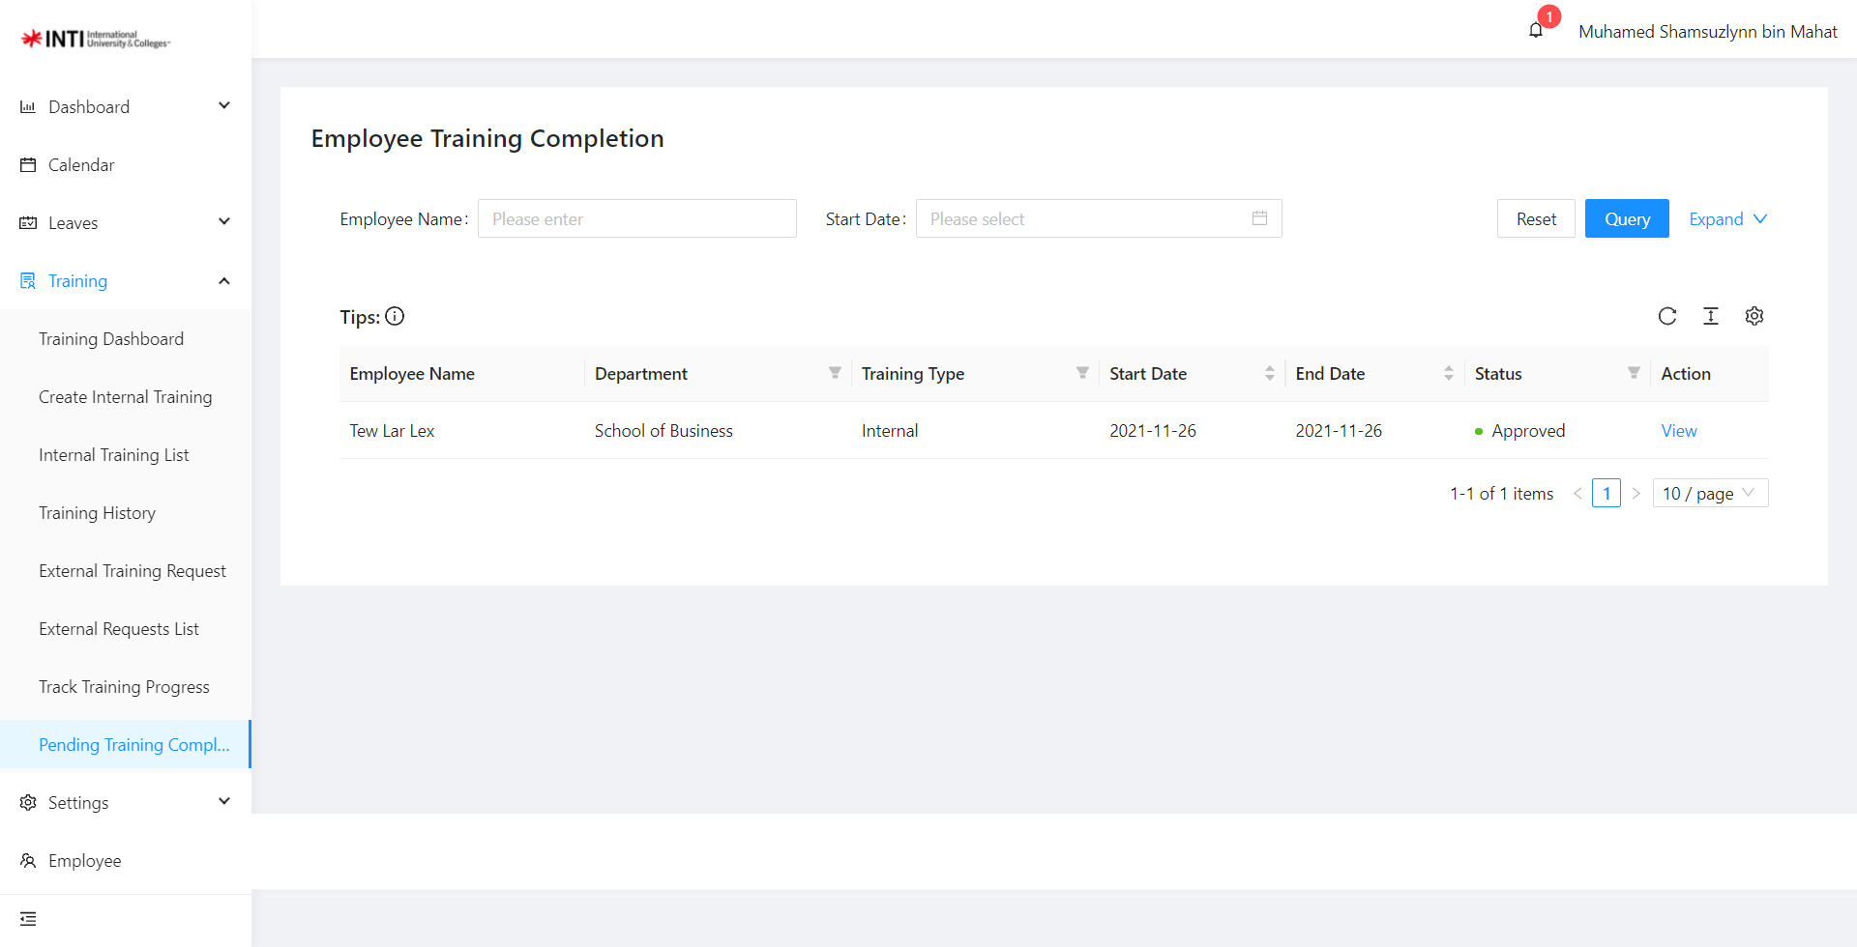

*Figure 21: Pending Training Completion*

Here in figure 20above show the pending training completion page where the list of the training progress will be shown. Admin and Supervisor can click on the view button to view and decide to approve or reject the employee status for the training they completed.

### 6.8 Track Training Progress

*Figure 22 : Track Training Progress*

Here in figure 22 above show the track training progress page, after the workshop has ended the event. The workshop that you have joined will be shown here when you need to upload the cert as evident that you have joined the workshop. When you have uploaded the cert, the supervisor or admin will verify it. After once they have verified and approved it, the training hours that you have completed will be minus from the remaining hours.

## 7.0 Setting Module

### 7.1 Setting > Holiday

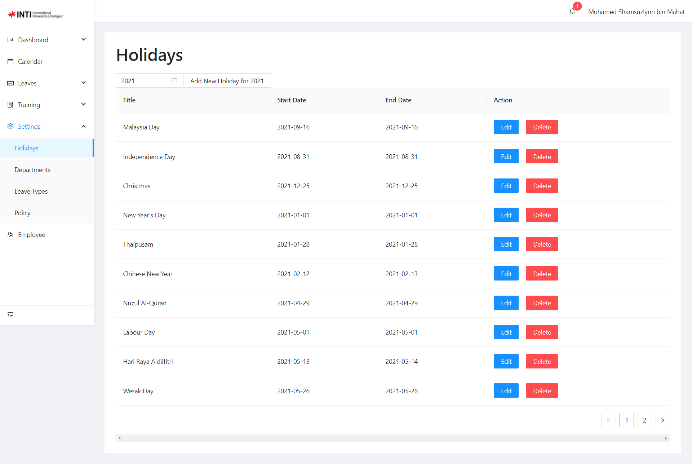

*Figure 23: Holiday Setting*

Here at figure 23 shows the Holiday setting page where admin adds all the public holidays to be shown on the calendar. Where the admin can add, edit, and delete the holiday.

### 7.2 Settings > Department

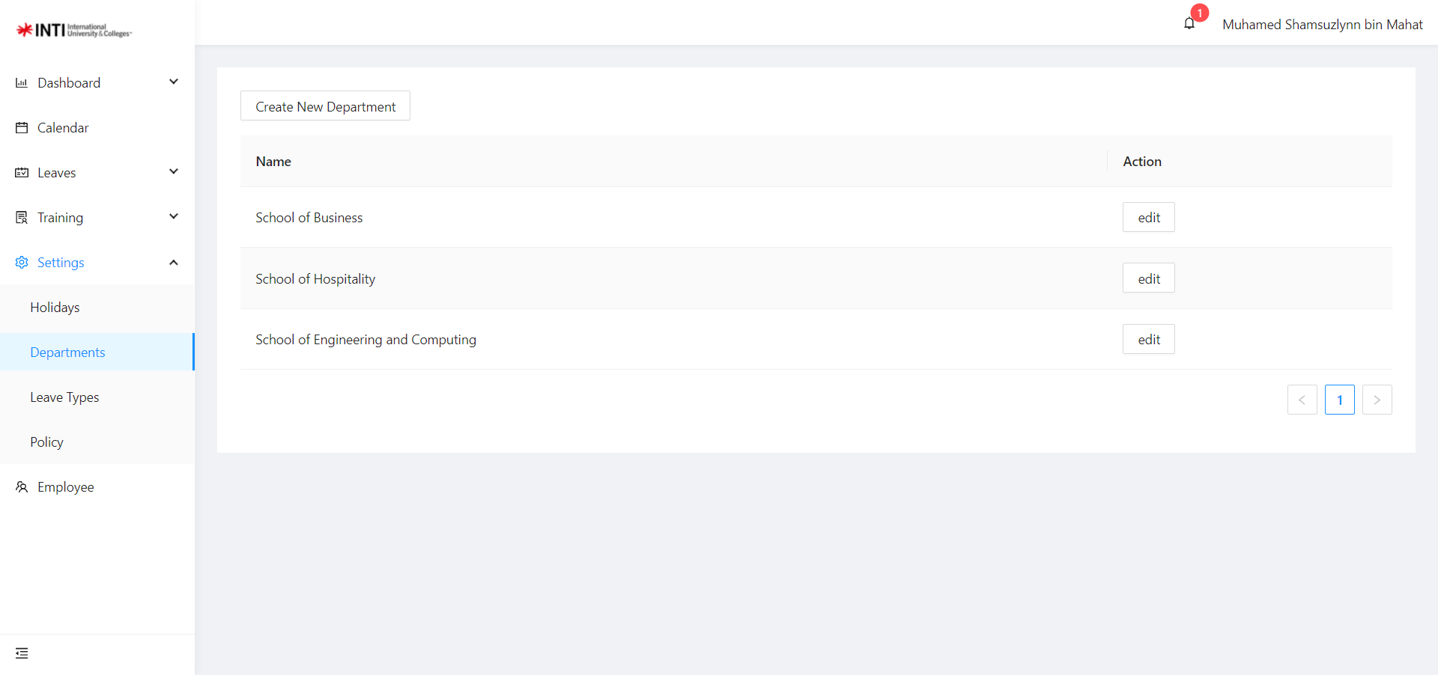

*Figure 24: Department Setting*

Here at figure 24 shows the Department setting page where admin can add the department.

## 8.0 Employee Module

### 8.1 Employee

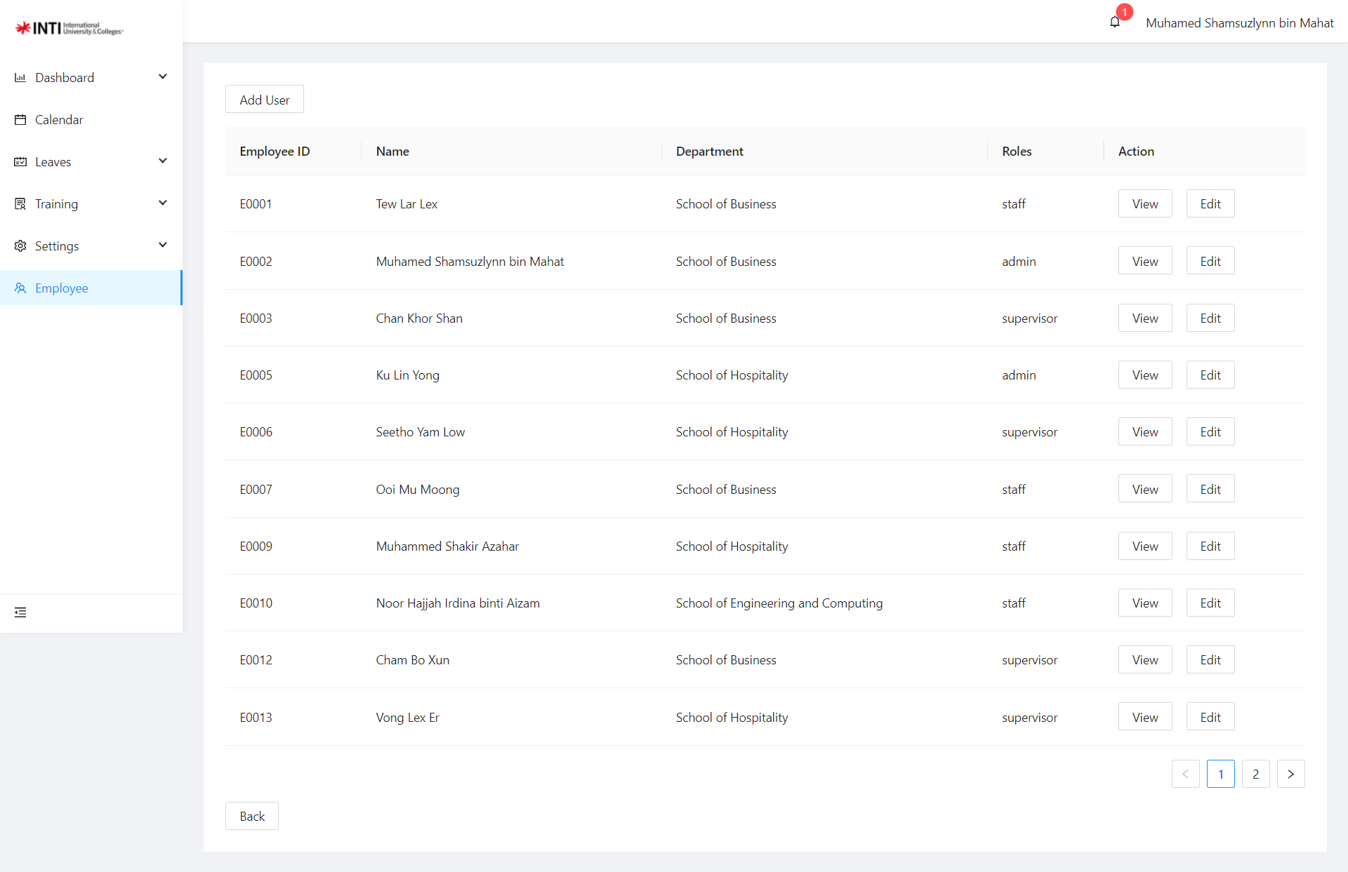

*Figure 25: Employee List*

Here at figure 25 above shows the employee list page where the admin is able to view the list of employee on the department and click the view button to view the employee details.

## 9.0 Setup Process

### 9.1 Create Department

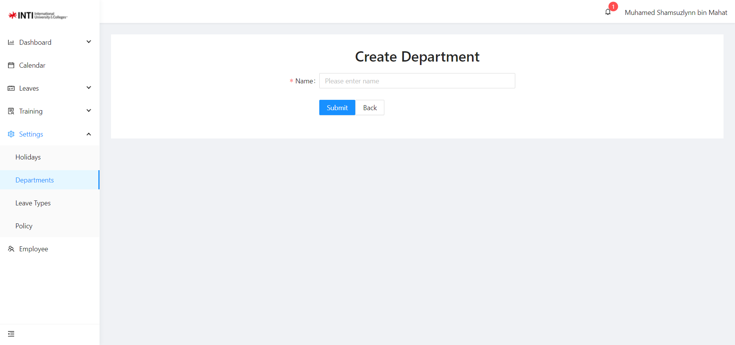

*Figure 26: Create Department Page*

To create a department first you need to login to the admin account and go to Settings > Department, on the top left corner click on the button called “Create New Department”. A small window will prompt out and ask you to insert the name of the department. After once filling in and department name, click submit and it will be added to the department list.

### 9.2 Create Leave Type

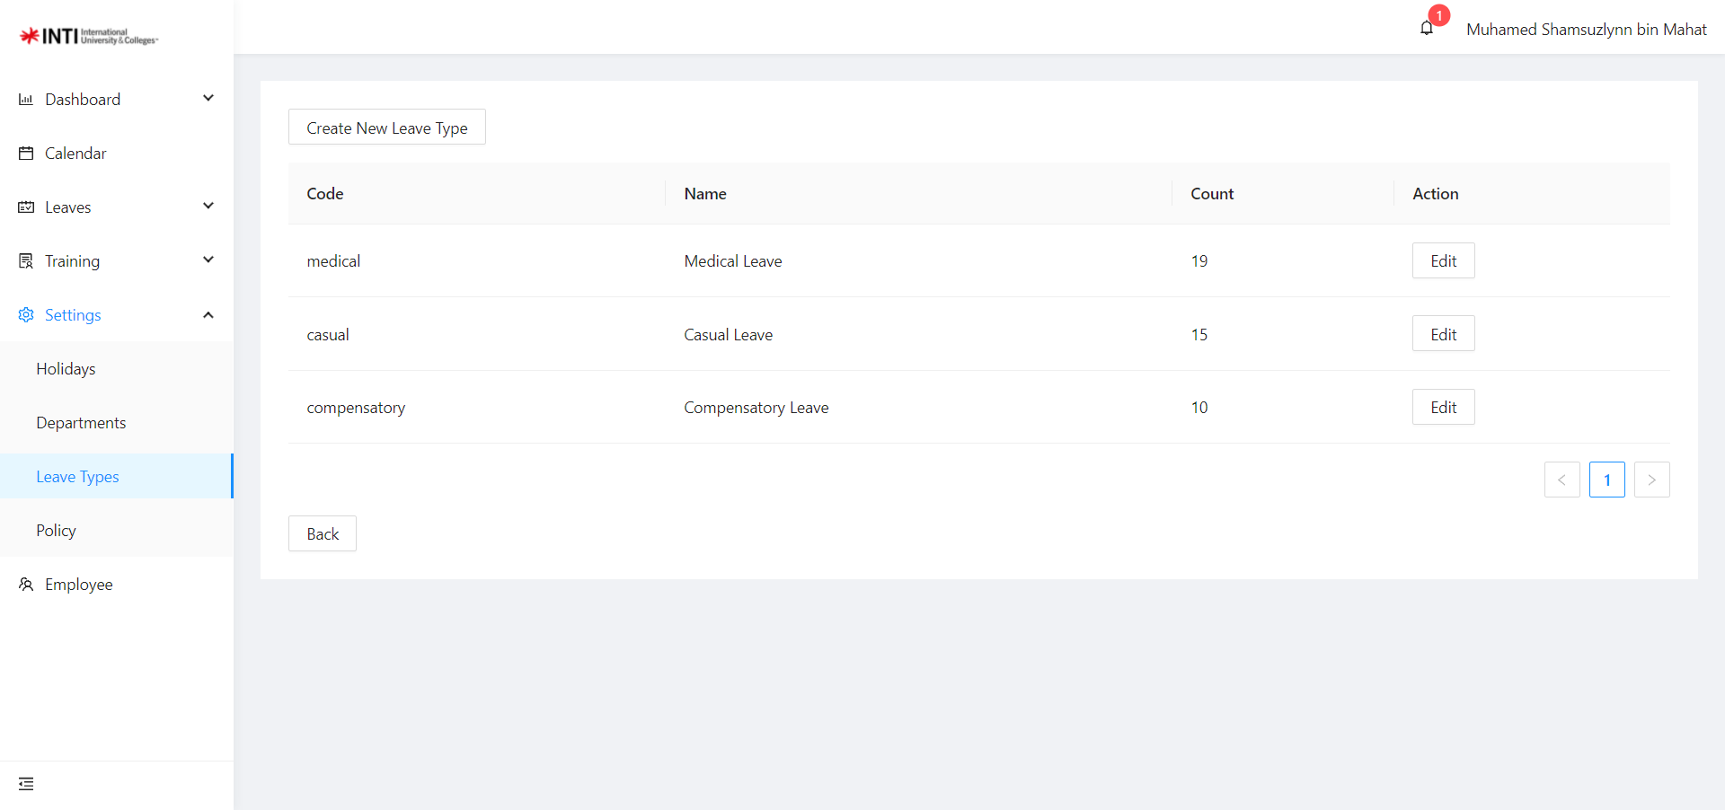

*Figure 27: Create Leave Type Page*

To create a Leave Type for employees to apply for leave, first you need to login to the admin account and go to Settings > LeaveType, on the top left corner click on the button called “Create Leave Type”. A small window will prompt you to fill-in the code, name, color and constraint of the leave type. After once filling in the code and department name, click submit and it will be added to the department list.

### 9.3 Create Policy

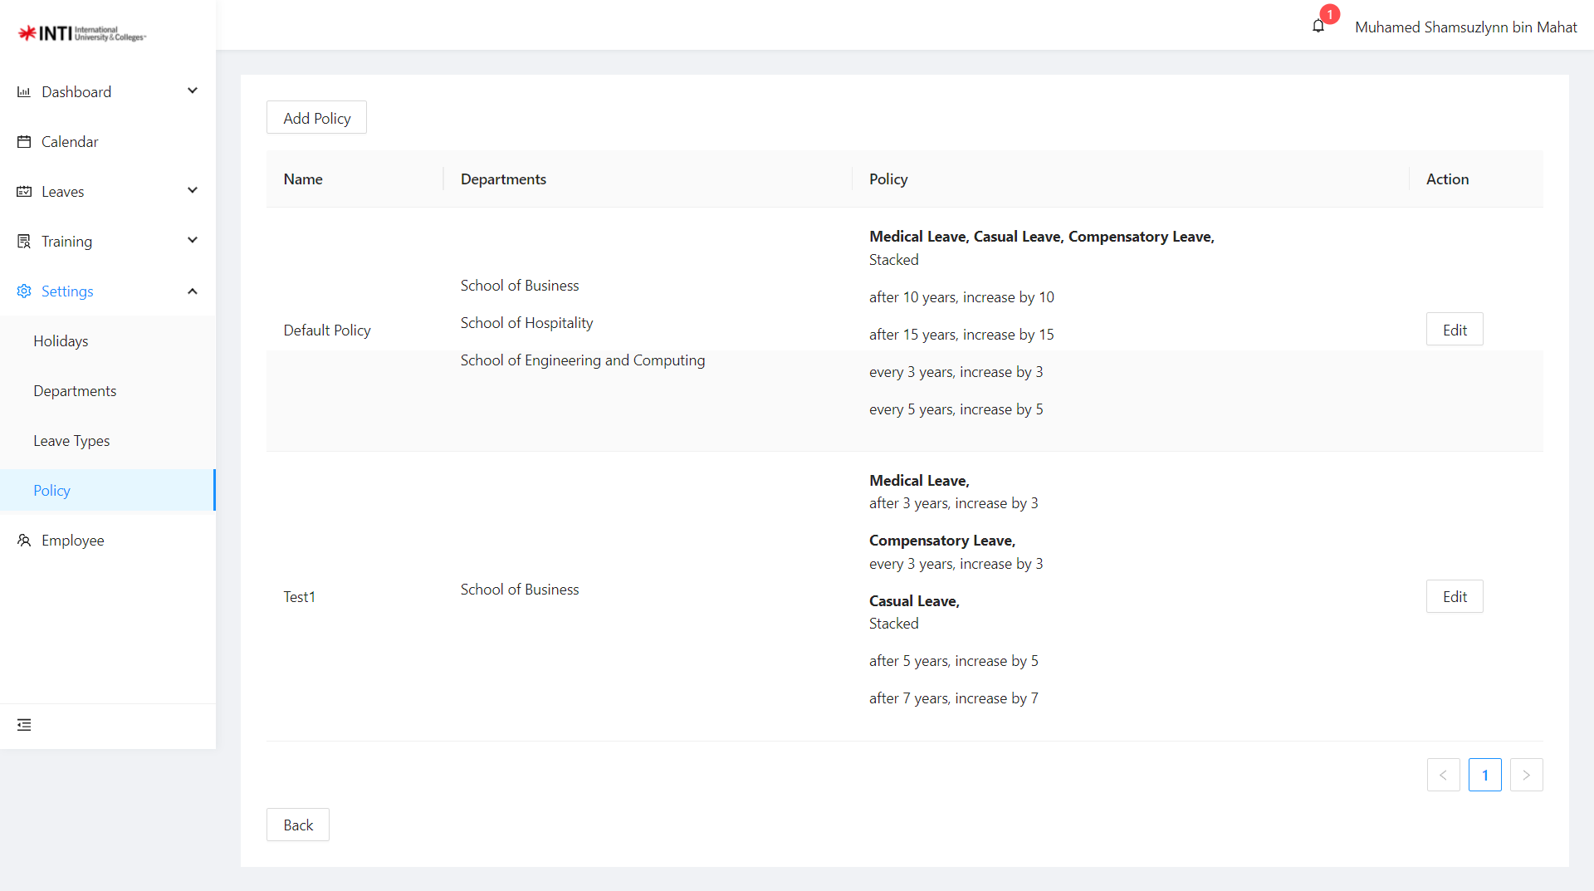

*Figure 28: Create Policy Page*

*NOTE: To create a Policy, Department and Leave Type must be created first*

To create a Policy, first you need to login to the admin account and go to Settings > Policy, on the top left corner click on the button called “Add Policy”. A small window will prompt you to fill-in the Name, select the departments that the policy will apply to and add some conditions to the policy. After filling up the policy, click submit and the policy will be updated to the department that you have selected.

### 9.4 Create New User Account

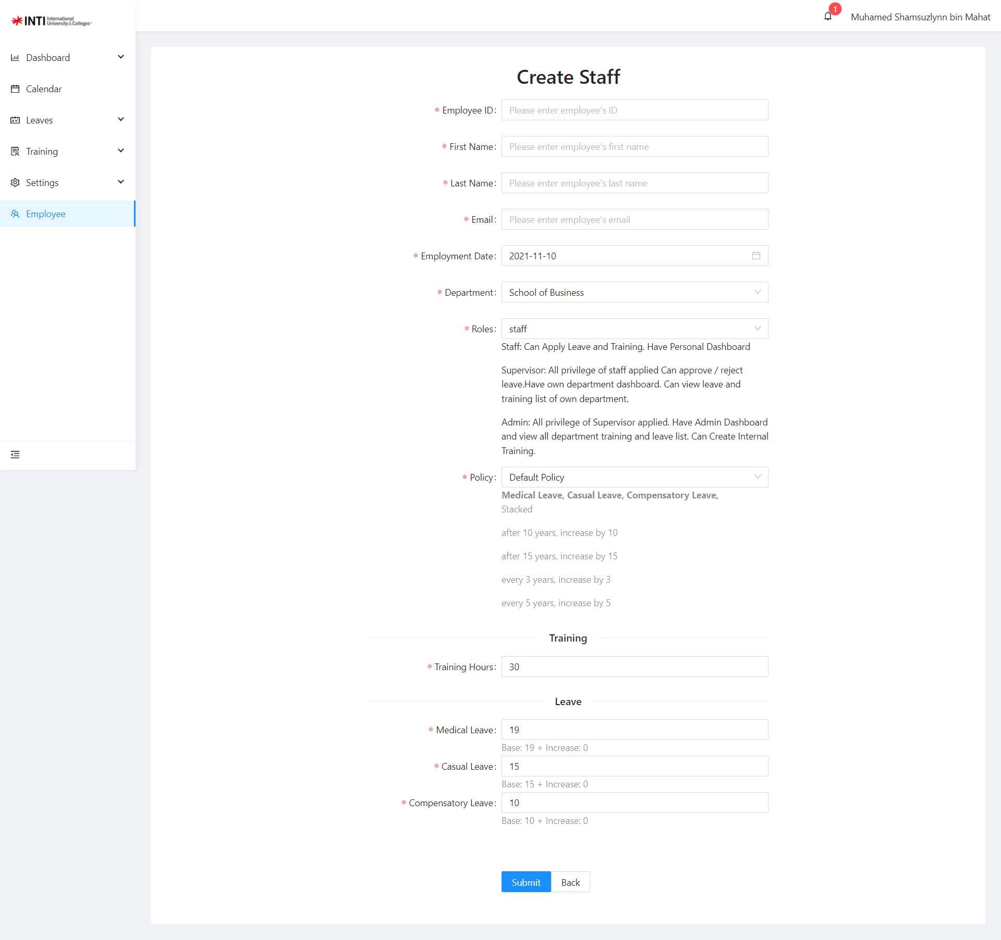

*Figure 29: Create New User Account Page*

*NOTE: To Create a new User, Department and Leave Type and Policy Terms must be created first*

To create an Employee Account, first you need to login to the admin account and on the side bar click on Employee, on the top left corner click on the button called “Add User”. A small window will prompt you to fill-in the Employee details and assign the employee to its role and department. After filling up the details, an email will be sent to the employee under that email that you have set which the password is auto generated. The employee can then login and change to its desired password.