**CS202L**

**Lab 10 Practice Assignment**

**Lab Date: 02/11/2018**

**10.1: A company wants to create a Duck simulator, where various types of ducks will appear with customized behaviors.**

RubberDuck can’t fly and it squeaks.

MallardDuck quacks and has flying ability.

RedHeadDuck can't fly but able to quack.

DecoyDuck can't fly and cannot even quack.

[display method represents each duck uniquely]

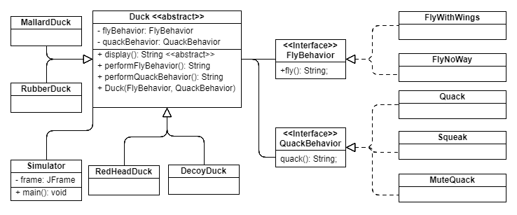

**Implement the class diagram and demonstrate the simulation using GUI libraries.**

**Create one button for each Duck. Print the Duck details [image also] in a label on the click of button by the user.**

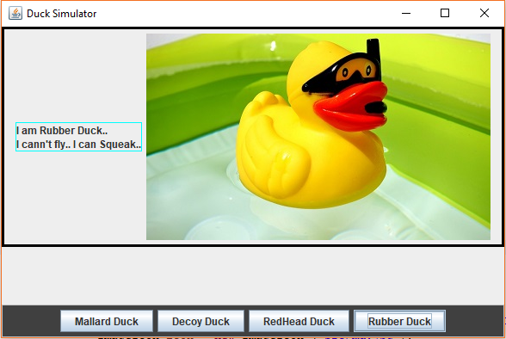

**10.2 : Create A GUI based Application. Configurations are as follows:**

1. **Input [Text Field]: Fahrenheit temperature**
2. **Output [Label]: Temperature in Celsius**
3. **Demo is given below:**

