**CS202L**

**Lab 10 Programming Assignment**

**Lab Date: 02/11/2018**

**10.1: Create a simple GUI application to sort the numbers given by the user.**

**A: One textfield to take user input (example input [56,345,788,34])**

**B: Label: to show the sorted numbers.**

**C: button: on the click on this button sorting should be performed and output at the Label.**

**D: radio buttons: r1: ascending order sort[default selected] r2: descending order sort**

**E: Exceptions must be handled with meaningful message at GUI.**

**F: Extra Labels can added for better representation.**

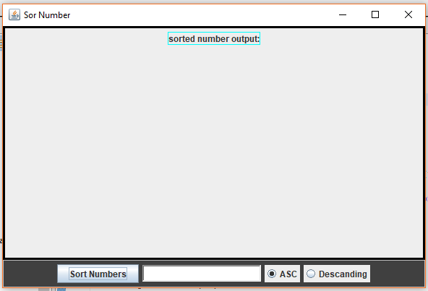 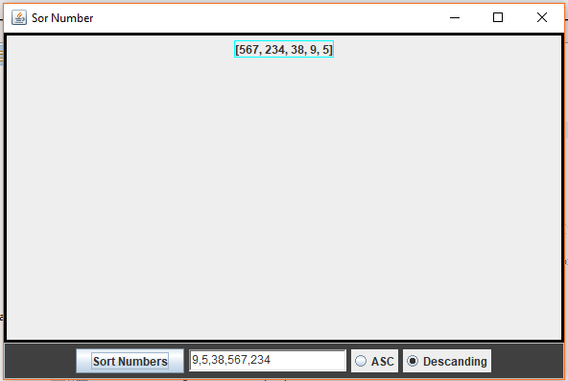

**10.2: Create A GUI simulator, which shows the LightBulb Image and changes when we click on/off button. At first the LightBulb will be on.**

**Configurations:**

**A: Two buttons: ON/OFF….. If LightBulb is on then ON button must be disable. Same for OFF condition.**

**B: demo screenshots is given below:**

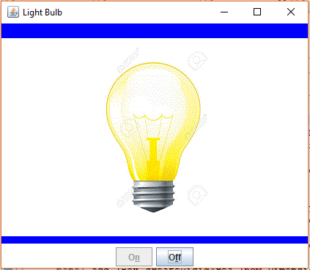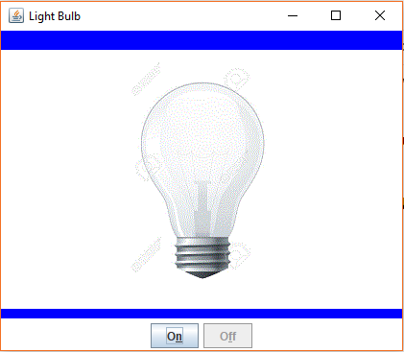

**C: Class Diagram**

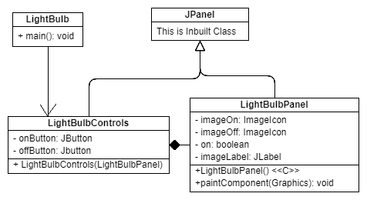

**LightBulb class will create main panel of the Application.**