**Assignment Lab 5**

5.1: Draw the class diagram for the requirement statement given as follows:

There is an institute, which has number of department and a library. Each department has faculties and students. Library has various books. Every faculty have at least one publication. A faculty can have various research projects. Students are also active in publishing research papers.

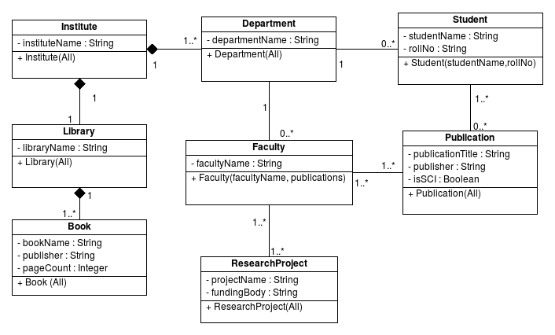

5.2 Draw the class diagram for the requirement statement given as follows:

A Railway station at least has one platform, on which multiple trains are scheduled. A train consists of minimum one engine and number of coaches. There can be at most 2 escalators on each platform. Railway station has various types of ticket counters, like reservation ticket counter, normal ticket counter and platform ticket counter. Railway station may have zero of more waiting rooms for the sleeper and AC class travellers.

