**CS202L**

**Lab 6 Practice Assignment**

**Lab Date: 03/10/2018**

**6.1**  A class diagram of Shape hierarchy is given below.

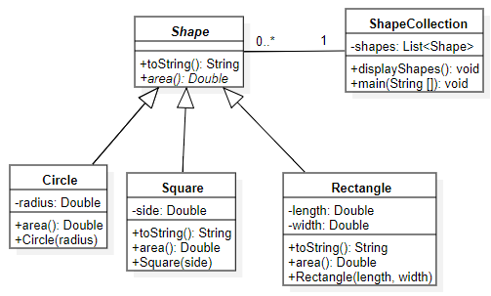

1. Code the above class diagram.
2. Instantiate some dummy Objects of Circle, Square, Rectangle and save in shapes.
3. Print the list of shapes in “shapes” attribute of ShapeCollection class.