**CS202L**

**Lab 6 Programming Assignment**

**Lab Date: 03/10/2018**

**6.1**  A class diagram of “Railway Station Management” is given below (already covered in the last lab).

Here the concept of Inheritance is introduced.

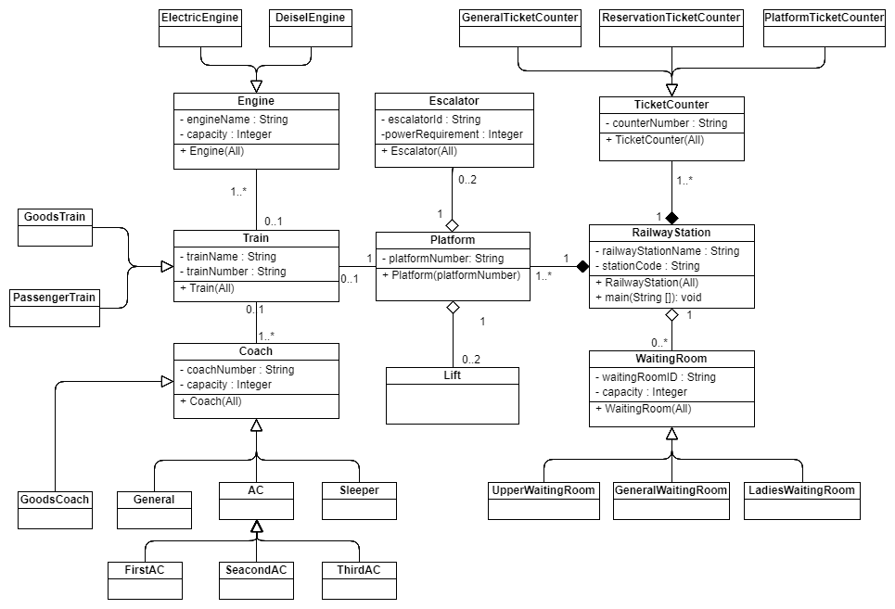

1. Code the above class diagram & Instantiate the Objects for task 2.
2. Print the train detail on a particular platform of the railway station. [train number, type, engine type, engine details, detail of each coach.] You are free to add attributes, methods as per the need.