**CS202L**

**Lab 7 Practice Assignment**

**Lab Date: 10/10/2018**

**6.1**  A class diagram for Various Dessert items is given below.

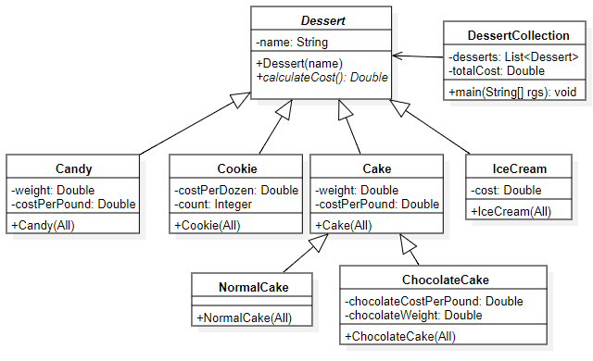

Note: Cake is also an abstract class.

1. Code the above class diagram.
2. Provide Definition to calculateCost() method as per the requirement.
3. Instantiate some dummy Objects of various desserts in main method of DessertCollection class.
4. Calculate the overall cost.