**CS202L**

**Lab 7 Programming Assignment**

**Lab Date: 10/10/2018**

**6.1**  A class diagram of “Toll Plaza Management” is given below.

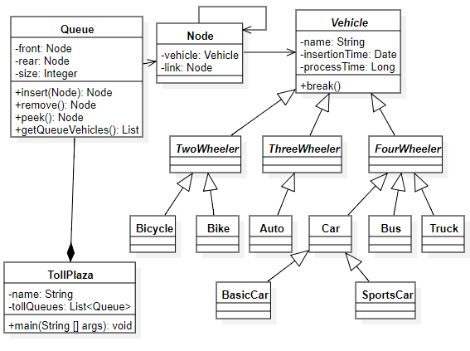

note : Additional constructors ,methods can be added as per the need.

1. Code the above class diagram & Instantiate the required objects for task 2.
2. You need to simulate the toll plaza environment(consider only one queue), where various types of vehicles are coming at the toll plaza ( with random timing). Bikes and Bicycles will not be charged any toll( pass directly with zero process time). You need to insert incoming vehicles in the queue and remove the vehicles who have completed process time. Process time of vehicles given as follows:
   1. Bus : 3 seconds
   2. Truck : 4 seconds
   3. Basic Car : 2 seconds
   4. Sports Car : 2 seconds
   5. Auto : 3 seconds