**CS202L**

**Lab 8 Programming Assignment**

**Lab Date: 10/10/2018**

**8.1**  A class diagram is given below.

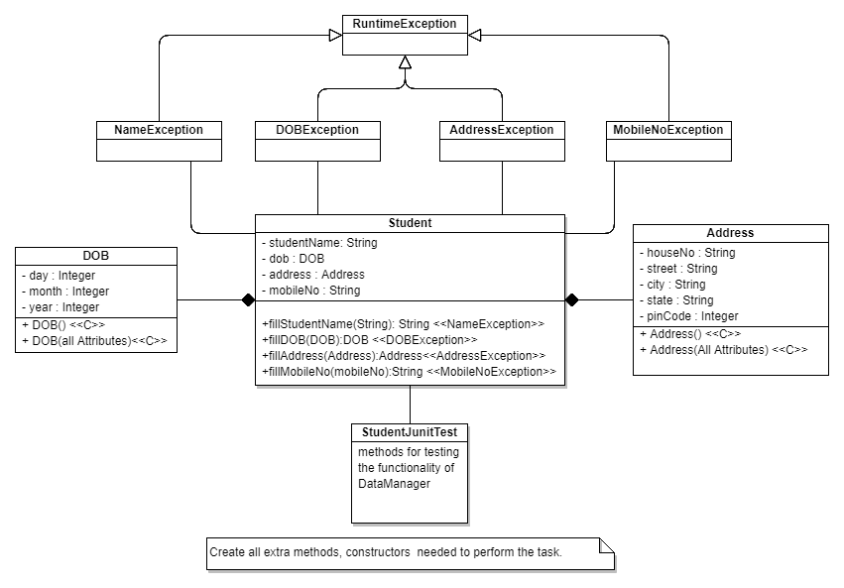

note : Additional constructors ,methods can be added as per the need.

1. Write a Java program to implement above class diagram.
2. Implement the methods given in the Student class, with following constraints:

2.1 name must not contain non-alphabetic characters.

2.2 DOB

Must be between 01-01-1993 to 31-12-1997.

DOB should follow default date constraints. (like 31 days in Aug, Oct, 28 in Feb)

2.3 Address:

All the fields must be non-empty.

Pin code must be Integer.

2.4 Mobile No.

Mobile no length must be 12.

Mobile no. must contain only numeric characters.

Mobile no must start with 91.

3. Write Exception classes as given in the diagram. Give specific message based on failing of constraint.