**CS202L**

**Lab 9 Practice Assignment**

**Lab Date: 31/10/2018**

**9.1: A Class diagram is given below, which shows the relation among operating system behavior and its implementations:**

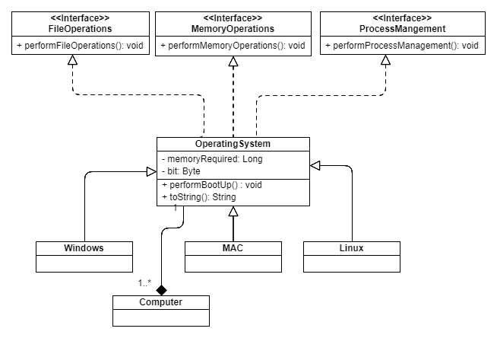

**9.2 : Collection is very important block of Java. PPT file contains information about hierarchy of collection’s important class and interfaces.**

**Go through the Java source code and analyze the diagram with code.**

**[ how the abstract methods are implemented by the sub-class any many more.]**

Folder path of Java source code: [your OS drive / program files / Java / jdk x.x.x.x / src.zip]