**CS202L**

**Lab 9 Programming Assignment**

**Lab Date: 31/10/2018**

**9.1: A company wants to create a Duck simulator, where various types of ducks will appear with customized behaviors.**

RubberDuck can’t fly and it squeaks.

MallardDuck quacks and has flying ability.

RedHeadDuck can fly but unable to quack.

DecoyDuck can fly and quack.

[display method represents each duck uniquely]

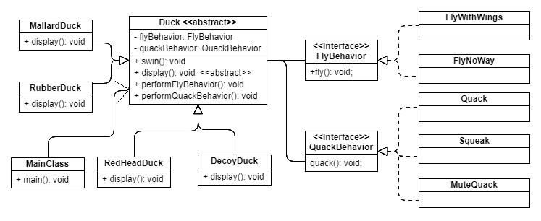

**Implement the class diagram and demonstrate the simulation in the main class.**

**[generate ducks of various types on the request of user input and display its behaviors. ]**