Book one way outstation cab and display the lowest charges

Software Requirements Specification

|  |  |  |  |
| --- | --- | --- | --- |
|  | Prepared By | Reviewed By | Approved By |
| Name | Sawan Kumar |  |  |
| Role | GenC |  |  |

**Table of Contents**

Table of Contents…………………………………………………………..…..Pg No

1. Introduction…………………………………………………………………..…3

1.1 Intended Audience………………………………………………...... 3

1.2 Project Scope…………………………...……………………………3

2. Overall Description…………………………………………….……………….3

2.1 Operating Environment……………………...……………………....3

3. Requirements……………………………………………………………...…….4

3.1 REQ_001…………………………………………………………….4

3.2 REQ_002……………………………………………….....................5

3.3 REQ_003.……..…………………………..........................................5

**1. Introduction**

MakeMyTrip is travelling site for travel services including airline tickets, domestic and international holiday packages holiday packages, hotel reservations, rail, and bus tickets. We are performing the test to

* To verify the "SEARCH" functionality of "Cabs" by providing valid inputs
* To verify the functionality of "Gift Cards" by providing invalid email id
* To verify the functionality of "Hotels" to extract numbers for Adult persons
* To verify all possible fields available for the functionalities

**1.1 Intended Audience**

* Business Unit (BU) SME
* Academy coach
* Technical Trainer

**1.2 Project Scope**

* This document defines at a functional level the business activities that are encompassed by the system and the rules that apply to them. It also encompasses some of the key high- and low-level technical requirements of the system.
* It draws heavily on both proposed Framework and Business Rules and the Technical Architecture documents. The scope of the detailed analysis project phase specifies that this document will include.
* Classification of requirements according to their functional areas.
* A description of each process in the system, including their inputs, outputs, and data transformation rules.

**2. Overall Description**

**2.1 Operating Environment**

* Windows operating system
* Website

**3. Requirements**

**Pre-Requirement**

‘Make My Trip’ website should be opened- <https://www.makemytrip.com/>

**3.1 REQ_001-** To verify the "SEARCH" functionality of "Cabs" by providing valid inputs.

* Select the “Cabs” button
* Select the ‘from’ textbox and send ‘Delhi’.
* Select the ‘to’ textbox and send ‘Manali, Himachal Pradesh, India
* Select the ‘departure date’ from calendar.
* Select the ‘return date’ from calendar.
* Select the ‘pickup time’ from dropdown
* Select the ‘return time’ from dropdown
* Click on the search button

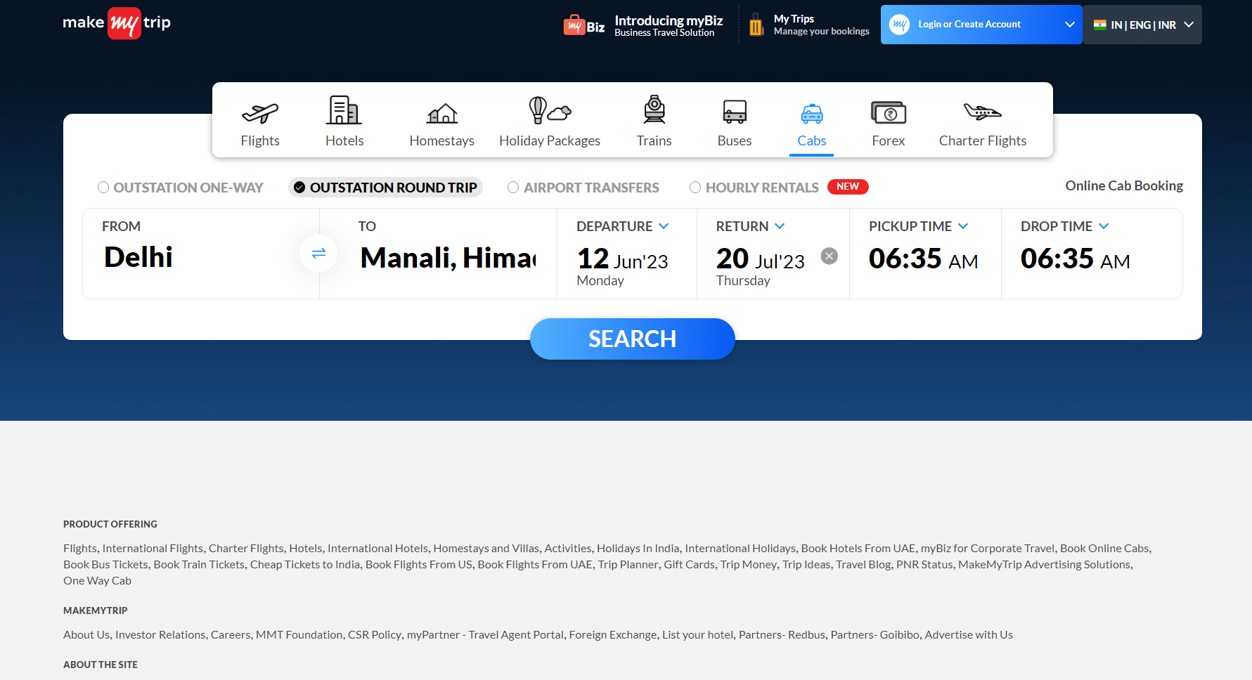

**3.2 REQ_002** **To verify the functionality of "Gift Cards" by providing invalid email id**

* Select the ‘Gift Cards’ from the menu option.
* Click the email button and fill the data with invalid ‘email Id’.
* A screenshot of a computer

  Description automatically generated with low confidenceCapture the error message

**3.3 REQ_003-** To verify the functionality of "Hotels" to extract numbers for adult persons.

* Select hotel from the menu.
* Select Room and Guest textbox.
* Extract total number of Adults.

