RoyalStay Luxury Hotel Website Template
Theme: Royal Blue & Off-White
Style: Luxury, Premium, Classy
Layout: Full Vertical Scrolling Website
Sections Included:
• Hero Section (Luxury Banner)
• Rooms Section (Deluxe, Royal, Premium)
• Gallery Section
• Location with Map
• Contact Form

Website Preview (Full Scroll Design)
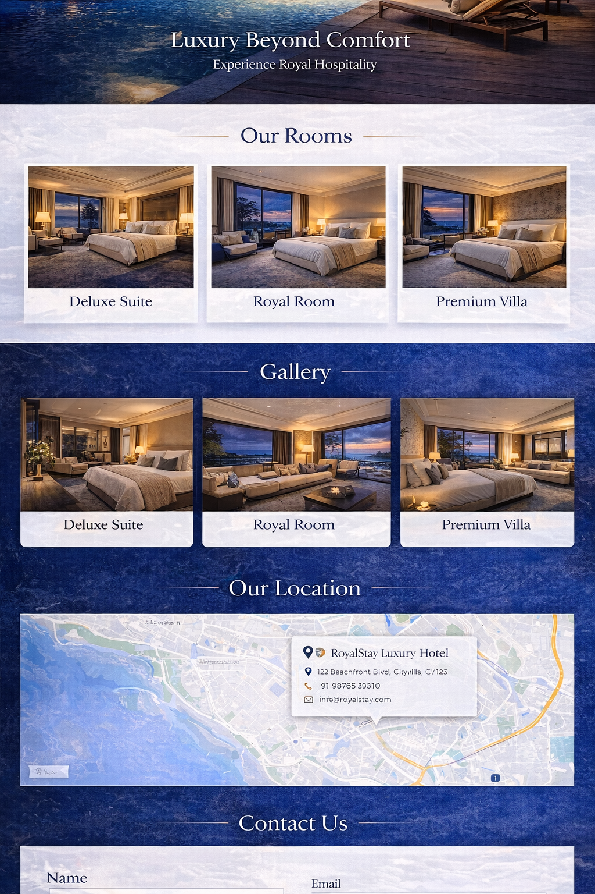

Features
✔ Mobile Responsive Design
✔ Smooth Scrolling Navigation
✔ Luxury UI Cards for Rooms
✔ Gallery Grid Layout
✔ Google Map Integration
✔ Contact Form Section
✔ Ready for Booking System Integration

Next Upgrade Options
• Booking System with Date Selection
• Room Availability Management
• Login & Registration
• Admin Dashboard
• Backend with Database

