Alex Torres

EE6973

10/20/2016

Assignment 4

1. For this section of the assignment I used most of the code from the tutorial. I varied the learning rate and also the number of epochs and found I couldn’t get any greater than 47% accuracy on the test data set. For this accuracy, I used an exponential decay learning rate of 0.0008 (tutorial default), 1000 epochs, and tensorflow’s gradient descent optimizer. The error is plotted on the y-axis and the number of epochs on the x-axis, with final accuracy on test set shown above the plot.

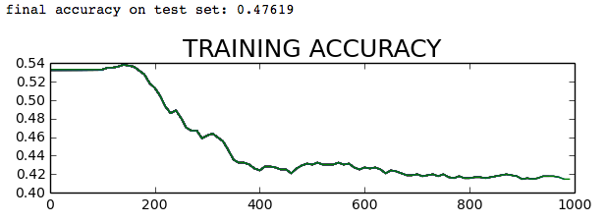

b) After adding a layer of nodes I was able to achieve 100% accuracy on the test data set. For this accuracy, I used 1000 epochs and tensorflow’s momentum optimizer with a learning rate of 0.01 and momentum set to 0.1. The error is shown on the y-axis and number of epochs on the x-axis with final accuracy on test set shown above the plot.

