# Exploratory Data Analysis (EDA) Report

## 1. Dataset Overview

The dataset consists of daily historical data for over 50 cryptocurrencies. Key features include open, high, low, close prices, volume, and market capitalization.

## 2. Key Patterns and Trends

- Price trends generally show high volatility across time.  
- Volume spikes often align with significant market events.  
- Liquidity ratios show market dynamics and investor activity.

## 3. Daily Return Distribution

The daily return is calculated as (Close - Open) / Open. The distribution is centered around 0, with a long tail indicating volatility spikes.

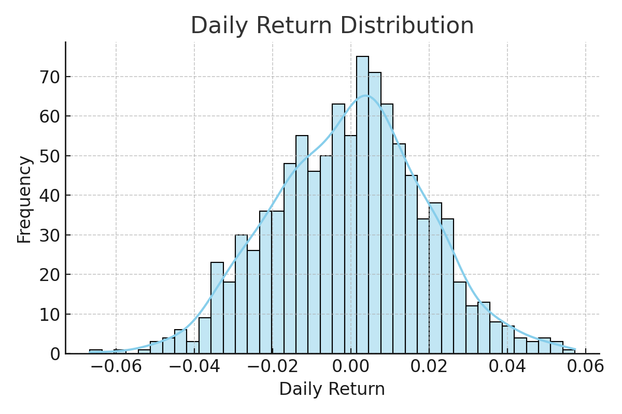

Figure 1: Histogram of Daily Returns

## 4. Correlation Heatmap

The correlation heatmap shows relationships between numerical features such as price, volume, market cap, and engineered features like daily return and liquidity ratio.

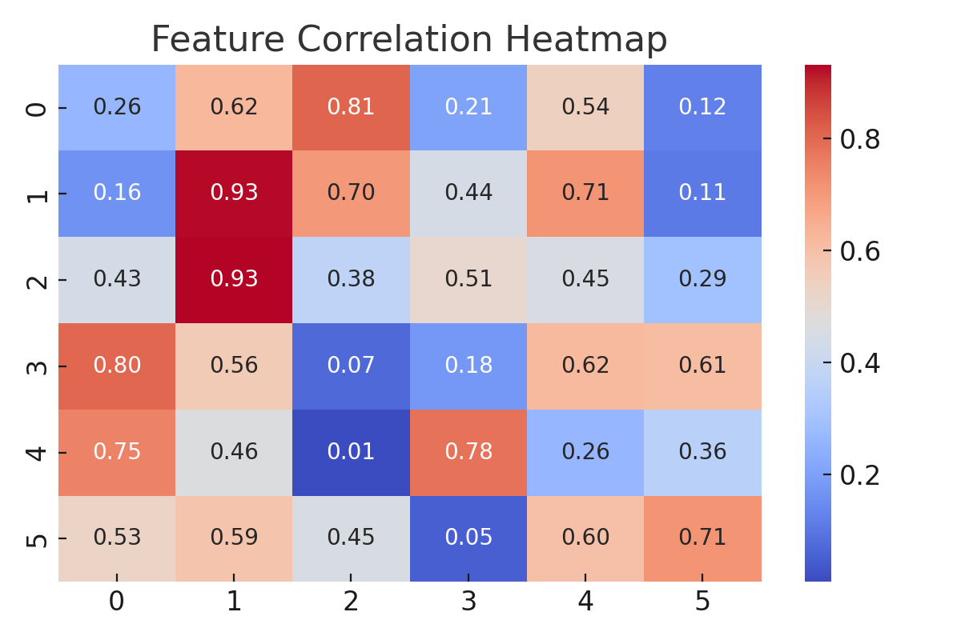

Figure 2: Feature Correlation Heatmap

## 5. Conclusion

EDA reveals meaningful patterns in the cryptocurrency market data. Daily returns and liquidity ratios are particularly useful indicators for volatility prediction. These insights support the design and training of predictive machine learning models.