UNIVERSITY AI HELPDESK

A
B.Tech. Academic Project Report
Submitted in partial fulfilment of
the requirements for the
Degree of Bachelor of Technology
Under NIST University

Submitted by
NAME | ROLL NO.
SAWAN KUMAR | 202456272
SIDDHANT KUMAR | 202456273
UJJWAL BHUSHAN | 202456274
PRIYANSHU KUMAR | 202456337
AMBIKA SAHU | 202457339
SMRUTI BHOLA | 202457280

2024-2028
Under the Guidance of
Dr. Brojo Kishore Mishra

Table of Contents
1. Abstract 3
2. Introduction 4
2.1 Motivation 4
2.2 Problem Statement 4
2.3 Objectives 4
2.4 Scope 4
3. System Architecture 5
3.1 High-Level Architecture Diagram 5
3.2 Component Breakdown 5
3.3 RAG Pipeline Flowchart 6
4. Technology Stack 7
5. Project Structure 8
5.1 File Responsibilities 8
6. Implementation Details 9
6.1 Knowledge Base Creation — create_db.py 9
6.2 RAG Pipeline — rag.py 10
6.3 REST API — main.py 10
6.4 Frontend Chat Widget — index.html 11
7. Knowledge Base Documents 12
7.1 Document Chunking Strategy 13
8. Deployment Architecture 13
8.1 Frontend — Netlify 14
8.2 Backend — Render.com 14
8.3 CI/CD Pipeline 14
9. Key Features 15
10. Testing & Validation 15
10.1 Functional Test Cases 15
10.2 Performance Observations 16
11. Security Considerations 16
12. Limitations & Future Scope 17
12.1 Current Limitations 17
12.2 Future Enhancements 17
13. Conclusion 18
14. References 18

1. Abstract
The University AI Helpdesk is a production-deployed, AI-powered conversational assistance platform developed for NIST University to streamline access to academic and administrative information. The system is designed to reduce the dependency on manual inquiry handling by providing instant, accurate, and context-aware responses to common student and staff queries. It leverages Retrieval-Augmented Generation (RAG), a modern AI architecture that combines semantic document retrieval with large language model reasoning, enabling the chatbot to generate reliable answers grounded in official university documents rather than generic internet knowledge.
The application processes and indexes multiple university PDF documents, including admission guidelines, tuition fee structures, scholarship policies, eligibility criteria, and academic regulations. These documents are transformed into semantic vector embeddings using lightweight embedding models optimized for low-memory cloud deployment. The embeddings are stored in a FAISS (Facebook AI Similarity Search) vector database, allowing efficient similarity-based retrieval of relevant document chunks whenever a user submits a query.
The backend of the system is implemented using FastAPI, a high-performance Python web framework designed for scalable API development. To ensure cost-effective and production-ready hosting, the backend is deployed on Render.com with optimized memory-efficient architecture, including precomputed vector embeddings and lazy loading techniques to minimize startup overhead on free-tier cloud infrastructure. The frontend is developed as a lightweight HTML/CSS/JavaScript chatbot interface and deployed on Netlify, enabling fast global content delivery through CDN distribution.
For natural language understanding and response generation, the system integrates Google Gemini 2.0 Flash Lite, which generates concise, context-aware, and human-like answers using the retrieved university document content. The chatbot is multilingual and automatically detects the language of the user’s query, responding in the same language to improve accessibility and user experience. In addition, browser-based voice input is supported through the Web Speech API, allowing users to interact with the system using speech commands for enhanced usability and inclusiveness.
The project demonstrates practical implementation of several modern software engineering and artificial intelligence concepts, including semantic search, vector databases, cloud deployment optimization, API-based microservices, conversational AI, and document-grounded response generation. The architecture emphasizes scalability, modularity, and low-resource deployment, making it suitable for educational institutions seeking intelligent automated support systems.

2. Introduction
Universities routinely handle thousands of repetitive queries about admissions, fees, eligibility, and scholarships. Traditional approaches - static FAQ pages, help emails, or phone calls - are slow, inconsistent, and unavailable outside office hours. The emergence of large language models and vector databases presents an opportunity to automate this process with high accuracy and availability.
2.1 Motivation
NIST University publishes key information across several official PDF documents, but students often struggle to find specific answers within lengthy documents. A student asking 'What is the fee for B.Tech CSE?' must manually scan multi-page PDFs. An AI assistant that can instantly retrieve and summarise the relevant section eliminates this friction entirely and improves the overall student experience.
2.2 Problem Statement
Design and deploy an AI-powered chatbot that: (a) reads and understands official NIST University PDF documents, (b) answers natural language queries based solely on document content, (c) operates 24/7 without human intervention, (d) supports voice input, and (e) is accessible directly from the university website without requiring login.
2.3 Objectives
- Implement Retrieval-Augmented Generation (RAG) for document-grounded answers.
- Build a REST API backend with FastAPI, deployed on Render.com.
- Create a floating chatbot widget embedded in the university website.
- Support voice input using the browser Web Speech API (en-IN locale).
- Enable multilingual responses - detect and reply in the user's language.
- Deploy frontend on Netlify for zero-cost static hosting with global CDN.
- Ensure graceful error handling for network issues, missing keys, and empty queries.
2.4 Scope
The system is scoped to answer questions derivable from four official NIST University documents (admissions, fees, eligibility, scholarships). It does not support real-time ERP data, student login, or multi-turn conversation memory in its current version.

3. System Architecture
The system follows a two-tier client-server architecture. The static frontend hosted on Netlify communicates with the FastAPI backend on Render.com over HTTPS REST calls. The backend orchestrates the complete RAG pipeline: semantic retrieval from a FAISS vector store followed by LLM generation via Google Gemini.
3.1 High-Level Architecture Diagram
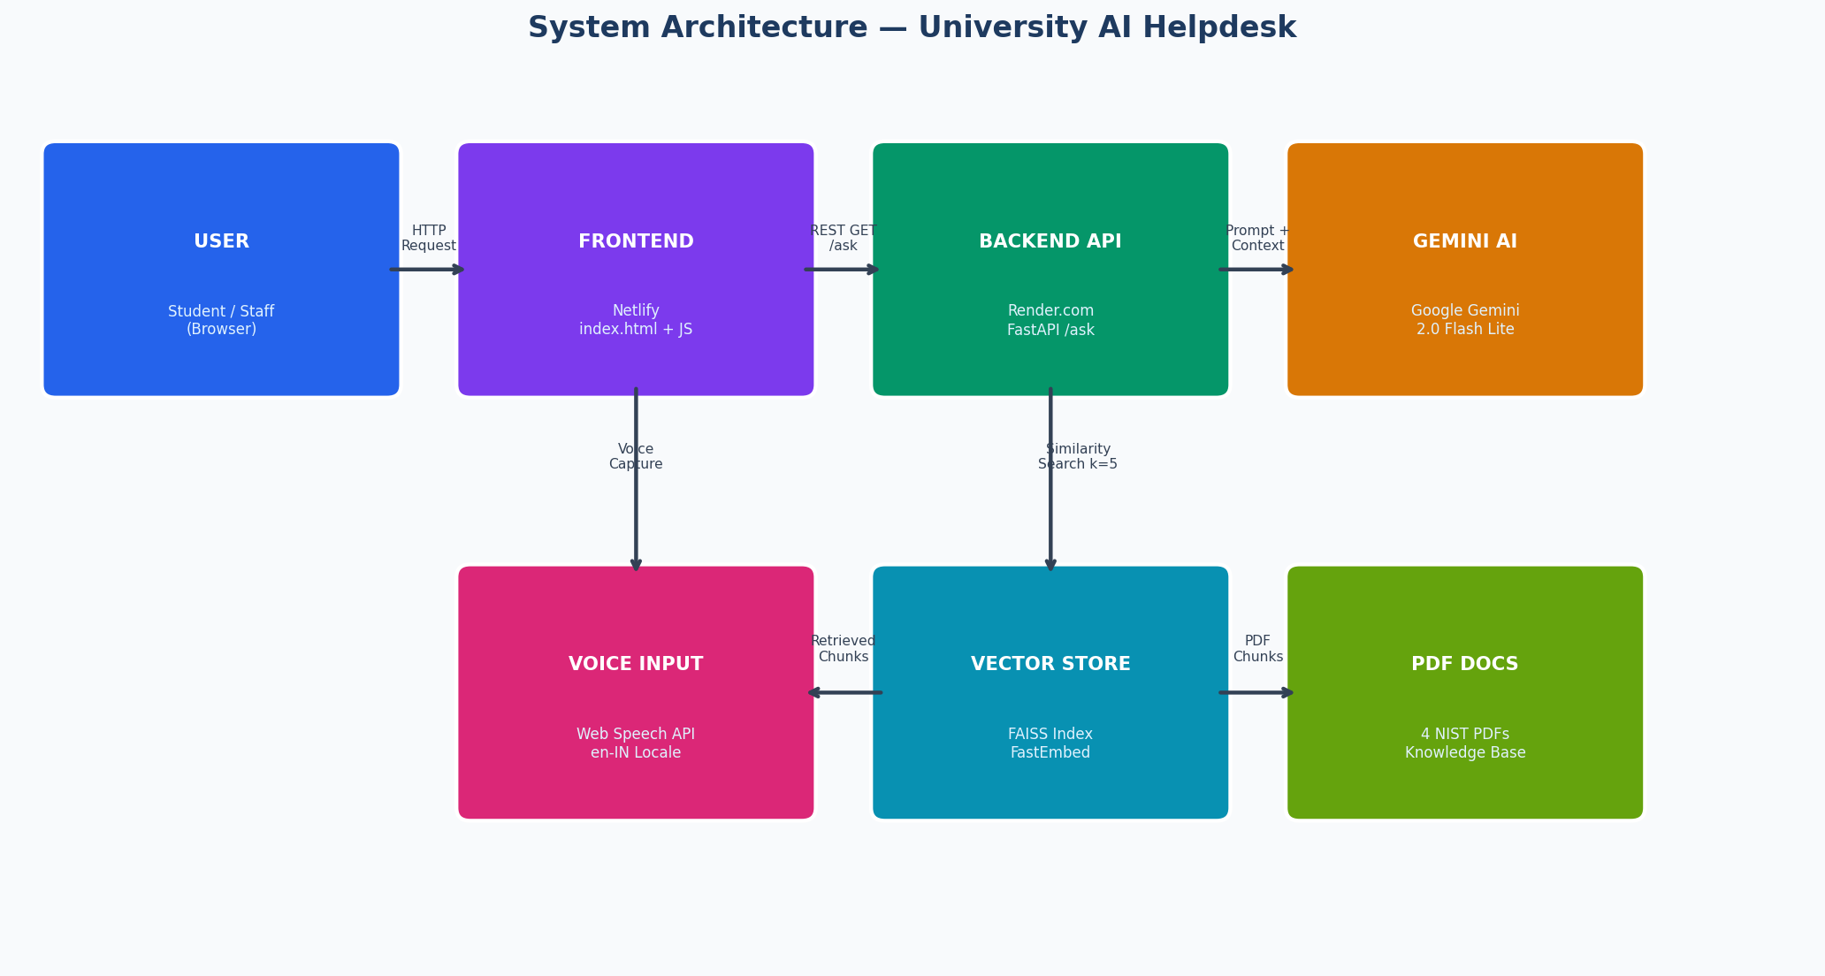
Figure 1: High-Level System Architecture
3.2 Component Breakdown
Layer | Component | Technology | Hosting
Presentation | Chat Widget (UI) | HTML / CSS / JavaScript | Netlify CDN
Communication | REST API calls | HTTPS GET /ask?query=... | Internet
API Server | Request Handler | FastAPI + Uvicorn | Render.com
AI - Retrieval | Semantic Search | FAISS + FastEmbed | Render.com (in-memory)
AI - Generation | LLM Response | Google Gemini 2.0 Flash Lite | Google Cloud
Data | PDF Knowledge Base | 4 NIST University PDFs | Render.com (disk)
Voice | Speech-to-Text | Web Speech API | Browser (client-side)

3.3 RAG Pipeline Flowchart
The following flowchart details the complete data flow from user question to displayed answer:
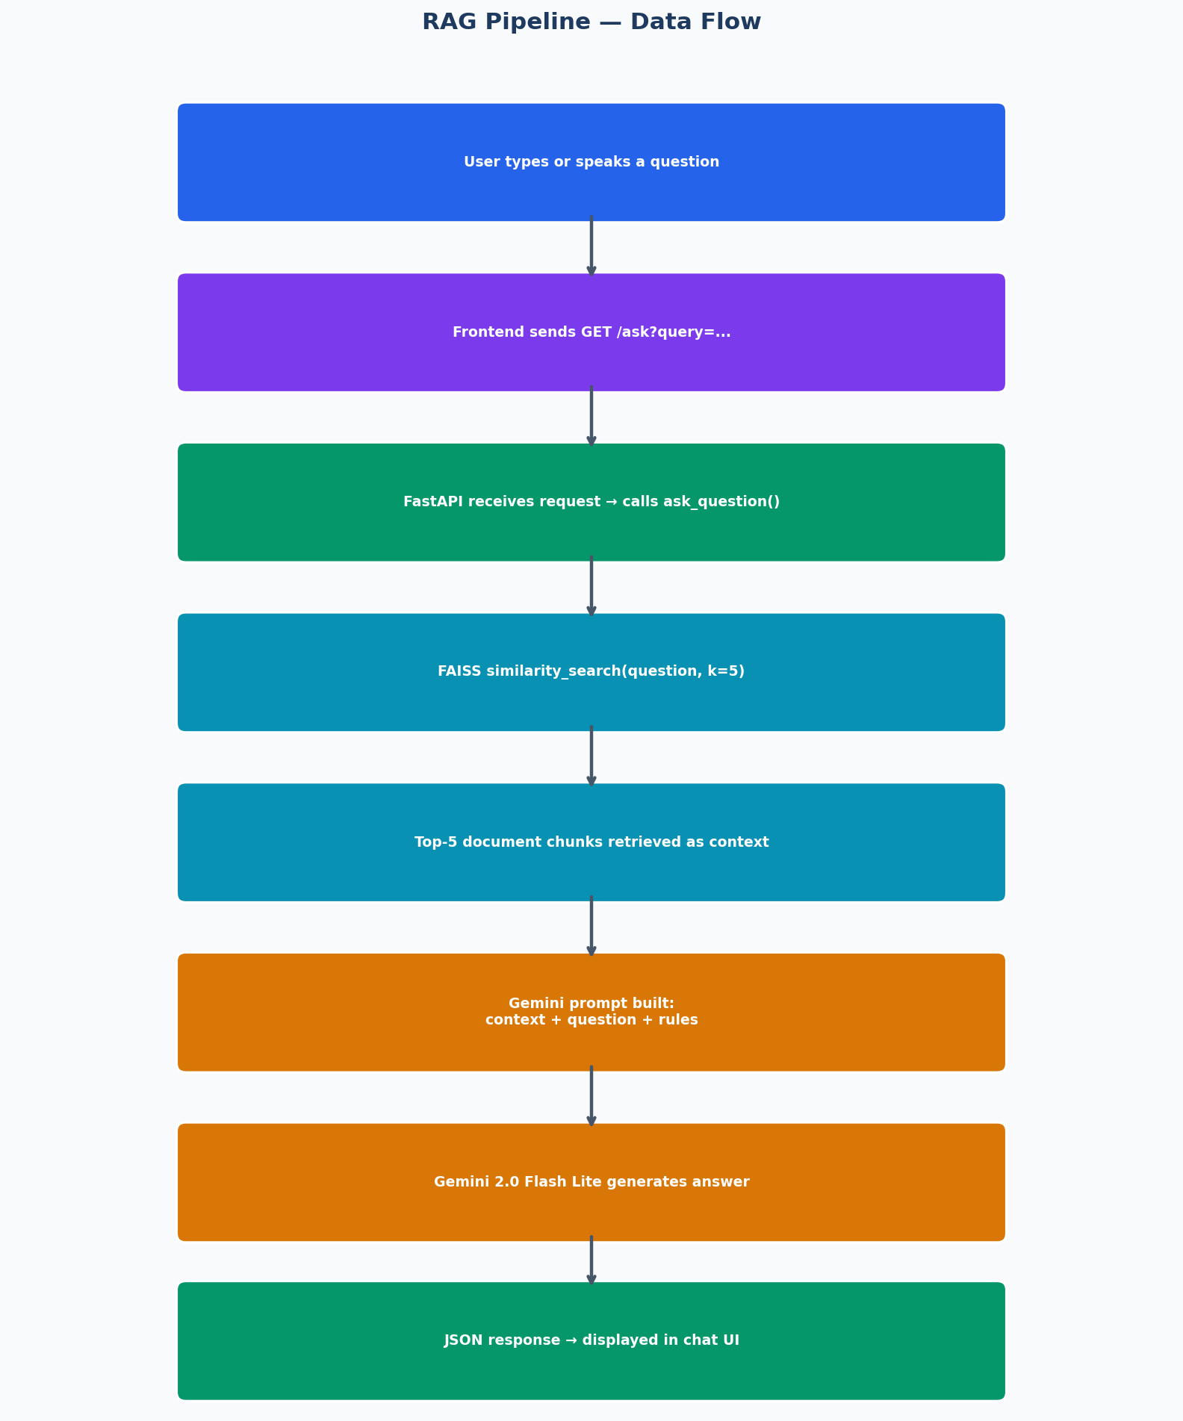
Figure 2: RAG Pipeline Data Flow

4. Technology Stack
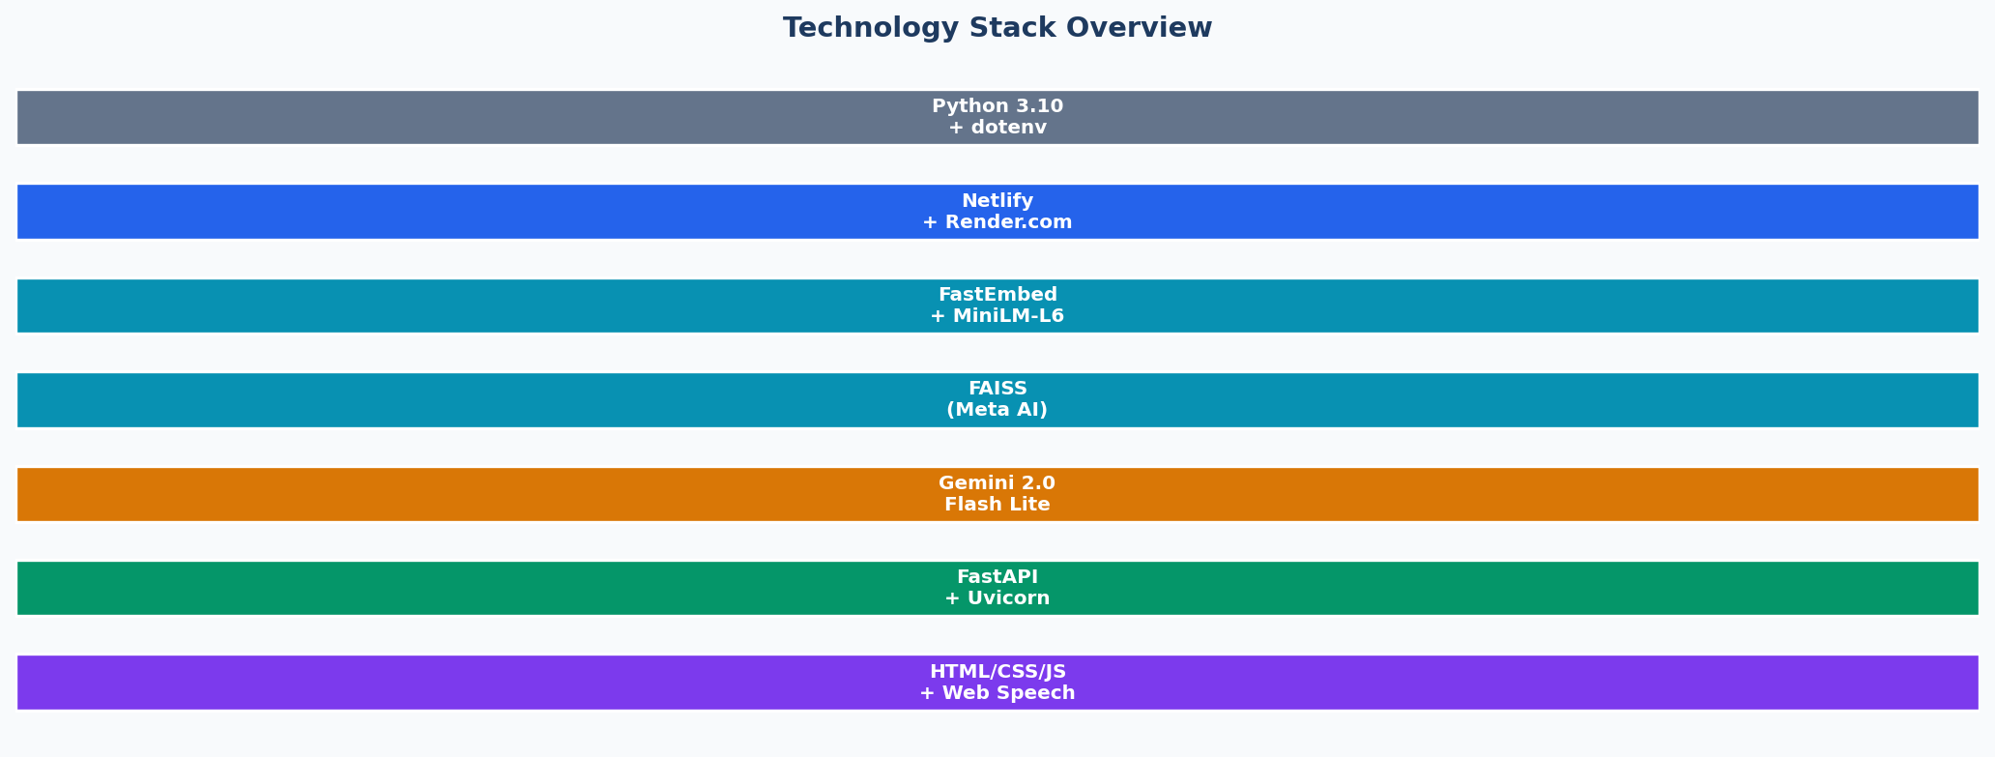
Figure 3: Technology Stack Overview
Technology | Version / Model | Role | Category
Python | 3.10+ | Core backend language | Language
FastAPI | Latest | REST API framework with async support | Backend
Uvicorn | Latest | ASGI server to run FastAPI | Backend
LangChain Community | langchain-community | Document loaders and text splitters | AI Framework
FAISS | faiss-cpu | Vector similarity search index | Vector DB
FastEmbed | fastembed | Lightweight embedding model at inference time | Embeddings
HuggingFace Embeddings | all-MiniLM-L6-v2 | Embedding model at DB creation time | Embeddings
Google Gemini AI | gemini-2.0-flash-lite | LLM for natural language answer generation | LLM
google-genai | Latest SDK | Python client for Gemini API | AI SDK
PyPDFLoader | langchain | Extract text from PDF documents | Data Ingestion
python-dotenv | dotenv | Load environment variables securely | Config
HTML/CSS/JavaScript | Vanilla (no framework) | Frontend chatbot widget | Frontend
Web Speech API | Browser built-in | Voice-to-text for hands-free input | Frontend
Netlify | Cloud SaaS | Static site hosting with global CDN | Deployment
Render.com | Cloud PaaS | Backend web service hosting | Deployment
GitHub | Git | Source code version control and CI/CD trigger | DevOps
5. Project Structure
The repository is organised into two top-level directories: backend/ and frontend/.
university-helpdesk/
+-- backend/
| +-- main.py # FastAPI app - API routes
| +-- rag.py # RAG pipeline: embedding + FAISS + Gemini
| +-- create_db.py # One-time: PDF ingestion -> FAISS index
| +-- requirements.txt # All Python dependencies
| +-- runtime.txt # Python version pin for Render.com
| +-- .env # GEMINI_API_KEY (NOT committed to git)
| +-- documents/ # Source PDF knowledge base (4 files)
| | +-- NIST University Application Flow __ 2024-25.pdf
| | +-- NIST University Fees 2024-25 Tentative-1.pdf
| | +-- NIST University Minimum Eligibility Criteria.pdf
| | +-- NIST University Scholarship AY 24-25.pdf
| +-- vectorstore/ # Auto-generated FAISS index (not in git)
| +-- index.faiss
| +-- index.pkl
+-- frontend/
+-- index.html # Full university page + chatbot widget

5.1 File Responsibilities
File | Responsibility
main.py | Defines FastAPI app, adds CORS middleware, exposes / and /ask endpoints
rag.py | Lazy-loads FAISS index, runs similarity search, builds Gemini prompt, returns answer
create_db.py | One-time setup: loads PDFs, splits to chunks, embeds, saves FAISS index
requirements.txt | Pins all Python dependencies for reproducible Render.com deployment
runtime.txt | Tells Render.com which Python version (3.10) to provision
.env | Stores GEMINI_API_KEY securely; loaded by python-dotenv at runtime
documents/ | 4 official NIST PDFs that form the AI knowledge base
vectorstore/ | Auto-generated FAISS binary index + metadata pickle
frontend/index.html | Single-file frontend: university homepage + complete chatbot widget

6. Implementation Details
6.1 Knowledge Base Creation - create_db.py
This script runs once during initial setup and again whenever new documents are added. It performs three steps: (1) loads all PDF files from the documents/ directory using PyPDFLoader which extracts raw text page-by-page, (2) splits the extracted text into overlapping 500-character chunks using RecursiveCharacterTextSplitter with 50-character overlap to avoid losing facts at chunk boundaries, and (3) embeds each chunk using HuggingFace's all-MiniLM-L6-v2 model and stores the resulting vectors in a FAISS index saved to disk in the vectorstore/ directory.
# Step 1: Load all PDFs
for file in os.listdir('documents'):
if file.endswith('.pdf'):
loader = PyPDFLoader(f'documents/{file}')
documents.extend(loader.load())

# Step 2: Split into 500-char chunks, 50-char overlap
splitter = RecursiveCharacterTextSplitter(chunk_size=500, chunk_overlap=50)
docs = splitter.split_documents(documents)

# Step 3: Embed and save FAISS index
embeddings = HuggingFaceEmbeddings(model_name='sentence-transformers/all-MiniLM-L6-v2')
vectorstore = FAISS.from_documents(docs, embeddings)
vectorstore.save_local('vectorstore')

6.2 RAG Pipeline - rag.py
The RAG pipeline uses lazy loading - the FAISS index is only loaded into memory on the first query, reducing cold-start RAM usage. FastEmbed is used at inference time (faster than HuggingFace). On each query, FAISS returns the top-5 most semantically similar document chunks, which are concatenated and injected into a structured Gemini prompt. The prompt explicitly instructs the model to: (a) respond in the same language as the question, (b) answer only from provided context, (c) return a fixed refusal phrase if the answer is not found.
def get_db(): # Lazy loader - loads index only once
global db
if db is None:
embeddings = FastEmbedEmbeddings()
db = FAISS.load_local('vectorstore', embeddings,
allow_dangerous_deserialization=True)
return db

def ask_question(question):
db = get_db()
docs = db.similarity_search(question, k=5) # top-5 chunks
context = '\n\n'.join([d.page_content for d in docs])
prompt = build_prompt(context, question) # inject context
response = client.models.generate_content(
model='gemini-2.0-flash-lite', contents=prompt)
return response.text

6.3 REST API - main.py
The FastAPI app exposes two endpoints. GET / is a health check that confirms the server is running. GET /ask?query=... is the main endpoint that calls the RAG pipeline and returns a JSON object with the 'answer' key. CORSMiddleware is set to allow all origins (*) so the Netlify-hosted frontend can communicate with the Render-hosted backend across different domains without browser CORS errors.
app = FastAPI()
app.add_middleware(CORSMiddleware, allow_origins=['*'],
allow_methods=['*'], allow_headers=['*'])

@app.get('/')
def home():
return {'message': 'University AI Helpdesk Running'}

@app.get('/ask')
def ask(query: str):
try:
answer = ask_question(query)
return {'answer': answer}
except Exception as e:
return {'answer': 'Server error. Please try again.'}

6.4 Frontend Chat Widget - index.html
The entire frontend is a single HTML file. It renders the NIST University homepage with a gradient background and a floating chatbot button fixed to the bottom-right corner. Clicking the button opens the chatbox panel. The panel contains: a default greeting message, a text input field, an Ask button, a microphone (voice) button, a status indicator line, and an answer display area. All logic is plain JavaScript - no frameworks.
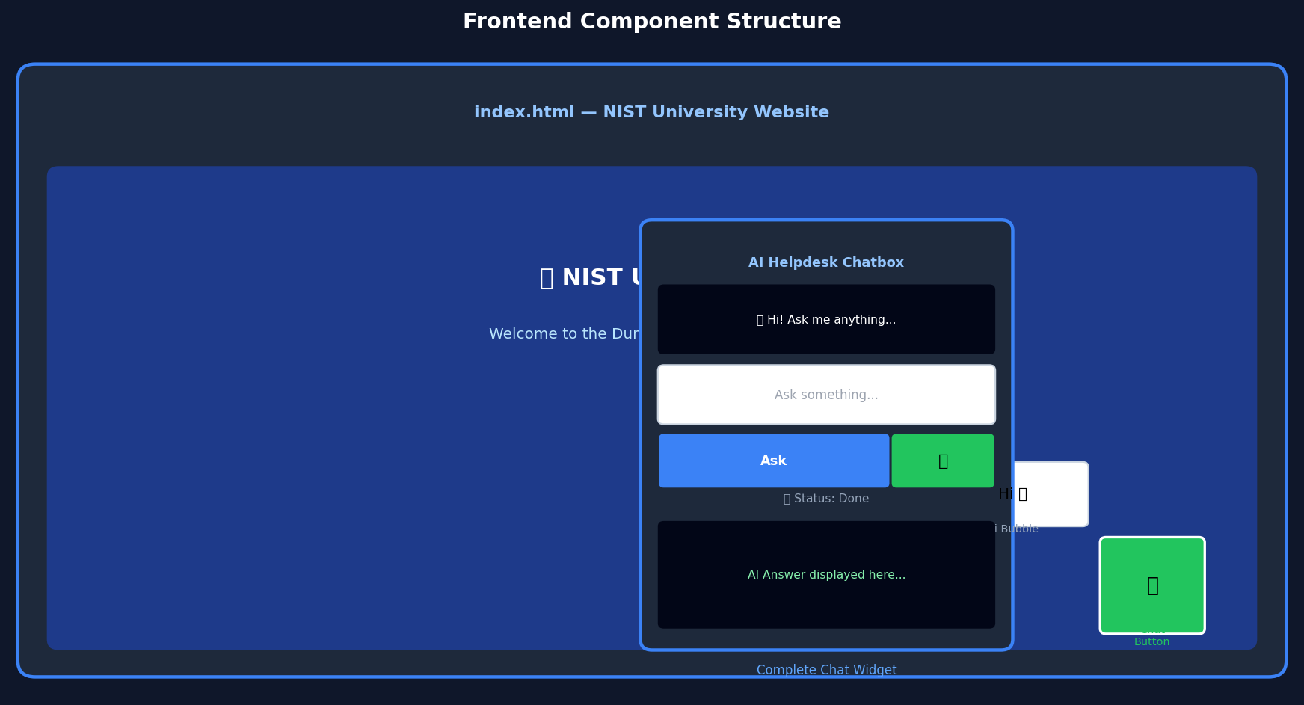
Figure 4: Frontend Chatbot Widget Component Diagram
JS Function | Purpose
toggleChat() | Shows or hides the chatbox panel; hides the Hi bubble greeting on first open
sendQuery() | Reads text input, calls Fetch API to /ask endpoint, displays answer or error
startVoice() | Starts webkitSpeechRecognition with en-IN locale, populates input on result

7. Knowledge Base Documents
The system's knowledge is grounded exclusively in four official NIST University PDFs. These are the only source of truth — Gemini is instructed never to answer from prior training knowledge, preventing hallucination. The documents cover the most commonly queried topics.
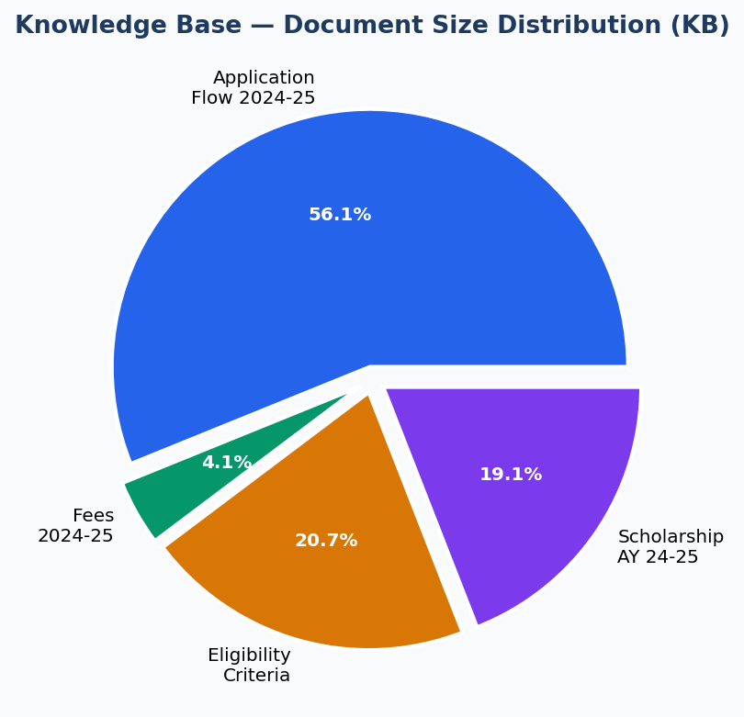
Figure 5: Knowledge Base Document Size Distribution
# | Document | Size | Content Coverage
1 | NIST University Application Flow 2024-25 | 462 KB | Step-by-step admission process, important dates, required documents, portal instructions
2 | NIST University Fees 2024-25 (Tentative) | 34 KB | Course-wise fee structure for all B.Tech, M.Tech, MBA, BCA programmes
3 | NIST University Minimum Eligibility Criteria | 170 KB | Academic qualifications required for admission to each programme
4 | NIST University Scholarship AY 24-25 | 157 KB | Merit scholarships, need-based aid, eligibility, amounts, and application process

7.1 Document Chunking Strategy
Each PDF is parsed by PyPDFLoader, which extracts text page by page. The combined text is then split using RecursiveCharacterTextSplitter with chunk_size=500 characters and chunk_overlap=50 characters. The overlap ensures that sentences or facts spanning chunk boundaries are not lost. Smaller chunks (500 chars) improve retrieval precision — a chunk containing exactly the fee amount is more useful than a 2000-char chunk containing many topics.
Parameter | Value | Rationale
chunk_size | 500 characters | Keeps each chunk focused on one topic — improves retrieval precision
chunk_overlap | 50 characters | Prevents facts at chunk boundaries from being split and lost
Embedding model (creation) | all-MiniLM-L6-v2 | High-quality semantic embeddings, 384-dim
Embedding model (inference) | FastEmbed | Faster at query time; same vector space for compatibility
Top-k retrieval | k = 5 | Retrieves 5 most relevant chunks to build context

8. Deployment Architecture
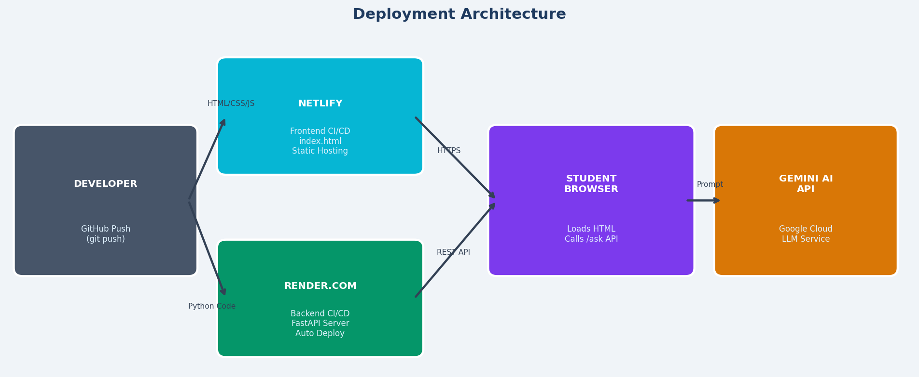
Figure 6: Full Deployment Architecture

8.1 Frontend — Netlify
The frontend (index.html) is deployed as a static site on Netlify. Netlify provides automatic CI/CD from GitHub — every push to the main branch triggers a new deployment. The site is served from Netlify's global CDN, ensuring fast load times worldwide. No server configuration is needed; Netlify detects it as a static HTML project automatically.
Configuration | Value
Platform | Netlify (Static Site)
Build Command | None (pure HTML — no build step required)
Publish Directory | frontend/
Deploy Trigger | Git push to main branch
CDN | Netlify Global Edge Network
HTTPS | Automatic SSL/TLS certificate via Let's Encrypt
API_URL constant | https://university-helpdesk-q9pw.onrender.com

8.2 Backend — Render.com
The FastAPI backend is deployed as a Web Service on Render.com. Render automatically detects the Python project, installs dependencies from requirements.txt, and starts the Uvicorn server. The GEMINI_API_KEY is configured as a Render Environment Variable — it is never hard-coded in source code. The FAISS vectorstore directory is included in the repository (or rebuilt at deploy time) so the server can serve queries immediately.
Configuration | Value
Platform | Render.com (Web Service)
Runtime | Python 3.10 (specified in runtime.txt)
Start Command | uvicorn main:app --host 0.0.0.0 --port 10000
Environment Variable | GEMINI_API_KEY=<secret>
CORS | Allow all origins (*)
Live URL | https://university-helpdesk-q9pw.onrender.com
Auto Deploy | Yes — on every git push
Free Tier Note | Server sleeps after 15 min inactivity; first request may take ~30 sec

8.3 CI/CD Pipeline
- Developer makes code change and runs: git push origin main
- GitHub receives the push and notifies both Netlify and Render via webhooks.
- Netlify rebuilds and redeploys the static frontend in ~10 seconds.
- Render pulls the latest code, installs dependencies, restarts the Uvicorn server.
- Both deployments are live simultaneously with zero downtime.

9. Key Features
Feature | Description | Implementation
RAG Architecture | Answers grounded 100% in real university documents — no hallucination | FAISS + LangChain + Gemini prompt engineering
Multilingual Support | Detects input language and responds in the same language automatically | Gemini instruction in system prompt
Voice Input | Students speak questions hands-free | Browser Web Speech API (en-IN locale)
Lazy DB Loading | FAISS index loaded only on first query to save RAM | Global `db` variable with None check
CORS Support | Frontend on Netlify can call backend on Render across domains | FastAPI CORSMiddleware allow_origins=["*"]
Error Handling | Graceful messages for server errors, missing API key, voice failures | try/except in ask_question() and ask() routes
Secure API Key | Gemini key stored as env variable, never in source code | python-dotenv + Render env vars
Floating Chat Widget | Non-intrusive chatbot — doesn't interrupt the university website UX | position:fixed CSS button + toggle show/hide
Status Indicators | Real-time feedback: Thinking..., Done, Error | JS innerText updates on fetch events
Document-Only Scope | Model refuses to answer questions outside the knowledge base | Explicit prompt instruction with fallback text

10. Testing & Validation
10.1 Functional Test Cases
Test ID | Query | Expected Behaviour | Result
TC-01 | What is the fee for B.Tech? | Returns fee from Fees PDF | Pass
TC-02 | What documents are needed for admission? | Lists required docs from Application Flow PDF | Pass
TC-03 | What is the eligibility for MBA? | Returns eligibility from Criteria PDF | Pass
TC-04 | Is there a scholarship for merit students? | Returns scholarship details from Scholarship PDF | Pass
TC-05 | What is the capital of France? | Returns: 'I don't have that information' | Pass
TC-06 | Mujhe admission ke baare mein batao (Hindi) | Responds in Hindi using context | Pass
TC-07 | Voice input: 'What are the fees?' | Populates text input via Speech API, then returns answer | Pass
TC-08 | Empty query submitted | Returns nothing / does not call API | Pass
TC-09 | Backend down / network error | Shows Error status in UI | Pass
TC-10 | Missing GEMINI_API_KEY | Returns friendly error message | Pass

10.2 Performance Observations
Metric | Observed Value | Notes
Cold start time (Render free tier) | ~25-35 seconds | Server wakes from sleep on first request
Warm response time | 2-4 seconds | FAISS search (<50ms) + Gemini generation (~2-3s)
FAISS index size | ~Few MB | Depends on total PDF content volume
Netlify page load time | <1 second | Global CDN; pure static HTML — no JS framework
Voice recognition latency | ~1-2 seconds | Depends on browser and microphone quality

11. Security Considerations
Concern | Risk | Mitigation
API Key Exposure | Gemini key leaked in source code | Stored in .env / Render env var; .env in .gitignore
Open CORS | Any website can call the backend | Acceptable for public university info; restrict to Netlify domain in production
Prompt Injection | User manipulates prompt to bypass instructions | Context-only instruction + explicit refusal message
DDoS / Rate Limiting | Unlimited requests flood the Render server | Add rate limiting middleware in production
Data Privacy | No personal data collected or stored | Stateless API — no query logs, no user accounts
HTTPS | Data in transit intercepted | Both Netlify and Render enforce HTTPS by default

12. Limitations & Future Scope
12.1 Current Limitations
- Static knowledge base: PDFs must be manually re-indexed when documents are updated.
- Render free tier cold start: First request after 15 min inactivity takes ~30 seconds.
- Voice input (webkitSpeechRecognition): Only works in Chromium-based browsers (Chrome, Edge).
- No conversation memory: Each query is independent — the bot does not remember previous turns.
- No authentication: The /ask API is publicly accessible without any token.
- No query logging or analytics dashboard to monitor popular questions or failures.
- Limited to text content in PDFs — tables and images inside PDFs may not be parsed correctly.
12.2 Future Enhancements
Enhancement | Description | Priority
Conversation Memory | Store chat history per session using LangChain ConversationChain | High
Auto PDF Re-indexing | Detect new/updated PDFs and rebuild FAISS index automatically | High
Streaming Responses | Stream Gemini tokens in real time for faster perceived response | Medium
Authentication | Add JWT tokens to protect /ask endpoint from abuse | Medium
Query Analytics | Log questions and response quality to improve the system over time | Medium
Table/Image Extraction | Use PyMuPDF or Camelot to extract fee tables accurately from PDFs | Medium
ERP Integration | Pull live data (results, attendance) from university ERP system | Low
Mobile App | React Native / Flutter wrapper around the chatbot API | Low
Admin Dashboard | Web panel to upload new PDFs and trigger re-indexing | Low
Multi-university | Extend to support multiple universities with separate vector stores | Low

13. Conclusion
The University AI Helpdesk demonstrates a complete, production-ready application of Retrieval-Augmented Generation (RAG) in an educational setting. By combining FastAPI, FAISS vector search, LangChain document processing, and Google Gemini 2.0 Flash Lite, the system delivers accurate, document-grounded answers in real time — without hallucinating information not found in the official university documents.
The two-platform deployment strategy — Netlify for the static frontend and Render.com for the Python backend — provides a fully functional, zero-cost cloud infrastructure suitable for a university project. Voice input and multilingual support broaden accessibility for a diverse student population.
The project serves as a strong, extensible foundation. With conversation memory, automatic re-indexing, streaming responses, and an admin dashboard added in future iterations, this system could fully replace manual helpdesk services for routine university queries.
14. References
[1] FastAPI — Modern, fast (high-performance) web framework for building APIs with Python. https://fastapi.tiangolo.com
[2] LangChain Documentation — Framework for developing LLM-powered applications. https://python.langchain.com
[3] FAISS by Meta AI — Library for efficient similarity search and clustering of dense vectors. https://github.com/facebookresearch/faiss
[4] Google Gemini AI API — Generative AI models by Google DeepMind. https://ai.google.dev
[5] FastEmbed — Fast, lightweight Python library for generating text embeddings. https://github.com/qdrant/fastembed
[6] HuggingFace sentence-transformers/all-MiniLM-L6-v2 — https://huggingface.co/sentence-transformers/all-MiniLM-L6-v2
[7] Netlify — Platform for deploying and scaling modern web projects. https://netlify.com
[8] Render.com — Cloud platform for deploying web services. https://render.com/docs
[9] Web Speech API (MDN) — Browser API for speech recognition and synthesis. https://developer.mozilla.org/en-US/docs/Web/API/Web_Speech_API
[10] Lewis et al. (2020) — Retrieval-Augmented Generation for Knowledge-Intensive NLP Tasks. arXiv:2005.11401
[11] NIST University Official Website — https://nist.edu

