Project - High Level Design
on ProjectTitle
  - Course Name:

Institution Name: Medicaps University – Datagami Skill Based Course

Student Name(s) & Enrolment Number(s):
Sr no | Student Name | Enrolment Number
1 | Siddharth Pagare | EN22CS301954
2 | Sawan Moyal | EN22CS301890
3 | Simran Goyal | EN22CS301959
4 | Saloni S Singh | EN22CS301847
5 | Shailee Gupta | EN22CS301896

Group Name:Group 07D8
Project Number:AAI-42
Industry Mentor Name:
University Mentor Name:Prof. Pradeep Baniya
Academic Year:2025-26

Table of Contents
1 Introduction
1.1 Scope of the Document
1.2 Intended Audience
1.3 System Overview
- System Design
2.1 Application Design
2.2 System Architecture
2.3 Process Flow
2.4 Information Flow
2.5 Component Design
2.6 Key Design Considerations
2.7 API Catalogue
- Data Design
3.1 Data Model Overview
3.2 Data Access Mechanism
3.3 Data Retention Policies
3.4 Data Migration
- Interfaces
4.1 User Interface
4.2 Backend Interface
- State and Session Management
- Caching Strategy
- Non-Functional Requirements
7.1 Security Considerations
7.2 Performance and Scalability
7.3 Reliability and Availability
7.4 Maintainability and Extensibility
- Architecture Diagrams
8.1 High-Level Architecture Diagram
8.2 Workflow Diagram
- Assumptions and Limitations
- Future Enhancements
- References

1. Introduction
1.1 Scope of the Document
This document presents the High-Level Design (HLD) for the Healthcare Planning Assistant Agent.
The purpose of this document is to describe the overall system architecture, major components, data flow, external interfaces, tools, APIs, and quality attributes of the system.
This HLD serves as a blueprint for system implementation. Detailed logic, algorithms, and code-level structures are described separately in the Low-Level Design (LLD).
The system focuses on AI-driven planning for healthcare workflows, converting high-level user goals into structured execution plans with dependencies and resource validation.

1.2 Intended Audience
This document is intended for:
- Faculty evaluators and academic reviewers
- Software architects and system designers
- Developers implementing agent-based AI systems
- Students studying Agentic AI system design

1.3 System Overview
The Healthcare Planning Assistant Agent is a goal-driven Agentic AI system designed to assist users in generating structured healthcare execution plans.
The system:
- Accepts healthcare-related goals through a command-line interface
- Uses CrewAI to orchestrate agent planning and execution
- Processes user intent using Large Language Models (LLMs) via LiteLLM
- Generates step-by-step healthcare workflows
- Maintains logical dependencies between steps
- Validates resource availability using a Resource Checker tool
- Produces a structured execution plan for the user

Unlike traditional chatbots, the system performs multi-step reasoning and task orchestration to simulate real-world healthcare planning scenarios.

2. System Design
2.1 Application Design
The system follows a modular, agent-based layered architecture consisting of:
Interaction Layer
- CLI-based user input and output
Reasoning Layer
- Planner Agent (CrewAI)
- LLM-based task decomposition and decision-making
Execution Layer
- Task sequencing
- Dependency management
- Resource validation
Configuration Layer
- Environment variables using .env
- API key management
At the core is the Main Controller, which coordinates:
- User input handling
- Planner Agent initialization
- Tool execution
- Result generation
This architecture ensures modularity, scalability, and easy extensibility.
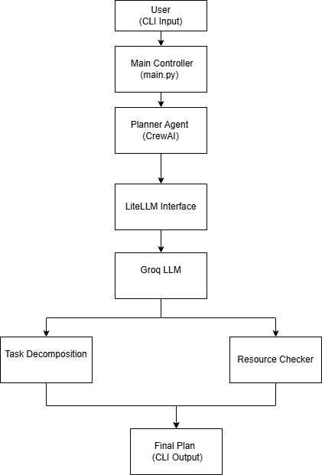

2.2 Process Flow
High-level execution flow:
- User enters a healthcare goal (e.g., “Treatment plan for fever”)
- Main Controller initializes the Planner Agent
- Planner Agent sends the goal to the LLM
- LLM generates a structured healthcare plan
- CrewAI manages execution and step sequencing
- Resource Checker validates each step
- Final execution plan is displayed to the user

This workflow demonstrates controlled autonomy with structured reasoning.

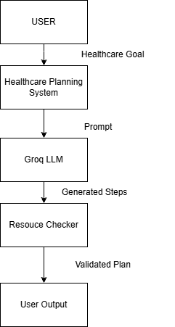

2.3 Information Flow
- Input: User healthcare Goal
- Intermediate Artifacts:
- Interpreted intent
- Generated task list
- Step dependencies
- Resource validation results

- Output: Structured healthcare execution plan

2.4 Component Design
The system consists of the following high-level components:
Main Controller (main.py)
Manages system execution, user interaction, and agent initialization.
Planner Agent (CrewAI)
Interprets user goals and generates ordered healthcare planning steps.
Task Module (planning_tasks.py)
Defines planning objectives and execution structure.
Resource Checker Tool
Validates the availability of required resources for each step.
LLM Integration (LiteLLM + Groq API)
Processes prompts and generates structured plans using AI reasoning.

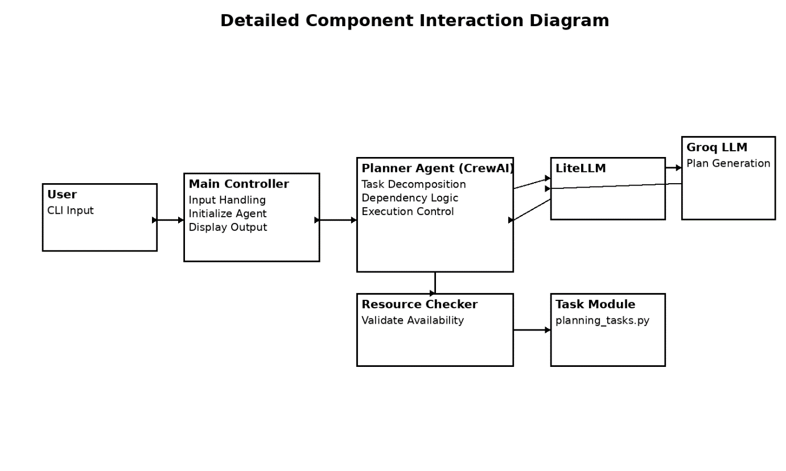

2.5 Key Design Considerations
- Modularity – Each module has a single responsibility
- Loose Coupling – Components communicate through defined interfaces
- Scalability – Easy addition of new tools or agents
- Controlled Autonomy – AI operates within defined planning boundaries
- Extensibility – Future support for web UI, database, or multi-agent systems

2.6 API Catalogue
API / Tool | Purpose
CrewAI | Agent orchestration and task execution
LiteLLM | Unified interface for LLM calls
Groq API | High-speed LLM inference
python-dotenv | Secure environment variable management

External Dependencies
- Groq LLM service
- CrewAI framework
- Python runtime environment

3. Data Design
3.1 Data Model Overview
Field | Description
Goal | User-provided healthcare objective
Steps | Generated planning steps
Dependencies | Execution order between steps
Resource Status | Availability validation results
Timestamp | Execution time

3.2 Data Access Mechanism
- Phase 1: In-memory processing (no persistent storage)
- Future Phase: File-based or database storage for plan history

3.3 Data Retention Policies
1. No personal or patient data stored
2. Data used only for academic demonstration
3. Temporary processing during execution

3.4 Data Migration
Future enhancement may include migration to database or cloud storage for maintaining planning history.

4. Interfaces
- User Interface: Command Line Interface (CLI)
- Backend Interface: Python module-based communication between components

5. State and Session Management
- Stateless execution for each user request
- Each goal processed independently
- No session persistence in current version

6. Caching Strategy
- Currently no caching implemented
- Future enhancement: cache frequently generated plans to reduce LLM calls

7. Non-Functional Requirements
7.1 Security Considerations
- API keys stored securely in .env
- No sensitive healthcare data processed
- Read-only interaction with external services

7.2 Performance and Scalability
- Fast inference using Groq API
- Lightweight CLI-based system
- Modular design supports scaling and feature extension

8. References
- CrewAI Documentation – https://docs.crewai.com
- LiteLLM Documentation – https://docs.litellm.ai
- Groq API Documentation – https://console.groq.com/docs
- Python Documentation – https://docs.python.org
- Agentic AI System Design Concepts – Academic resources

