HEALTHCARE PLANNING ASSISTANT AGENT
  - Course Name: Agentic AI

Institution Name: Medicaps University – Datagami Skill-Based Course

Student Name(s) & Enrolment Number(s):
Sr no | Student Name | Enrolment Number
1 | Siddharth Pagare | EN22CS301954
2 | Sawan Moyal | EN22CS301890
3 | Simran Goyal | EN22CS301959
4 | Saloni S Singh | EN22CS301847
5 | Shailee Gupta | EN22CS301896

Group Name: 07-D8
Project Number: AAI-42
Industry Mentor Name: Ms. Aashruti Shah
University Mentor Name: Prof. Pradeep Baniya
Academic Year: 2026

Table of Contents

- Abstract
- Introduction
- Problem Statement
- Objectives
- System Overview
- High-Level Architecture
- Activity Workflow
- Sequence Flow
  - Module Explanation
9.1 main.py
9.2 planner_agent.py
9.3 planning_tasks.py
9.4 resource_checker.py
- Data Flow & Processing
- Testing and Validation
- Advantages
- Limitations
- Future Enhancements
- Screenshots Section
- Conclusion

1. Abstract
The Healthcare Planning Assistant Agent is an AI-driven planning system designed to generate structured healthcare execution plans from high-level user goals. Unlike traditional chatbot systems that provide general responses, this system performs goal decomposition, dependency management, and resource validation to simulate real-world healthcare workflow planning.
The system utilizes CrewAI for agent orchestration, LiteLLM for unified model access, and Groq API for high-speed inference. It accepts healthcare objectives through a Command Line Interface (CLI) and produces detailed step-by-step plans.
This project demonstrates the practical implementation of Agentic AI with controlled autonomy, modular architecture, and scalable design.
2. Introduction
Modern healthcare planning requires structured decision-making and coordination across multiple steps. Traditional AI systems generate text responses but lack structured planning capabilities.
Agentic AI introduces intelligent agents capable of:
- Understanding goals
- Breaking them into actionable steps
- Managing dependencies
- Validating execution feasibility
This project implements a Planner Agent that converts healthcare goals such as:
- “Treatment plan for fever”
- “Pre-surgery preparation”
- “Post-discharge care plan”
into structured execution workflows.
The system highlights key Agentic AI concepts:
- Goal-based reasoning
- Sequential planning
- Tool integration
- Modular architecture

3. Problem Statement
Traditional AI healthcare assistants:
- Provide unstructured responses
- Do not maintain task order or dependencies
- Lack resource feasibility checks
The problem addressed:
Design an AI system that:
- Converts healthcare goals into structured plans
- Maintains logical execution order
- Validates resource availability
- Demonstrates controlled multi-step reasoning

4. Objectives
Primary Objective:
Develop a goal-driven healthcare planning system using Agentic AI.
Specific Objectives:
- Implement Planner Agent using CrewAI
- Enable multi-step task generation
- Maintain step dependencies
- Integrate Resource Checker tool
- Use LiteLLM with Groq API for fast inference
- Build a modular and scalable architecture

5. System Overview
The system consists of four layers:

1. Interaction Layer
- CLI for user input/output

2. Reasoning Layer
- Planner Agent (CrewAI)
- LLM-based task decomposition

3. Execution Layer
- Step sequencing
- Dependency handling
- Resource validation

4. Configuration Layer
- Environment variables (.env)
- API key management
Workflow:
User Goal → Planner Agent → LLM → Task Plan → Resource Check → Final Plan

6. High-Level Architecture Diagram
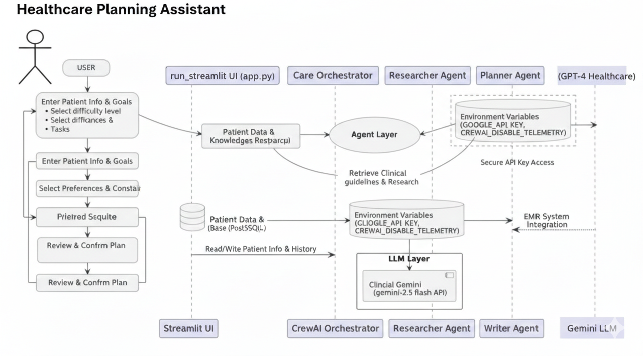
EXPLAINATION :
The High-Level Architecture diagram represents the structural organization of the Healthcare Planning Assistant Agent. It visually demonstrates how a user-provided healthcare goal flows through different system layers, where it is processed, analyzed, validated, and converted into a structured execution plan.
The architecture consists of:
• User Interface (Command Line Interface) – Handles user interaction by accepting healthcare goals and displaying the final structured plan.
• Application Layer (main.py) – Acts as the central controller. It manages user input, initializes the system, loads environment configurations, triggers the Planner Agent, and coordinates the overall workflow.
• Agent Layer (Planner Agent – CrewAI) – Performs goal interpretation and planning. The agent decomposes the healthcare objective into multiple actionable steps, maintains execution order, and manages dependencies between tasks.
• LLM Integration Layer (LiteLLM) – Serves as a unified interface for communicating with external language models. It formats prompts, sends requests, and returns structured responses to the Planner Agent.

• AI Processing Layer (Groq LLM) – Generates intelligent outputs by analyzing the healthcare goal and producing logically ordered planning steps using high-speed inference.
• Tool Layer (Resource Checker) – Validates the availability of required resources such as medicines, diagnostic tests, medical staff, and equipment to ensure the feasibility of each step.
• Data Processing Layer (In-Memory Execution) – Temporarily holds generated plans, dependencies, and validation results during execution. No persistent storage is used in the current version.
Architectural Flow
User → CLI -> main.py → Planner Agent → LiteLLM → Groq LLM → Generated Task Plan
-> Resource Checker Validation -> Final Structured Healthcare Plan Displayed to User

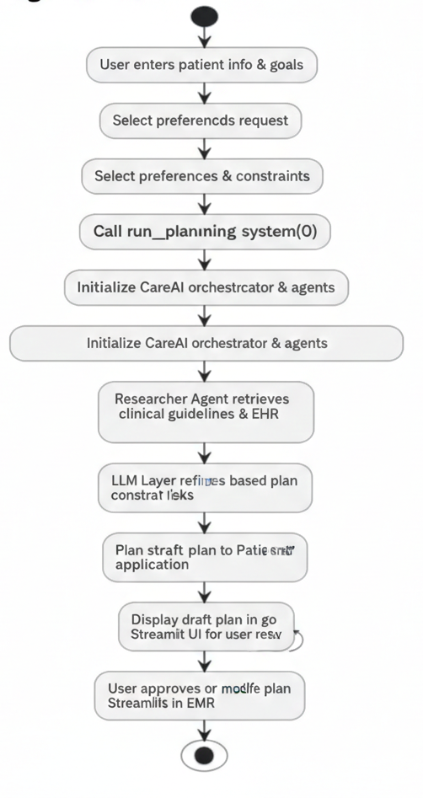
7. Activity Diagram

Explanation
The Activity Workflow diagram represents the step-by-step operational flow of the Healthcare Planning Assistant Agent. It shows how a user’s healthcare goal is processed and transformed into a structured and validated execution plan.:
The activity flow consists of:
• Start – System execution begins
• User Input – User enters a healthcare goal through CLI
• Agent Initialization – Main Controller activates the Planner Agent
• Goal Processing – Goal is sent to the LLM via LiteLLM
• Plan Generation – LLM generates structured healthcare steps
• Dependency Handling – Planner Agent organizes steps in logical order
• Resource Validation – Resource Checker verifies availability for each step
• Output Display – Final structured plan is shown to the user
• End – Execution completes

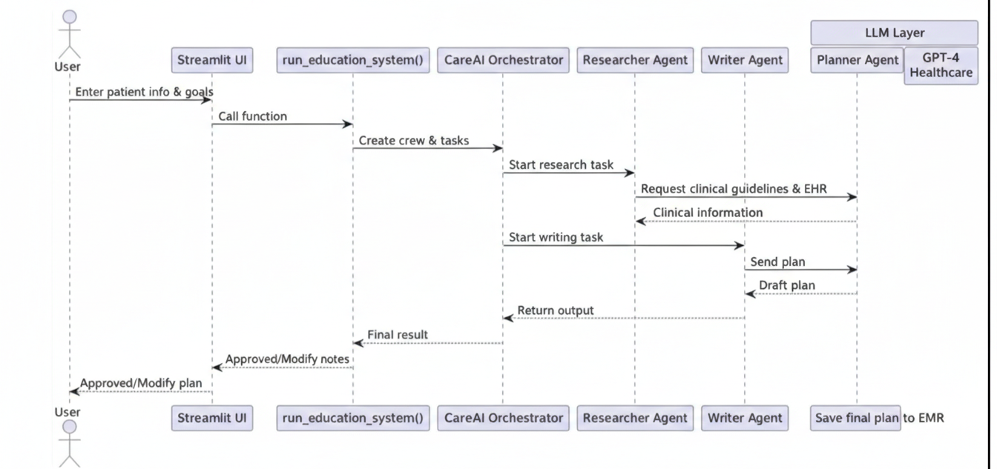
8. Sequence Diagram

Explanation
The Sequence Flow diagram illustrates the time-ordered interaction between the components of the Healthcare Planning Assistant Agent. It shows how the user request moves through the system and how each component collaborates to generate the final output.
The sequence flow includes:
• User Input – The user enters a healthcare goal through the CLI
• Request Handling – CLI sends the input to the Main Controller (main.py)
• Agent Activation – Main Controller initializes the Planner Agent
• LLM Processing – Planner Agent sends the goal to the LLM via LiteLLM
• Plan Generation – Groq LLM returns structured healthcare steps
• Resource Validation – Resource Checker verifies availability for each step
• Response Output – Final structured and validated plan is returned to the CLI and displayed to the user
This sequence ensures coordinated component interaction, structured processing, and reliable plan generation.

9. Detailed Module Explanation

9.1 main.py
This module acts as the central orchestration engine of the system. It manages user interaction, initializes system components, and controls the overall execution workflow.
The main function controls:
• Accepting healthcare goals from the CLI
• Loading environment variables (.env)
• Planner Agent initialization
• Task execution using CrewAI
• Displaying the final structured plan
This module coordinates the complete planning process from input to output.

9.2 planner_agent.py
This module defines the core Planner Agent responsible for goal interpretation and workflow generation.

Agent Defined
Agent | Role | Responsibility
Planner Agent | Healthcare Workflow Planning | Decompose user goal into structured steps, maintain order, and identify dependencies
The agent:
• Interprets healthcare objectives
• Generates step-by-step execution plans
• Ensures logical sequencing of tasks
The execution uses:
process = Process.sequential
This ensures controlled and ordered task generation.

9.3 planning_tasks.py
This module defines the planning structure and task templates used by the Planner Agent.
Responsibilities:
• Define planning objectives
• Structure the expected output format
• Guide the LLM to generate healthcare-specific workflows
• Maintain consistency in task generation
It ensures standardized and structured planning responses.

9.4 resource_checker.py
This module validates the feasibility of each generated step.
Responsibilities:
• Check availability of medicines
• Validate diagnostic tests and facilities
• Verify required medical resources or staff
• Return availability status for each step
This adds real-world feasibility to AI-generated plans.

10. System Workflow
The workflow ensures structured execution of healthcare planning.
Workflow Steps:
- User enters healthcare goal through CLI
- System initializes Planner Agent
- Goal is processed using LiteLLM and Groq
- Structured planning steps are generated
- Resource Checker validates each step
- Final structured plan is displayed to the user
This process ensures controlled reasoning and feasibility validation.

11. Testing and Validation
The system is tested using various functional scenarios.
Test Case | Input | Expected Output | Result
Basic Goal | Fever treatment | Structured plan generated | Pass
Complex Goal | Surgery preparation | Ordered workflow | Pass
Resource Check | Lab test required | Availability status shown | Pass
Multiple Runs | Different goals | Independent execution | Pass

12. Advantages
The system provides the following benefits:
• Goal-driven healthcare planning
• Modular and scalable architecture
• Structured and ordered workflow generation
• Resource feasibility validation
• Fast inference using Groq API
• Easy integration of additional agents or tools

13. Limitations
The current system has some limitations:
• CLI-based interface only
• No persistent database storage
• Sequential processing only
• Single-agent architecture
• No real-time hospital data integration

14. Future Enhancements
Future improvements may include:
• Web-based interface (Streamlit or React)
• Database for plan history
• Multi-agent system (Doctor, Nurse, Reviewer)
• Vector database for medical knowledge
• Parallel task execution
• Cloud deployment
• User authentication system

15. Screenshots Section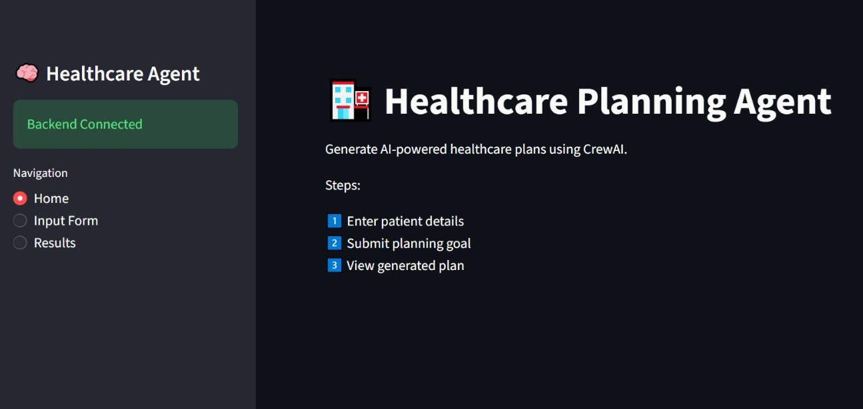
Fig. Healthcare Planning Assistant – Home Interface

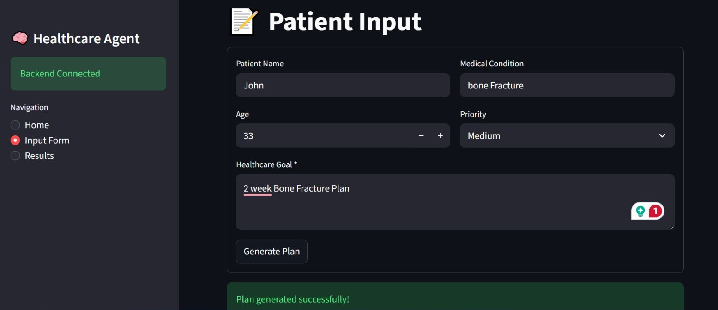

Fig. Patient Details and Healthcare Goal Input Form

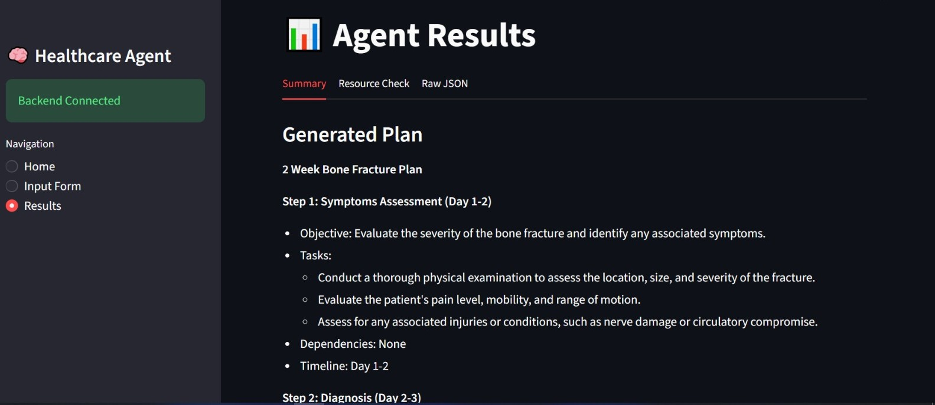Fig. Successful Healthcare Plan Generation Message

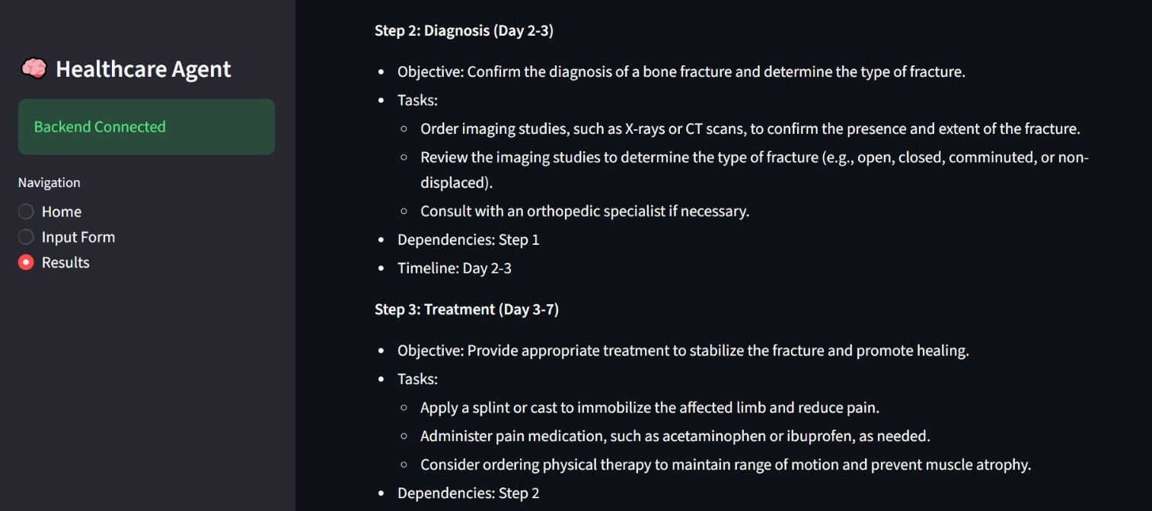Fig. Generated Healthcare Execution Plan (Summary Tab)
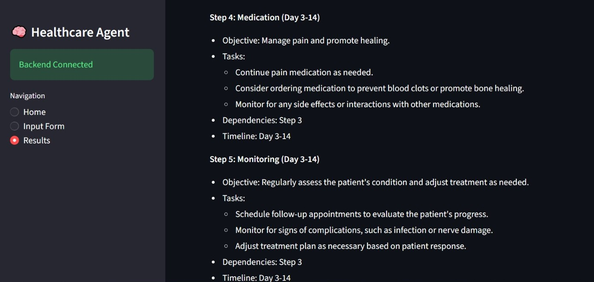

Fig. Detailed Planning Steps with Dependencies and Timeline

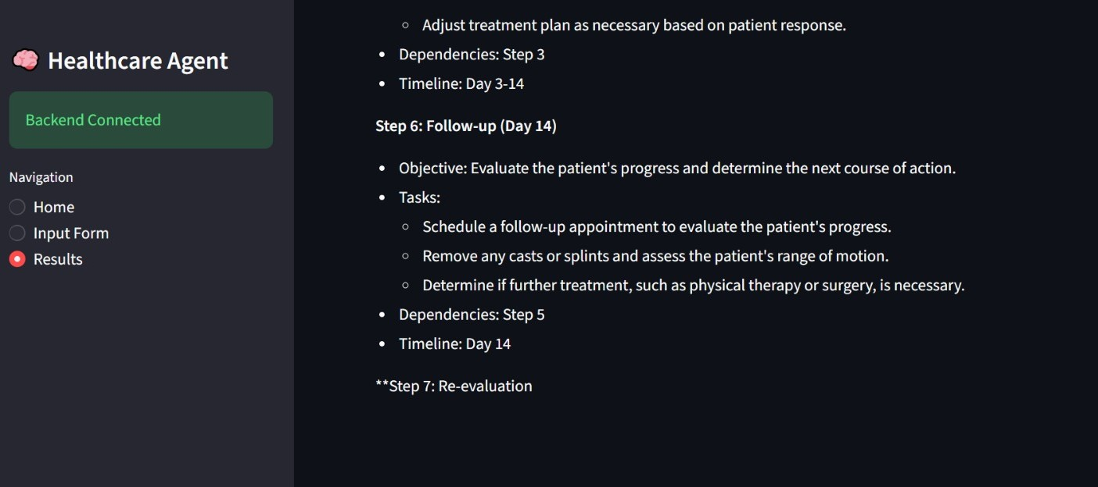

16. Conclusion
The Healthcare Planning Assistant Agent demonstrates the implementation of an Agentic AI system that converts high-level healthcare goals into structured and actionable execution plans. The system uses CrewAI for agent orchestration, LiteLLM for model integration, and Groq for fast AI processing.
With its modular architecture, dependency handling, and resource validation, the system ensures organized and practical healthcare planning. This project highlights key Agentic AI concepts such as goal-based reasoning, controlled execution, and tool integration, and provides a strong foundation for future enhancements like multi-agent support, database integration, and web deployment.

