**PIZZA SHOP MANAGEMENT**

**ABSTRACT**

The objective and scope of my Project Pizza shop management is to record the details various activities of user. It will simplifies the task and reduse the paper work. Pizza Ordering System rolled out to your area of responsibility. The system is very user friendly and it is anticipated that functions of the system

**OBJECTIVE**

To establish the market presence needed to support marketing and sales goals and to attract customers.to reach healthy sales rate.to expand locally and globally in the future.tp present our customer bettor-quality at a low-price and offer customer service that is second to none.

**STRUCTURE OF TABLE**

**CUSTOMERS:-**

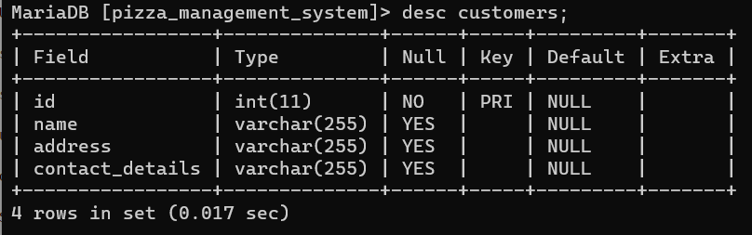

**DELIVERY :-**

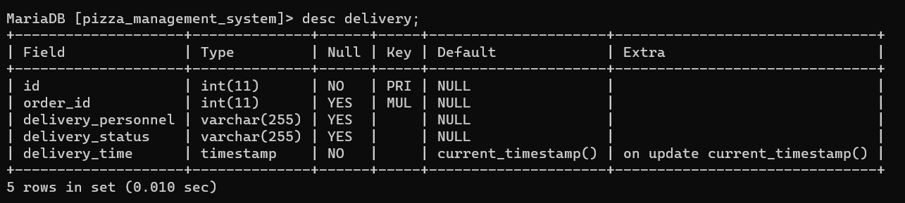

**INGREDIENTS :-**

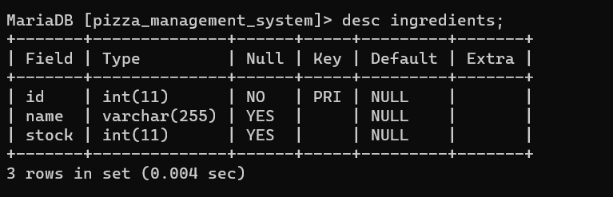

**ORDERS:-**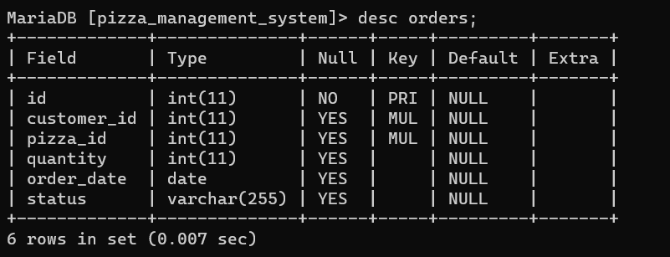

**PIZZAS :**

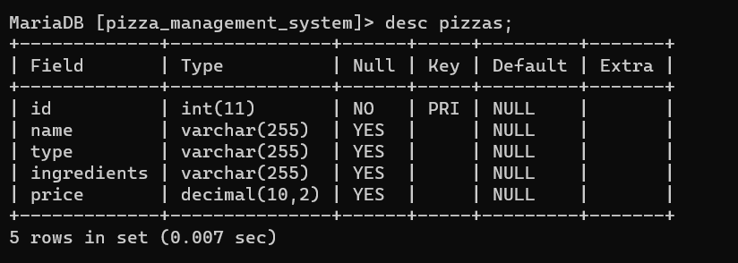

**CONTENTS OF TABLES**

**CUSTOMERS :-**

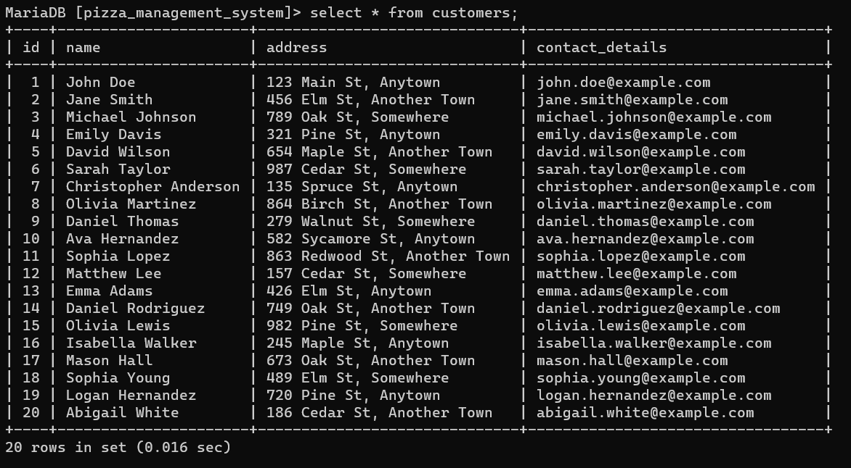

**DELIVERY :-**

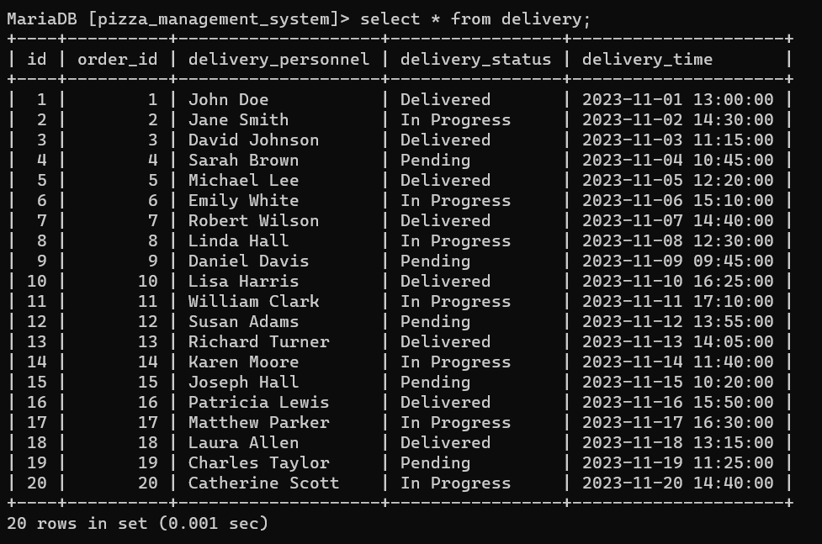

**INGREDIENTS :-**

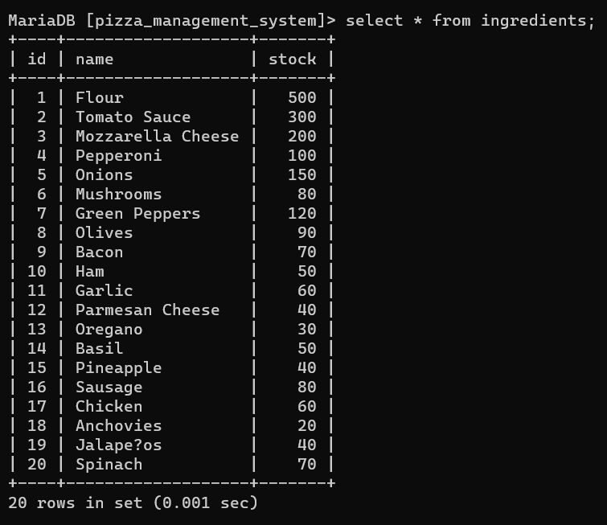

**ORDERS :-**

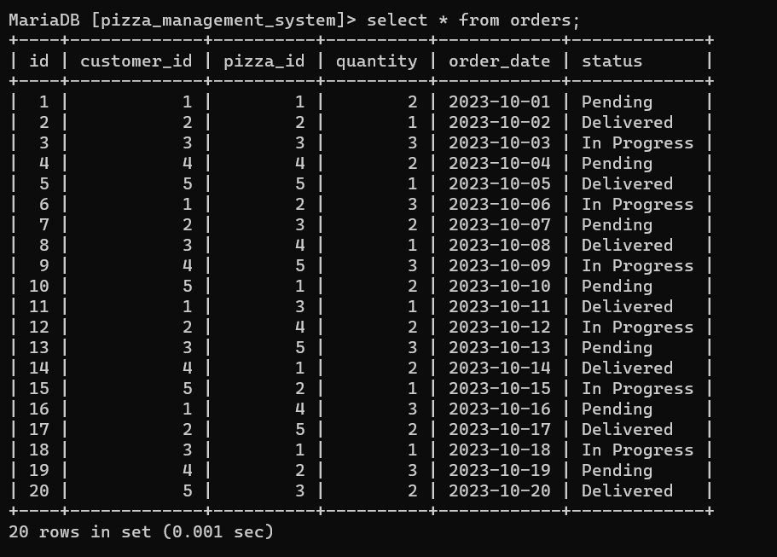

**PIZZAS :-**

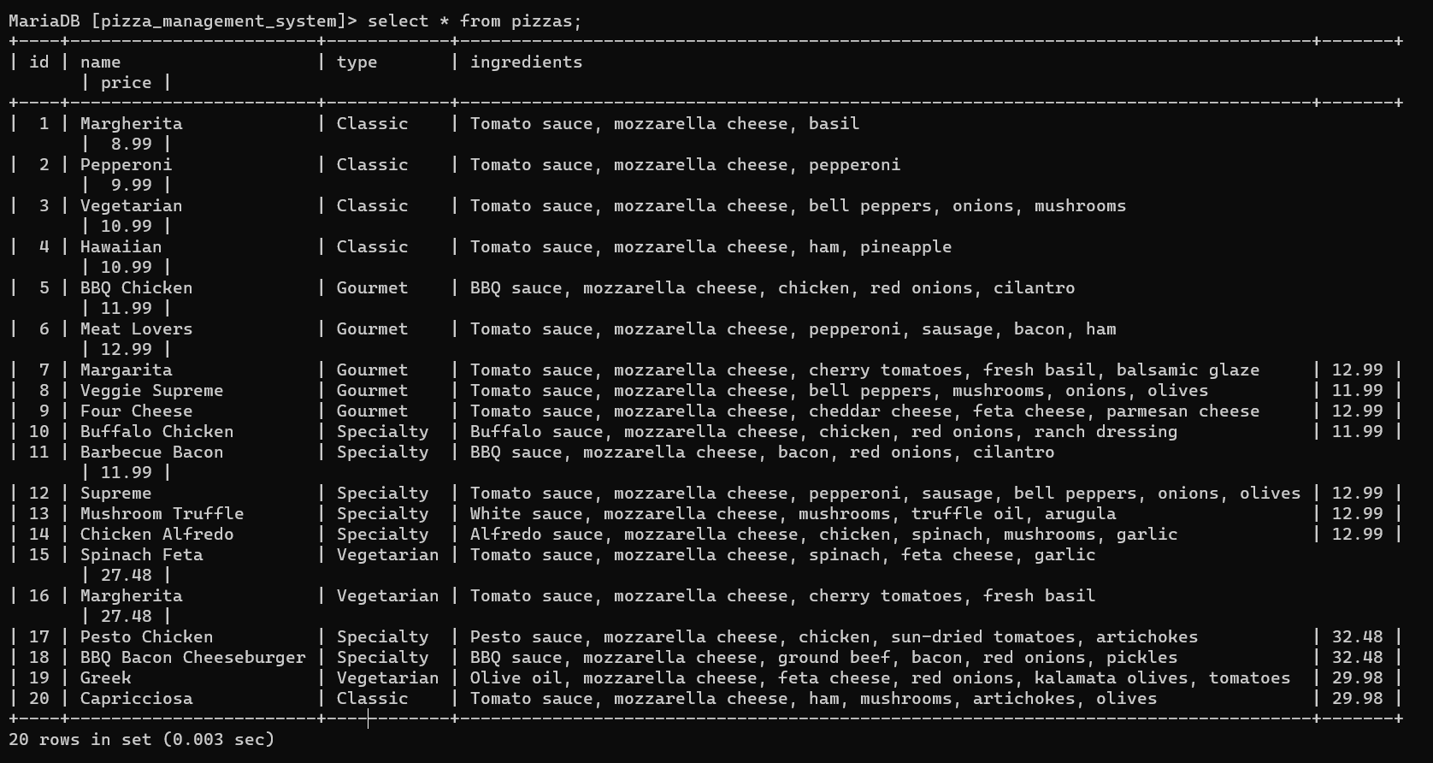

**SUB QUERIES**

1.write the query to find the pizza who are paid highest price?

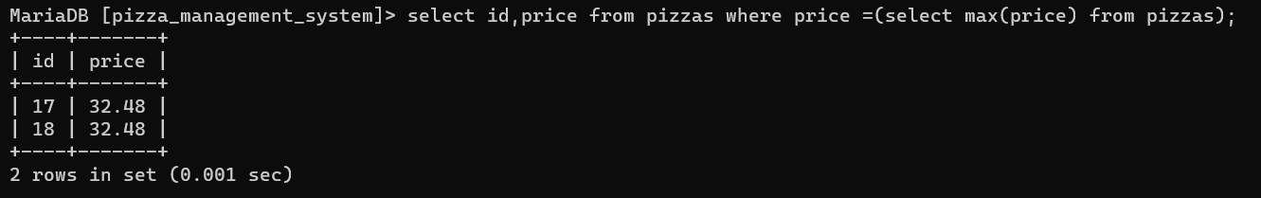

2.write a quary to find the pizzas whose price is less than at least on price in id is 10?(multiple sub query with all)

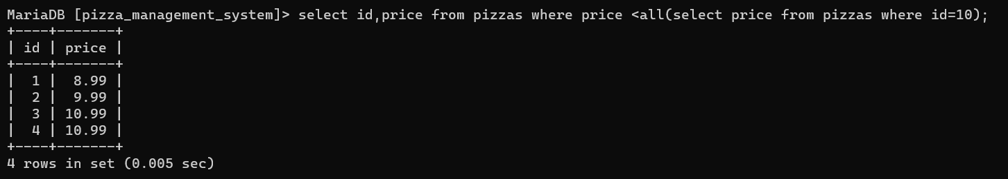

3.Update the price by 2.5 times of pizzas table for all pizzas whose id is greater then or equal to 15?(sub queries with update)

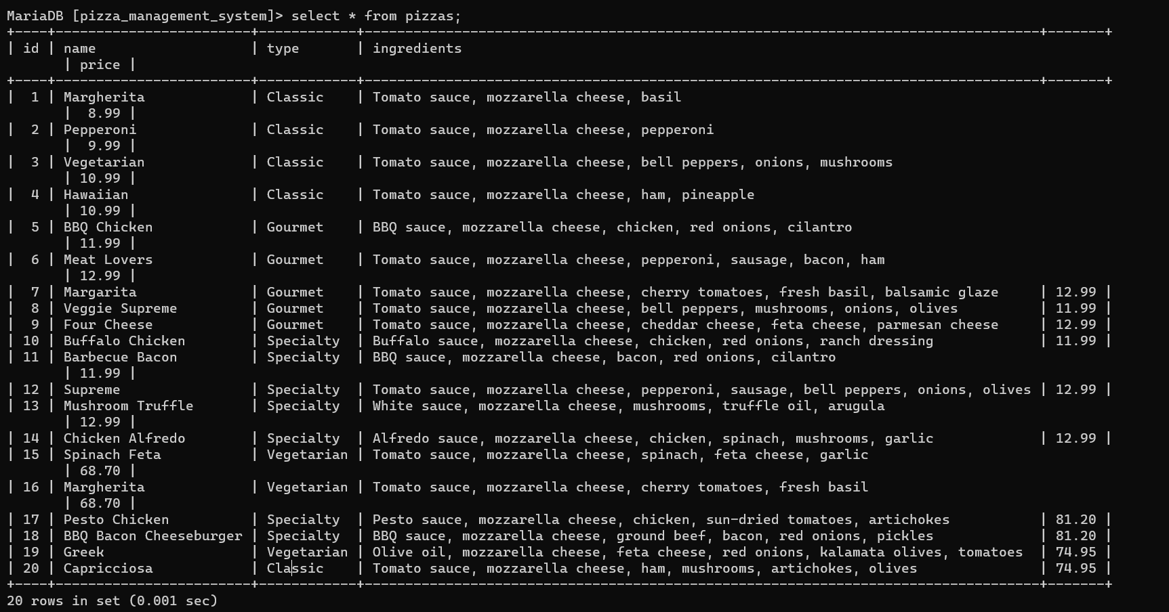

**JOINS**

1. Returns all customers and their associated orders (if any).?

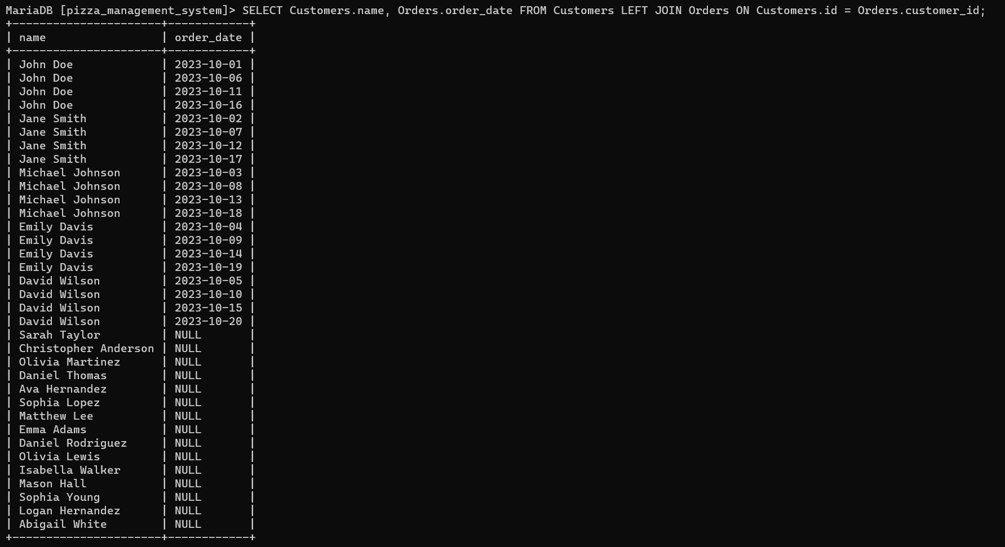

2. Returns all orders and the corresponding customer details (if any).

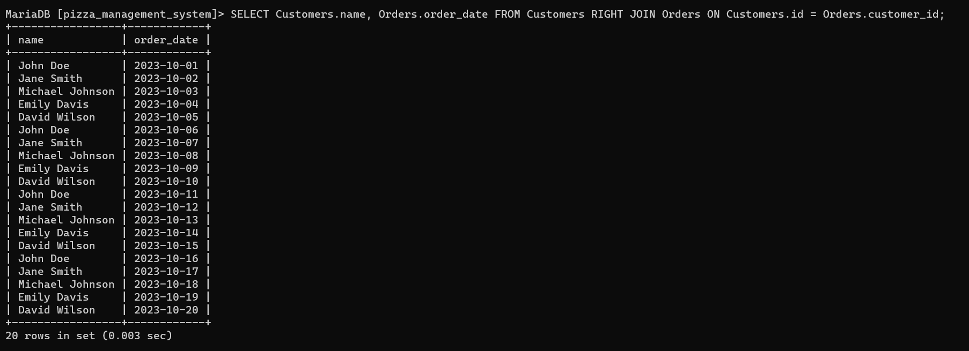

3. Returns customer names and their order details for orders that have been placed.

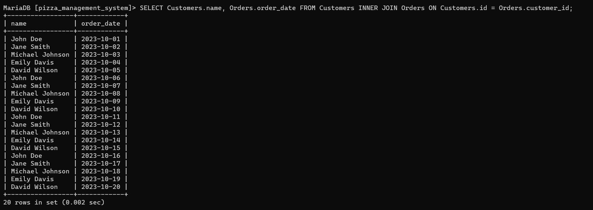

4. Generates a result set that combines all customers with all orders, resulting in every possible combination.

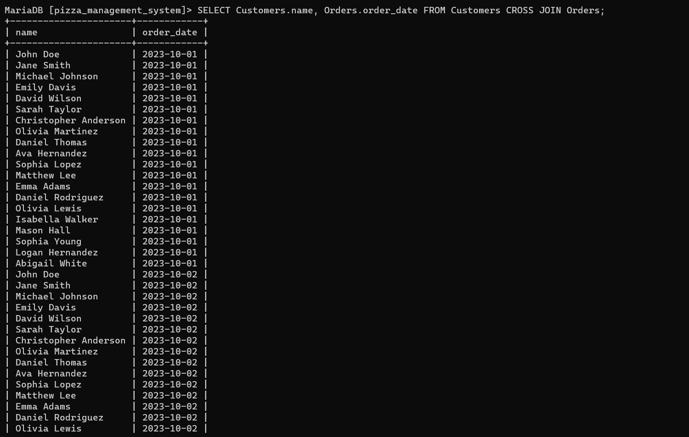

**VIEWS**

1. This view lists ingredients that are currently in stock.

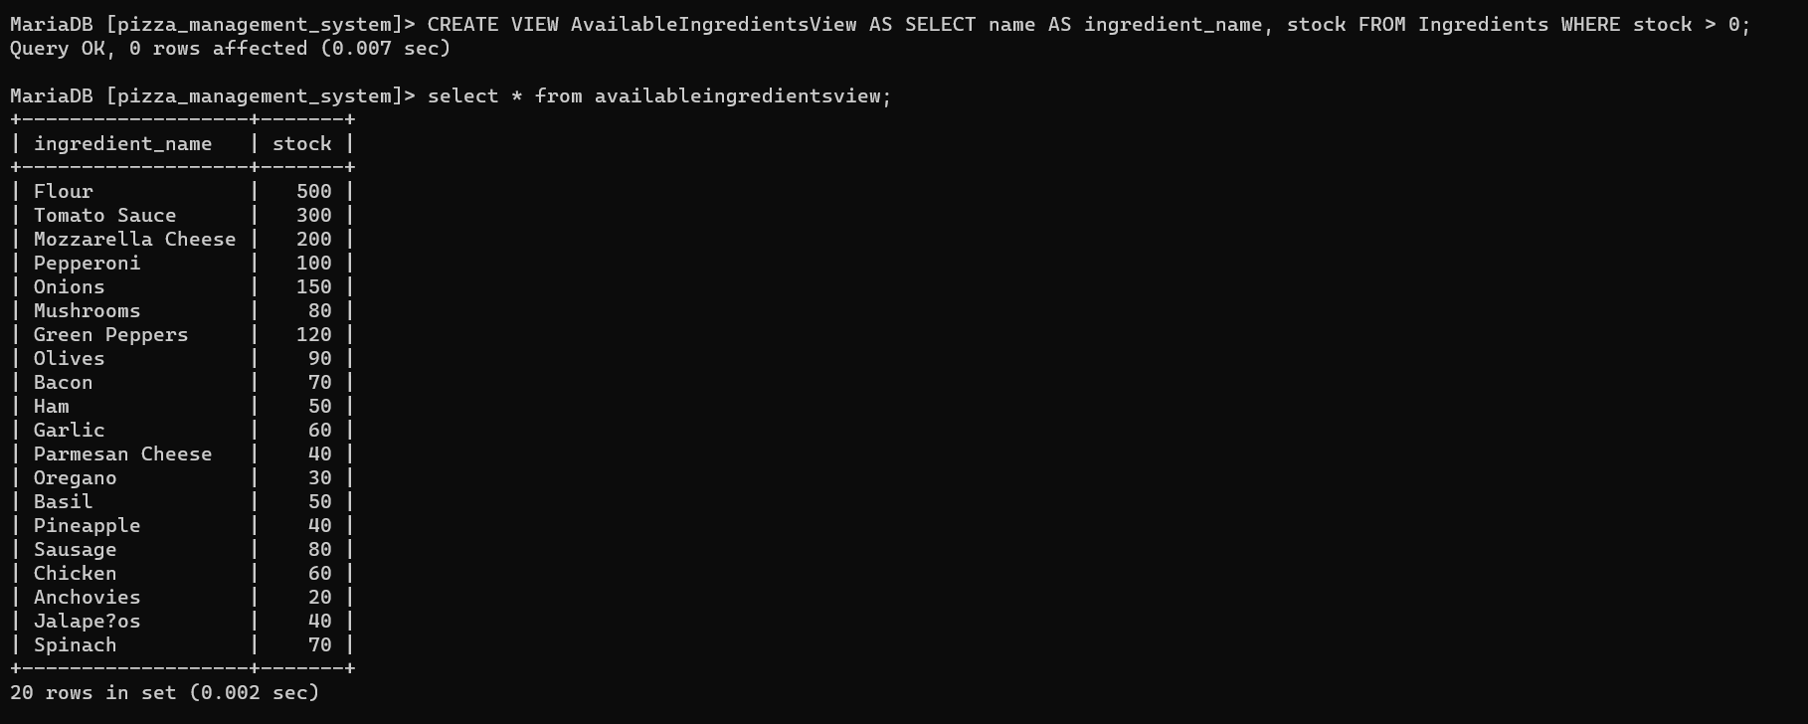

2. This view provides details about deliveries, including the delivery personnel, delivery status, and delivery time.

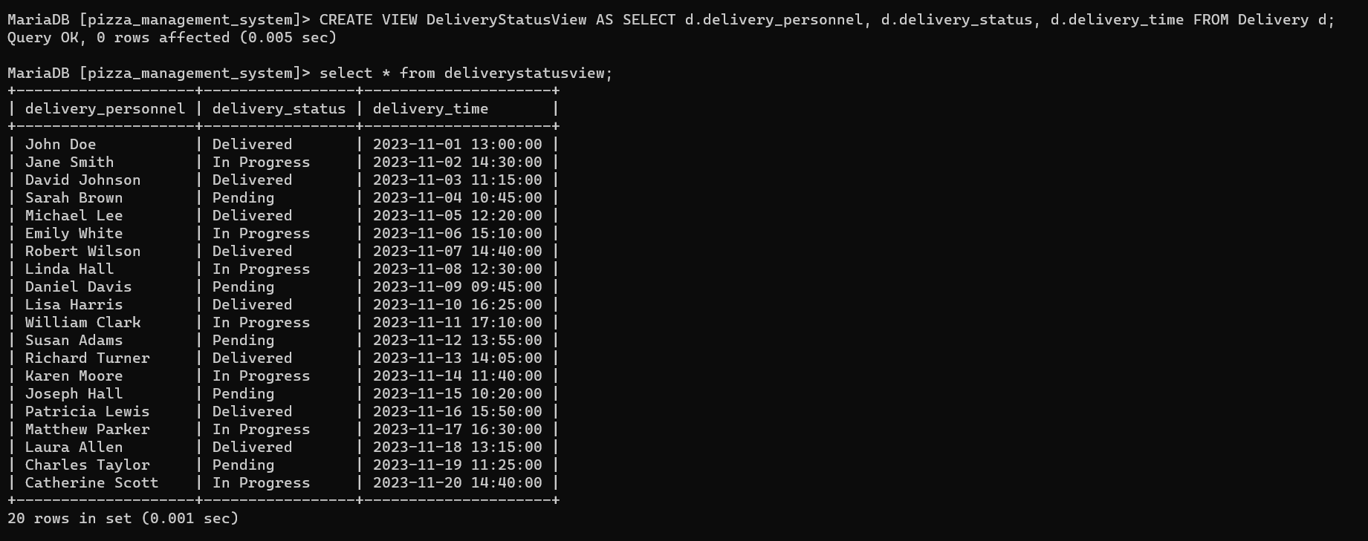

3. This view provides information about customer orders, including customer name, order date, pizza name, and quantity

