Hierarchical Clustering of Corals using Transfer Learning

Rudra S.
School of Information Technology and Electrical Engineering
The University of Queensland, Qld., 4072, Australia

Abstract

In this project we aim to find a hierarchical relationship between different types of corals by using transfer learning techniques and image clustering on the coral dataset. We use the pretrained models VGG16, InceptionV3 and DenseNet to train and extract feature vectors from coral dataset. These vectors are then clustered using the Agglomerative Heirarchical Clustering to obtain a Hierarchy of corals.

1 Introduction
One of the areas where image classification might prove to be very useful is the hierarchical classification of coral species. Since the 1980s, analysis of the skeletal structure and morphology of the corals has been used for the construction of coral taxonomy. Most of these methods used skilled human observers. Although these methods have successful classified many corals, they often have inaccuracies and limitations when compared with the molecular study of the corals [2]. The classifications done using the morphological similarities doesn’t show corresponding similarities in the molecular structure of the corals [3]. Image classifications algorithms today have proved to be better at pattern recognition tasks than humans and hence can be used to accurately classify the different types of corals [4] based on their morphology and texture. We shall try to achieve this goal in this project by using state-of-the-art techniques in image classification on a coral dataset obtained from the Queensland Museum. We propose the use of transfer learning models to predict hierarchical relationships between corals. For this we will be using pretrained models to extract important features from the dataset and then group the corals based on their similarity.

2 Literature Review
Many approaches have been proposed and implemented on the task of classification of corals. A simple model using a CNN with data augmentation used in the paper [5], was able to achieve more than 99% accuracy in classifying coral reef species. Thus proving the effectiveness of CNNs in this task. In the paper [6], the authors proposed a new type of CNN called MDNet, which used multi-scaled patches on point annotated data and dense connections between its layers to classify the coral images, instead of relying on pixel data. Another approach was proposed in the paper [7], which implemented a two level classifier using ResNet models. A ResNet model in the first layer identifies whether the image is a texture or structure image and based on that, the coral species is identified using either a ResNet model trained on RSMAS texture dataset or a ResNet model trained on StructureRSMAS dataset. Though this approach assumed the independence of the texture and structural features in classification of corals, it had a good accuracy on classification task. Although the above-mentioned approaches were effective, they required considerable amounts of data to train the model in order to obtain good accuracy. Like most real-world datasets, the dataset to be used in this project is limited and hence the above approaches would not give a good classification performance.
Transfer Learning is a technique that can use pretrained models to extract feature descriptors and perform classification. The paper [8], shows that different transfer learning approaches based on ResNet, with few-shots learning and data augmentation can achieve good accuracy with a dataset having less than 100 labels per class. This shows that transfer learning can work well on image classification with very limited data. The paper [9], uses this technique to classify images of steel defeats and achieves 99.4% accuracy. It uses a pretrained VGG16 model to extract the feature descriptors, PCA to reduce their dimensionality and k-means to cluster and classify the descriptors. It showed that high accuracy could be achieved in image classification without the need of a large and labelled dataset. The paper [10] proposed a hybrid approach to transfer learning, where handcrafted features were used along with the features obtained from the pretrained VGGNet. There hand-crafted features were colour and texton based features selected from the same patch as the CNN based features. The model could achieve better performance than other benchmark models on MLC coral dataset. An alternative approach mention in paper [11], suggested an iterative approach using hand crafted features at the start. It used transfer learning and unsupervised learning in each iteration to choose reliable labels and optimize them. The above approaches using hand-crafted features face a limitation in cases where obtaining them is difficult, like in the case of our project. A promising solution to this problem was implemented in the paper [12] by adding two new layers to the pretrained CNN models and training them. It implements two different models, one that applied transfer learning from ImageNet dataset to coral texture images dataset and second which applied transfer learning from MLC-2008 coral dataset to coral texture images dataset. These approaches could achieve high accuracy making them candidates to be used in this project. Moreover, the paper [13] showed that an ensemble of CNNs when used to classify corals achieves better accuracy than that of any single CNN.
The coral dataset provided by the Queensland Museum has not been used much for image classification apart from the thesis study [14], which tried cluster the images into classes by reducing the dimensions using PCA. The author was able to identify the features responsible for the assignment of the respective cluster using the LIME explainability model. This shows that the dataset can be utilized effectively for clustering if the correct features are extracted.

3 Methodology
Preprocessing: The dataset was obtained from Queensland Museum and consisted of 8745 images of corals belonging to 1006 different categories. The images were of different types. Some were of the corals taken in-situ mostly in underwater environment, some were taken by a microscope, while most of the images were of corals skeletal structures taken in laboratory environment. To obtain uniformity across images, only the images of corals taken in laboratory environment were used. These were of better quality and did not have much background light or colour present. Some of the categories containing too few images (less than 3) were removed to avoid overfitting. Hence a final dataset of 3998 coral images belonging to 502 categories was obtained and used for project. Since the number of images per category was still low, different methods of data augmentation like rotation, horizontal and vertical flipping, zooming in, sheering and changing the brightness were used to increase the dataset.

Transfer Learning: Three different pretrained image classification models were used to compare their performance on the coral dataset. These were VGG16, InceptionV3 and DenseNet. Each of these models have been pretrained on the ImageNet dataset and the resultant weights were imported and used as initial weights for training.
At first the models were trained by replacing their top layer and training only the last layer on the coral dataset. The performance of these models was then compared. In a second approach, the last two layers of the models were trained on the coral dataset to check if it improved the performance. The model with the best performance was selected for further processing.

Extracting features: Once trained the top layer of the model was removed and feature vectors of the images were extracted by passing each of them as input to the model. These vectors represented the images in such a way that could capture the similarities (or dissimilarities) between them. The method of Principal Conponent Analysis (PCA) was used to reduce the dimensions of the vectors. Two sets of vectors are obtained after dimensionality reduction, one perserving 95% variance while the other preserving 99% variance. The quality of the two sets was compared by evaluating their performance in clustering.

Heirarchical Clustering: The Agglomerative Heirarchical Clustering algorithm was used to cluster the feature vectors. The clustering was implemented using the Single-link, Complete-link, Average-link and Ward’s criteria. The performance across these different clustering was tested using the Silhouette score. To obtain a general hierarchy across all categories, mean vectors for each category were calculated and used.

4 Results
The results obtained after training only the top layer of the pretrained VGG16, InceptionV3 and DenseNet models are given by Table 1.

 | VGG16 | InceptionV3 | DenseNet
Train Acc. | 46.55% | 76.32% | 70.07%
Train Loss | 3.34 | 15.60 | 8.15
Test Acc. | 20.44% | 24.79% | 28.81%
Table 1: Accuracy and loss of models with only top layer trained. (Acc. stands for Accuracy)

The results after training the top two layers of the above-mentioned models are given by Table 2.

 | VGG16 | InceptionV3 | DenseNet
Train Acc. | 55.28% | 72.77% | 88.74%
Train Loss | 1.7191 | 12.72 | 0.70
Test Acc. | 21.11% | 25.63% | 39.70%
Table 2: Accuracy and loss of models with the top two layers trained. (Acc. stands for Accuracy)

The DenseNet model with top two layers of it trained on coral dataset, was selected due to its performance, for extracting feature-vectors of images. After dimensionality reduction the dimensions of the vectors preserving 95% variance were reduced from 51192 to 375 while the ones preserving 99% variance were reduced to 428. The Silhouette scores of the clustering of these feature vectors using Agglomerative Heirarchical Clustering are mentioned in Table 3.

Criterion | 95% variance | 99% variance
Average-link | 0.3953 | 0.3831
Ward’s | 0.0254 | 0.0552
Complete-link | 0.3934 | 0.3812
Single-link | 0.3952 | 0.3829
Table 3: Silhouette scores of feature vectors

The mean features were computed and used to obtain a general hierarchy of corals. The results obtained are in Table 4 below.

Criterion | 95% variance | 99% variance
Average-link | 0.3953 | 0.3831
Ward’s | 0.0254 | 0.0552
Complete-link | 0.3934 | 0.3812
Single-link | 0.3952 | 0.3829
Table 3: Silhouette scores of mean -feature vectors

5 Conclusion
As seen from the results on the performance of the transfer learning models, training the top two layers of the DenseNet Model on the coral dataset gives us the best performance on the task of classification of coral images into their categories. Although it had a high training accuracy of 88.74%, the test accuracy is low at 39.7. This could be because of the low number of images available per category (~6 image per category) as well as the low diversity in data (most images in a category are of the same coral sample). The best clustering obtained had an average silhouette score, suggesting overlap between clusters. Although the results obtained by this project are average in terms of accuracy, they might still be very useful for finding the possible closely related categories to a given coral. It could also be used to find the how closely two corals are
related. The methodology used proves that transfer learning can be very useful on coral classification tasks. In future work we need to increase and improve the quality of the dataset to get better performance.

Acknowledgment
I acknowledge the motivation and guidance of my supervisor Prof. Gianluca Demartini, which helped me throughout this project. I also thank the Queensland Museum for providing the dataset.

References
- A. B. Smith, C. D. Jones, and E. F. Roberts, “Article title,” Journal, vol. 1, no. 1, pp. 1-10, Date.
- C. D. Jones, A.B. Smith, and E.F. Roberts, Book Title, Publisher, Location, Date.
- C. D. Jones, A. B. Smith, and E. F. Roberts, “Article title,” in Proceedings Title. IEEE, 2003, vol. II, pp. 803–806.
- Gene H. Golub and Charles F. Van Loan, Matrix Computations, Johns-Hopkins University Press, 3rd ed., 1996.
- Claude E. Shannon, “A mathematical theory of communication,” Bell Syst. Tech. J., vol. 27, pp. 379–423, 623–656, Jul./Oct. 1948.
- P. W. Wolniansky, G. J. Foschini, G. D. Golden, and R. A. Valenzuela, “V-BLAST: An architecture for realizing very high data rates over the rich-scattering wireless channel,” in Proc. URSI Internat. Sympos. Signals Syst. Electronics, pp. 295–300, Sept. 1998.
- Motorola, Inc.: DSP56002 Users Manual, 1993.

Biography
You should add a biography after all other material. The biography should focus on your professional accomplishments and interests, although can add some personal notes as well. Please keep it to less than 100 words.

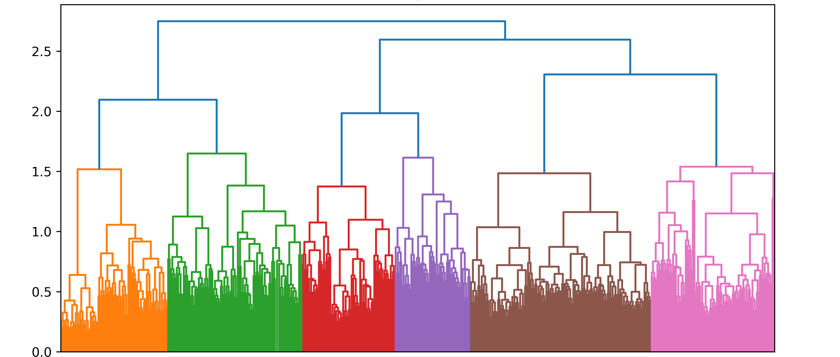

Fig 1. Dendogram showing hierarchical relationships between coral categories.

