Domain: Health Analytics
US opiate overdoses:
Accidental death by fatal drug overdose is a rising trend in the United States.
This dataset contains summaries of prescription records for 250 common opioid and non-opioid drugs written by 25,000 unique licensed medical professionals in 2014 in the United States for citizens covered under Class D Medicare as well as some metadata about the doctors themselves. This data is sourced from cms.gov. The full dataset contains almost 24 million prescription instances in long format.
The increase in overdose fatalities is a well-known problem, and the search for possible solutions is an ongoing effort.
The data consists of the following characteristics for each prescriber
- NPI – unique National Provider Identifier number
- Gender - (M/F)
- State - U.S. State by abbreviation
- Credentials - set of initials indicative of medical degree
- Specialty - description of type of medicinal practice
- A long list of drugs with numeric values indicating the total number of prescriptions written for the year by that individual
- Opioid.Prescriber - a boolean label indicating whether or not that individual prescribed opiate drugs more than 10 times in the year

Dataset:
For the analysis with reference to https://www.cms.gov/Research-Statistics-Data-and-Systems/Statistics-Trends-and-Reports/Medicare-Provider-Charge-Data/PartD2014.html detailed data for 2014 ranging upto 2 gb is used.

Following data dictionary provides details about data to be used for analysis.
https://www.cms.gov/Research-Statistics-Data-and-Systems/Statistics-Trends-and-Reports/Medicare-Provider-Charge-Data/Downloads/Prescriber_Methods.pdfhttps://www.cms.gov/Research-Statistics-Data-and-Systems/Statistics-Trends-and-Reports/Medicare-Provider-Charge-Data/Downloads/Prescriber_Methods.pdf

Summary of the Analysis:

- State-wise categorization of drug overdose
- Top 10 most widely consumed drugs
- Total cost and supply per drug
- Drug prescription as per drug categorization(antibiotic,anti psychotic,highriskmedication and opioid)
- State-wise death count
- Prescriber categorization as per states
- Total cost and supply of opioid drugs
- Opioid drugs count prescribed by each physician.
- State-wise binning to display different types of physicians specialties
- Classification to determine if physician is probable opioid prescriber
- Co relation between state-wise death due to opioid and state-wise opioid prescription
12. Per physician prescribed opioids

Analysis And Visualization:
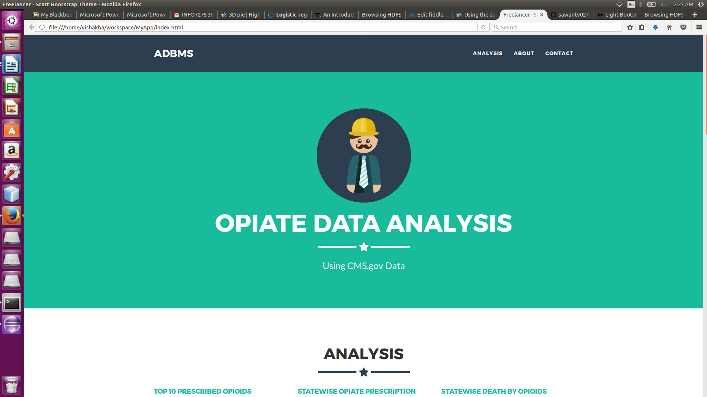

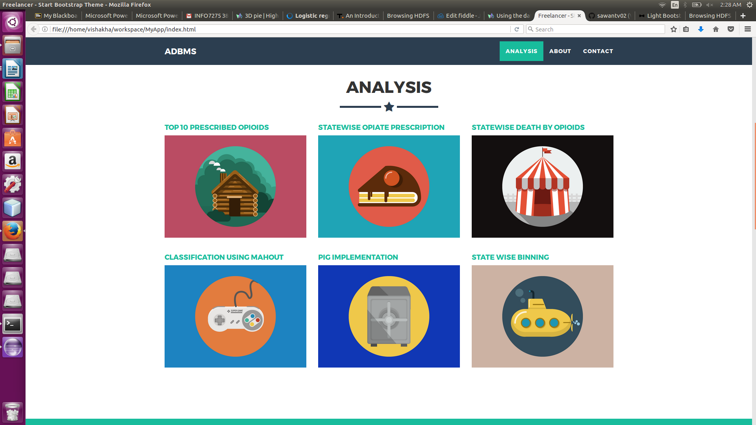

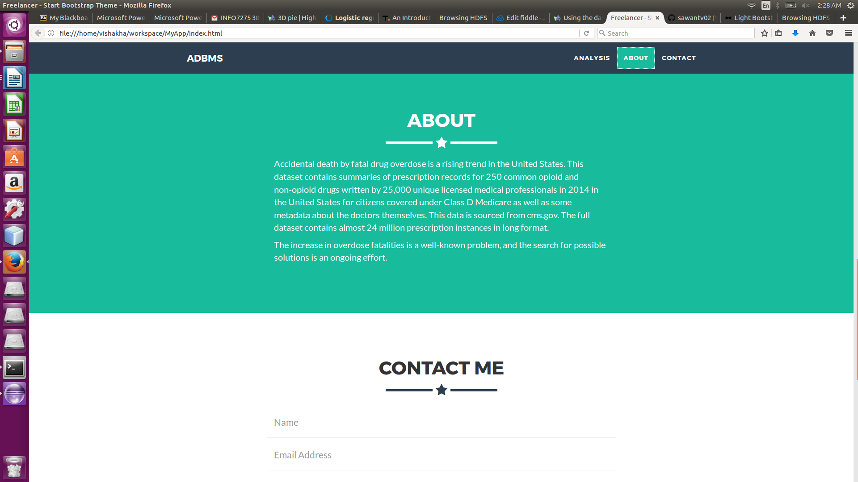

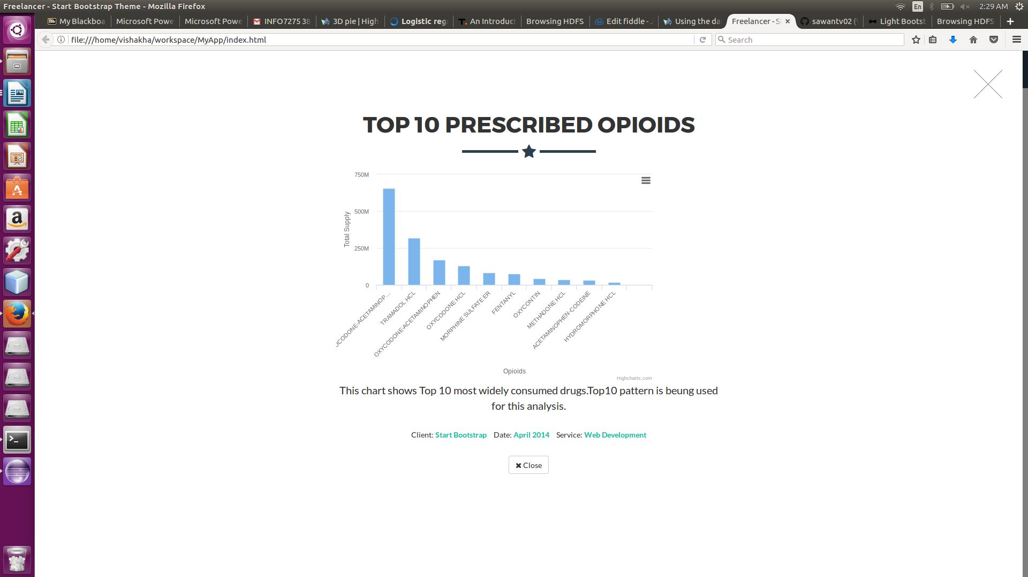

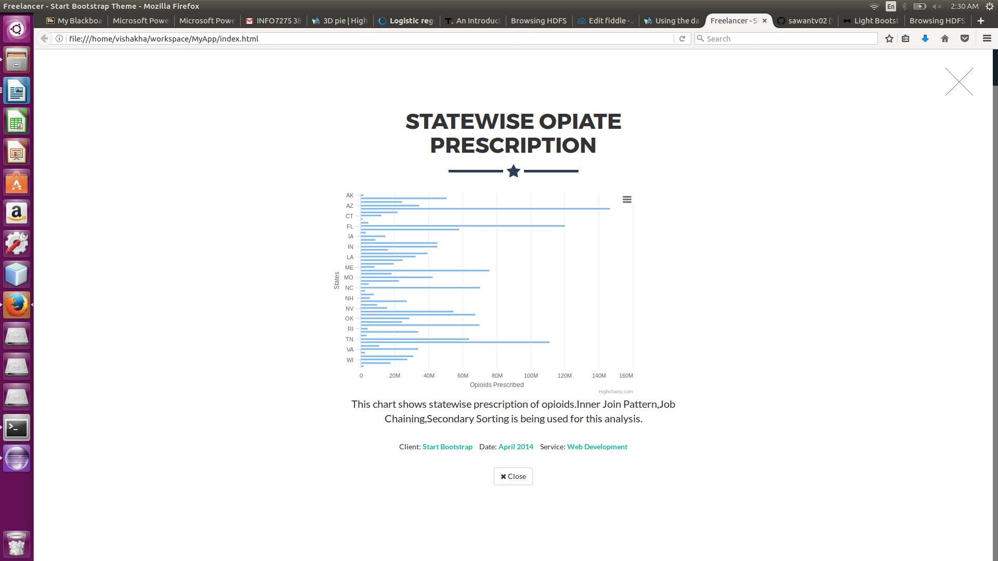

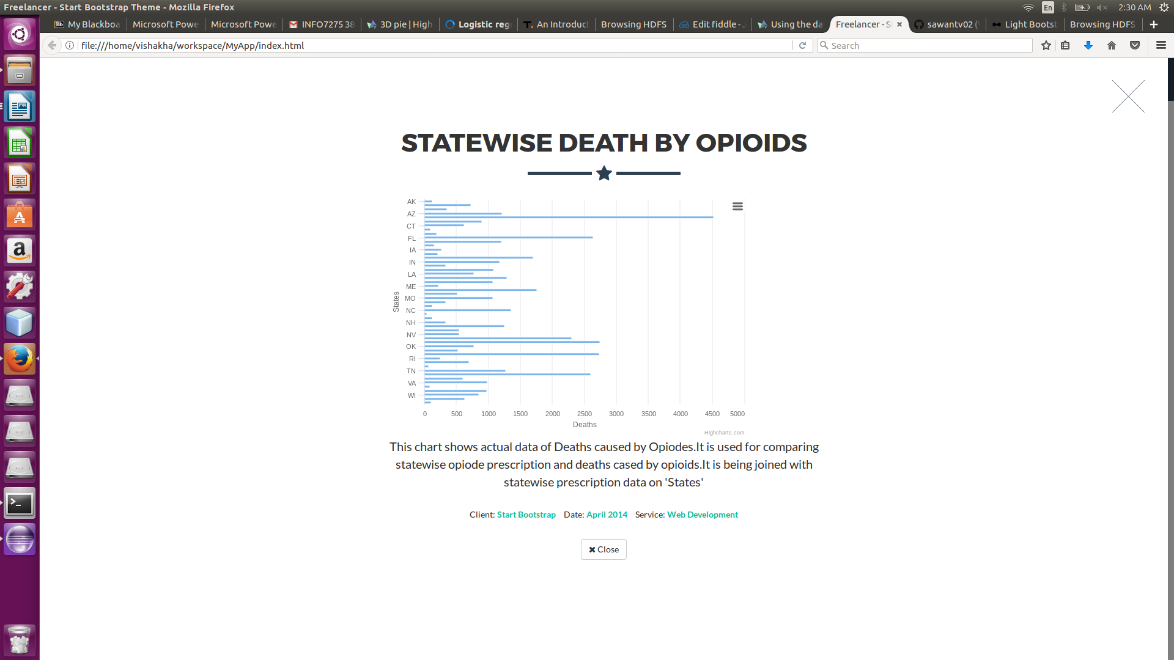

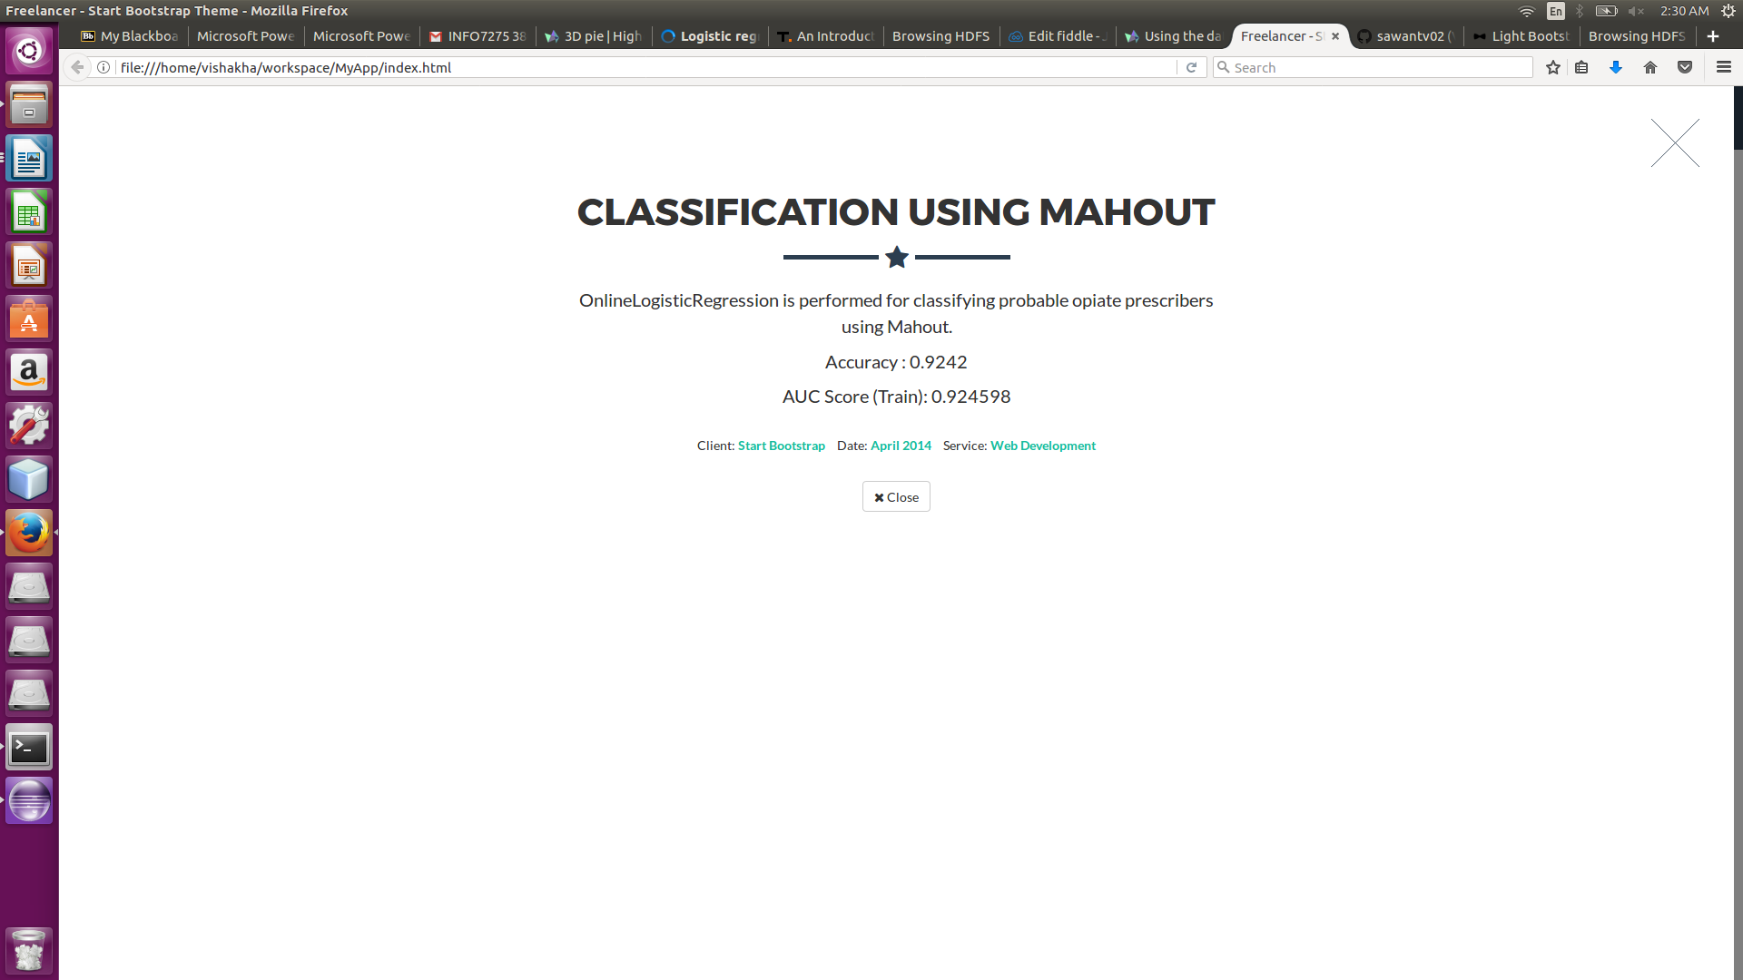

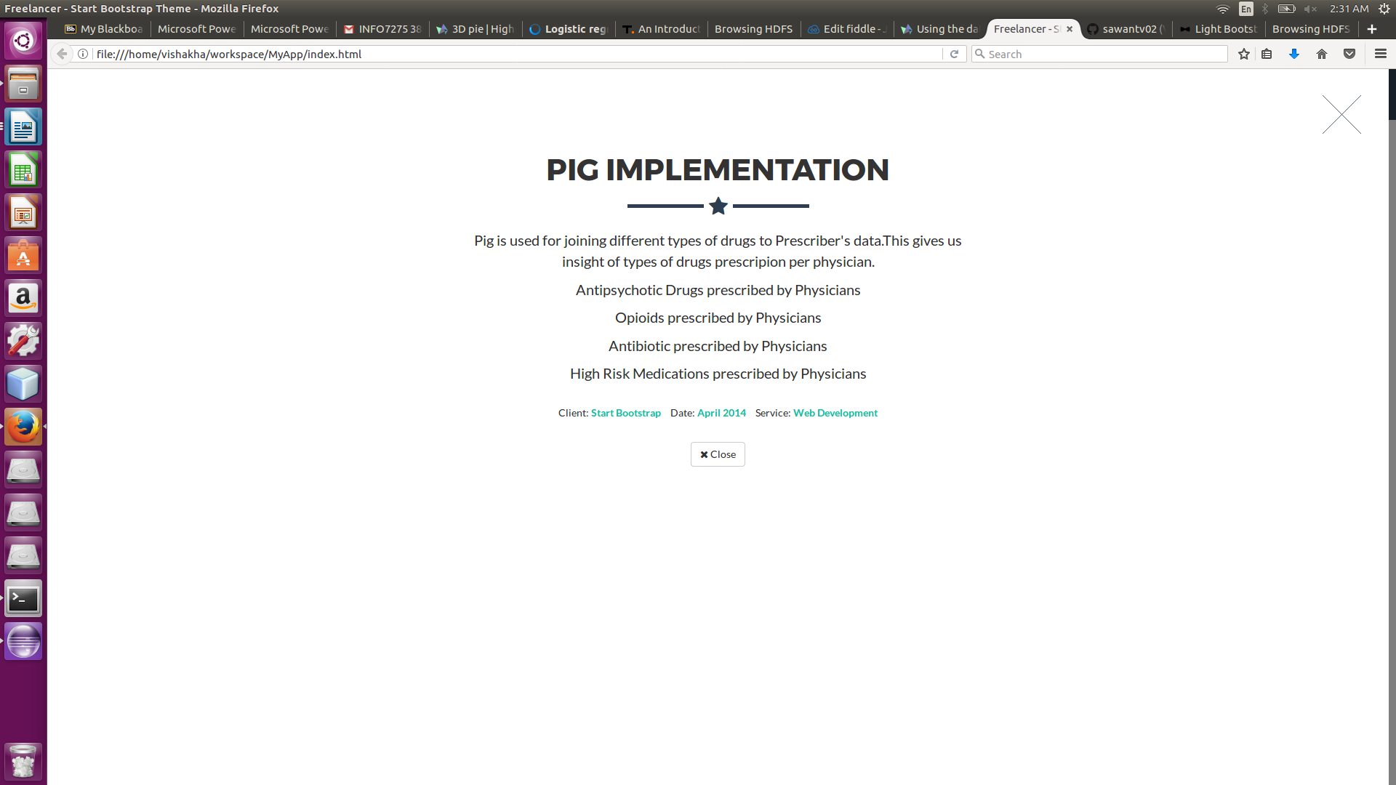

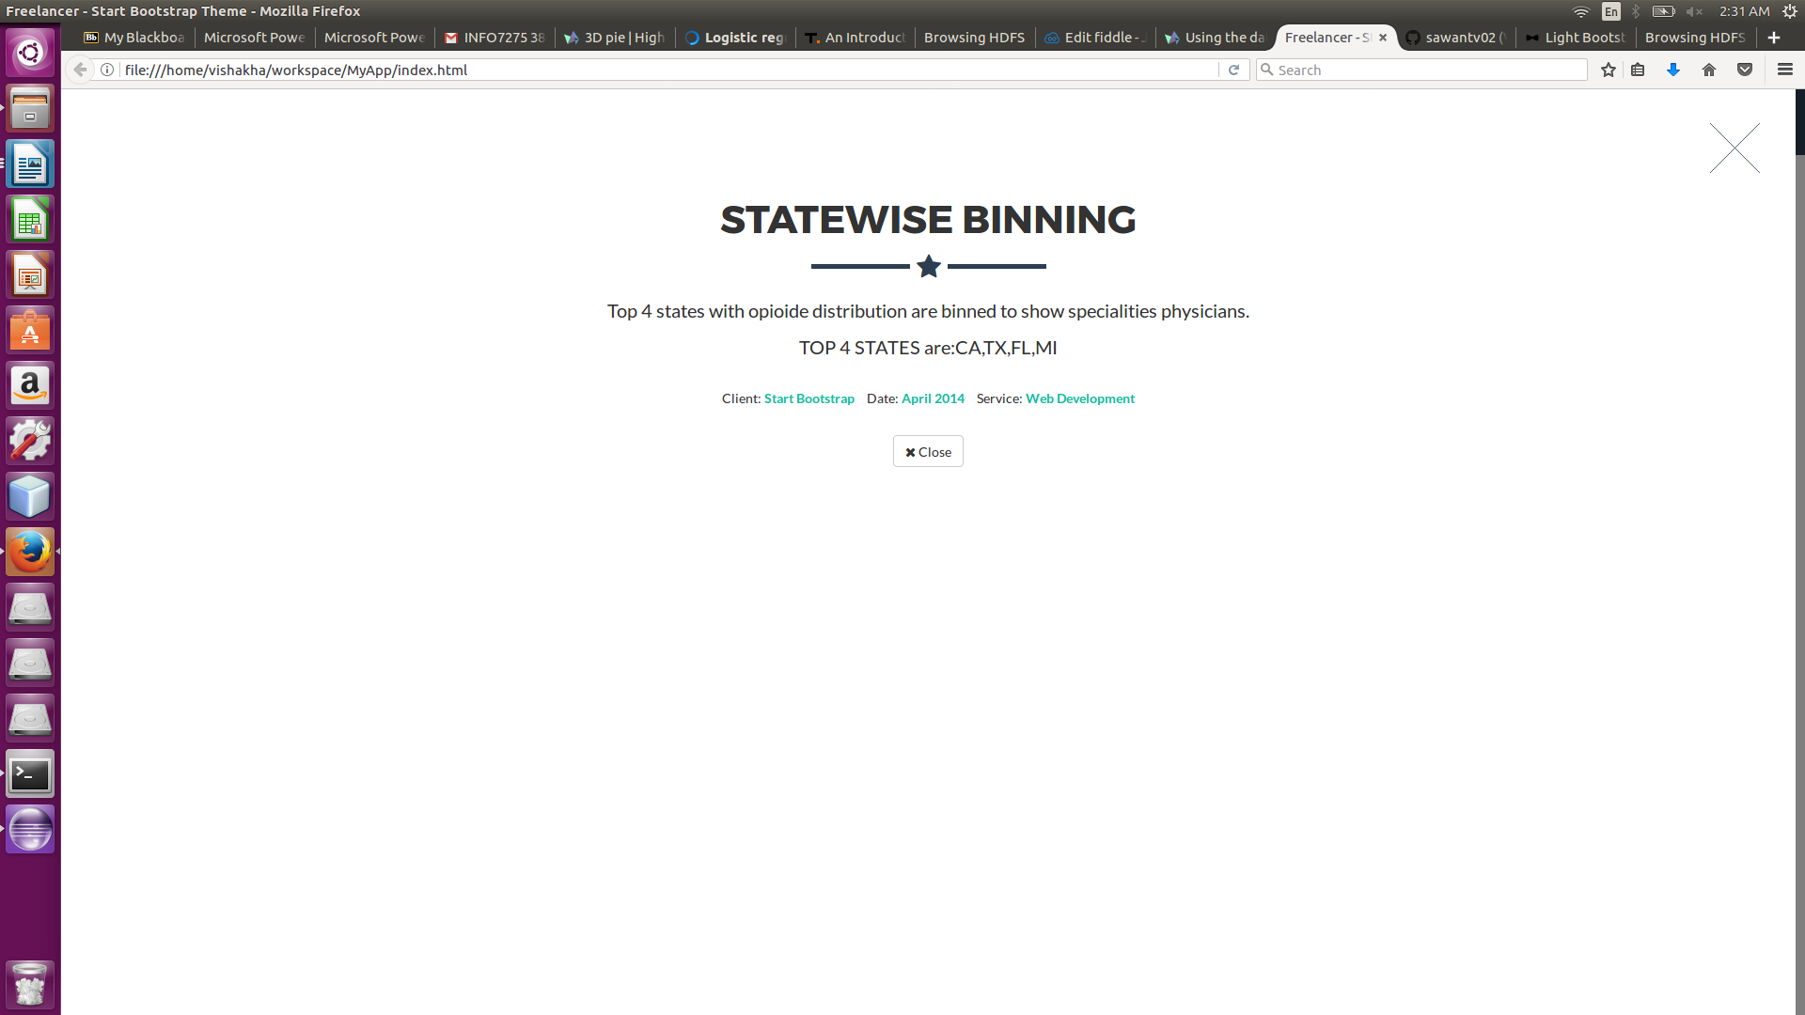

Code:
1.BinningByState:
/*
* To change this license header, choose License Headers in Project Properties.
* To change this template file, choose Tools | Templates
* and open the template in the editor.
*/
package BinningByState;

import java.io.IOException;
import org.apache.hadoop.conf.Configuration;
import org.apache.hadoop.fs.Path;
import org.apache.hadoop.io.LongWritable;
import org.apache.hadoop.io.NullWritable;
import org.apache.hadoop.io.Text;
import org.apache.hadoop.mapreduce.Job;
import org.apache.hadoop.mapreduce.Mapper;
import org.apache.hadoop.mapreduce.Reducer;
import org.apache.hadoop.mapreduce.lib.input.FileInputFormat;
import org.apache.hadoop.mapreduce.lib.output.FileOutputFormat;
import org.apache.hadoop.mapreduce.lib.output.MultipleOutputs;
import org.apache.hadoop.mapreduce.lib.output.TextOutputFormat;

/**
*
* @author vishakha
*/
public class Driver {

public static void main(String args[]) throws IOException, InterruptedException, ClassNotFoundException {
Configuration conf = new Configuration();
Job job = Job.getInstance(conf, "BinningByState");
MultipleOutputs.addNamedOutput(job, "bins", TextOutputFormat.class, Text.class, NullWritable.class);
MultipleOutputs.setCountersEnabled(job, true);
job.setJarByClass(Driver.class);
job.setMapperClass(BinningMapper.class);
job.setMapOutputKeyClass(Text.class);
job.setMapOutputValueClass(NullWritable.class);
job.setNumReduceTasks(0);
// job.setOutputKeyClass(Text.class);
// job.setOutputValueClass(NullWritable.class);
FileInputFormat.addInputPath(job, new Path(args[0]));
FileOutputFormat.setOutputPath(job, new Path(args[1]));

System.exit(job.waitForCompletion(true) ? 0 : 1);
}

public static class BinningMapper extends Mapper<LongWritable, Text, Text, Text> {

private MultipleOutputs<Text, NullWritable> mos = null;

@Override
protected void setup(Context context) throws IOException, InterruptedException {
mos = new MultipleOutputs(context);
}

@Override
protected void map(LongWritable key, Text value, Context context) throws IOException, InterruptedException {
String line = value.toString();
String[] row = line.split("\t");

String state = row[0];

if (state.equalsIgnoreCase("CA")) {
mos.write("bins", value, NullWritable.get(), state);
}
if (state.equalsIgnoreCase("FL")) {
mos.write("bins", value, NullWritable.get(), state);
}
if (state.equalsIgnoreCase("TX")) {
mos.write("bins", value, NullWritable.get(), state);
}
if (state.equalsIgnoreCase("MI")) {
mos.write("bins", value, NullWritable.get(), state);
}

}

@Override
protected void cleanup(Context context) throws IOException, InterruptedException {
mos.close();
}

}

}

2.PrescribedOpioidsByNPI:

/*
* To change this license header, choose License Headers in Project Properties.
* To change this template file, choose Tools | Templates
* and open the template in the editor.
*/
package OpioidesByNpi;

import java.io.IOException;
import org.apache.hadoop.conf.Configuration;
import org.apache.hadoop.fs.Path;
import org.apache.hadoop.io.LongWritable;
import org.apache.hadoop.io.Text;
import org.apache.hadoop.mapreduce.Job;
import org.apache.hadoop.mapreduce.Mapper;
import org.apache.hadoop.mapreduce.Reducer;
import org.apache.hadoop.mapreduce.lib.input.FileInputFormat;
import org.apache.hadoop.mapreduce.lib.output.TextOutputFormat;

/**
*
* @author vishakha
*/
public class Driver {

public static void main(String args[]) throws IOException, InterruptedException, ClassNotFoundException {
Configuration conf = new Configuration();
Job job = Job.getInstance(conf, "PrescribedOpioidsByNPI");
job.setJarByClass(Driver.class);
job.setMapperClass(DriverMapper.class);
job.setMapOutputKeyClass(Text.class);
job.setMapOutputValueClass(Text.class);
// job.setCombinerClass(InvertedReducer.class);
job.setReducerClass(DriverReducer.class);
job.setOutputKeyClass(Text.class);
job.setOutputValueClass(Text.class);

FileInputFormat.addInputPath(job, new Path(args[0]));
TextOutputFormat.setOutputPath(job, new Path(args[1]));
System.exit(job.waitForCompletion(true) ? 0 : 1);
}

public static class DriverMapper extends Mapper<LongWritable, Text, Text, Text> {

private Text drugname = new Text();
private Text npi = new Text();

@Override
protected void map(LongWritable key, Text value, Context context) throws IOException, InterruptedException {

if(key.get()==0){
return;
}
String tokens[] = value.toString().split("\t");
drugname.set(tokens[1]);
npi.set(tokens[0]);
context.write(npi,drugname);
}

}

public static class DriverReducer extends Reducer<Text, Text, Text, Text> {

private Text result = new Text();

@Override
protected void reduce(Text key, Iterable<Text> values, Context context) throws IOException, InterruptedException {
StringBuilder sb = new StringBuilder();

boolean first = true;

for (Text id : values) {
if (first) {
first = false;
} else {
sb.append("\t");
}
sb.append(id.toString());

}
result.set(sb.toString());
context.write(key, result);
}

}

}

3.OpioidePrescriberClassification:

a.Driver :
/*
* To change this license header, choose License Headers in Project Properties.
* To change this template file, choose Tools | Templates
* and open the template in the editor.
*/
package OpioidePrescriberClassification;

import com.google.common.collect.Lists;
import java.util.Collections;
import java.util.List;
import java.util.Random;
import org.apache.mahout.classifier.evaluation.Auc;
import org.apache.mahout.classifier.sgd.L1;
import org.apache.mahout.classifier.sgd.OnlineLogisticRegression;
import org.apache.mahout.common.RandomUtils;

/**
*
* @author vishakha
*/
public class Driver {

public static final int NUM_CATEGORIES = 2;

public static void main(String args[]) throws Exception {
List<Opioides> calls = Lists.newArrayList(new Parser("/input1/try.csv"));
double heldOutPercentage = 0.10;
// for (int run = 0; run < 20; run++)
{
// Random random = RandomUtils.getRandom();
Collections.shuffle(calls);
int cutoff = (int) (heldOutPercentage * calls.size());
List<Opioides> test = calls.subList(0, cutoff);
List<Opioides> train = calls.subList(cutoff, calls.size());

OnlineLogisticRegression lr = new OnlineLogisticRegression(NUM_CATEGORIES, Opioides.FEATURES, new L1())
.learningRate(1)
.alpha(1)
.lambda(0.000001)
.stepOffset(10000)
.decayExponent(0.2);

// for (int pass = 0; pass < 2 ; pass++)
{
System.err.println("pass");
for (Opioides observation : train){
lr.train(observation.getTarget(), observation.asVector());
}
// if (pass % 2 == 0)
{
Auc eval = new Auc(0.5);
for (Opioides testCall : test){
eval.add(testCall.getTarget(), lr.classifyScalar(testCall.asVector()));
}
System.out.printf("%d, %.4f, %.4f\n",1, lr.currentLearningRate(), eval.auc());
}
}
}
}

}

b.Opioides
/*
* To change this license header, choose License Headers in Project Properties.
* To change this template file, choose Tools | Templates
* and open the template in the editor.
*/
package OpioidePrescriberClassification;

import java.util.Iterator;
import java.util.LinkedHashMap;
import java.util.Map;
import org.apache.mahout.math.DenseVector;
import org.apache.mahout.math.RandomAccessSparseVector;
import org.apache.mahout.math.Vector;
import org.apache.mahout.vectorizer.encoders.ConstantValueEncoder;
import org.apache.mahout.vectorizer.encoders.FeatureVectorEncoder;
import org.apache.mahout.vectorizer.encoders.StaticWordValueEncoder;

/**
*
* @author vishakha
*/
public class Opioides {

public static final int FEATURES = 14;
private static final ConstantValueEncoder interceptEncoder = new ConstantValueEncoder("intercept");
private static final FeatureVectorEncoder featureEncoder = new StaticWordValueEncoder("feature");
// private DenseVector vector = new DenseVector(13);
private DenseVector vector;
private Map<String, String> fields = new LinkedHashMap<>();

public Opioides(Iterable<String> fieldNames, Iterable<String> values) {
vector = new DenseVector(FEATURES);
Iterator<String> value = values.iterator();
interceptEncoder.addToVector("1", vector);
for (String name : fieldNames) {
String fieldValue = value.next();
fields.put(name, fieldValue);
switch (name) {
case "DOXYCYCLINE.HYCLATE": {
double v = Double.parseDouble(fieldValue);
featureEncoder.addToVector(name, Math.log(v), vector);
break;
}
case "TRAMADOL.HCL": {
double v;
v = Double.parseDouble(fieldValue);
featureEncoder.addToVector(name, Math.log(v), vector);
break;
}
case "OXYCODONE.ACETAMINOPHEN": {
double v;
v = Double.parseDouble(fieldValue);
featureEncoder.addToVector(name, Math.log(v), vector);
break;
}
case "Gender": {
featureEncoder.addToVector(name + ":" + fieldValue, 1, vector);
break;
}
case "HYDROCODONE.ACETAMINOPHEN": {
double v;
v = Double.parseDouble(fieldValue);
featureEncoder.addToVector(name, Math.log(v), vector);
break;
}
case "ACETAMINOPHEN.CODEINE": {
double v;
v = Double.parseDouble(fieldValue);
featureEncoder.addToVector(name, Math.log(v), vector);
break;
}
case "AMOX.TR.POTASSIUM.CLAVULANATE": {
double v;
v = Double.parseDouble(fieldValue);
featureEncoder.addToVector(name, Math.log(v), vector);
break;
}
case "CEPHALEXIN": {
double v;
v = Double.parseDouble(fieldValue);
featureEncoder.addToVector(name, Math.log(v), vector);
break;
}
case "AZITHROMYCIN": {
double v;
v = Double.parseDouble(fieldValue);
featureEncoder.addToVector(name, Math.log(v), vector);
break;
}
case "IBUPROFEN": {
double v;
v = Double.parseDouble(fieldValue);
featureEncoder.addToVector(name, Math.log(v), vector);
break;
}
case "CHLORHEXIDINE.GLUCONATE": {
double v;
v = Double.parseDouble(fieldValue);
featureEncoder.addToVector(name, Math.log(v), vector);
break;
}
case "CLINDAMYCIN.HCL": {
double v;
v = Double.parseDouble(fieldValue);
featureEncoder.addToVector(name, Math.log(v), vector);
break;
}
case "AMOXICILLIN": {
double v;
v = Double.parseDouble(fieldValue);
featureEncoder.addToVector(name, Math.log(v), vector);
break;
}
case "Opioid.Prescriber":
break;
default:
break;

}
}
}

public Vector asVector() {
return vector;
}

public int getTarget() {
return Integer.parseInt(fields.get("Opioid.Prescriber"));
}

}

c.Parser
/*
* To change this license header, choose License Headers in Project Properties.
* To change this template file, choose Tools | Templates
* and open the template in the editor.
*/
package OpioidePrescriberClassification;

import com.google.common.base.CharMatcher;
import com.google.common.base.Splitter;
import com.google.common.collect.AbstractIterator;
import com.google.common.io.Resources;
import java.io.BufferedReader;
import java.io.File;
import java.io.FileReader;
import java.io.IOException;
import java.io.InputStreamReader;
import java.util.Iterator;
import java.util.logging.Level;
import java.util.logging.Logger;

/**
*
* @author vishakha
*/
public class Parser implements Iterable<Opioides> {

private String resourceName;
private final Splitter onSemi = Splitter.on(",").trimResults(CharMatcher.anyOf("\""));

public Parser(String resourceName) {
String filePath = new File("").getAbsolutePath();

System.out.println(filePath);
this.resourceName = filePath+resourceName;
}

@Override
public Iterator<Opioides> iterator() {
try {
return new AbstractIterator<Opioides>() {

BufferedReader input
= new BufferedReader(new FileReader(resourceName));

Iterable<String> fieldNames = onSemi.split(input.readLine());

@Override
protected Opioides computeNext() {
try {
String line = input.readLine();
if (line == null) {
return endOfData();
}

return new Opioides(fieldNames, onSemi.split(line));
} catch (IOException e) {
throw new RuntimeException("Error reading data", e);
}
}
};
} catch (IOException e) {
throw new RuntimeException("Error reading data", e);
}
}

}

4.PrescribedDrugData:

a.Driver
/*
* To change this license header, choose License Headers in Project Properties.
* To change this template file, choose Tools | Templates
* and open the template in the editor.
*/
package PrescribedDrugData;

import Prescriberdata.PrescriberDetailsWritable;
import java.io.IOException;
import org.apache.hadoop.conf.Configuration;
import org.apache.hadoop.fs.Path;
import org.apache.hadoop.io.DoubleWritable;
import org.apache.hadoop.io.IntWritable;
import org.apache.hadoop.io.LongWritable;
import org.apache.hadoop.io.Text;
import org.apache.hadoop.mapreduce.Job;
import org.apache.hadoop.mapreduce.Mapper;
import org.apache.hadoop.mapreduce.Reducer;
import org.apache.hadoop.mapreduce.lib.input.FileInputFormat;
import org.apache.hadoop.mapreduce.lib.output.FileOutputFormat;

/**
*
* @author vishakha
*/
public class Driver {

public static void main(String args[]) throws IOException, InterruptedException, ClassNotFoundException {
Configuration conf = new Configuration();
Job job = Job.getInstance(conf, "PrescribedDrugs");
job.setJarByClass(Driver.class);
job.setMapperClass(DriverMapper.class);
// job.setCombinerClass(DriverReducer.class);
job.setMapOutputKeyClass(PrescribedDrugWritable.class);
job.setMapOutputValueClass(DrugsWithCost.class);
job.setReducerClass(DriverReducer.class);
job.setOutputKeyClass(PrescribedDrugWritable.class);
job.setOutputValueClass(DrugsWithCost.class);

FileInputFormat.addInputPath(job, new Path(args[0]));
FileOutputFormat.setOutputPath(job, new Path(args[1]));
System.exit(job.waitForCompletion(true) ? 0 : 1);
}

public static class DriverMapper extends Mapper<LongWritable, Text, PrescribedDrugWritable, DrugsWithCost> {

private IntWritable totalDrugSupply = new IntWritable(0);

@Override
protected void map(LongWritable key, Text value, Context context) throws IOException, InterruptedException {

if (key.get() == 0 && value.toString().contains("NPPES") /*Some condition satisfying it is header*/) {
return;
}
String values[] = value.toString().split("\t");
PrescribedDrugWritable pdw = new PrescribedDrugWritable(values[0], values[7], values[4], values[8]);
DrugsWithCost dc = new DrugsWithCost(values[11], values[12]);
context.write(pdw, dc);
}

}

public static class DriverReducer extends Reducer<PrescribedDrugWritable, DrugsWithCost, PrescribedDrugWritable, DrugsWithCost> {

PrescribedDrugWritable pdw;
IntWritable drugcount = new IntWritable();
DoubleWritable drugcost = new DoubleWritable();
private Text entry = new Text();

@Override
protected void reduce(PrescribedDrugWritable key, Iterable<DrugsWithCost> values, Context context) throws IOException, InterruptedException {
int count = 0;
double cost = 0;
for (DrugsWithCost val : values) {
count += Integer.parseInt(val.getTotalDrugSupply());
cost += Double.parseDouble(val.getTotalDrugCost());
}
drugcount.set(count);
drugcost.set(cost);
context.write(key, new DrugsWithCost(drugcount.toString(), drugcost.toString()));
}

}

}

b.DrugsWithCost
/*
* To change this license header, choose License Headers in Project Properties.
* To change this template file, choose Tools | Templates
* and open the template in the editor.
*/
package PrescribedDrugData;

import java.io.DataInput;
import java.io.DataOutput;
import java.io.IOException;
import org.apache.hadoop.io.Writable;
import org.apache.hadoop.io.WritableComparable;
import org.apache.hadoop.io.WritableUtils;

/**
*
* @author vishakha
*/
public class DrugsWithCost implements Writable {

private String TotalDrugSupply;
private String TotalDrugCost;

public DrugsWithCost() {
}

public DrugsWithCost(String TotalDrugSupply, String TotalDrugCost) {
this.TotalDrugSupply = TotalDrugSupply;
this.TotalDrugCost = TotalDrugCost;
}

@Override
public void write(DataOutput d) throws IOException {
WritableUtils.writeString(d, TotalDrugSupply);
WritableUtils.writeString(d, TotalDrugCost);

}

public String getTotalDrugSupply() {
return TotalDrugSupply;
}

public String getTotalDrugCost() {
return TotalDrugCost;
}

@Override
public void readFields(DataInput di) throws IOException {
TotalDrugSupply = WritableUtils.readString(di);
TotalDrugCost = WritableUtils.readString(di);
}

public String toString() {
return (new StringBuilder().append(TotalDrugSupply).append("\t").append(TotalDrugCost).toString());
}

}

c.PrescribedDrugWritable
/*
* To change this license header, choose License Headers in Project Properties.
* To change this template file, choose Tools | Templates
* and open the template in the editor.
*/
package PrescribedDrugData;

import java.io.DataInput;
import java.io.DataOutput;
import java.io.IOException;
import org.apache.hadoop.io.Writable;
import org.apache.hadoop.io.WritableComparable;
import org.apache.hadoop.io.WritableUtils;

/**
*
* @author vishakha
*/
public class PrescribedDrugWritable implements WritableComparable<PrescribedDrugWritable>{

private String npi;
private String drugname;
private String state;
private String GenericName;

public PrescribedDrugWritable() {
}

public PrescribedDrugWritable(String npi,String drugname,String state,String GenericName) {
this.npi=npi;
this.drugname=drugname;
this.state = state;
this.GenericName = GenericName;
}

@Override
public void write(DataOutput d) throws IOException {
WritableUtils.writeString(d,npi);
WritableUtils.writeString(d,drugname);
WritableUtils.writeString(d,state);
WritableUtils.writeString(d,GenericName);
}

@Override
public void readFields(DataInput di) throws IOException {
npi=WritableUtils.readString(di);
drugname=WritableUtils.readString(di);
state = WritableUtils.readString(di);
GenericName=WritableUtils.readString(di);
}

public String getNpi() {
return npi;
}

public void setNpi(String npi) {
this.npi = npi;
}

public String getDrugname() {
return drugname;
}

public void setDrugname(String drugname) {
this.drugname = drugname;
}

public String getState() {
return state;
}

public void setState(String state) {
this.state = state;
}

public String getGenericName() {
return GenericName;
}

public void setGenericName(String GenericName) {
this.GenericName = GenericName;
}

public String toString() {
return (new StringBuilder().append(npi).append("\t").append(drugname).append("\t").append(state).append("\t").append(GenericName).toString());
}

@Override
public int compareTo(PrescribedDrugWritable o) {
int result=npi.compareTo(o.npi);

if(result==0){
result=drugname.compareTo(o.drugname);
}
return result;
}

}

5.PrescribedOpioidStats:

a.Driver
/*
* To change this license header, choose License Headers in Project Properties.
* To change this template file, choose Tools | Templates
* and open the template in the editor.
*/
package PrescribedOpioidStats;

import java.io.IOException;
import java.util.ArrayList;
import org.apache.hadoop.conf.Configuration;
import org.apache.hadoop.fs.Path;
import org.apache.hadoop.io.LongWritable;
import org.apache.hadoop.io.NullWritable;
import org.apache.hadoop.io.Text;
import org.apache.hadoop.mapreduce.Job;
import org.apache.hadoop.mapreduce.Mapper;
import org.apache.hadoop.mapreduce.Reducer;
import org.apache.hadoop.mapreduce.lib.input.FileInputFormat;
import org.apache.hadoop.mapreduce.lib.input.MultipleInputs;
import org.apache.hadoop.mapreduce.lib.input.TextInputFormat;
import org.apache.hadoop.mapreduce.lib.output.FileOutputFormat;
import org.apache.hadoop.mapreduce.lib.output.TextOutputFormat;

/**
*
* @author vishakha
*/
public class Driver {

public static void main(String args[]) throws IOException, InterruptedException, ClassNotFoundException {
Configuration conf = new Configuration();
Job job = Job.getInstance(conf, "PrescribedOpioids");
job.setJarByClass(Driver.class);

MultipleInputs.addInputPath(job, new Path(args[0]), TextInputFormat.class, DriverOpioidsCountMapper.class);
MultipleInputs.addInputPath(job, new Path(args[1]), TextInputFormat.class, DriverOpioidsMapper.class);

job.setReducerClass(DriverReducer.class);
job.setOutputKeyClass(Text.class);
job.setMapOutputValueClass(Text.class);
job.setOutputValueClass(NullWritable.class);
job.setOutputFormatClass(TextOutputFormat.class);

TextOutputFormat.setOutputPath(job, new Path(args[2]));
System.exit(job.waitForCompletion(true) ? 0 : 1);
}

public static class DriverOpioidsCountMapper extends Mapper<LongWritable, Text, Text, Text> {

private Text drugname = new Text();
private Text outvalue = new Text();

@Override
protected void map(LongWritable key, Text value, Context context) throws IOException, InterruptedException {

if (key.get() == 0 && value.toString().contains("NPPES") /*Some condition satisfying it is header*/) {
return;
}
String values[] = value.toString().split("\t");
drugname.set(values[1]);
outvalue.set("C" + value.toString());
context.write(drugname, outvalue);
}

}

public static class DriverOpioidsMapper extends Mapper<LongWritable, Text, Text, Text> {

private Text drugname = new Text();
private Text outvalue = new Text();

@Override
protected void map(LongWritable key, Text value, Mapper.Context context) throws IOException, InterruptedException {

if (key.get() == 0 && value.toString().contains("Generic Name")/*Some condition satisfying it is header*/) {
return;
}
String values[] = value.toString().split(",");
System.out.println(values[0]);
drugname.set(values[0]);
outvalue.set("D" + value.toString());
context.write(drugname, outvalue);
}

}

public static class DriverReducer extends Reducer<Text, Text, Text, NullWritable> {

private static final Text Empty_Text = new Text(" ");
private Text temp = new Text();

private ArrayList<Text> listC = new ArrayList<>();
private ArrayList<Text> listD = new ArrayList<>();

@Override
protected void reduce(Text key, Iterable<Text> values, Context context) throws IOException, InterruptedException {
listC.clear();
listD.clear();

while (values.iterator().hasNext()) {
temp = values.iterator().next();

if (temp.charAt(0) == 'C') {
listC.add(new Text(temp.toString().substring(1)));
} else if (temp.charAt(0) == 'D') {
listD.add(new Text(temp.toString().substring(1)));
}
}

executeInnerJoinLogic(context);
}

private void executeInnerJoinLogic(Context context) throws IOException, InterruptedException {
if (!listC.isEmpty() && !listD.isEmpty()) {
for (Text C : listC) {
// for (Text D : listD)
{
context.write(C, NullWritable.get());
}
}
}
}

}
}

b.PrescribedOpioidStats:
/*
* To change this license header, choose License Headers in Project Properties.
* To change this template file, choose Tools | Templates
* and open the template in the editor.
*/
package PrescribedOpioidStats;

import java.io.DataInput;
import java.io.DataOutput;
import java.io.IOException;
import org.apache.hadoop.io.Writable;
import org.apache.hadoop.io.WritableUtils;

/**
*
* @author vishakha
*/
public class PrescribedOpioidsWritable implements Writable {

private String npi;
private String drugname;
private String genericname;
private String state;
private String totalDrugSupply;
private String totalDrugCost;

public PrescribedOpioidsWritable() {
}

public PrescribedOpioidsWritable(String npi, String drugname, String genericname, String state, String totalDrugSupply, String totalDrugCost) {
this.npi = npi;
this.drugname = drugname;
this.genericname = genericname;
this.state = state;
this.totalDrugSupply = totalDrugSupply;
this.totalDrugCost = totalDrugCost;
}

@Override
public void write(DataOutput d) throws IOException {
WritableUtils.writeString(d, npi);
WritableUtils.writeString(d, drugname);
WritableUtils.writeString(d, genericname);
WritableUtils.writeString(d, state);
WritableUtils.writeString(d, totalDrugSupply);
WritableUtils.writeString(d, totalDrugCost);
}

@Override
public void readFields(DataInput di) throws IOException {
npi = WritableUtils.readString(di);
drugname = WritableUtils.readString(di);
genericname = WritableUtils.readString(di);
state = WritableUtils.readString(di);
totalDrugSupply = WritableUtils.readString(di);
totalDrugCost = WritableUtils.readString(di);
}

public String toString() {
return (new StringBuilder().append(npi).append("\t").append(drugname).append("\t").append(genericname).append("\t").append(state).append("\t").append(totalDrugSupply).append("\t").append(totalDrugCost).toString());
}

}

6.Prescriberdata:

a.Driver
/*
* To change this license header, choose License Headers in Project Properties.
* To change this template file, choose Tools | Templates
* and open the template in the editor.
*/
package Prescriberdata;

import java.io.IOException;
import org.apache.hadoop.conf.Configuration;
import org.apache.hadoop.fs.Path;
import org.apache.hadoop.io.LongWritable;
import org.apache.hadoop.io.Text;
import org.apache.hadoop.mapreduce.Job;
import org.apache.hadoop.mapreduce.Mapper;
import org.apache.hadoop.mapreduce.Reducer;
import org.apache.hadoop.mapreduce.lib.input.FileInputFormat;
import org.apache.hadoop.mapreduce.lib.output.FileOutputFormat;

/**
*
* @author vishakha
*/
public class Driver {

public static void main(String args[]) throws IOException, InterruptedException, ClassNotFoundException{
Configuration conf = new Configuration();
Job job = Job.getInstance(conf, "Prescriber");
job.setJarByClass(Driver.class);
job.setMapperClass(DriverMapper.class);
// job.setCombinerClass(DriverReducer.class);
job.setMapOutputKeyClass(Text.class);
job.setMapOutputValueClass(PrescriberDetailsWritable.class);
job.setReducerClass(DriverReducer.class);
job.setOutputKeyClass(Text.class);
job.setOutputValueClass(PrescriberDetailsWritable.class);

FileInputFormat.addInputPath(job, new Path(args[0]));
FileOutputFormat.setOutputPath(job, new Path(args[1]));
System.exit(job.waitForCompletion(true) ? 0 : 1);
}

public static class DriverMapper extends Mapper<LongWritable, Text, Text,PrescriberDetailsWritable> {
private Text npi = new Text();
@Override
protected void map(LongWritable key, Text value, Context context) throws IOException, InterruptedException {

if (key.get() == 0 && value.toString().contains("NPPES") /*Some condition satisfying it is header*/)
return;
String values[] = value.toString().split("\t");
npi.set(values[0]);
PrescriberDetailsWritable pdw=new PrescriberDetailsWritable(values[1],values[2],values[12],values[14],values[4],values[5]);
context.write(npi,pdw);
}

}

public static class DriverReducer extends Reducer<Text,PrescriberDetailsWritable,Text,PrescriberDetailsWritable>{

PrescriberDetailsWritable pdw;
@Override
protected void reduce(Text key, Iterable<PrescriberDetailsWritable> values, Context context) throws IOException, InterruptedException {
for(PrescriberDetailsWritable val:values){
pdw=new PrescriberDetailsWritable(val.getLast_name(),val.getFirst_name(),val.getState(),val.getSpeciality(),val.getCreds(),val.getGender());
}
context.write(key,pdw);
}

}

}

b.PrescriberDetailsWritable
/*
* To change this license header, choose License Headers in Project Properties.
* To change this template file, choose Tools | Templates
* and open the template in the editor.
*/
package Prescriberdata;

import java.io.DataInput;
import java.io.DataOutput;
import java.io.IOException;
import org.apache.hadoop.io.Writable;
import org.apache.hadoop.io.WritableUtils;

/**
*
* @author vishakha
*/
public class PrescriberDetailsWritable implements Writable{

private String last_name;
private String first_name;
private String state;
private String speciality;
private String creds;
private String gender;

public PrescriberDetailsWritable() {
}

public PrescriberDetailsWritable(String last_name, String first_name, String state, String speciality, String creds, String gender) {
this.last_name = last_name;
this.first_name = first_name;
this.state = state;
this.speciality = speciality;
this.creds = creds;
this.gender = gender;
}

@Override
public void write(DataOutput d) throws IOException {
WritableUtils.writeString(d,last_name);
WritableUtils.writeString(d,first_name);
WritableUtils.writeString(d,state);
WritableUtils.writeString(d,speciality);
WritableUtils.writeString(d,creds);
WritableUtils.writeString(d,gender);
}

@Override
public void readFields(DataInput di) throws IOException {
last_name = WritableUtils.readString(di);
first_name = WritableUtils.readString(di);
state = WritableUtils.readString(di);
speciality = WritableUtils.readString(di);
creds = WritableUtils.readString(di);
gender = WritableUtils.readString(di);
}

public String toString() {
return (new StringBuilder().append(last_name).append("\t").append(first_name).append("\t").append(state).append("\t").append(speciality).append("\t").append(creds).append("\t").append(gender).toString());
}

public String getLast_name() {
return last_name;
}

public void setLast_name(String last_name) {
this.last_name = last_name;
}

public String getFirst_name() {
return first_name;
}

public void setFirst_name(String first_name) {
this.first_name = first_name;
}

public String getState() {
return state;
}

public void setState(String state) {
this.state = state;
}

public String getSpeciality() {
return speciality;
}

public void setSpeciality(String speciality) {
this.speciality = speciality;
}

public String getCreds() {
return creds;
}

public void setCreds(String creds) {
this.creds = creds;
}

public String getGender() {
return gender;
}

public void setGender(String gender) {
this.gender = gender;
}

}

7.SpecializedByState:

a.Driver
/*
* To change this license header, choose License Headers in Project Properties.
* To change this template file, choose Tools | Templates
* and open the template in the editor.
*/
package SpecializedByState;

import java.io.IOException;
import org.apache.hadoop.conf.Configuration;
import org.apache.hadoop.fs.Path;
import org.apache.hadoop.io.IntWritable;
import org.apache.hadoop.io.LongWritable;
import org.apache.hadoop.io.Text;
import org.apache.hadoop.mapreduce.Job;
import org.apache.hadoop.mapreduce.Mapper;
import org.apache.hadoop.mapreduce.Reducer;
import org.apache.hadoop.mapreduce.lib.input.FileInputFormat;
import org.apache.hadoop.mapreduce.lib.output.FileOutputFormat;

/**
*
* @author vishakha
*/
public class Driver {

public static void main(String args[]) throws IOException, InterruptedException, ClassNotFoundException {
Configuration conf = new Configuration();
Job job = Job.getInstance(conf, "Specialities by State");
job.setJarByClass(Driver.class);
job.setMapperClass(DriverMapper.class);
// job.setCombinerClass(DriverReducer.class);
job.setMapOutputKeyClass(SpecialityDetailsWritable.class);
job.setGroupingComparatorClass(GroupingStateComparator.class);
job.setMapOutputValueClass(IntWritable.class);
job.setReducerClass(DriverReducer.class);
job.setOutputKeyClass(SpecialityDetailsWritable.class);
job.setOutputValueClass(IntWritable.class);

FileInputFormat.addInputPath(job, new Path(args[0]));
FileOutputFormat.setOutputPath(job, new Path(args[1]));
System.exit(job.waitForCompletion(true) ? 0 : 1);
}

public static class DriverMapper extends Mapper<LongWritable, Text, SpecialityDetailsWritable, IntWritable> {

private Text npi = new Text();

@Override
protected void map(LongWritable key, Text value, Context context) throws IOException, InterruptedException {
if (key.get() == 0 && value.toString().contains("NPPES") /*Some condition satisfying it is header*/) {
return;
}
String values[] = value.toString().split("\t");
SpecialityDetailsWritable sdw = new SpecialityDetailsWritable(values[0], values[3], values[4]);
context.write(sdw, new IntWritable(1));
}
}

public static class DriverReducer extends Reducer<SpecialityDetailsWritable, IntWritable, SpecialityDetailsWritable, IntWritable> {

@Override
protected void reduce(SpecialityDetailsWritable key, Iterable<IntWritable> values, Context context) throws IOException, InterruptedException {
int specialists = 0;
for (IntWritable val : values) {
specialists += Integer.parseInt(val.toString());
}

context.write(key, new IntWritable(specialists));
}

}
}

b.GroupingStateComparator
/*
* To change this license header, choose License Headers in Project Properties.
* To change this template file, choose Tools | Templates
* and open the template in the editor.
*/
package SpecializedByState;

import org.apache.hadoop.io.WritableComparable;
import org.apache.hadoop.io.WritableComparator;

/**
*
* @author vishakha
*/
public class GroupingStateComparator extends WritableComparator {

protected GroupingStateComparator() {
super(SpecialityDetailsWritable.class, true);
}

@Override
public int compare(WritableComparable a, WritableComparable b) {
SpecialityDetailsWritable cw1 = (SpecialityDetailsWritable) a;
SpecialityDetailsWritable cw2 = (SpecialityDetailsWritable) b;

return cw1.getState().compareTo(cw2.getState());
}

}

c.SpecialityDetailsWritable:
/*
* To change this license header, choose License Headers in Project Properties.
* To change this template file, choose Tools | Templates
* and open the template in the editor.
*/
package SpecializedByState;

import java.io.DataInput;
import java.io.DataOutput;
import java.io.IOException;
import org.apache.hadoop.io.Writable;
import org.apache.hadoop.io.WritableComparable;
import org.apache.hadoop.io.WritableUtils;

/**
*
* @author vishakha
*/
public class SpecialityDetailsWritable implements WritableComparable<SpecialityDetailsWritable> {

private String npi;
private String state;
private String speciality;

public SpecialityDetailsWritable() {
}

public SpecialityDetailsWritable(String npi, String state, String speciality) {
this.npi = npi;
this.state = state;
this.speciality = speciality;

}

@Override
public void write(DataOutput d) throws IOException {
WritableUtils.writeString(d, npi);
WritableUtils.writeString(d, state);
WritableUtils.writeString(d, speciality);

}

@Override
public void readFields(DataInput di) throws IOException {
npi=WritableUtils.readString(di);
state = WritableUtils.readString(di);
speciality = WritableUtils.readString(di);

}

@Override
public int compareTo(SpecialityDetailsWritable o) {
int result=speciality.compareTo(o.speciality);

if(result==0){
result=state.compareTo(o.state);
}
return result;
}

public String getNpi() {
return npi;
}

public String getState() {
return state;
}

public String getSpeciality() {
return speciality;
}

@Override
public String toString() {
return (new StringBuilder().append(state).append("\t").append(speciality).append("\t").toString());
}

}

8.StatesByOpioids:

a.driver
/*
* To change this license header, choose License Headers in Project Properties.
* To change this template file, choose Tools | Templates
* and open the template in the editor.
*/
package StatesByOpioids;

import java.io.IOException;
import java.util.ArrayList;
import org.apache.hadoop.conf.Configuration;
import org.apache.hadoop.fs.Path;
import org.apache.hadoop.io.DoubleWritable;
import org.apache.hadoop.io.IntWritable;
import org.apache.hadoop.io.LongWritable;
import org.apache.hadoop.io.NullWritable;
import org.apache.hadoop.io.Text;
import org.apache.hadoop.mapreduce.Job;
import org.apache.hadoop.mapreduce.Mapper;
import org.apache.hadoop.mapreduce.Reducer;
import org.apache.hadoop.mapreduce.lib.input.FileInputFormat;
import org.apache.hadoop.mapreduce.lib.input.MultipleInputs;
import org.apache.hadoop.mapreduce.lib.input.TextInputFormat;
import org.apache.hadoop.mapreduce.lib.output.FileOutputFormat;
import org.apache.hadoop.mapreduce.lib.output.TextOutputFormat;

/**
*
* @author vishakha
*/
public class Driver {

public static void main(String args[]) throws IOException, InterruptedException, ClassNotFoundException {
Configuration conf = new Configuration();
Job job = Job.getInstance(conf, "Statewise Analysis by Joining");
job.setJarByClass(Driver.class);

MultipleInputs.addInputPath(job, new Path(args[0]), TextInputFormat.class, DriverCountMapper.class);
MultipleInputs.addInputPath(job, new Path(args[1]), TextInputFormat.class, DriverDeathMapper.class);

job.setReducerClass(DriverJoinReducer.class);
job.setOutputKeyClass(Text.class);
job.setMapOutputValueClass(Text.class);
job.setOutputValueClass(Text.class);
job.setOutputFormatClass(TextOutputFormat.class);

FileOutputFormat.setOutputPath(job, new Path(args[2]));

boolean complete = job.waitForCompletion(true);

Configuration conf2 = new Configuration();
Job job2 = Job.getInstance(conf2, "chaining");

if (complete) {
job2.setJarByClass(Driver.class);
job2.setMapperClass(DriverStateMapper.class);
job2.setMapOutputKeyClass(Text.class);
job2.setMapOutputValueClass(SupplyAndCost.class);

job2.setReducerClass(DriverStateReducer.class);
job2.setOutputKeyClass(Text.class);
job2.setOutputValueClass(SupplyAndCost.class);

FileInputFormat.addInputPath(job2, new Path(args[2]));
FileOutputFormat.setOutputPath(job2, new Path(args[3]));
System.exit(job2.waitForCompletion(true) ? 0 : 1);
}
}

public static class DriverCountMapper extends Mapper<LongWritable, Text, Text, Text> {

private Text statekey = new Text();
private Text count = new Text();

@Override
protected void map(LongWritable key, Text value, Context context) throws IOException, InterruptedException {

if (key.get() == 0) {
return;
}
String values[] = value.toString().split("\t");
statekey.set(values[2]);
count.set('C' + values[2]+"\t"+values[4]);
context.write(statekey, count);
}

}

public static class DriverDeathMapper extends Mapper<LongWritable, Text, Text, Text> {

private Text statekey = new Text();
private Text death = new Text();

@Override
protected void map(LongWritable key, Text value, Mapper.Context context) throws IOException, InterruptedException {

if (key.get() == 0 && value.toString().contains("2014")) {
return;
}
String values[] = value.toString().split(",");
statekey.set(values[0]);
death.set('D' + values[0]+"\t"+values[2]);
context.write(statekey, death);
}

}

public static class DriverJoinReducer extends Reducer<Text, Text, Text, Text> {

private static final Text Empty_Text = new Text(" ");
private Text temp = new Text();

private ArrayList<Text> listC = new ArrayList<>();
private ArrayList<Text> listD = new ArrayList<>();

@Override
protected void reduce(Text key, Iterable<Text> values, Context context) throws IOException, InterruptedException {
listC.clear();
listD.clear();

while (values.iterator().hasNext()) {
temp = values.iterator().next();

if (temp.charAt(0) == 'C') {
listC.add(new Text(temp.toString().substring(1)));
} else if (temp.charAt(0) == 'D') {
listD.add(new Text(temp.toString().substring(1)));
}
}

executeInnerJoinLogic(context);
}

private void executeInnerJoinLogic(Reducer.Context context) throws IOException, InterruptedException {
if (!listC.isEmpty() && !listD.isEmpty()) {
for (Text C : listC) {
for (Text D : listD) {
context.write(C, D);
}
}
}
}

}

public static class DriverStateMapper extends Mapper<Object, Text, Text, SupplyAndCost> {

private Text statekey = new Text();

@Override
protected void map(Object key, Text value, Mapper.Context context) throws IOException, InterruptedException {

if (key.toString().isEmpty()) {
return;
}
String values[] = value.toString().split("\t");
statekey.set(values[0]);
SupplyAndCost sc = new SupplyAndCost(values[1], values[3]);
context.write(statekey, sc);
}

}

public static class DriverStateReducer extends Reducer<Text, SupplyAndCost, Text, SupplyAndCost> {

DoubleWritable drugcount = new DoubleWritable();
DoubleWritable drugdeath = new DoubleWritable();

@Override
protected void reduce(Text key, Iterable<SupplyAndCost> values, Context context) throws IOException, InterruptedException {
Double count = 0.0;
Double cost = 0.0;
for (SupplyAndCost val : values) {
count += Double.parseDouble(val.getTotalDrugSupply());
cost= Double.parseDouble(val.getTotalDeath());
}
drugcount.set(count);
drugdeath.set(cost);
context.write(key, new SupplyAndCost(drugcount.toString(), drugdeath.toString()));
}

}
}

b.SupplyAndCost
/*
* To change this license header, choose License Headers in Project Properties.
* To change this template file, choose Tools | Templates
* and open the template in the editor.
*/
package StatesByOpioids;

import Top10PrescribedOpioidDrugs.*;
import java.io.DataInput;
import java.io.DataOutput;
import java.io.IOException;
import org.apache.hadoop.io.Writable;
import org.apache.hadoop.io.WritableComparable;
import org.apache.hadoop.io.WritableUtils;

/**
*
* @author vishakha
*/
public class SupplyAndCost implements Writable{

private String TotalDrugSupply;
private String TotalDeath;

public SupplyAndCost() {
}

public SupplyAndCost(String TotalDrugSupply, String TotalDeath) {
this.TotalDrugSupply = TotalDrugSupply;
this.TotalDeath = TotalDeath;
}

@Override
public void write(DataOutput d) throws IOException {
WritableUtils.writeString(d, TotalDrugSupply);
WritableUtils.writeString(d, TotalDeath);
}

@Override
public void readFields(DataInput di) throws IOException {
TotalDrugSupply = WritableUtils.readString(di);
TotalDeath = WritableUtils.readString(di);
}

public String getTotalDrugSupply() {
return TotalDrugSupply;
}

public String getTotalDeath() {
return TotalDeath;
}

public String toString() {
return (new StringBuilder().append(TotalDrugSupply).append("\t").append(TotalDeath).toString());
}

// @Override
// public int compareTo(SupplyAndCost o) {
// Double result = Double.parseDouble(TotalDrugSupply)-Double.parseDouble(o.TotalDrugSupply);
//// if(result==0){
//// result=Double.parseDouble(TotalDrugCost)-Double.parseDouble(o.TotalDrugCost);
//// }
// if(result>=0)
// return 1;
// else
// return -1;
// }

}

9.Top10PrescribedOpioidDrugs:

a.Driver
/*
* To change this license header, choose License Headers in Project Properties.
* To change this template file, choose Tools | Templates
* and open the template in the editor.
*/
package Top10PrescribedOpioidDrugs;

import PrescribedDrugData.DrugsWithCost;
import PrescribedDrugData.PrescribedDrugWritable;
import java.io.IOException;
import java.util.TreeMap;
import org.apache.hadoop.conf.Configuration;
import org.apache.hadoop.conf.Configured;
import org.apache.hadoop.fs.Path;
import org.apache.hadoop.io.DoubleWritable;
import org.apache.hadoop.io.IntWritable;
import org.apache.hadoop.io.LongWritable;
import org.apache.hadoop.io.NullWritable;
import org.apache.hadoop.io.Text;
import org.apache.hadoop.mapreduce.Job;
import org.apache.hadoop.mapreduce.Mapper;
import org.apache.hadoop.mapreduce.Reducer;
import org.apache.hadoop.mapreduce.lib.input.FileInputFormat;
import org.apache.hadoop.mapreduce.lib.input.TextInputFormat;
import org.apache.hadoop.mapreduce.lib.output.FileOutputFormat;
import org.apache.hadoop.mapreduce.lib.output.TextOutputFormat;
import org.apache.hadoop.util.Tool;
import org.apache.hadoop.util.ToolRunner;

/**
*
* @author vishakha
*/
public class Driver {

public static void main(String args[]) throws IOException, InterruptedException, ClassNotFoundException, Exception {

Configuration conf = new Configuration();
Job job = Job.getInstance(conf, "Top10PrescribedOpioideDrugsByChaining");
job.setJarByClass(Driver.class);
job.setMapperClass(DriverMapper.class);
// job.setCombinerClass(DriverReducer.class);
job.setMapOutputKeyClass(Text.class);
job.setMapOutputValueClass(SupplyAndCost.class);
job.setReducerClass(DriverReducer.class);
job.setOutputKeyClass(Text.class);
job.setOutputValueClass(DoubleWritable.class);

FileInputFormat.addInputPath(job, new Path(args[0]));
FileOutputFormat.setOutputPath(job, new Path(args[1]));
boolean complete = job.waitForCompletion(true);

Configuration conf2 = new Configuration();
Job job2 = Job.getInstance(conf2, "chaining");

if (complete){
job2.setJarByClass(Driver.class);
job2.setMapperClass(DriverMapper2.class);
job2.setMapOutputKeyClass(Text.class);
job2.setMapOutputValueClass(NullWritable.class);

job2.setNumReduceTasks(0);

FileInputFormat.addInputPath(job2,new Path(args[1]));
FileOutputFormat.setOutputPath(job2,new Path(args[2]));
System.exit(job2.waitForCompletion(true)?0:1);
}
}

public static class DriverMapper extends Mapper<LongWritable, Text, Text, SupplyAndCost> {

private Text outkey = new Text();

@Override
protected void map(LongWritable key, Text value, Context context) throws IOException, InterruptedException {

if (key.get() == 0 && value.toString().contains("NPPES") /*Some condition satisfying it is header*/) {
return;
}
String values[] = value.toString().split("\t");
outkey.set(values[1]);
SupplyAndCost sc = new SupplyAndCost(values[4], values[5]);
context.write(outkey, sc);
}

}

public static class DriverReducer extends Reducer<Text, SupplyAndCost, Text, SupplyAndCost> {

private TreeMap<Text, SupplyAndCost> recordMap = new TreeMap<Text, SupplyAndCost>();
DoubleWritable drugcount = new DoubleWritable();
DoubleWritable drugcost = new DoubleWritable();

@Override
protected void reduce(Text key, Iterable<SupplyAndCost> values, Context context) throws IOException, InterruptedException {
Double count = 0.0;
Double cost = 0.0;
for (SupplyAndCost val : values) {
count += Double.parseDouble(val.getTotalDrugSupply());
cost += Double.parseDouble(val.getTotalDrugCost());
}
drugcount.set(count);
drugcost.set(cost);
context.write(key, new SupplyAndCost(drugcount.toString(), drugcost.toString()));

}
}

public static class DriverMapper2 extends Mapper<Object, Text, Text, NullWritable> {

private TreeMap<Double, Text> recordMap = new TreeMap<>();

@Override
protected void map(Object key, Text value, Context context) throws IOException, InterruptedException {
Double supply = Double.parseDouble(value.toString().split("\t")[1]);
Double cost = Double.parseDouble(value.toString().split("\t")[2]);

recordMap.put(supply, new Text(value.toString()));

if (recordMap.size() > 10) {
recordMap.remove(recordMap.firstKey());
}

}

@Override
protected void cleanup(Context context) throws IOException, InterruptedException {
for (Double c : recordMap.descendingKeySet()) {
context.write(recordMap.get(c), NullWritable.get());
}
}

}

}

b.SupplyAndCost

/*
* To change this license header, choose License Headers in Project Properties.
* To change this template file, choose Tools | Templates
* and open the template in the editor.
*/
package Top10PrescribedOpioidDrugs;

import java.io.DataInput;
import java.io.DataOutput;
import java.io.IOException;
import org.apache.hadoop.io.Writable;
import org.apache.hadoop.io.WritableComparable;
import org.apache.hadoop.io.WritableUtils;

/**
*
* @author vishakha
*/
public class SupplyAndCost implements Writable{

private String TotalDrugSupply;
private String TotalDrugCost;

public SupplyAndCost() {
}

public SupplyAndCost(String TotalDrugSupply, String TotalDrugCost) {
this.TotalDrugSupply = TotalDrugSupply;
this.TotalDrugCost = TotalDrugCost;
}

@Override
public void write(DataOutput d) throws IOException {
WritableUtils.writeString(d, TotalDrugSupply);
WritableUtils.writeString(d, TotalDrugCost);
}

@Override
public void readFields(DataInput di) throws IOException {
TotalDrugSupply = WritableUtils.readString(di);
TotalDrugCost = WritableUtils.readString(di);
}

public String getTotalDrugSupply() {
return TotalDrugSupply;
}

public String getTotalDrugCost() {
return TotalDrugCost;
}

public String toString() {
return (new StringBuilder().append(TotalDrugSupply).append("\t").append(TotalDrugCost).toString());
}

// @Override
// public int compareTo(SupplyAndCost o) {
// Double result = Double.parseDouble(TotalDrugSupply)-Double.parseDouble(o.TotalDrugSupply);
//// if(result==0){
//// result=Double.parseDouble(TotalDrugCost)-Double.parseDouble(o.TotalDrugCost);
//// }
// if(result>=0)
// return 1;
// else
// return -1;
// }

}

