CPE301 – SPRING 2019

Design Assignment 1A

Student Name: Rimon Sawa

Student #: 5001529281

Student Email: sawar1@unlv.nevada.edu

Primary Github address: https://github.com/sawar1/UNLV301

Directory:

1. **COMPONENTS LIST AND CONNECTION BLOCK DIAGRAM w/ PINS**

Components used: ATmega328p and Atmel Studio. No pins were used for this assignment.

1. **INITIAL/MODIFIED/DEVELOPED CODE OF TASK 1/A**

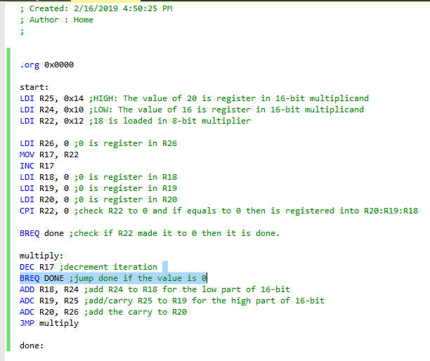

1. **SCREENSHOTS OF EACH TASK OUTPUT (ATMEL STUDIO OUTPUT)**

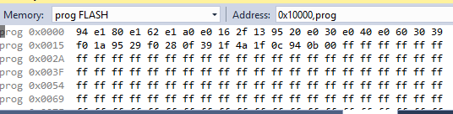

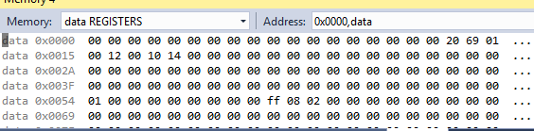

1. **SCREENSHOT OF EACH DEMO (BOARD SETUP)**

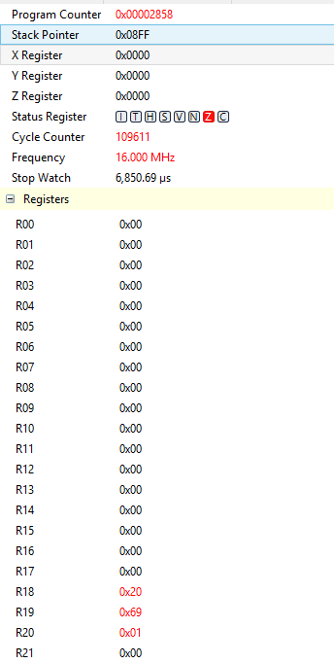

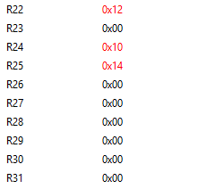

1. **VIDEO LINKS OF EACH DEMO**
2. **GITHUB LINK OF THIS DA**

https://github.com/sawar1/UNLV301

**Student Academic Misconduct Policy**

<http://studentconduct.unlv.edu/misconduct/policy.html>

“This assignment submission is my own, original work”.

RIMON SAWA