Rimon Sawa

CPE301 – SPRING 2019

Design Assignment 1B

Student Name: Rimon Sawa

Student #: 5001529281

Student Email: sawar1@unlv.nevada.edu

Primary Github address: https://github.com/sawar1/UNLV301

Directory:

* **COMPONENTS LIST AND CONNECTION BLOCK DIAGRAM w/ PINS**

Components used: ATmega328p and Atmel Studio. No pins were used for this assignment.

* **INITIAL/DEVELOPED CODE OF TASK 1/A**

2. 99 addresses

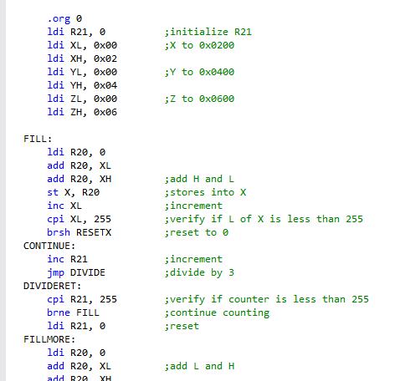

3. Verify if the value is divisible by 3

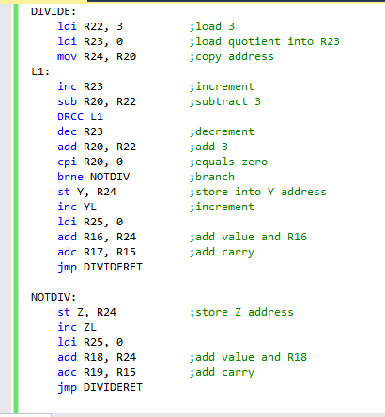

4. values in R16:R17 also R18:R19

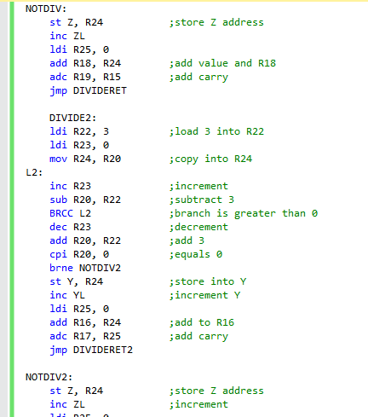

* **MODIFIED CODE OF TASK 2/A from TASK 1/A**



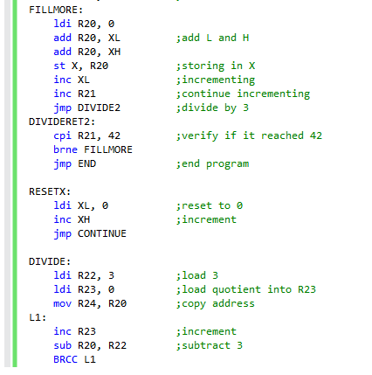

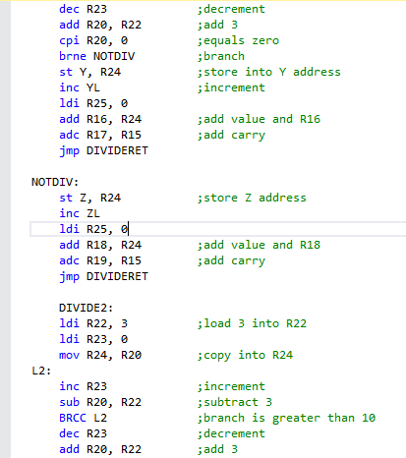

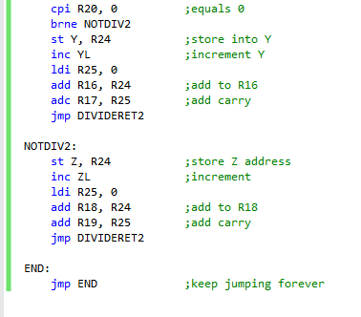

* **SCHEMATICS**
* **SCREENSHOTS OF EACH TASK OUTPUT (ATMEL STUDIO OUTPUT)**

Outputs 0x0200

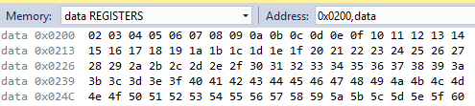

Outputs 0x0400

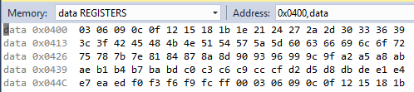

Outputs 0x0600

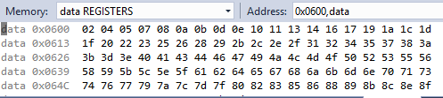

* **SCREENSHOT OF EACH DEMO (BOARD SETUP)**

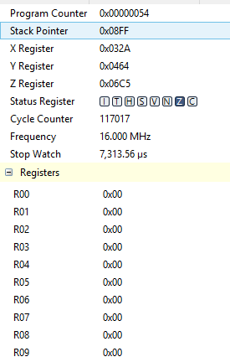

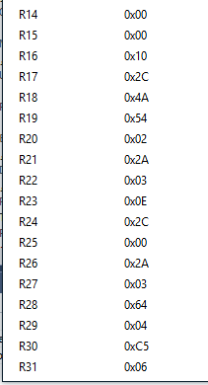

* **VIDEO LINKS OF EACH DEMO**
* **GITHUB LINK OF THIS DA**

<https://github.com/sawar1/UNLV301>

**Student Academic Misconduct Policy**

<http://studentconduct.unlv.edu/misconduct/policy.html>

“This assignment submission is my own, original work”.

RIMON SAWA