Rimon Sawa

**CPE301 – SPRING 2019**

Design Assignment 2A

Student Name: Rimon Sawa

Student #: 5001529281

Student Email: sawar1@unlv.nevada.edu

Primary Github address: https://github.com/sawar1/UNLV301

Directory:

1. **COMPONENTS & BLOCK DIAGRAM**

Components: ATmega328p chip, Atmel studio, yellow LED, push button, and 10K resistors.

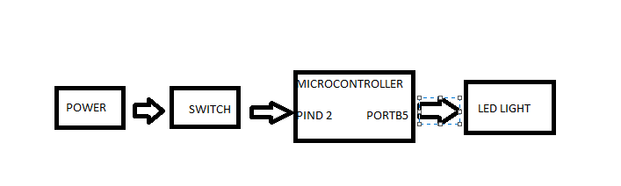

1. **CODE TASK 1/A & 1/C**

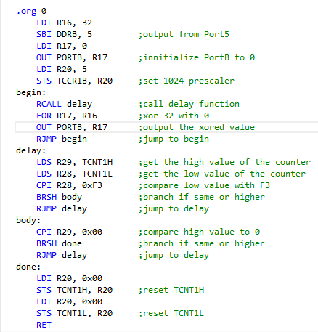

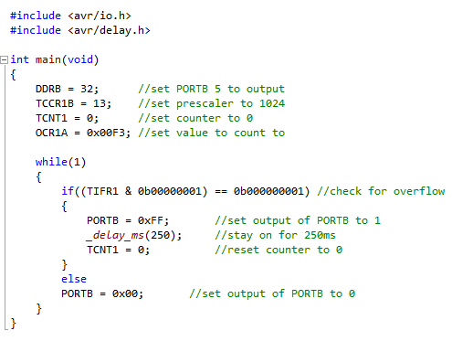

**CODE TASK 2/A & 2/C**

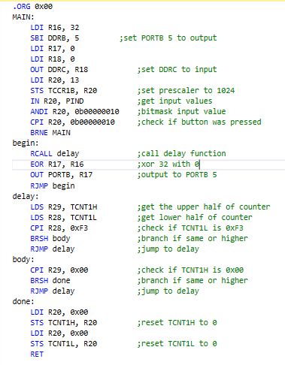

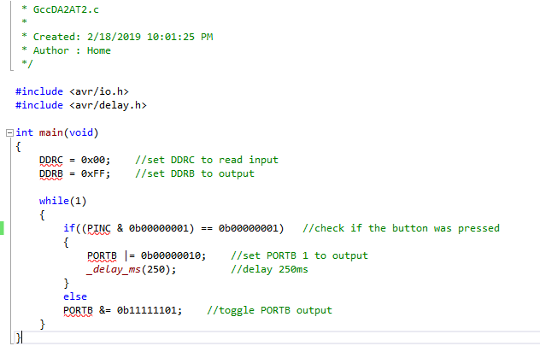

1. **SCHEMATICS**

1 schematic:

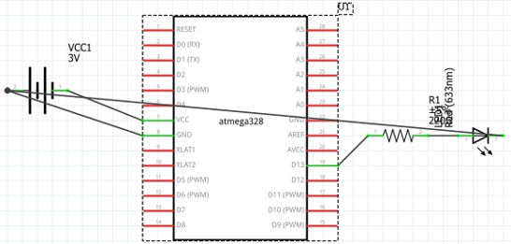

2 schematic:

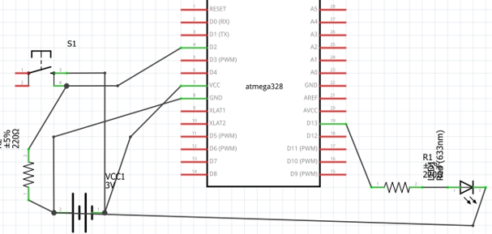

1. **PICTURES OF CIRCUIT/WAVEFORM**

**TASK 1 WAVEFORM:**

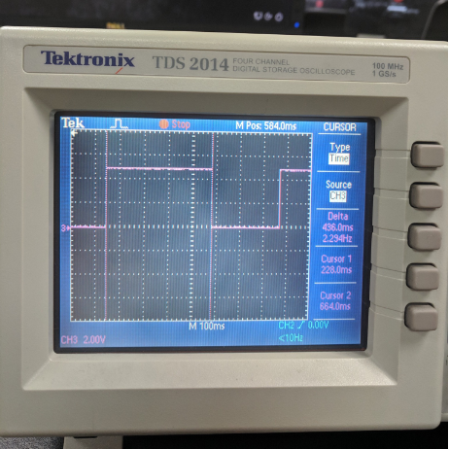

**TASK 1:**

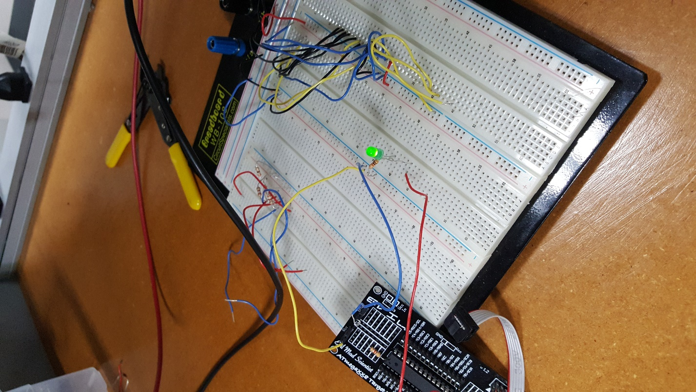

**TASK 2:**

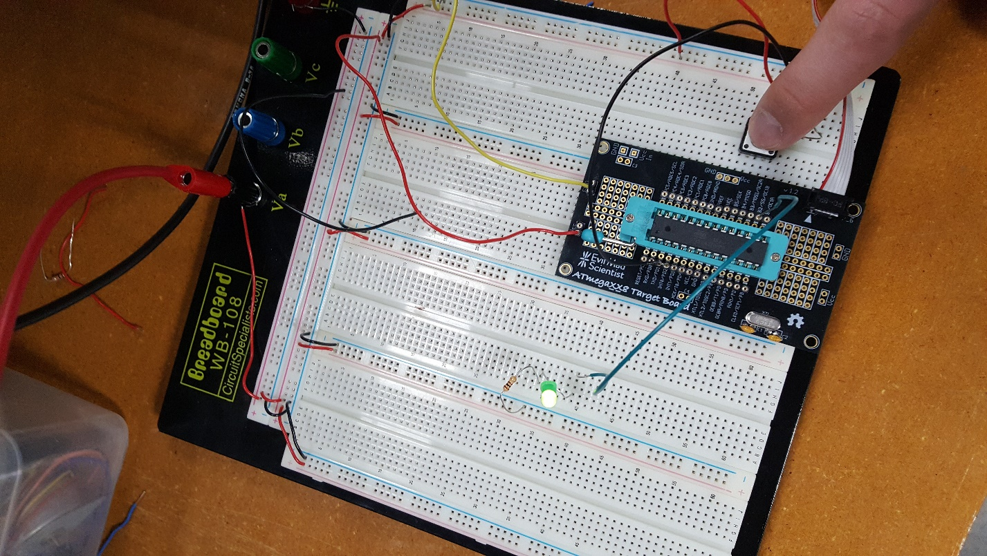

1. **VIDEO LINKS OF EACH DEMO**

<https://youtu.be/dRP64--GdyU>

1. **GITHUB LINK OF THIS DA**

<https://github.com/sawar1/UNLV301>

**Student Academic Misconduct Policy**

<http://studentconduct.unlv.edu/misconduct/policy.html>

“This assignment submission is my own, original work”.

RIMON SAWA