CPE301 – SPRING 2019

Design Assignment 2C

Student Name: Rimon Sawa

Student #: 5001529281

Student Email: sawar1@unlv.nevada.edu

Primary Github address: <https://github.com/sawar1/UNLV301>

Directory: DA2C

1. **COMPONENTS LIST AND CONNECTION BLOCK DIAGRAM w/ PINS**

Atmel Studio 7, ATmega328p Xplained mini, LED, switch

1. **INITIAL/MODIFIED/DEVELOPED CODE OF TASK 1/A**

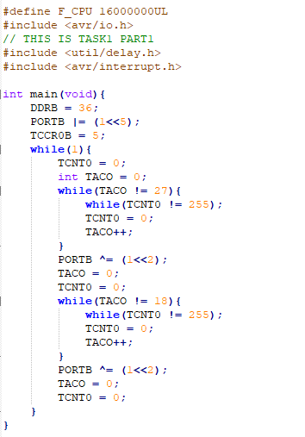

1. **INITIAL/MODIFIED/DEVELOPED CODE OF TASK 1/B**

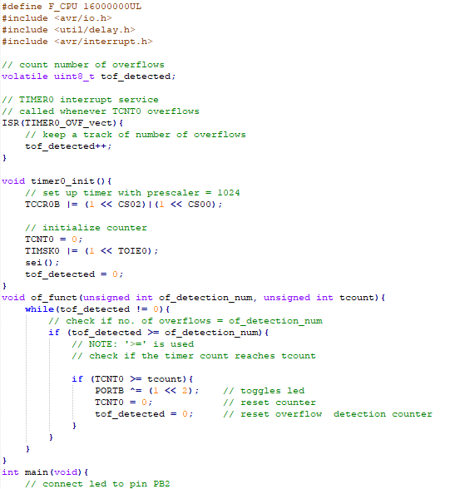

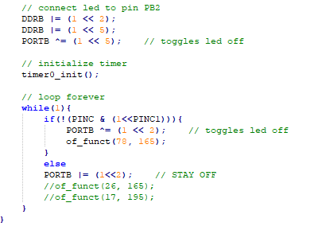

1. **INITIAL/MODIFIED/DEVELOPED CODE OF TASK 2/A**

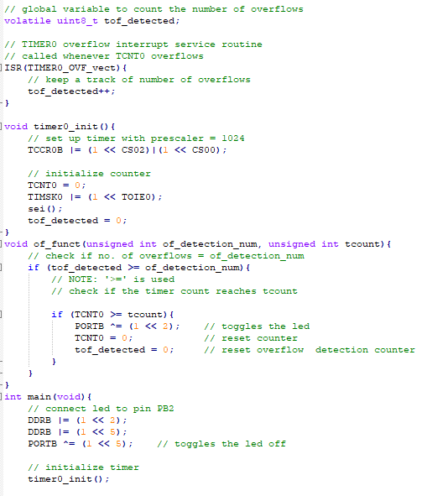

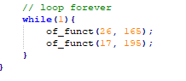

1. **INITIAL/MODIFIED/DEVELOPED CODE OF TASK 2/B**

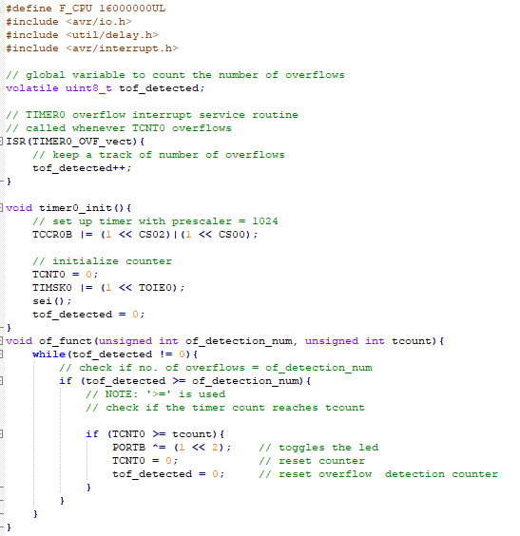

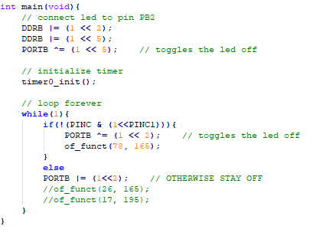

1. **INITIAL/MODIFIED/DEVELOPED CODE OF TASK 3/A**

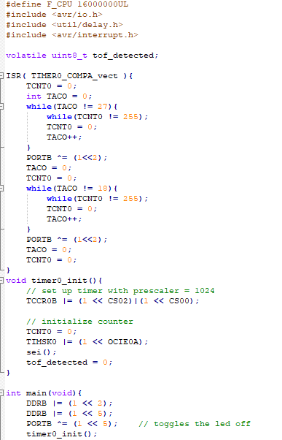



1. **INITIAL/MODIFIED/DEVELOPED CODE OF TASK 3/B**

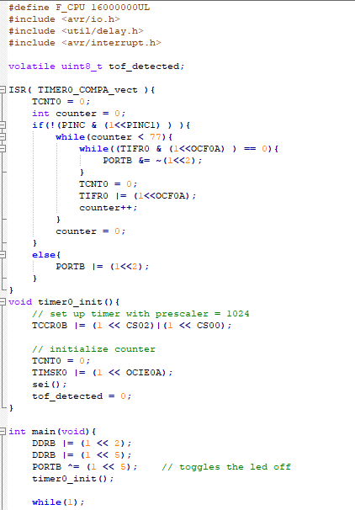

1. **SCHEMATICS**

1 & 2 schematic:

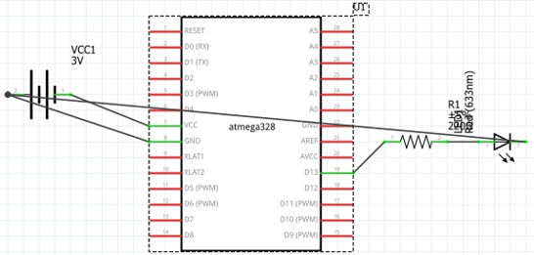

1. schematic:

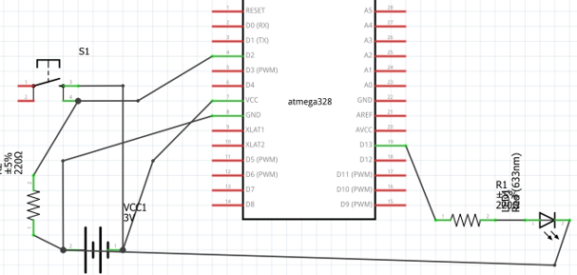

1. **PICTURES OF CIRCUIT**

**TASK 1:**

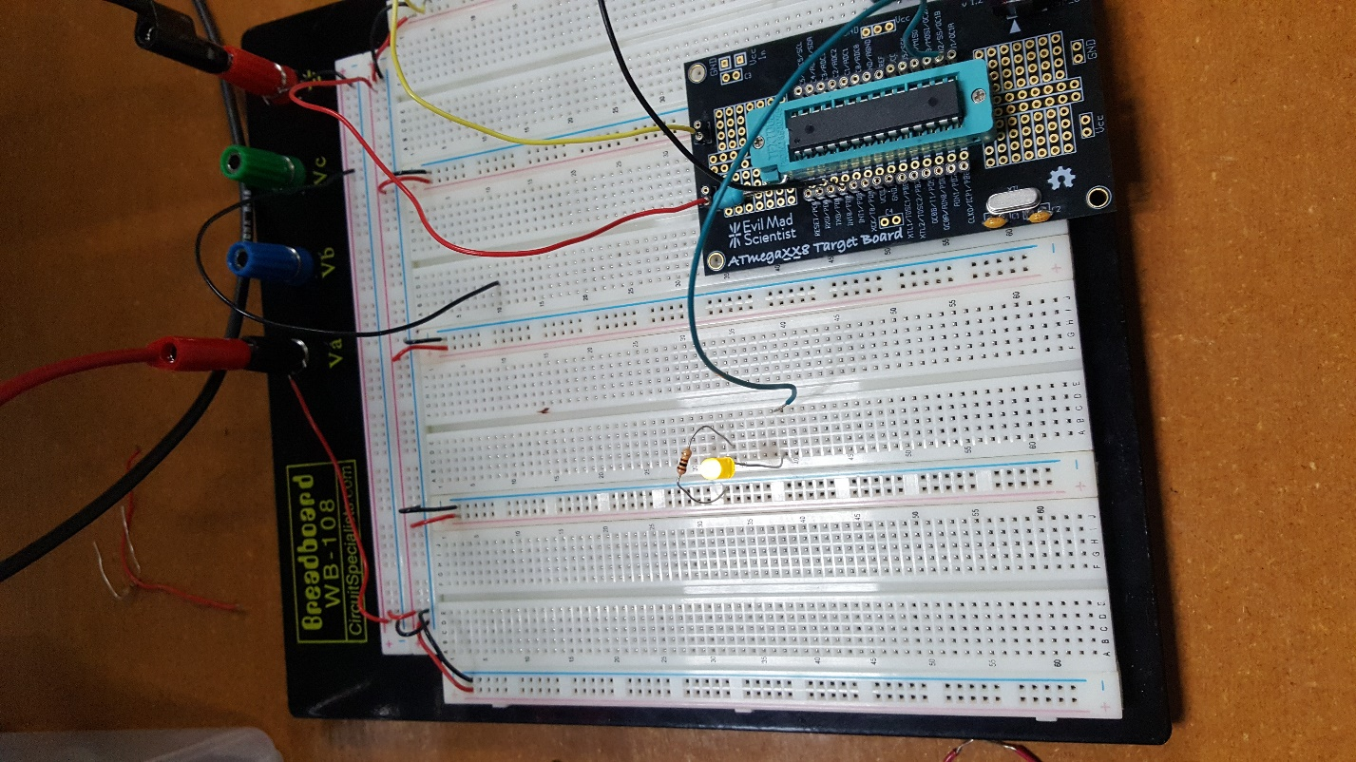

**TASK 2:**

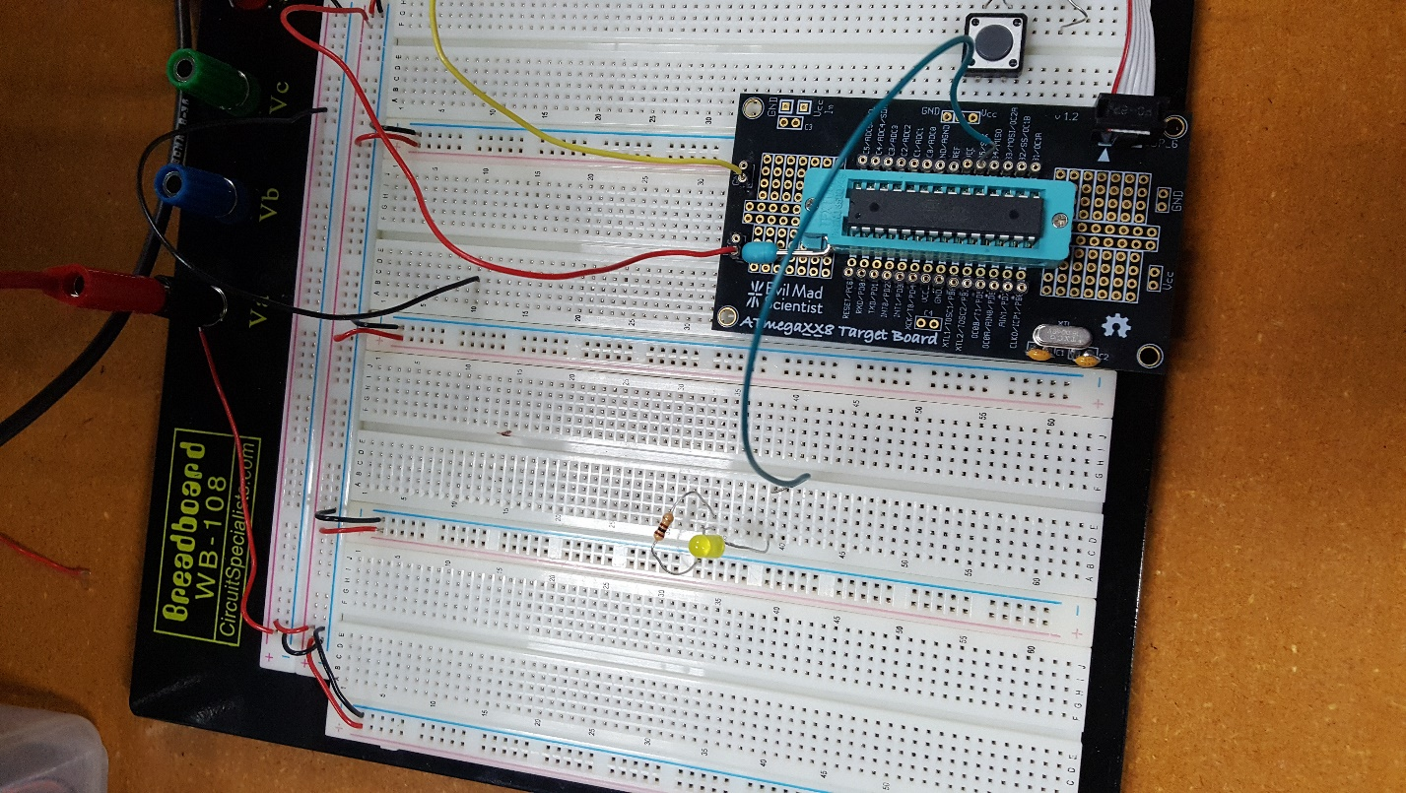

**TASK 3:**



1. **VIDEO LINKS OF EACH DEMO**

<https://youtu.be/bcpcXxqKedo>

1. **GITHUB LINK OF THIS DA**

<https://github.com/sawar1/UNLV301>

**Student Academic Misconduct Policy**

<http://studentconduct.unlv.edu/misconduct/policy.html>

“This assignment submission is my own, original work”.

RIMON SAWA