CPE301 – SPRING 2019

Design Assignment DA3B

Student Name: Rimon Sawa

Student #: 5001529281

Student Email: sawar1@unlv.nevada.edu

Primary Github address: <https://github.com/sawar1/UNLV301>

Directory: DA3B

1. **COMPONENTS LIST AND CONNECTION BLOCK DIAGRAM w/ PINS**

Atmega328 Xplained Mini, Computer, LM34 chip.

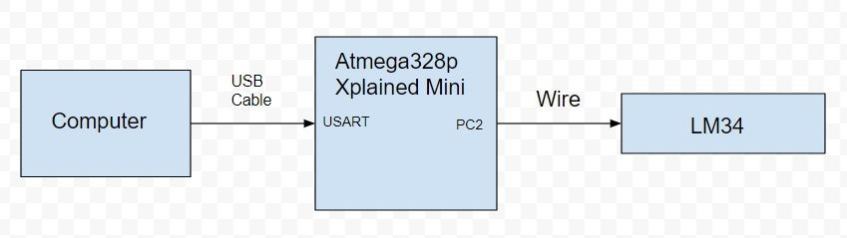

1. **INITIAL/MODIFIED/DEVELOPED CODE OF TASK 1/A**

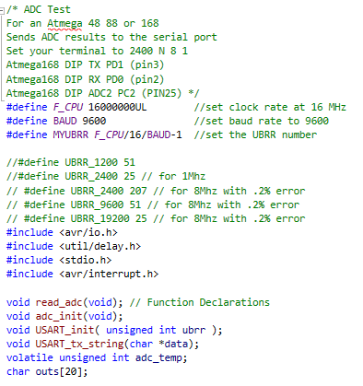

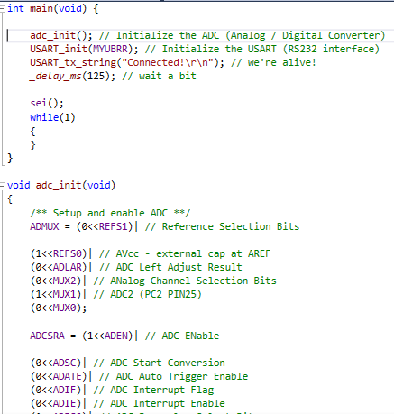

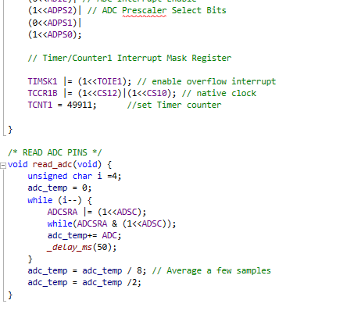

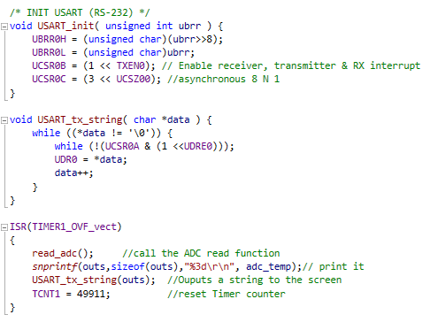

1. **schematic**

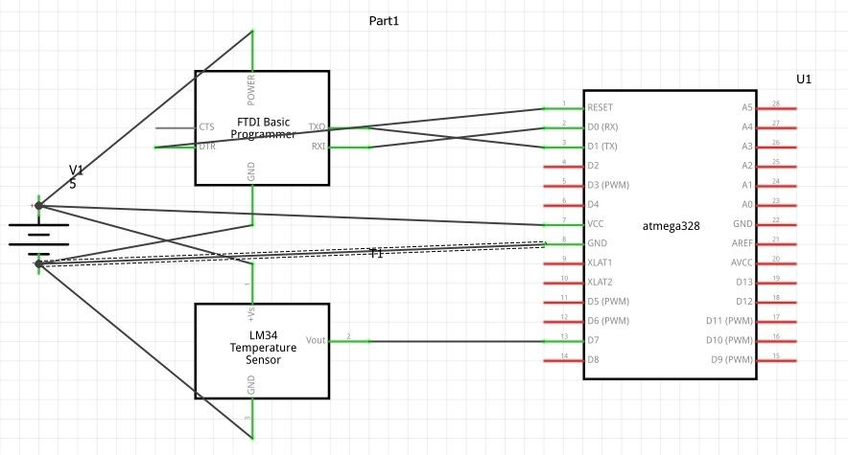

1. **SCREENSHOTS OF EACH TASK OUTPUT (ATMEL STUDIO OUTPUT)**

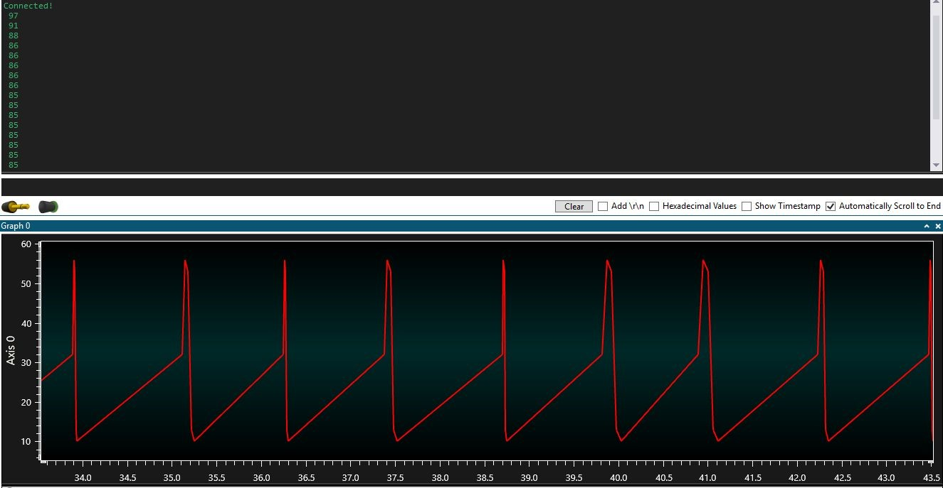

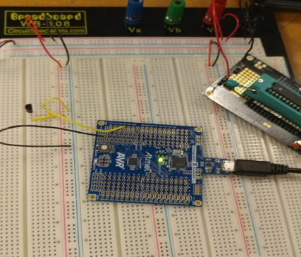

1. **VIDEO LINKS OF EACH DEMO**

<https://youtu.be/Z1EN-JD3wV4>

1. **GITHUB LINK OF THIS DA**

<https://github.com/sawar1/UNLV301>

**Student Academic Misconduct Policy**

<http://studentconduct.unlv.edu/misconduct/policy.html>

“This assignment submission is my own, original work”.

RIMON SAWA