Output 1: Display All Products
This output displays all records present in the Products table
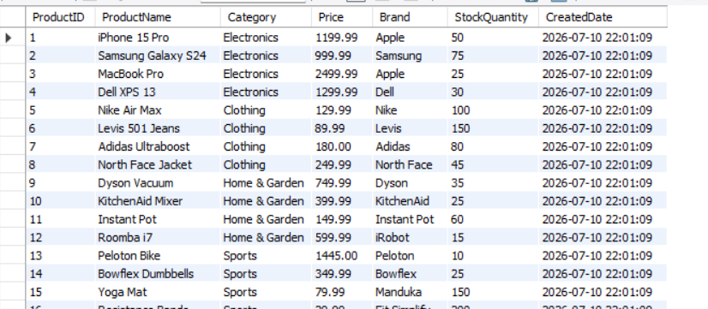

Output 2: ROW_NUMBER()
This output assigns a unique row number to each product based on price in descending order.
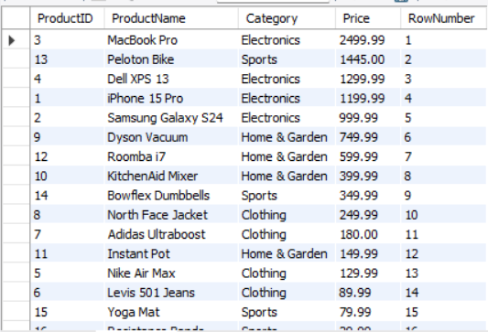

Output 3: RANK()
This output ranks products by price. Products with the same price receive the same rank, and the next rank is skipped.
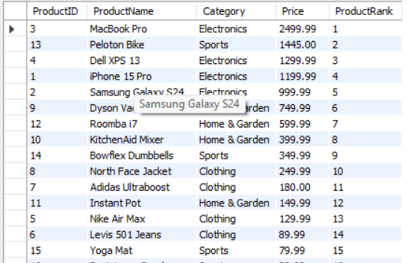

Output 4: DENSE_RANK()
This output ranks products by price without skipping rank numbers when duplicate prices occur.
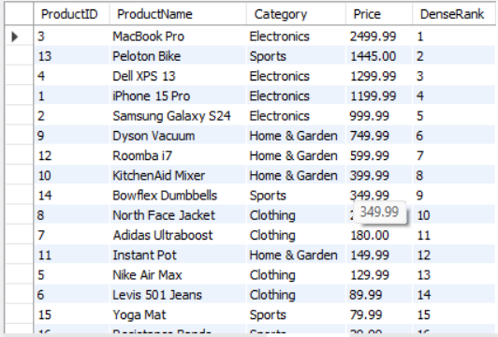

Output 5: ROW_NUMBER() with PARTITION BY
This output assigns a unique row number to products within each category based on descending price.
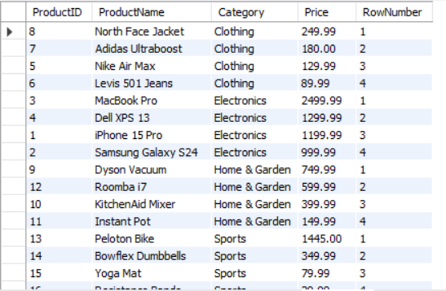

Output 6: RANK() with PARTITION BY
This output ranks products within each category. Products with equal prices receive the same rank.
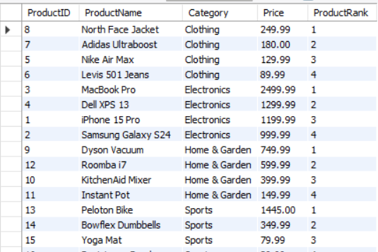

Output 7: DENSE_RANK() with PARTITION BY
This output assigns dense ranks to products within each category without skipping rank numbers.
