Output
- All Employee Records
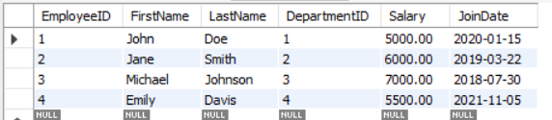

- Execute Stored Procedure – Retrieve Employees by Department
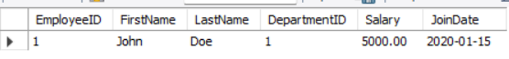

- Execute Stored Procedure – Total Employees in Department
