Week 9 – Basics of Information Systems
Database Project Check: Cinema Ticketing System
Team: Cinema Ticketing System

1. Team members and roles
# | Name | Student ID | Team role | Oral role (Task 09)
1 | Shakarbekov Zhakhongir | 24B032107 | Systems Analysis & Requirements | Main action and tables
2 | Idakhan Akzhol | 24B031813 | Testing, Analytics Integration | Primary keys and data rules
3 | Saparkhan Sanzhar | 24B031998 | Application & Development | Foreign keys and relationships
4 | Yeskenov Aldiyar | 24B031763 | Data and Database | ERD and repeated data
5 | Abiltayev Ulan | 24B031593 | Architecture & Security | SQL and business use + security and transactions

2. Main action
Booking tickets for a screening. A registered customer selects a movie, a screening (date, time, hall), chooses free seats on the hall map and pays online. The system creates one booking, one ticket for every chosen seat and one payment record.
Data collected: customer contact data, movie, hall, seat, screening time and price, booking status, ticket price, payment method and status.

3. Shared database plan
Table | Purpose | Important fields | PK | FK | Rules and data types
CUSTOMER | A person who buys tickets online | full_name, email, phone, created_at | customer_id | — | customer_id INT AUTO; full_name VARCHAR(100) NOT NULL; email VARCHAR(100) NOT NULL UNIQUE; phone VARCHAR(20); created_at TIMESTAMP DEFAULT now
MOVIE | A film the cinema shows | title, duration_min, age_rating, release_year | movie_id | — | title VARCHAR(150) NOT NULL; duration_min INT CHECK (40–300); age_rating VARCHAR(5) IN ('0+','6+','12+','16+','18+'); release_year INT CHECK (1900–2100). Genre is NOT stored here (see GENRE)
GENRE | Reference list of film genres | genre_id, name | genre_id | — | genre_id INT AUTO; name VARCHAR(30) NOT NULL UNIQUE (no 'Sci-Fi' and 'sci fi' twice)
MOVIE_GENRE (bridge) | Links a movie to each of its genres; resolves M:N MOVIE–GENRE | movie_id, genre_id | (movie_id, genre_id) composite | movie_id → MOVIE; genre_id → GENRE | both INT NOT NULL; composite PK – the same genre cannot be added to a movie twice
HALL | A physical hall in the cinema | name, capacity, hall_type | hall_id | — | name VARCHAR(30) NOT NULL UNIQUE; capacity INT CHECK (>0); hall_type VARCHAR(10) IN ('2D','3D','IMAX')
SEAT | One seat inside one hall | hall_id, row_label, seat_number, seat_type | seat_id | hall_id → HALL | row_label CHAR(2) NOT NULL; seat_number INT CHECK (>0); UNIQUE (hall_id, row_label, seat_number); seat_type IN ('standard','vip')
SCREENING | One show of one movie in one hall at one time | movie_id, hall_id, start_time, base_price | screening_id | movie_id → MOVIE; hall_id → HALL | start_time TIMESTAMP NOT NULL; base_price DECIMAL(8,2) CHECK (>0); UNIQUE (hall_id, start_time)
BOOKING | One purchase made by a customer (event) | customer_id, booking_time, status, total_amount | booking_id | customer_id → CUSTOMER | status VARCHAR(10) NOT NULL IN ('pending','paid','cancelled') DEFAULT 'pending'; total_amount DECIMAL(10,2) CHECK (>=0)
TICKET (bridge) | One seat sold for one screening inside one booking; resolves M:N SCREENING–SEAT | booking_id, screening_id, seat_id, price | ticket_id | booking_id → BOOKING; screening_id → SCREENING; seat_id → SEAT | all FKs NOT NULL; price DECIMAL(8,2) CHECK (>0); UNIQUE (screening_id, seat_id) – no double booking
PAYMENT | Money received for one booking | booking_id, amount, method, status, paid_at | payment_id | booking_id → BOOKING (UNIQUE ⇒ 1:1) | amount DECIMAL(10,2) CHECK (>0); method IN ('card','kaspi','cash'); status IN ('success','failed','refunded'); paid_at TIMESTAMP

Relationships
Relationship | Type | Business rule
CUSTOMER – BOOKING | 1:M | One customer can make many bookings; a booking belongs to one customer.
BOOKING – TICKET | 1:M | One booking contains one or more tickets (seats).
BOOKING – PAYMENT | 1:1 | One booking is paid once; payment.booking_id is UNIQUE.
MOVIE – SCREENING | 1:M | One movie is shown in many screenings.
MOVIE – GENRE | M:N | A movie can have many genres; a genre has many movies. Resolved by bridge table MOVIE_GENRE.
HALL – SCREENING | 1:M | One hall hosts many screenings (never two at the same start_time).
HALL – SEAT | 1:M | One hall has many seats; a seat belongs to one hall.
SCREENING – SEAT | M:N | Resolved by bridge table TICKET (UNIQUE screening_id + seat_id).

ERD
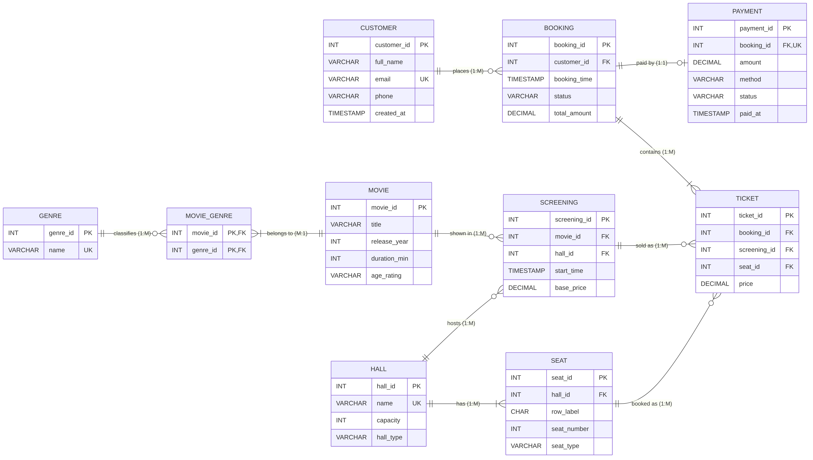
Figure 1. ERD of the Cinema Ticketing System. Bridge tables: TICKET (SCREENING–SEAT, M:N) and MOVIE_GENRE (MOVIE–GENRE, M:N).

4. SQL query and business use

Query
SELECT m.title,
h.name AS hall,
s.start_time,
h.capacity,
COUNT(t.ticket_id) AS tickets_sold,
ROUND(100.0 * COUNT(t.ticket_id) / h.capacity, 1) AS occupancy_pct,
COALESCE(SUM(t.price), 0) AS revenue
FROM screening s
JOIN movie m ON m.movie_id = s.movie_id
JOIN hall h ON h.hall_id = s.hall_id
LEFT JOIN ticket t ON t.screening_id = s.screening_id
LEFT JOIN booking b ON b.booking_id = t.booking_id
WHERE s.start_time BETWEEN NOW() AND NOW() + INTERVAL '7 days'
AND (b.status = 'paid' OR t.ticket_id IS NULL)
GROUP BY m.title, h.name, s.start_time, h.capacity
ORDER BY occupancy_pct ASC;

Question it answers: How full is every screening of the next 7 days and how much money has each one earned? LEFT JOIN keeps screenings with zero tickets, so empty shows are visible too.

Example result
title | hall | start_time | capacity | tickets_sold | occupancy_pct | revenue (₸)
The Silent Coast | Hall 3 | 2026-11-03 11:00 | 80 | 9 | 11.3 | 22 500
Dune: Part Two | Hall 2 | 2026-11-03 14:00 | 120 | 41 | 34.2 | 102 500
Kazakh Comedy | Hall 1 | 2026-11-06 19:00 | 150 | 138 | 92.0 | 414 000

Data → information → decision
- Data: single TICKET rows – ticket #501, seat 34, screening 12, price 2 500 ₸.
- Information: after grouping, 'The Silent Coast' on Tuesday 11:00 is only 11 % full, while Friday 19:00 'Kazakh Comedy' is 92 % full.
- Decision: the manager moves the morning show to a smaller hall (or cancels it) and adds an extra Friday evening screening of the popular film – more revenue, less empty hall cost.

5. Security and transaction

Access to sensitive data
Role | Can see / change | Cannot see / change
Customer | Movies, screenings, free seats; only own bookings, tickets, payments | Other customers' data, prices editing, reports
Cashier | Today's bookings and tickets; can sell and cancel tickets | Payment details, customer list export, price changes
Manager | Movies, halls, screenings, prices; sales reports (aggregated) | Customer passwords, payment tokens
Admin | User accounts and roles, all tables for support | — (actions are logged)
Sensitive fields: CUSTOMER.email, CUSTOMER.phone, PAYMENT data. Card numbers are not stored – only the payment provider's transaction token.

Transaction: book tickets
BEGIN;
-- 1. create booking
INSERT INTO booking (customer_id, booking_time, status, total_amount)
VALUES (17, NOW(), 'pending', 5000) RETURNING booking_id; -- 1001
-- 2. one ticket per chosen seat (UNIQUE(screening_id, seat_id) blocks a taken seat)
INSERT INTO ticket (booking_id, screening_id, seat_id, price) VALUES
(1001, 12, 34, 2500), (1001, 12, 35, 2500);
-- 3. payment
INSERT INTO payment (booking_id, amount, method, status, paid_at)
VALUES (1001, 5000, 'kaspi', 'success', NOW());
-- 4. confirm booking
UPDATE booking SET status = 'paid' WHERE booking_id = 1001;
COMMIT; -- on any error: ROLLBACK;

If step 2 fails (seat already sold) → ROLLBACK removes the booking from step 1. If step 3 fails (payment declined) → ROLLBACK removes the booking and both tickets, so the seats become free again. The database never keeps a half-finished booking.

6. Oral explanation – talking points
Points to show on the ERD/tables while speaking (about 2 minutes each). Do not read – point to the diagram.

Student 1 – Shakarbekov Zhakhongir: Main action and tables
- Main action: a customer books tickets for a screening – chooses movie → time → seats → pays → gets tickets.
- Data collected: who buys (CUSTOMER), what is shown (MOVIE), where (HALL, SEAT), when (SCREENING), the purchase (BOOKING), each seat sold (TICKET), the money (PAYMENT).
- Each table = one thing or one event: MOVIE, HALL, SEAT, CUSTOMER are things; SCREENING, BOOKING, TICKET, PAYMENT are events.
- Difficult part: at first we had one ORDERS table with movie title, hall and seat list in one row. It mixed several things and repeated movie data, so we split it into SCREENING, BOOKING and TICKET.
Personal statement:
- My personal contribution was listing the data the booking screen needs and proposing the first table list.
- One database decision I helped make was separating SCREENING from MOVIE because one movie is shown many times in different halls.
- Still unclear: whether we need a separate PRICE_RULE table for student/child discounts.
- Our next action is adding discount types, and Shakarbekov Zhakhongir is responsible for it.

Student 2 – Idakhan Akzhol: Primary keys and data rules
- Every table has a surrogate PK: customer_id, movie_id, hall_id, seat_id, screening_id, booking_id, ticket_id, payment_id (INT, AUTO_INCREMENT, NOT NULL).
- Why unique and stable: the DBMS generates the number, it never repeats and never changes. Email or phone can change, so we do not use them as PK (email is only UNIQUE).
- What stops two rows with the same PK: the PRIMARY KEY constraint – the second INSERT with the same id is rejected.
- Rule example 1: TICKET UNIQUE (screening_id, seat_id) – the same seat cannot be sold twice for the same show.
- Rule example 2: SCREENING.base_price CHECK (> 0) and BOOKING.status IN ('pending','paid','cancelled') – no negative price, no unknown status. NOT NULL on start_time – a show cannot exist without time.
Personal statement:
- My personal contribution was defining data types and CHECK / UNIQUE rules for every table.
- One database decision I helped make was using surrogate INT keys instead of email because email can change.
- Still unclear: how to validate phone format (+7 7xx xxx xx xx) – in the DB or only in the form.
- Our next action is writing the CHECK for phone format, and Idakhan Akzhol is responsible for it.

Student 3 – Saparkhan Sanzhar: Foreign keys and relationships
- CUSTOMER 1:M BOOKING (booking.customer_id); BOOKING 1:M TICKET (ticket.booking_id); BOOKING 1:1 PAYMENT (payment.booking_id is FK + UNIQUE).
- MOVIE 1:M SCREENING; HALL 1:M SCREENING; HALL 1:M SEAT.
- SCREENING M:N SEAT – one show has many seats, one seat is used in many shows. Resolved by the bridge table TICKET (screening_id, seat_id).
- MOVIE M:N GENRE – Dune is Sci-Fi and Adventure, Sci-Fi has many movies. Resolved by MOVIE_GENRE with composite PK (movie_id, genre_id).
- Connecting record example: TICKET #501 → booking_id 1001 (customer Aruzhan) → screening_id 12 (Dune 2, Hall 1, 19:00) → seat_id 34 (row C, seat 7).
- Orphan prevention: every FK has REFERENCES parent(pk) and NOT NULL. INSERT of a ticket with screening_id 999 that does not exist → error. Deleting a movie that has screenings → ON DELETE RESTRICT blocks it.
Personal statement:
- My personal contribution was defining all foreign keys and the ON DELETE rules.
- One database decision I helped make was making TICKET the bridge table because a direct SCREENING–SEAT link cannot store who bought the seat and for what price.
- Still unclear: the DB does not yet check that the seat belongs to the same hall as the screening.
- Our next action is adding a trigger/check for seat.hall_id = screening.hall_id, and Saparkhan Sanzhar is responsible for it.

Student 4 – Yeskenov Aldiyar: ERD and repeated data
- Explain the ERD left to right: CUSTOMER → BOOKING → TICKET / PAYMENT; MOVIE and HALL → SCREENING → TICKET; HALL → SEAT → TICKET. Crow's foot = 'many', double bar = 'exactly one', circle = 'optional'.
- Repeated data in the first version: every ticket row stored movie title, hall name and customer email. If a title was corrected, many rows had to be updated.
- Now one fact – one place: movie title only in MOVIE, hall name only in HALL, email only in CUSTOMER, genre name only in GENRE. TICKET and MOVIE_GENRE store only ids. Genres are not written as text "Sci-Fi, Adventure" in MOVIE – that breaks 1NF.
- Intentional copy: TICKET.price – the price at the moment of sale. base_price can change later, but a sold ticket must keep its real price (historical fact, not duplication).
Personal statement:
- My personal contribution was drawing the ERD and checking that it matches the table plan.
- One database decision I helped make was removing movie title and hall name from TICKET because they already live in MOVIE and HALL.
- Still unclear: whether total_amount in BOOKING should be stored or always calculated from TICKET.
- Our next action is deciding on total_amount (calculate via view), and Yeskenov Aldiyar is responsible for it.

Student 5 – Abiltayev Ulan: SQL, business use, security and transactions
- Query (Section 4) answers: 'How full is each screening of the coming week, and how much money did it bring?'
- Decision: shows below 30 % occupancy → move to a smaller hall or cancel; shows above 90 % → add an extra screening.
- Security: Customer sees only own bookings; Cashier sees bookings of today, cannot change prices; Manager edits movies/screenings/prices and sees reports; Admin manages users. Nobody except Admin/DB sees payment details; card numbers are not stored (payment provider token only).
- Transaction (book tickets): 1) INSERT BOOKING 'pending' 2) INSERT TICKET for each seat 3) INSERT PAYMENT 4) UPDATE BOOKING to 'paid' → COMMIT.
- If step 2 fails (seat already taken – UNIQUE error) or step 3 fails (payment declined) → ROLLBACK: the booking and the tickets inserted earlier are undone, the seats stay free.
Personal statement:
- My personal contribution was writing the SELECT query and the booking transaction.
- One database decision I helped make was using a transaction for booking because without it a seat could stay taken while payment failed.
- Still unclear: what to do with 'pending' bookings when the user closes the page.
- Our next action is adding hold expiry (10 min), and Abiltayev Ulan is responsible for it.

7. Problem and next action
Current problem | Why it matters | Proposed solution | Responsible student | Deadline
Seats of a 'pending' booking stay blocked if the customer leaves the payment page; also the DB does not check that SEAT belongs to the SCREENING's hall. | Real seats look sold but no money comes → lost revenue; a ticket could point to a seat in another hall → wrong data. | Add BOOKING.hold_expires_at (NOW()+10 min) and a scheduled job that cancels expired 'pending' bookings and deletes their tickets; add a trigger: seat.hall_id must equal screening.hall_id. | Abiltayev Ulan (hold expiry); Saparkhan Sanzhar (hall trigger) | 13.11.2026 (Week 11)

