Jefferson E-commerce

User Manual

Contents:

**User Specific Pages………………………………3**- Account Creation………………………………………4-5  
- User Log In………………………………………………6  
- Account Settings……………………………………….7-8

**Site Navigation and Ordering…………………….9  
-** Home Page……………………………………………...10  
- Searching……………………………………………….11  
- Product Information………………………………….....12  
- Cart……………………………………………………..13  
- Checkout………………………………………….……14

**User Specific Pages**

Account Creation

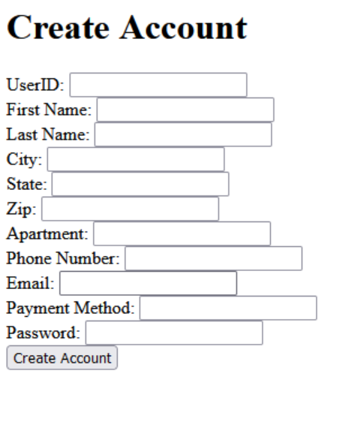

When creating an account for the site, please ensure you fill out every text box in the form by clicking on each box and filling the necessary information with your keyboard.

User ID: The username that will be displayed on the site, as well as being a part of your log in.

For billing purposes, the following is required.  
- Your first name.  
- Your last name.  
- Your city of residence.  
- Your state of residence.  
- Your zip code.  
- Your apartment or home address.

Phone Number: Your phone number is needed for identification, order confirmation, and an added layer of account security.

Email: Your phone number is needed for contact, order confirmation, and an added layer of account security.

Payment Method: Your preferred method of payment, including all necessary information, is needed to make purchases on the site.

Password: Your password will be needed to verify your log in. Please ensure your password meets the requirements of..  
  
- A minimum length of 8 characters.  
- At least one number.  
- At least one uppercase letter.  
- At least one lowercase letter.  
- At least one special character.

PLEASE NOTE: Never share your password with anyone. Jefferson E-commerce will never ask for your password.

Once all information has been filled out, please click the “Create Account” button to finalize the creation of your account.

User Login

The log in page is where the username and password selected during account creation is entered in the same manner to gain access to your account. Once the username and password are entered, click the Login button to gain access to your account.

Account Settings

The account settings page will allow you to modify your personal and account information. This includes:

* First Name
* Last Name
* Email
* Home/Apartment Address
* City
* State
* Zip Number
* Phone Number
* Payment Method
* Password

Once modification is complete, click the “Submit Query” button to save those changes.

Order History is present on this page as well. Clicking this link will direct you to a list of your orders, including their total price and product information, as well as when the order was submitted and when it will arrive based on estimations.

**Site Navigation and Ordering**

Home Page

The home page features a selection of products to browse from, including images, descriptions, and a button to view more info in detail on each product.

At any point if a user is looking to return to the home page, they may click the “ECOMMERCE++!” link in the upper left. This button will be present across the website. The same goes for the “Search”, “Cart”, and “Login/Settings” buttom/

The header has individual links to a search bar, your active cart, and your account settings.  
NOTE: Account settings will be replaced with Log in if you have yet to log in to your account.

Searching

After clicking the search button, a new section will appear on the webpage.

This new section presents a text box to search for specific products or a general selection of products to browse. Fill out the text box, and optionally use the “sort by” dropdown to narrow your search. Then, click “Search” to begin browsing products by your parameters.

Product Information

The product information page appears after choosing to view more product information. It will present itself with a product photo, name, cost, and quantity in stock. There will be a description of the item, as well as a drop-down menu to select options for the product depending on what product is being viewed.

Cart

The cart option presents the menu displayed above. For every product within the cart, it will display a photo, the product’s name, the price, and the quantity.

A subtotal will be calculated and displayed for the cart’s total value.

To finalize the order purchase of the cart, click the “Checkout” button. This will complete the transaction and bring you to the order confirmation screen.

Checkout

This dialogue will display after completing an order from the cart page. From here, two links will be displayed that the user may click on.

“Click to go back to Home”

“Settings”

From home you may once again continue browsing the catalogue or access other parts of the site. Settings will redirect you to your account details and settings.