The first git commit involved updating the readme.md file, but I don’t have a screenshot to show.

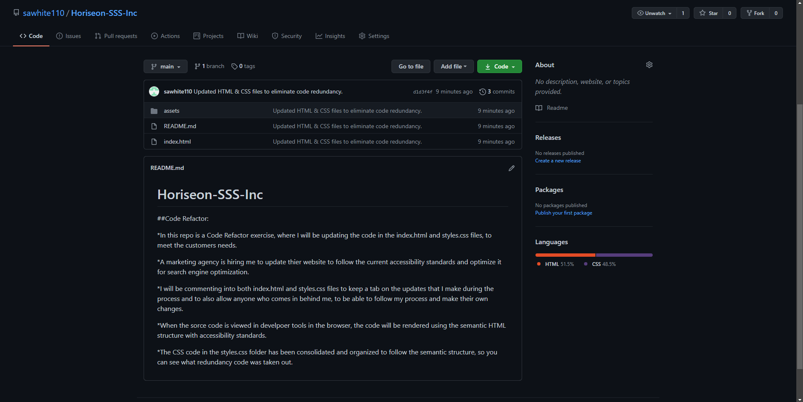Above is the second git commit to read, “Updated HTML & CSS files to eliminate code redundancy.”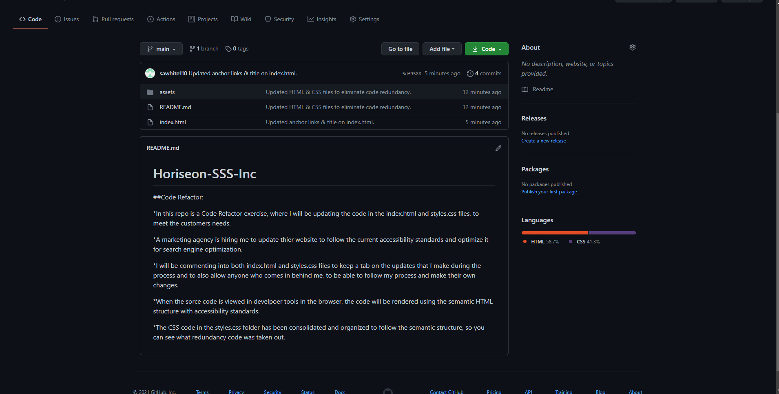Above is the third git commit to read, “Updated anchor links & title on index.html.”

