**Thinspeak Settings**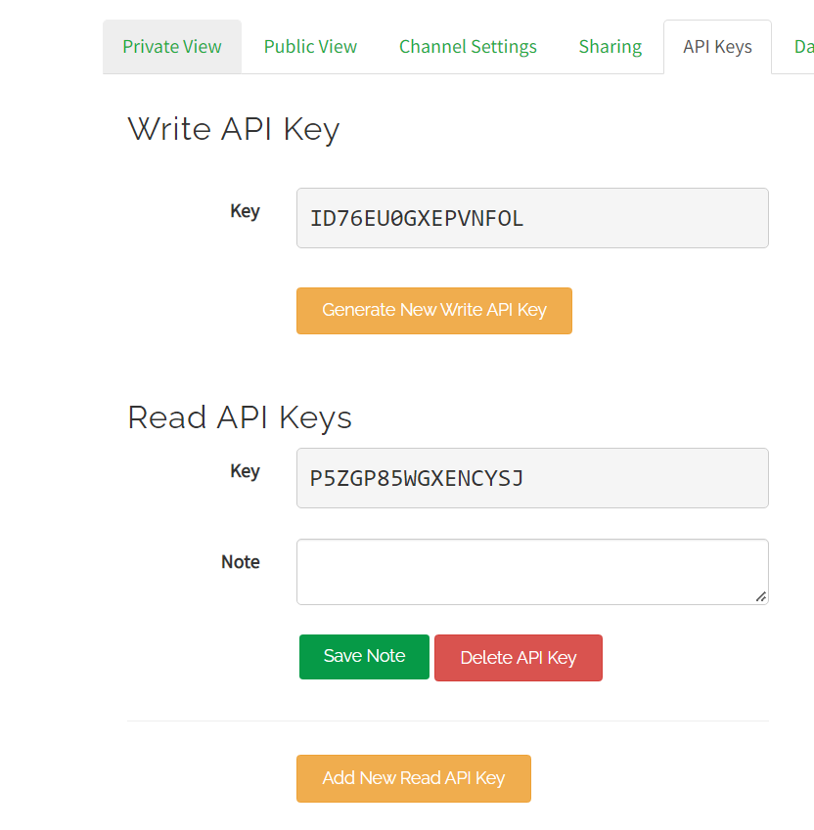

Write a channel feed:

GET https://api.thingspeak.com/update?api_key=ID76EU0GXEPVNFOL&field1=0

Read a channel feed:

GET https://api.thingspeak.com/channels/1706364/feeds.json?api_key=P5ZGP85WGXENCYSJ&results=2

Read a channel field:

GET https://api.thingspeak.com/channels/1706364/fields/1.json?api_key=P5ZGP85WGXENCYSJ&results=2

Read channel status update:

GET https://api.thingspeak.com/channels/1706364/status.json?api_key=P5ZGP85WGXENCYSJ

metin içeren bir resim

Açıklama otomatik olarak oluşturuldu

**Warnings:**

If Temp smaller than 20 : “Ortam sıcaklığı düşük.”

If Waterlevel smaller than 2 : “Sistemdeki su tükenmek üzere. Lütfen su ekleyin.”

If CO2 bigger than 1000: “Karbondiyoksit seviyesi yüksek.”