Make a web application for a wedding house and design a logo. Use a text editor for syntax highlighting and a vector graphics processing program.

**Graphics**

Using a vector graphics processing program, create a logo consistent with the image presented (below are the steps for making the logotype). 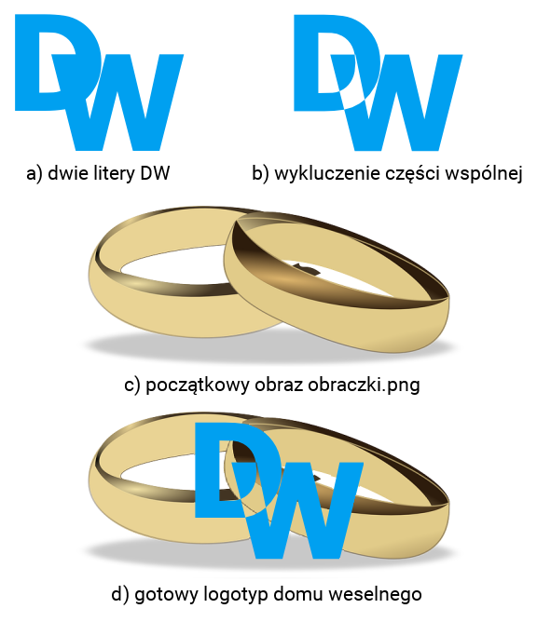

Graphics Requirements: • The background of the logo is transparent • Capital letters D and W should be written in any Sans Serif font, eg Arial, Tahoma; blue color, font size 144 • The relative positions of the letters are shown in the image above. It is required that D be higher than W and that both letters overlap • Both letter shapes use a function that excludes the common part of the objects • The obraczki.png image extracted from the archive is behind the letters • Graphics should be exported to PNG format and saved as logo.png

**Website**

Text file:

The website requires the file Regulamin.txt with the content: " Regulamin Domu Weselnego". The file should be placed in the folder where the site files will be located. 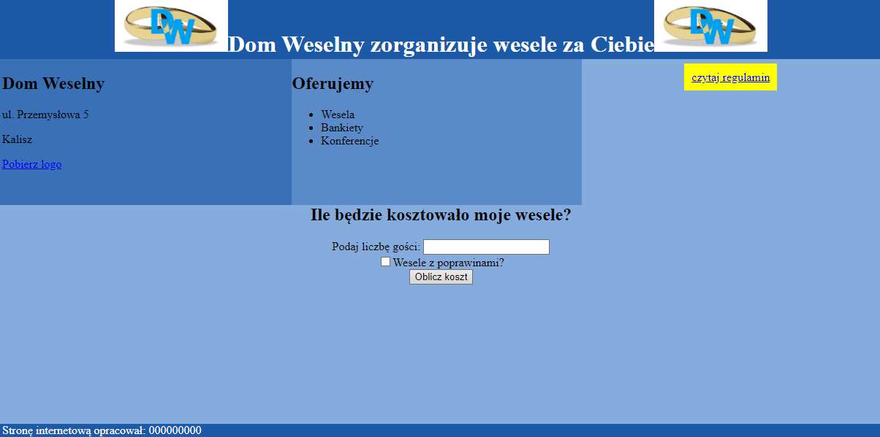

Site features:

* Filename: wesela.html
* The appropriate Polish character encoding standard was used
* The title of the page visible in the browser tab: "Dom Weselny"
* A stylesheet in a file named styl5.css correctly linked to the page code
* Division of the page into blocks: banner, below three panels: left, middle, right; below the bottom panel and a foot under it. Division done with section markers, as shown in the screen above
* The content of the banner is a first-level header containing:
  + Logo.png image, 70px high
  + Text: " Dom Weselny zorganizuje wesele za Ciebie"
  + Logo.png image, 70px high
* Left panel content:
  + The second-degree heading reads: " Dom Weselny"
  + Three paragraphs (paragraphs) with the content, in turn: "ul. Przemysłowa 5", "Kalisz", link to the file logo.png with the text " Pobierz logo"
* The contents of the center panel:
  + A second level heading saying " Oferujemy"
  + A point list with three elements: Wesela, Bankiety, Konferencje
* Right panel content:
  + The link in the paragraph to the file Regulamin.txt with the following text: " czytaj regulamin"
* Bottom panel content:
  + A second level headline that reads: " Ile będzie kosztowało moje wesele?”
  + Text: " Podaj liczbę gości:", then a numeric field
  + A checkbox, followed by the following: " Wesele z poprawinami?”
  + Button with the text " Oblicz koszt", which when selected, starts the script
  + A paragraph with a place for the results of the script operation
* Footer content: the inscription: " Stronę internetową opracował:", then your first name and Last Name is inserted, that should be written in italics.

**CSS style of the website**

The styl5.css file contains the following formatting

* Banner: background color # 1C59A7, white font color, center text alignment, height 80px
* Left Panel: background color # 3A70B5, 33% wide, 200px high
* Middle panel: background color # 5A8AC8, 33% wide, 200px high
* Right Panel: background color # 86ACDD, center text alignment, width 34%, height 200px
* Bottom panel: background color # 86ACDD, center text alignment, height 300px
* Footers: background color # 1C59A7, white font color
* Links from the right panel: yellow background, font color blue, internal margins 10px (Note: only the link from the right panel should be formatted with this style, other links are formatted by default)

**The script**

Script requirements:

* Executed on the browser side
* Retrieves data from both fields from the bottom panel (the number and state of the checkbox)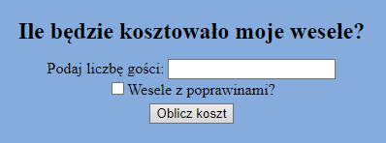
* Calculates the cost of the wedding based on the collected values, according to the guidelines:
  + Cost for one person is PLN 100
  + In the case of post-correction, the total cost should be increased by 30%
* Displays the text below the button: "Koszt Twojego wesela to ... złotych", with the calculated cost of the wedding in the dots.