

**COLLEGE OF ARTS AND SCIENCES**

**SCHOOL OF COMPUTING**

**STIA1113 PROGRAMMING I**

TOPIC 3 - NUMERICAL COMPUTATION & EXPRESSION PART 1

**EXERCISES**

1. **IDENTIFIER:** Identify whether the following identifiers are valid or not. If not, please give your reason(s).

|  |  |  |
| --- | --- | --- |
| a. | a | **Valid because it can start with a lowercase letter** |
| b. | Sales | **Valid because it can start with the uppercase letter** |
| c. | sales&profit | **Not valid because Java only allows identifiers with the symbol $ and _** |
| d. | int | **Not valid because these are the reserved words** |
| e. | Inter_1 | **Valid because the first letter can uppercase** |
| f. | 1doubleSales | **Not valid because it cannot start with the number** |
| g. | TAX_RATE | **Valid because the whole uppercase with this underscore can be constant names** |
| h. | stLetterChar | **Valid because this can be variable names** |
| i. | byte | **Not valid because these are the reserved words** |

1. **INITIALISING VARIABLES:** Based on the question given, write valid java statements.

|  |  |  |
| --- | --- | --- |
| a. | Declare a float variable named temp and assign temp the value 34.2. | **float temp = 34.2f;** |
| b. | Assign the value 200 to an int variable named subTotal. | **Int subTotal = 200;** |
| c. | Assign the value 456e10 to a double variable named numbers. | **double numbers = 456e10;** |
| d. | Declare a boolean variable named found and assign found the value true. | **boolean found = true;** |
| e. | Declare a char variable named gender and assign gender the character M. | **char gender = ‘M’;** |
| f. | Declare a constant named as MAX_LOAD with an int data type. | **final int MAX_LOAD;** |
| g. | Declare a String variable named address and assign address the value UUM,Sintok,Kedah. | **String address = “UUM, Sintok, Kedah”;** |
| h. | Given the following declaration:  double x=3.1, y=5.1, z=1;  calculate the total of the three double variables x, y, and z and print the result. | **double x = 3.1, y = 5.1, z = 1;**  **double y = x + y + z;**  **System.out.println(y);** |

1. Identify the error in the following codes and correct them.

|  |  |  |
| --- | --- | --- |
| a. | int x = 3.3; | **float x = 3.3f;** |
| b. | double x = 45.2;  float y = x; | **double x = 45.2;**  **float y = (float) x;** |
| c. | int x = 123;  double y = x; | **Int x = 123;**  **double y = (double) x;** |
| d. | int z = 7.5 % 3; | **double z = 7.5d % 3;** |
| e. | final int MAX_VALUE = 100;  MAX_VALUE = MAX_VALUE + 30; | **final int MAX_VALUE = 100;**  **int x = MAX_VALUE + 30;** |
| f. | boolean b = 1; | **byte b = 1;** |

1. In this exercise, you will learn how to assign values to variables and how to assign constant variables using the given formula. You also will learn how to write an arithmetic formula in Java. The formula to convert a temperature from Celsius to Fahrenheit is as below. Complete the following code to solve the above problem.

Fahrenheit = 9/5 x Celsius + 32

|  |
| --- |
| public class TempConverter  {  public static void main (String[] args)  {  // Declare a constant data type for BASE and CONVERSION_FACTOR  _________final int______ BASE = 32;  __________final double_____ CONVERSION_FACTOR = 9.0 / 5.0;  // Declare a fahrenheitTemp as double  _double fahrenheitTemp____________________________;  // Assign a value (eg 24) to celsiusTemp variable  int ___________celsiusTemp = 24______________; // value to convert  // Write a formula to convert from Fahrenheit to Celsius  fahrenheitTemp = ______CONVERSION_FACTOR * celsiusTemp + BASE________________________________________;  System.out.println("Celsius Temperature: " + celsiusTemp);  System.out.println("Fahrenheit Equivalent: " + fahrenheitTemp);  }  } |

1. Produce the output **JAVA** using **FOUR** **char** variables. Then, produce the same output using **ONE** **String** variable.

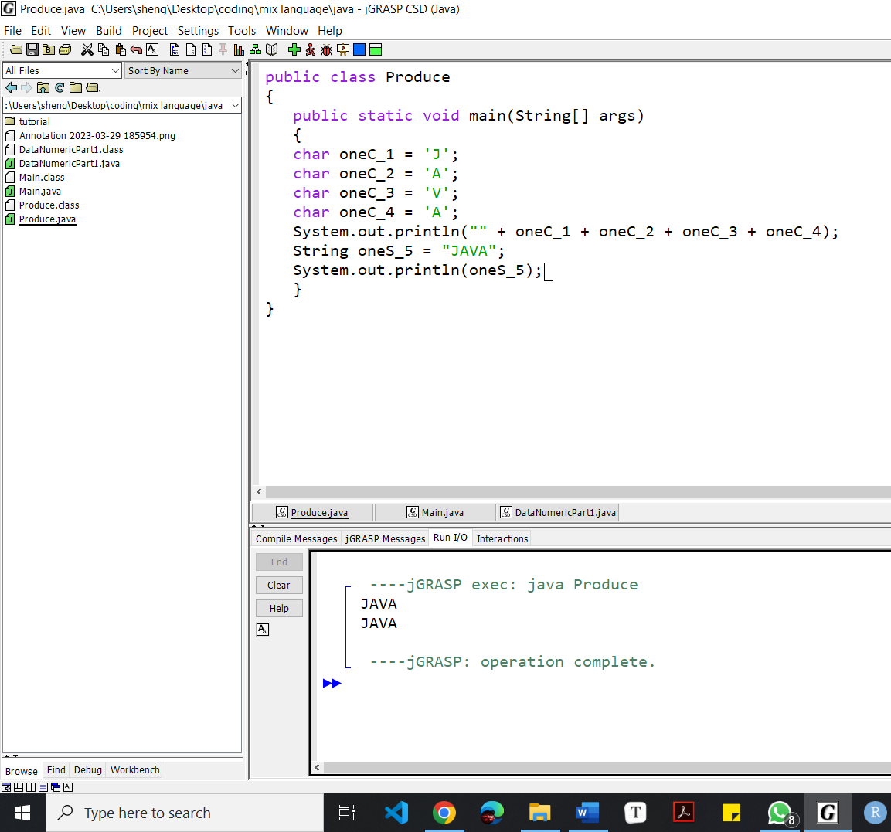

1. Develop a program that converts money in RM into USD. Assume that RM1 = USD0.24.

**STEP 1:** Analyze and write algorithm – pseudocode or flowchart

**STEP 2:** Convert the algorithm into a Java program. The following java program skeleton with comments is provided.

|  |
| --- |
| /**  * @author  */  public class DataNumericPart1 {  public static void main(String[] args) {  /** 1. What data values do we know?  * We know that RM1 is equivalent to USD0.24  * Declare a double constant named RM_USD  * Assign RM_USD the value 0.24*/  ______________________________________________  /** 2. What other data does the program require?  * For this program, we require the amount of money in RM  * Declare a double variable named ringgit.  * Assign any desired value to this variable*/  _______________________________________________  /** 3. Calculation: convert RM to USD  * Declare a double variable named dollar  * Multiply ringgit by RM_USD, store the result in dollar  */  _______________________________________________  /** 4. Output  * Write one or two statements that output  * the value in RM and its equivalent USD.  * Try to match the sample output below:  * RM1500.90 is equivalent to USD360.22*/  _______________________________________________  }//end of main  }//end of class |

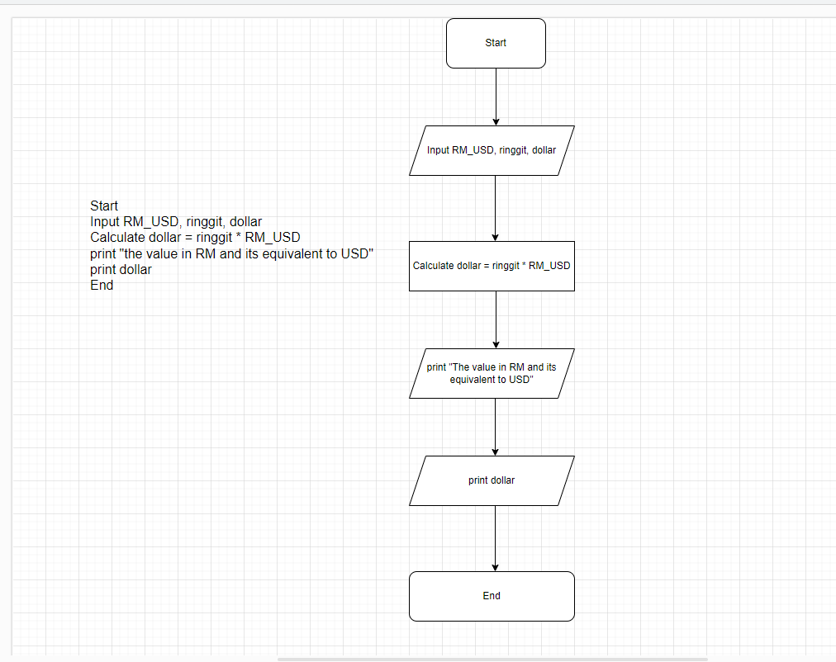

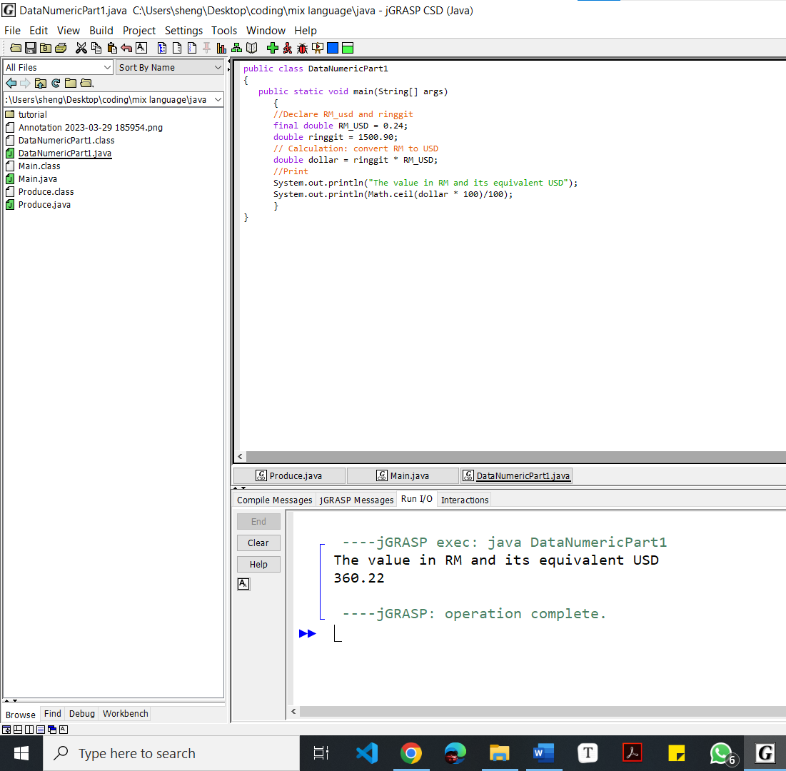

OR

