Credit report

Introduction
The credit data is collected in August, 2026. The dataset contains information of credit card holders of the bank. Total number of people in the dataset is 400.

Demography
The data covers 193 males and 207 females. The following table shows the ethnicity breakdowns.
ethnicity | n
African American | 99
Asian | 102
Caucasian | 199

Income distribution
Median income of the participant is 33.12 USD, ranging from 10.35 to 186.63 . Figure below show the income distribution.
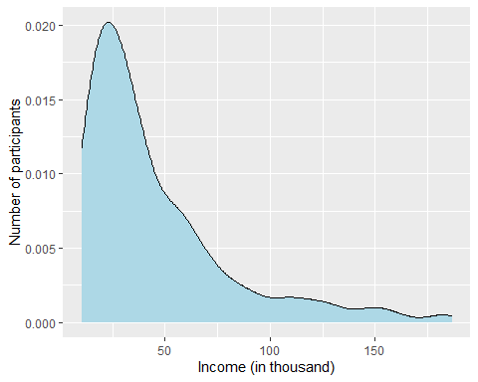
Average credit balance is 520.02 USD. As shown in the following figure, African American people recorded highest credit balance on average, followed by Caucasian.
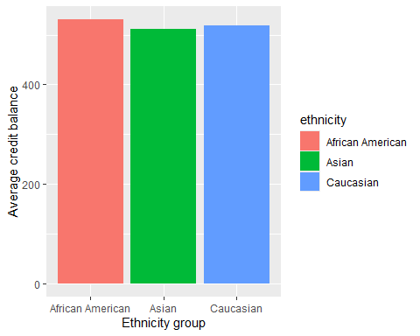

Variable associated with balance
There is a possible positive relationship between the credit card balance and annual income of card holders. The person who earns more is likely to have better credit balance.
