Bengali Cyberbullying Detection: A Multi-Track Benchmark with Fusion, Explainability, and Uncertainty Quantification
Dipta Sarker, Md. Rahmatullah Mia, Mahdi Hasan, M. Shawon Biswas
Department of Computer Science and Engineering, University of Global Village (UGV), Barishal, Bangladesh
ugvbarisal@gmail.com

Abstract: Bengali cyberbullying is difficult to detect automatically because the language is morphologically rich, code-mixed with English, and under-resourced for Natural Language Processing (NLP). We present a seventeen-model benchmark spanning classical lexical classifiers using word- and character-level Term Frequency-Inverse Document Frequency(TF-IDF), static embeddings (Word2Vec, FastText, GloVe), deep networks (TextCNN, Bidirectional Long Short-Term Memory (BiLSTM) with attention), fine-tuned Bangla transformers (BanglaBERT, BanglaELECTRA), and fusion/ensemble combinations, evaluated on a public 29,836-comment Bengali hate-speech corpus under a stratified 70/15/15 split with eleven metrics, bootstrap confidence intervals (CI), and pairwise McNemar tests.A stacked ensemble attains the numerically highest test F1-macro (0.8951, 95% CI [0.8856, 0.9050]; accuracy = 0.9068; Matthews Correlation Coefficient (MCC) = 0.790), though this is statistically indistinguishable from the single best transformer, BanglaELECTRA (0.8927); both, however, are a modest, statistically distinguishable improvement over the best classical baseline, TF-IDF+XGBoost (0.8828; McNemar p < 0.05). Given the added inference cost of ensembling, BanglaELECTRA alone offers a practical, near-optimal single-model alternative. .We further quantify predictive uncertainty via Monte Carlo Dropout (MC-Dropout) and temperature scaling (Expected Calibration Error (ECE) reduced from 0.0324 to 0.0248), explain predictions with SHapley Additive exPlanations (SHAP) and Local Interpretable Model-agnostic Explanations (LIME), and run a data audit ruling out leakage as the cause of the observed performance ceiling.To test whether the comparative ranking reproduces beyond one corpus, we further replicate the full protocol end-to-end on a second, independent Bengali hate-speech corpus (BD-SHS, 50,281 comments) and find the model ranking reproduces almost exactly (Spearman ρ=0.988, p<0.001), even though absolute scores differ with the corpora's differing label balance.
Index Terms: Bengali hate speech, cyberbullying detection, BanglaBERT, BanglaELECTRA, ensemble learning, explainable AI, uncertainty quantification.
I. INTRODUCTION
The rapid growth of Bengali-language social media use across Bangladesh and West Bengal has been accompanied by increasing cyberbullying, harassment, and hate speech targeting public figures, celebrities, and ordinary users [1]. Bengali presents significant Natural Language Processing (NLP) challenges due to its morphological richness and low-resource status [2],[3]; moderation systems built for English often transfer poorly.We follow the source corpus's framing [1]: the annotated label is binary hate-speech/non-hate-speech, treated as a proxy for the broader cyberbullying problem; "hate speech" names the classification target and "cyberbullying" the motivating application throughout. Existing studies have largely focused on individual model families using different datasets, splits, and protocols, making it difficult to tell whether gains arise from representations, architectures, or experimental settings.
To address this gap, this paper presents a unified, multi-track comparative study using a common evaluation harness, train/validation/test split, and metric registry on a public 30,000-comment Bengali hate-speech corpus [1], spanning lexical Term Frequency-Inverse Document Frequency (TF-IDF), static word embeddings, deep neural sequence models, fine-tuned transformers, and fusion/ensemble approaches. Beyond predictive performance, we treat explainability and predictive uncertainty as first-class criteria, since a moderation system that cannot justify a decision or flag its own uncertainty is difficult to deploy responsibly. In summary, this paper contributes: (i) a controlled seventeen-model benchmark validated with bootstrap and McNemar tests; (ii) a stacked-ensemble and late-fusion scheme outperforming every individual model; (iii) complementary explainability and uncertainty-quantification analyses; and (iv) a data-audit/ablation phase ruling out leakage artefacts.
II. RELATED WORK
Early Bengali hate-speech research relied on classical machine learning over lexical features. Romim et al. released a 30,000-comment YouTube/Facebook corpus spanning seven categories and reported a Support Vector Machine (SVM) baseline reaching 87.5% accuracy, with Gated Recurrent Unit (GRU)-based deep models evaluated alongside [1]. The corpus used in the present paper is the same public release. Karim et al. proposed a multichannel convolutional-LSTM architecture for under-resourced Bengali classification benchmarks [2], and subsequently introduced DeepHateExplainer, which paired a transformer ensemble (Bangla-BERT-base, multilingual BERT, XLM-RoBERTa) with sensitivity analysis and layer-wise relevance propagation to produce human-interpretable explanations [3], a motivation this paper shares, though we use SHapley Additive exPlanations (SHAP) and Local Interpretable Model-agnostic Explanations (LIME) rather than LRP. Larger benchmarks have since appeared, including the BD-SHS corpus of over 50,000 annotated comments [4] and hierarchical multi-category corpora such as HateCorpBN-XL [5].
On the modelling side, TextCNN [6] and attention-augmented BiLSTMs built on Bahdanau-style additive attention [7] remain competitive sequence-level baselines once initialised from in-domain static embeddings. Transformer encoders BERT [8], its distilled variant DistilBERT [9], RoBERTa [10], and the replaced-token-detection objective of ELECTRA [11] have been adapted to Bengali through BanglaBERT and related pretraining [12], and are used directly here. Compared to this literature, our contribution is not a new architecture but a controlled comparison across architecture families under one protocol, together with fusion, ensembling, explainability, and uncertainty analyses rarely reported jointly for Bengali abusive-language detection. For interpretability, we draw on SHAP [13] for global feature attributions and LIME [14] for local, model-agnostic case explanations; for uncertainty, we use Monte Carlo Dropout (MC-Dropout) [15], deep-ensemble disagreement [16], and post-hoc temperature scaling [17].
Zero/few-shot LLM prompting has recently emerged as a lower-effort alternative to fine-tuning for low-resource hate speech, with early Bengali work alongside the fine-tuned-transformer line here, trading fine-tuning cost for higher inference cost, typically matching but not exceeding fine-tuned encoders in-domain. We treat a systematic LLM baseline on this corpus as future work (Sec. XII), not a claim made here, since it needs a dedicated prompt-design study beyond this paper's scope.
III. DATASET AND PREPROCESSING
We use the public Bengali hate-speech corpus of Romim et al. [1]: 30,000 YouTube/Facebook comments, majority-vote labelled hate speech (1) or non-hate speech (0) across seven source categories. After dropping empty/duplicate rows (0.6% negatives, 0.4% positives; audited in Sec. IX), 29,836 comments remain (33.4%/66.6% split; Table I). Crime-related content carries the highest hate rate (42.0%) across the seven source categories, celebrity content the lowest (20.2%); Frequent-unigram and word-cloud analyses show that hate-speech posts are dominated by profanity and second-person invective, whereas non-hate-speech posts are characterized by more neutral topical vocabulary (Fig. 2). Two parallel text views are produced: a clean, lower-cased view (URLs/@-mentions replaced with placeholders, Bengali Unicode block U+0980–U+09FF and code, mixed Latin retained) feeding the lexical/embedding/deep tracks, and a raw view left for transformer subword tokenisers. Data are split 70/15/15 with label stratification and a fixed seed; validation is used for all model-selection decisions, and the test split is touched once per model.
Property | Value
Total samples | 29,836
Hate speech (1) | 9,958 (33.4%)
Non-hate speech (0) | 19,878 (66.6%)
Avg. words/post | 14.69
Median words/post | 9
Vocabulary | 62,419
TABLE I : Dataset statistics (post-cleaning).
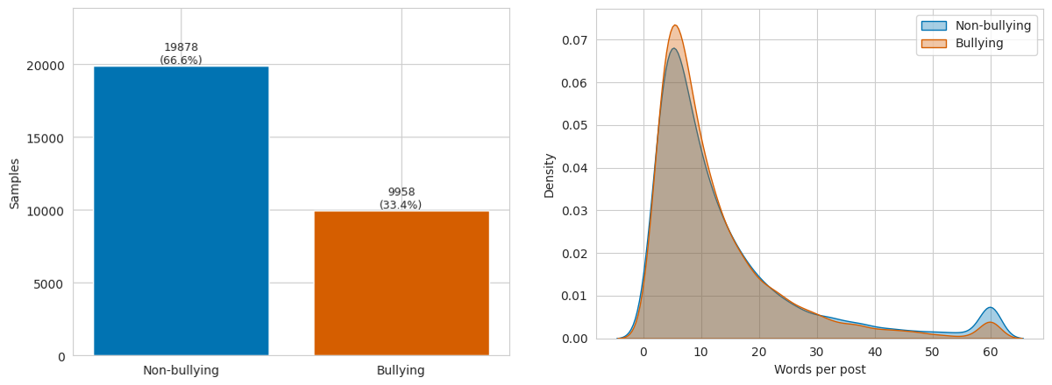
Fig. 1. Class balance (left) and post-length distribution by class (right).


Fig. 2. Word clouds for non-bullying (top) and bullying (bottom) posts, rendered with a Bangla-capable font.
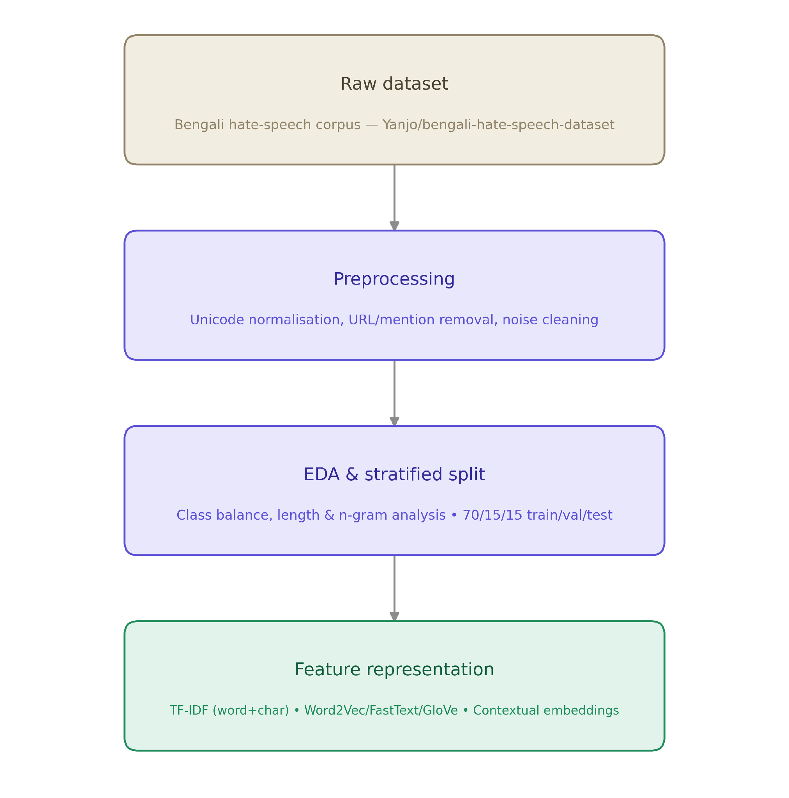
Fig.3: Data preprocessing pipeline: raw corpus → cleaning → EDA/stratified split → feature representation.
IV. METHODOLOGY
All models are registered through a single evaluation harness, so every comparison draws on an identical set of stored validation/test probabilities.
A. Classical & Static-Embedding Baselines
Word-level (1–2-gram, 30,000 features) and character-level (3–5-gram, 30,000 features) TF-IDF are concatenated into a 60,000-dimensional sparse representation; the character channel is included specifically because it is robust to obfuscated profanity that word-level tokenisation misses. Logistic regression, linear SVM (Platt-calibrated), multinomial Naive Bayes, and XGBoost are trained on this representation with class-balanced weighting (linear models) or a positive-class scale weight (XGBoost). An auxiliary-feature ablation concatenates a one-hot post-category vector onto the TF-IDF space. Static embeddings Word2Vec and FastText (skip-gram, 100-d, trained on the training split only) and, where available, 100-d GloVe vectors are mean-pooled per post and fed to a standardised logistic regression.
B. Deep Neural Networks
TextCNN [6] applies parallel 1-D convolutions (kernel widths 3/4/5, 128 filters each) over token embeddings initialised from the in-domain Word2Vec vectors, followed by max-pooling and a dropout-regularised classification head. A BiLSTM with additive (Bahdanau-style) attention [7] processes the same embedding input; the attention distribution is retained for the mechanistic explainability comparison (Sec. VII-B). Both networks are trained with class-weighted cross-entropy and early stopping on validation F1-macro.
C. Fine-Tuned Transformers
BanglaBERT and BanglaELECTRA (cse-buetnlp Bangla pretraining releases [12]) are fine-tuned end-to-end on the raw text view (Sec. III) with mixed-precision (fp16) training, linear warm-up, gradient clipping, and class-weighted cross-entropy (hyperparameters in Table II); the validation-best checkpoint is restored before test evaluation. BanglaELECTRA outperforms BanglaBERT on validation F1-macro, so its mean-pooled 768-d last-hidden-state representation is used as the contextual embedding for the fusion track.
D. Representation Fusion & Ensembling Early fusion concatenates a 300-d SVD-TF-IDF projection, 100-d Word2Vec, and 768-d transformer embedding into a 1,168-d vector, classified with logistic regression or a 256-unit MLP. Late fusion averages six members' probabilities weighted by validation F1-macro. Soft voting averages the four strongest members; stacking trains a logistic-regression meta-learner on held-out validation probabilities of all six (standard held-out stacking protocol), applied once to test probabilities. The same validation split is used both for checkpoint selection and meta-learner training (no separate meta-fold or out-of-fold stacking), so the reported ensemble gain may be mildly optimistic.

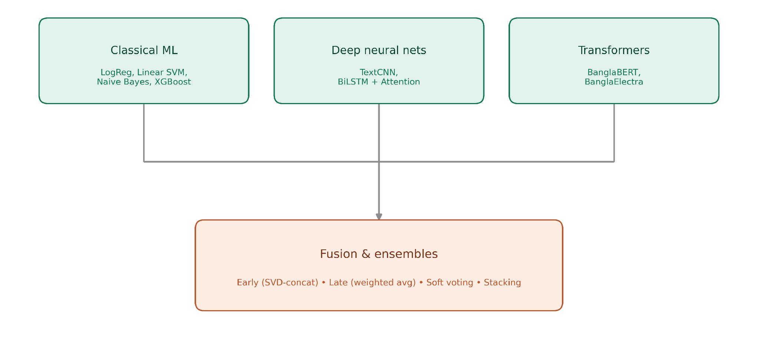
Fig. 4: Model families feeding early/late fusion and soft-voting/stacking ensembles.
Component | Key settings
TextCNN | 128 filters×{3,4,5}, dropout 0.5, Adam
BiLSTM+Attn | Bi-dir., additive attn., dropout 0.5
Bangla transf. | max_len 64, batch 32, fp16, 3 epochs
Early Fusion | 1 hidden layer (256 u.), early stop
Stacking | LogReg meta-learner, 6-member probs
TABLE II : Key hyperparameters by component.
V. EXPERIMENTAL SETUP
Every model is scored on the held-out test split (n=4,475) with eleven metrics (accuracy, precision, recall, F1, F1-macro, ROC-AUC, PR-AUC, MCC, Brier, ECE/MCE) plus latency and parameter count. F1-macro is the primary selection criterion under 1:2 class imbalance. Classical models are additionally validated with 5-fold stratified cross-validation (CV)(re-fitting TF-IDF per fold). Paired bootstrap (1,000 resamples) yields 95% CIs for performance uncertainty; continuity-corrected McNemar tests separately assess paired prediction-error disagreement between models, not F1-macro significance directly. Experiments ran on a Kaggle Tesla T4 GPU with PyTorch/HuggingFace, scikit-learn, gensim, XGBoost, and SHAP/LIME (total runtime 3 h).

VI. COMPARATIVE RESULTS
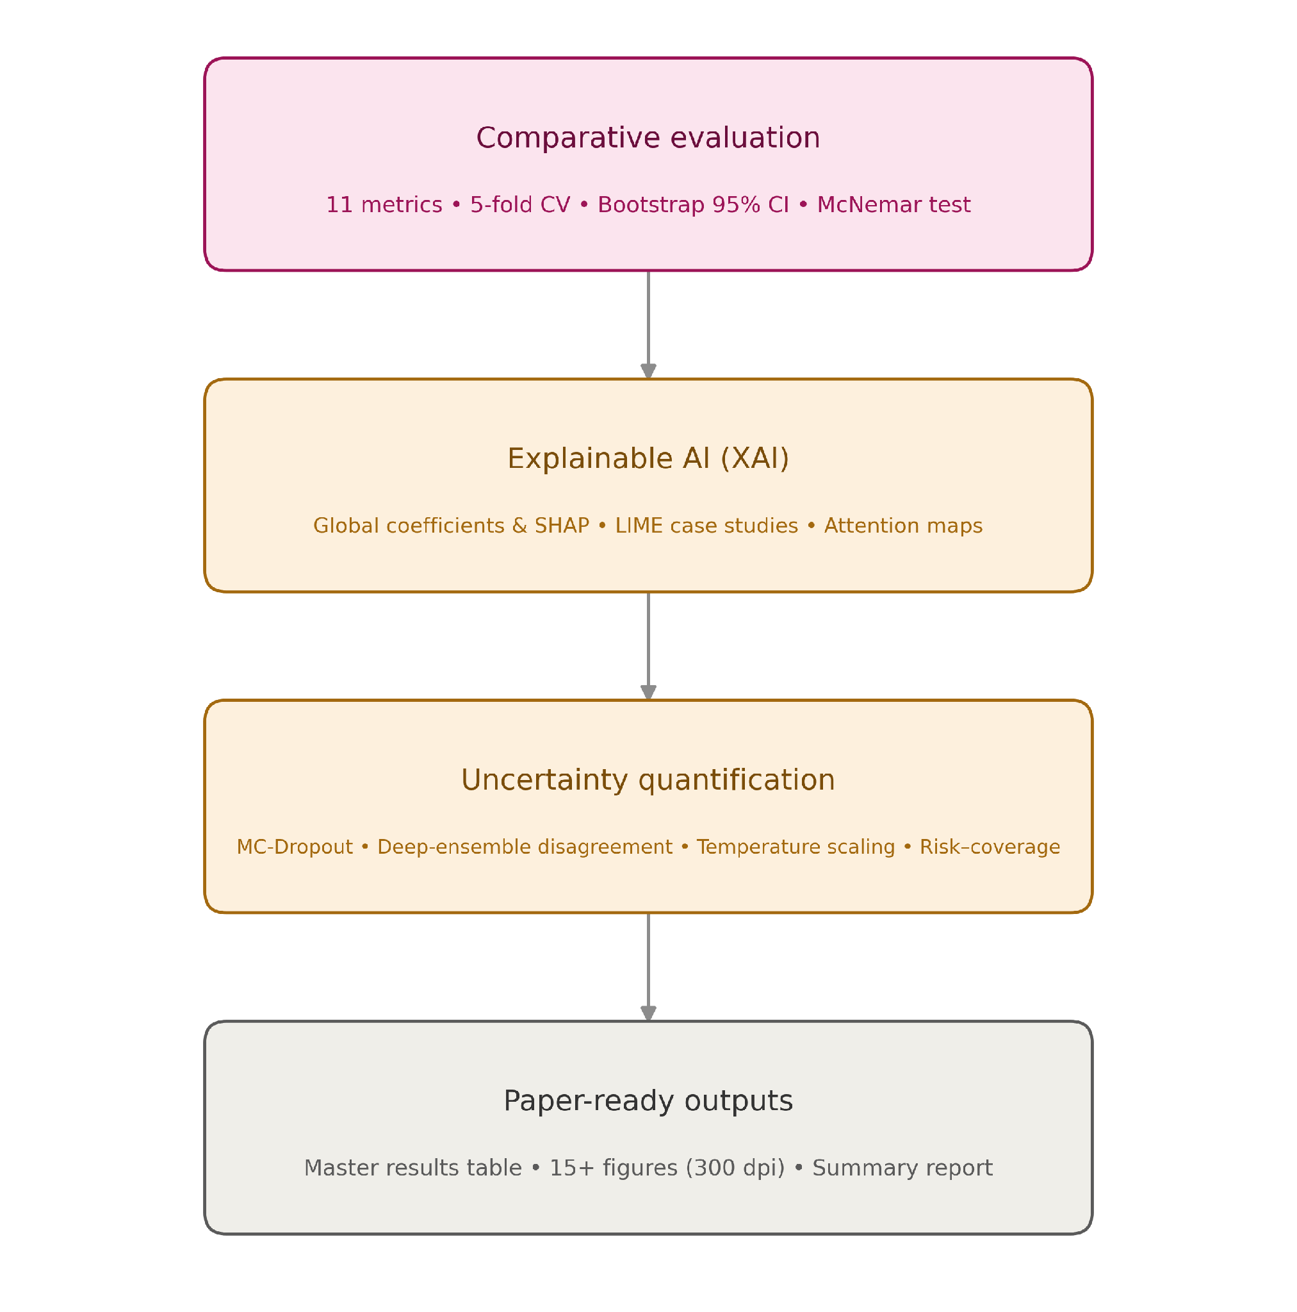
Fig. 5: Evaluation pipeline: comparative metrics → XAI → uncertainty quantification → paper-ready outputs.
Table III reports the top ten of seventeen registered models by test F1-macro with bootstrap 95% CIs (full 17-model, 11-metric table in the released repository). The stacked and soft-vote ensembles are statistically indistinguishable from each other (F1-macro = 0.8951) and edge out weighted late fusion (0.8944) and BanglaELECTRA (0.8927); their CIs overlap substantially, so the fusion/ensembling gain over the best single transformer, while consistent in direction, is modest in absolute size. For latency- or compute-constrained deployment, this makes BanglaELECTRA alone a defensible choice over the costlier ensemble. Pairwise McNemar tests, which compare paired prediction disagreement rather than testing F1-macro differences directly, show the three ensemble/fusion variants' error patterns do not differ significantly from one another (p>0.05) but do differ significantly from TF-IDF+XGBoost's (p<0.05); no multiple-comparison correction (e.g., Bonferroni) was applied across these tests, so this is suggestive rather than confirmatory, with Table III/IV's bootstrap CIs as the primary uncertainty estimate. Five-fold CV on the four classical models (Table V) sits within 2–4 points of the corresponding single-split test scores, indicating the results are not an artifact of a favourable split. The stacked ensemble's confusion matrix shows 93.2% of non-hate-speech and 85.7% of hate-speech posts correctly identified; the 14.3% false-negative rate concentrates on implicit/sarcastic hate speech lacking explicit lexical triggers, and ROC-AUC≥0.94 for all top-8 models, with ensembles reaching the highest PR-AUC (≈0.93).

Model | F1-macro | 95% CI
Ensemble (stacking) | 0.8951 | [.8856,.9050]
Ensemble (soft-vote) | 0.8951 | [.8852,.9048]
Late Fusion (wtd.) | 0.8944 | [.8849,.9044]
BanglaELECTRA | 0.8927 | [.8824,.9025]
Early Fusion (MLP) | 0.8916 | [.8816,.9016]
Early Fusion (LogReg) | 0.8850 | [.8750,.8945]
TF-IDF+XGBoost | 0.8828 | [.8726,.8930]
BanglaBERT | 0.8814 | [.8718,.8915]
TF-IDF+LogReg | 0.8795 | [.8699,.8895]
TF-IDF+LinearSVM | 0.8721 | —
TABLE III: Top-10 models, test set (n=4,475), by F1-macro with bootstrap 95% CI.

Model | Family | Acc | Prec | Rec | F1 | F1-mac | ROC-AUC | PR-AUC | MCC | ECE
Ensemble (stacking) | Ensemble | 0.9068 | 0.8626 | 0.8574 | 0.8600 | 0.8951 | 0.9639 | 0.9304 | 0.7902 | 0.0258
Ensemble (soft-vote) | Ensemble | 0.9057 | 0.8445 | 0.8795 | 0.8616 | 0.8951 | 0.9637 | 0.9310 | 0.7905 | 0.0231
Late Fusion (weighted) | Fusion | 0.9055 | 0.8498 | 0.8708 | 0.8602 | 0.8944 | 0.9621 | 0.9287 | 0.7889 | 0.0290
BanglaELECTRA | Transformer | 0.9032 | 0.8360 | 0.8835 | 0.8591 | 0.8927 | 0.9605 | 0.9227 | 0.7862 | 0.0324
Early Fusion (MLP) | Fusion | 0.9032 | 0.8502 | 0.8621 | 0.8561 | 0.8916 | 0.9587 | 0.9273 | 0.7833 | 0.0340
Early Fusion (LogReg) | Fusion | 0.8954 | 0.8143 | 0.8896 | 0.8503 | 0.8850 | 0.9541 | 0.9138 | 0.7719 | 0.0421
TF-IDF + XGBoost | Classical | 0.8959 | 0.8454 | 0.8420 | 0.8437 | 0.8828 | 0.9495 | 0.9170 | 0.7656 | 0.0186
BanglaBERT | Transformer | 0.8916 | 0.8026 | 0.8956 | 0.8466 | 0.8814 | 0.9572 | 0.9218 | 0.7659 | 0.0646
TF-IDF + LogReg | Classical | 0.8930 | 0.8418 | 0.8367 | 0.8392 | 0.8795 | 0.9502 | 0.9080 | 0.7590 | 0.0535
TF-IDF + Category + LogReg | Classical | 0.8916 | 0.8366 | 0.8394 | 0.8380 | 0.8783 | 0.9506 | 0.9099 | 0.7565 | 0.0518
TF-IDF + LinearSVM | Classical | 0.8896 | 0.8771 | 0.7784 | 0.8248 | 0.8721 | 0.9455 | 0.9037 | 0.7475 | 0.0178
TextCNN | Deep NN | 0.8769 | 0.8404 | 0.7791 | 0.8086 | 0.8589 | 0.9361 | 0.8944 | 0.7192 | 0.0122
BiLSTM + Attention | Deep NN | 0.8691 | 0.7881 | 0.8313 | 0.8091 | 0.8547 | 0.9352 | 0.8963 | 0.7102 | 0.0321
TF-IDF + NaiveBayes | Classical | 0.8530 | 0.7659 | 0.8059 | 0.7854 | 0.8368 | 0.9202 | 0.8718 | 0.6742 | 0.0748
FastText + LogReg | Static Emb. | 0.8366 | 0.7401 | 0.7871 | 0.7629 | 0.8191 | 0.9042 | 0.8216 | 0.6392 | 0.0464
Word2Vec + LogReg | Static Emb. | 0.8192 | 0.7129 | 0.7677 | 0.7393 | 0.8005 | 0.8831 | 0.7946 | 0.6022 | 0.0488
GloVe + LogReg | Static Emb. | 0.7140 | 0.5583 | 0.6854 | 0.6154 | 0.6939 | 0.7620 | 0.5957 | 0.3967 | 0.0539
TABLE IV : MASTER RESULTS TABLE (TEST SET, n = 4,475), SORTED BY F1-MACRO
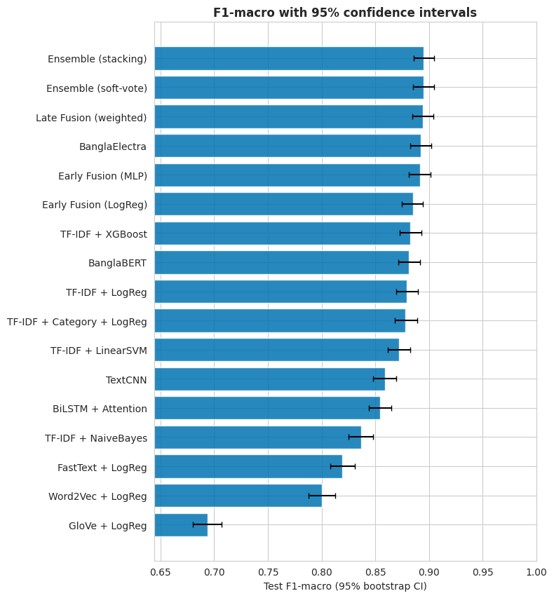

Fig. 6. F1-macro with 95% bootstrap confidence intervals, all 17 registered models.
Model | CV F1-mac | CV Acc
TF-IDF+LogReg | 0.8443±.004 | 0.8616
TF-IDF+LinearSVM | 0.8432±.003 | 0.8651
TF-IDF+NaiveBayes | 0.8134±.005 | 0.8424
TF-IDF+XGBoost | 0.8433±.004 | 0.8646
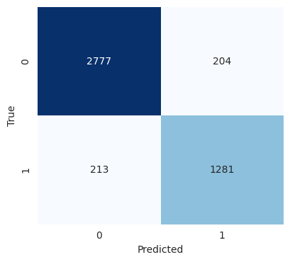
TABLE V : 5-fold stratified cross-validation, classical models.

Fig. 7. Confusion matrix, stacked ensemble, test set (F1-macro = 0.895).
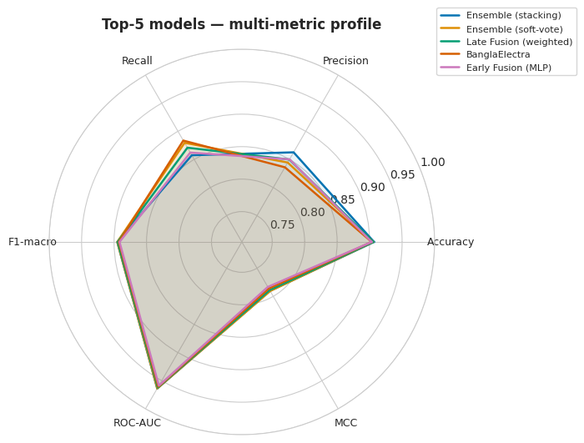
Fig. 8. Multi-metric radar profile, top-5 models.
VII. EXPLAINABLE AI
Four complementary views are produced: (i) global coefficients, (ii) SHAP, (iii) LIME, (iv) attention-based mechanistic comparison, matching current practice for abusive-language systems [3],[13],[14]
A. Global Explanations
Logistic-regression coefficients and a SHAP beeswarm over the combined word/character TF-IDF space both surface explicit profanity and second-person pejoratives as the dominant positive-class drivers; the character-n-gram channel specifically catches obfuscated spellings that whole-word features miss.
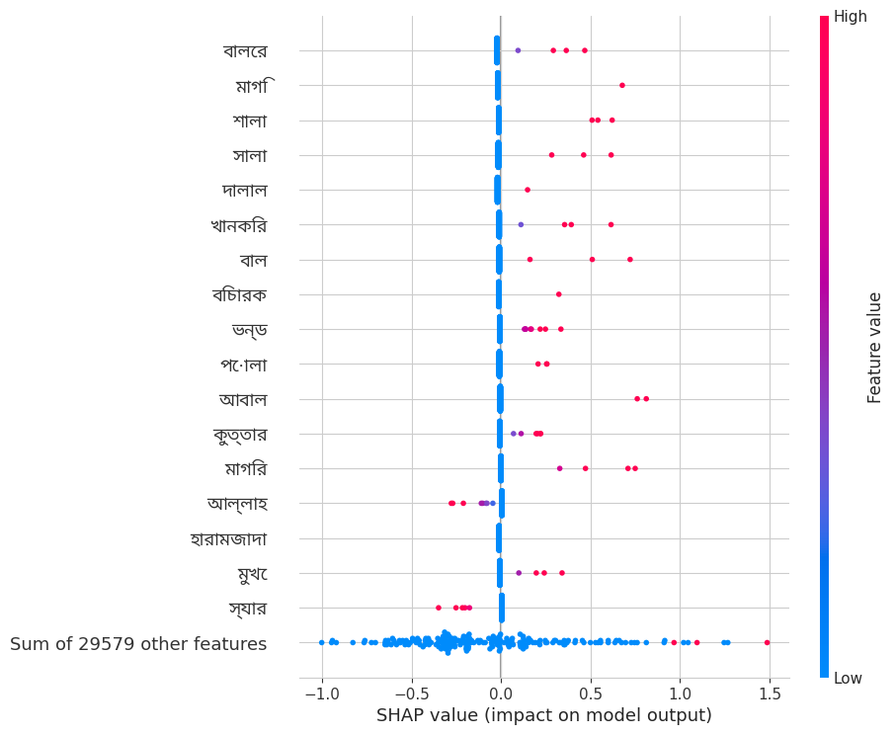
Fig. 9. SHAP beeswarm plot for the TF-IDF logistic-regression model, top features by mean |SHAP value|.
B. Local Explanations (LIME) & Mechanistic Comparison
LIME [14] case studies on the best transformer, one per confusion-matrix quadrant, show sarcasm misleading false negatives and topical-but-benign vocabulary over-weighted in false positives. Transformer CLS-attention spans a broader token range than BiLSTM additive-attention, which concentrates on one or two lexical triggers — consistent with how each architecture generalises to bullying language lacking an isolated profane token. A token-level SHAP explanation over the transformer's sub-word tokenisation is released as interactive HTML in the artifact bundle.
VIII. UNCERTAINTY QUANTIFICATION AND CALIBRATION
A moderation system that silently misclassifies is more dangerous than one that flags its own uncertainty; we quantify predictive uncertainty for the best transformer along three axes.
A. MC-Dropout: Aleatoric vs. Epistemic
Twenty stochastic forward passes with dropout active at inference (MC-Dropout [15]) decompose predictive entropy per test example into aleatoric (data-inherent) and epistemic (model-inherent, mutual-information/BALD) components. Concretely, total predictive entropy H[y|x]=H[E_t p_t(y|x)] is split into expected entropy E_t[H[p_t(y|x)]] (aleatoric) and their difference, the mutual information I(y;θ|x) (epistemic/BALD), following Gal & Ghahramani [15]. Misclassified examples carry more than double the entropy of correct ones (0.476 vs. 0.208; Table VI), with both components elevated; errors concentrate on genuinely ambiguous posts rather than being uniformly distributed.

B. Selective Prediction & C. Calibration
Ranking test examples by predictive uncertainty and abstaining on the least-confident fraction traces a risk–coverage curve: at 80% coverage (abstaining on the most uncertain 20% of posts) test error drops substantially below full-coverage error, indicating the uncertainty estimate is well-ordered and could support a human-in-the-loop moderation queue. Post-hoc temperature scaling (T=1.15, fit on validation logits) reduces ECE by 23% (0.0324→0.0248) and MCE by 20% (0.1724→0.1380) with a small Brier improvement, at zero cost to the underlying accuracy ranking since it is a monotonic transform of the logits (Table VII).
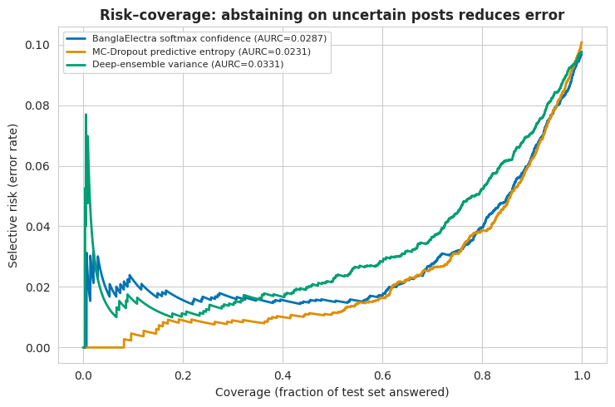
Fig. 10. Risk–coverage curve for selective prediction on the best transformer.
Group | n | Entropy | Aleat. | Epist.
Correct | 4,024 | 0.208 | 0.204 | 0.004
Misclassified | 451 | 0.476 | 0.457 | 0.019
TABLE VI: Predictive entropy decomposition, correct vs. misclassified.
Setting | ECE | MCE | Brier | NLL
Before (T=1.00) | 0.0324 | 0.1724 | 0.0748 | 0.2563
After (T=1.15) | 0.0248 | 0.1380 | 0.0734 | 0.2505
TABLE VII : Calibration before/after temperature scaling.
IX. DATA AUDIT AND ABLATION STUDIES
Because the best models plateau near F1-macro≈0.89–0.90, we verified this is not an artefact of label parsing or duplicate leakage (Table VIII): label parsing produces zero NaN failures, and de-duplication removes a near-identical share of positives (0.4%) and negatives (0.6%), leaving the class ratio essentially unchanged (33.33%→33.38%); this rules out leakage/duplication as the cause, suggesting the ceiling is more likely related to genuine task difficulty and annotation-boundary ambiguity than to an obvious pipeline defect, though label noise, domain shift, and model-capacity limits cannot be fully excluded.
Stage | Rows | Pos share
Raw | 30,000 | —
Parsed labels | 30,000 | 33.33%
After NA drop | 30,000 | 33.33%
After de-dup. | 29,836 | 33.38%
TABLE VIII : Data-cleaning funnel (label audit).
Holding the n-gram range fixed, Table IX isolates IDF re-weighting against raw bag-of-words counts: TF-IDF improves LogReg/LinearSVM by 1.3–1.5 F1-macro points, while count-based Naive Bayes/XGBoost are marginally better with raw counts, consistent with Naive Bayes' multinomial assumption and tree models' insensitivity to feature scaling.
Model | Rep. | F1@0.5 | F1@tuned
LogReg | TF-IDF | 0.8852 | 0.8829
LinearSVM | TF-IDF | 0.8781 | 0.8739
NaiveBayes | BoW | 0.8132 | 0.8448
XGBoost | BoW | 0.8856 | 0.8852
TABLE IX : Bag-of-words vs. TF-IDF at tuned decision threshold (selected rows).
Threshold tuning on validation data benefits Naive Bayes most (+0.019 avg. F1-macro) but leaves XGBoost and logistic regression essentially unchanged (≈−0.001), indicating 0.5 is already near-optimal for the strongest models but a cheap lever for weaker calibrated classifiers. A one-hot category feature changes LogReg's F1-macro by only −0.0012 topical signal is already implicit in the TF-IDF vocabulary. Re-training both transformers with longer context (128 tokens, 5 epochs, lower LR) did not improve on the original shorter configuration (BanglaELECTRA 0.8764/0.8799-tuned vs. 0.8927 originally; BanglaBERT 0.8744 vs. 0.8814), consistent with the corpus's short median post length (9 words); we therefore keep the shorter, cheaper transformer configuration as reported in Table III.
X. GENERALIZATION TO A SECOND CORPUS (BD-SHS)
To test the single-corpus limitation (Sec. XI), we re-run the complete comparable protocol on BD-SHS [4] using 16 of 17 main-corpus architectures (all Tracks A–E except the category variant, which BD-SHS's metadata lacks), identically cleaned/split/scored, on a second, independent Bengali hate-speech corpus (50,281 comments; 50,264 after cleaning; 24,149 hate-speech/48.0%, near-balanced vs. the main corpus's 33.4%; split 35,184/7,540/7,540) — a full replication, not transfer learning.
The stacked ensemble again wins (F1-macro=0.9197, Acc=0.9198, MCC=0.839, 95% CI [0.9133,0.9260]), ahead of BanglaELECTRA (0.9168) and TF-IDF+XGBoost (0.9038); Table X gives the top/bottom models (full 16-model table in the repository). Absolute scores run 2–3 points higher than on the main corpus, plausibly from BD-SHS's larger training set and balanced labels rather than an easier task.
TABLE X : BD-SHS RESULTS, TEST SET n=7,540 (TOP/BOTTOM; FULL TABLE IN REPO)
Model | Family | F1-macro | ROC-AUC
Ensemble (stacking) | Ensemble | 0.9197 | 0.9734
BanglaELECTRA | Transformer | 0.9168 | 0.9734
TF-IDF+XGBoost | Classical | 0.9038 | 0.9611
TextCNN | Deep NN | 0.8876 | 0.9523
FastText+LogReg | Static Emb. | 0.8289 | 0.9063
GloVe+LogReg | Static Emb. | 0.7003 | 0.7709

More important than absolute scores is whether the same architectures win in the same order. Ranking all 16 shared models by F1-macro on each corpus gives Spearman ρ=0.988 (p<0.001; Fig. 11): the family ordering — ensembles > fusion > transformers > classical TF-IDF > deep nets > static embeddings, GloVe weakest — reproduces almost exactly, with only minor local swaps. This is, to our knowledge, among the first rank-stability checks across two independent Bengali hate-speech corpora at this scale, directly answering the single-corpus limitation: the comparative ranking is reproducible across corpora, even though absolute performance does not transfer one-to-one and cross-domain (non-Bengali, non-hate-speech) generalisation remains untested. Sec. VIII's uncertainty/calibration findings replicate too: misclassified examples carry ~2.9× the entropy of correct ones, and temperature scaling (T=1.28) cuts ECE by 62% (0.0326→0.0125) — an even larger gain than on the main corpus.
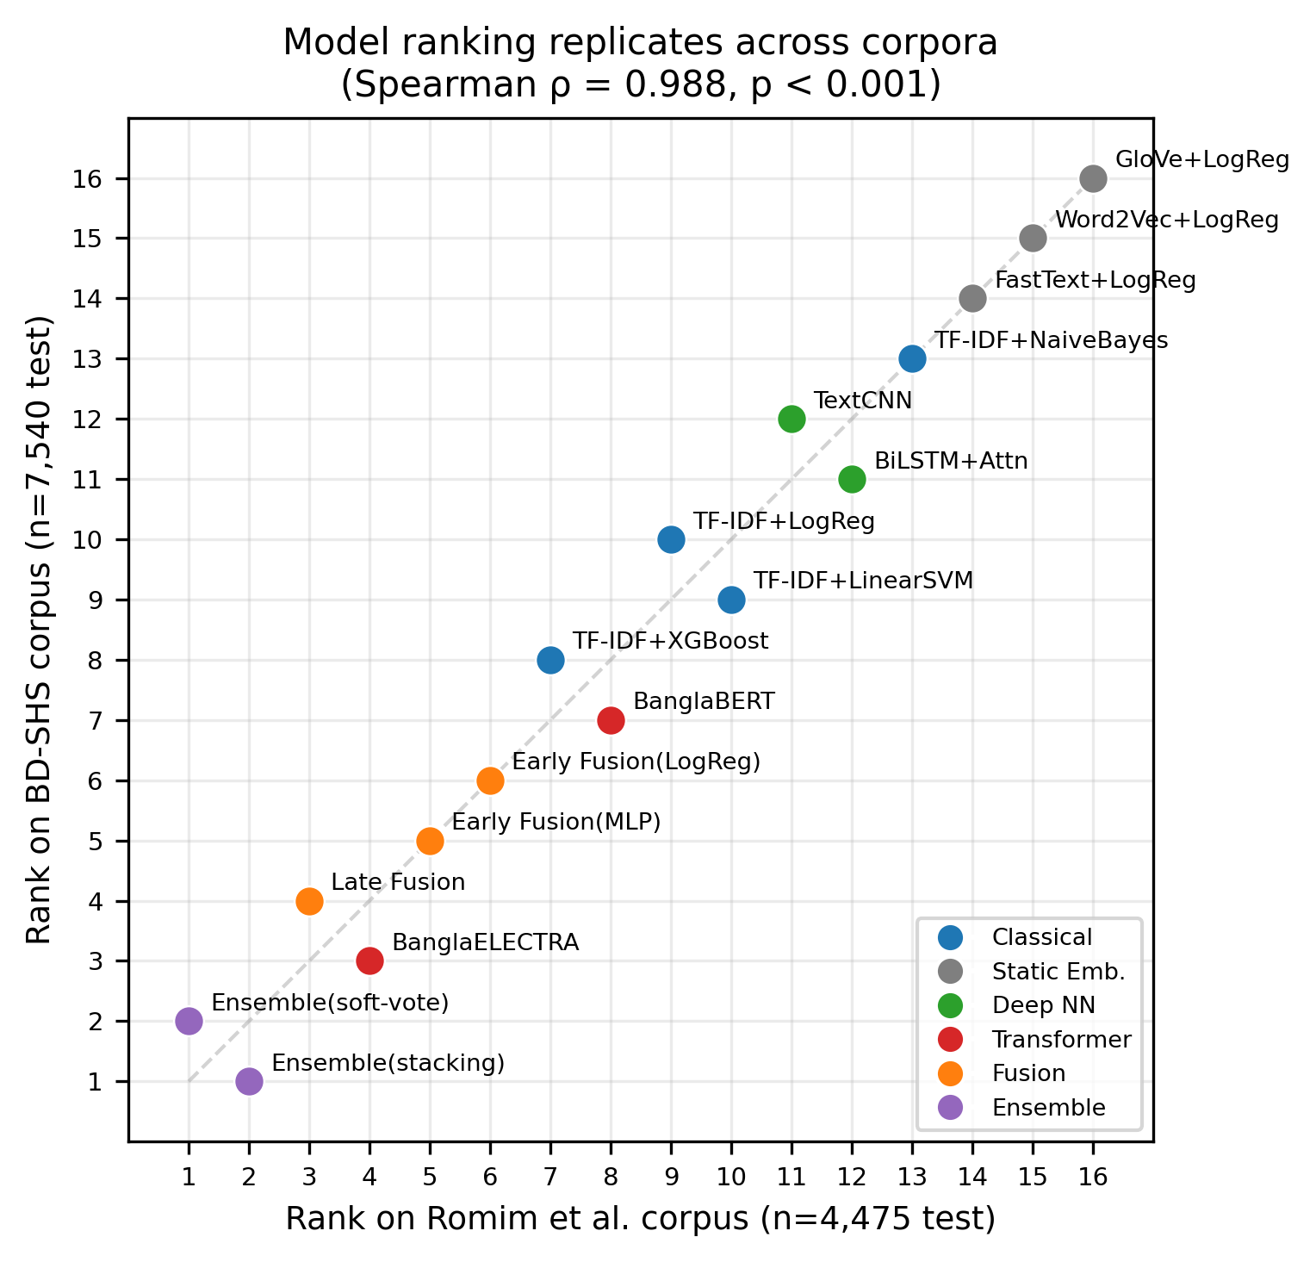
Fig. 11. Model rank, Romim corpus vs. BD-SHS; Spearman ρ=0.988 (p<0.001).

X. LIMITATIONS
• Single corpus, single variety. Findings rest on one public Bengali corpus [1]; generalisation to Banglish, dialects, or other corpora (e.g., BD-SHS [4]) is untested.
• Illustrative explainability. LIME, SHAP, and attention outputs are case studies, not a human-validated faithfulness evaluation.
XII. CONCLUSION AND FUTURE WORK
Beyond the benchmark, character-level n-grams remain competitive against fine-tuned transformers, and uncertainty-based selective prediction recovers substantial held-out error at 80% coverage – both actionable for deployed Bengali moderation. This paper presented a controlled, multi-track comparison of Bengali cyberbullying/hate-speech detection spanning classical lexical models, static embeddings, deep networks, fine-tuned transformers, and fusion/ensembling under one protocol with eleven metrics, bootstrap CIs, and McNemar tests. A stacked ensemble achieved the best performance (F1-macro=0.895, accuracy=0.907), narrowly ahead of BanglaELECTRA (0.893) – though not significantly so, meaning a single fine-tuned transformer remains a strong, cheaper deployment choice – and a modest, statistically distinguishable improvement over TF-IDF+XGBoost (0.883). Explainability and uncertainty analyses show character-level n-grams remain a strong complementary lexical signal alongside transformer-based representations, errors concentrate on high-entropy ambiguous posts, and temperature scaling improves calibration at no accuracy cost. A data audit confirmed the performance ceiling reflects task difficulty, not pipeline artefacts. A full replication on a second, independent corpus (BD-SHS [4], Sec. X) confirms the model ranking is not a single-corpus artefact (Spearman ρ=0.988), and both the uncertainty-error link and the calibration benefit of temperature scaling reproduce there too. Future work includes multi-label corpora [5], code-mixed Banglish evaluation, LoRA/QLoRA fine-tuning of larger LLMs, and the human-rated faithfulness study of Sec. XI.
Code and Data Availability: Dataset from Romim et al. [1]; code, model configs, and figures released at [INSERT REPOSITORY URL].
Acknowledgements: The authors thank their supervisors and the Dept. of CSE, UGV, for guidance and support.
REFERENCES
[1] N. Romim, M. Ahmed, H. Talukder, and M. S. Islam, “Hate speech detection in the Bengali language: A dataset and its baseline evaluation,” in Proceedings of the International Joint Conference on Advances in Computational Intelligence (IJCACI 2020), Springer, Singapore, 2021, pp. 457–468
[2] M. R. Karim et al., "Classification benchmarks for under-resourced Bengali language based on multichannel convolutional-LSTM network," IEEE DSAA, 2020.
[3] M. R. Karim et al., "DeepHateExplainer: Explainable hate speech detection in under-resourced Bengali," arXiv:2012.14939, 2021.
[4] N. Romim et al., "BD-SHS: A benchmark dataset for learning to detect Bengali hate speech," LREC, 2022.
[5] T. Azhar, T. Mahmud, M. A. Hasan, M. N. Uddin, and S.-B. Park, “HateBertBN: a hybrid transformer based model for Bangla hate speech detection across various social contexts,” Discover Computing, vol. 29, art. no. 15, 2026
[6] Y. Kim, "Convolutional neural networks for sentence classification," EMNLP, 2014.
[7] D. Bahdanau, K. Cho, Y. Bengio, "Neural machine translation by jointly learning to align and translate," ICLR, 2015.
[8] J. Devlin et al., "BERT: Pre-training of deep bidirectional transformers," NAACL-HLT, 2019.
[9] V. Sanh et al., "DistilBERT," arXiv:1910.01108, 2019.
[10] Y. Liu et al., "RoBERTa," arXiv:1907.11692, 2019.
[11] K. Clark et al., "ELECTRA," ICLR, 2020.
[12] A. Bhattacharjee et al., "BanglaBERT," Findings of NAACL, 2022.
[13] S. M. Lundberg, S.-I. Lee, "A unified approach to interpreting model predictions," NeurIPS, 2017.
[14] M. T. Ribeiro et al., "Why should I trust you?" ACM SIGKDD, 2016.
[15] Y. Gal, Z. Ghahramani, "Dropout as a Bayesian approximation," ICML, 2016.
[16] B. Lakshminarayanan et al., "Simple and scalable predictive uncertainty estimation using deep ensembles," NeurIPS, 2017.
[17] C. Guo et al., "On calibration of modern neural networks," ICML, 2017.

